1. **Sir, I know core java. Why should I go for Adv. Java?**
   1. With just core java, you can develop only **Stand Alone Application.**
2. **What is Stand-Alone Application?**
   1. An application that can be run on a single machine (computer)
   2. **Example**s:
      1. Hello Word Program.
      2. Ms-Word
      3. Calculator by MS
3. **2 Types of Stand-Alone Applications**
   1. **GUI-Based Applications** 🡺 Also known as Desktop Applications  
      Applications driven from Graphical User Interface
      1. Calculator by MS
      2. MS-Word
      3. MS-Paint
   2. **CUI-Based Applications** 🡺 Also known as Console Applications  
      Applications driven from Console
      1. java Test
4. 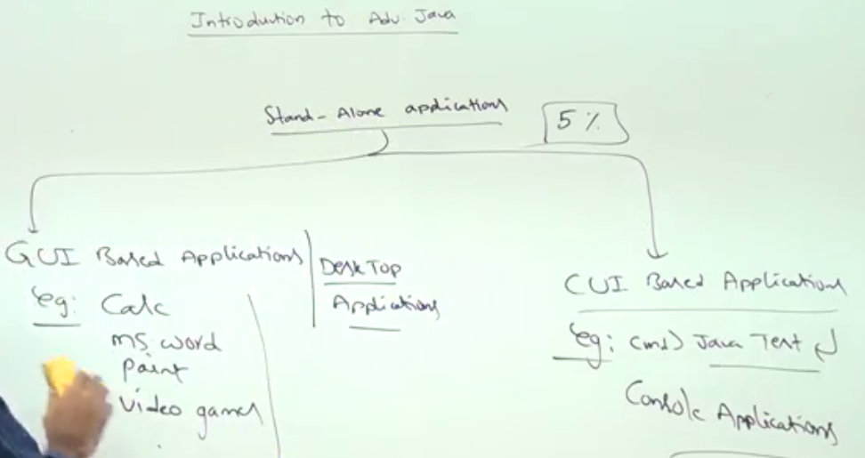
5. NOTE: To develop **Web Applications,** Core Java knowledge is not enough. So go for Adv. Java.

What is Web Application

1. **Web Application**: The application which can provide services over the web.
   1. **Example:**
      1. Gmail
      2. Face-book
2. d

Adv. Java Technologies

1. **There are only 3 technologies in Adv. Java**
   1. JDBC
   2. Servlet
   3. JSP
2. **NOTE:** Using these 3 technologies, we can develop **Web Applications**.

Role of 3 technologies🡺 JDBC, Servlet, JSP

1. **JSP**: Meant for **Presentation Logic**. To implement Pages. That is why ‘P’ alpha-letter in JS**P**.
2. **Servlet**: Meant for **Processing Logic**.
3. **JDBC**: Meant for **Communitation with Database**.   
   