1. **Ameerpet (Hyderabad)**: Having People demanding diamond and Gold. Here people speak peru language.
2. **XYZ Place:** Location where Diamonds and Gold are very cheap. Here people speak different Zero language.
3. **Translator:** To convert Peru into Zero and vice versa.
4. **Vehicle**: To send requirement from Ameerpet to XYZ place and Diamond and Gold from XYZ place to Ameerpet.
5. **Road**: Via which, vehicle will travel.
6. **Box**: Having Diamonds and Gold according to our requirement.

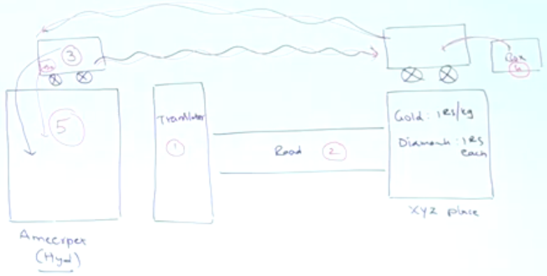

**Analogy of the above diagram with JDBC is as follows**  
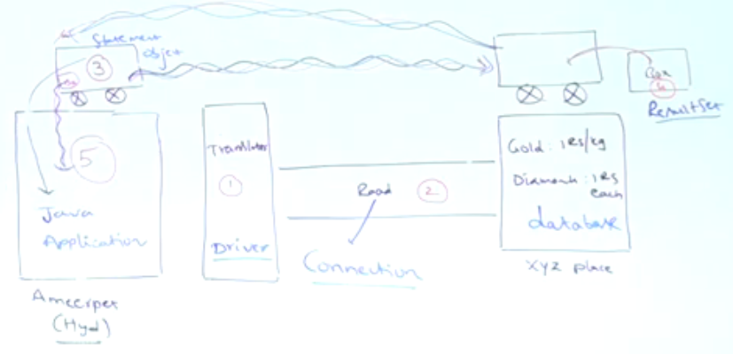

**Driver**: Translator to convert java specific calls into database specific calls and vice versa.

**Statement Object**: Carrier to carry our sql query to db and bring results from db after processing the query as resultset object.

**Connection Object**: Network Socket via which, statement travels.

**ResultSet Object**: After processing the query, database engine will place the result in a box called ResultSet.