1. **Storage areas can be divided into 2**
   1. Temporary Storage Area
   2. Permanent Storage Area
2. **All the following JVM Memory Areas are Temporary Storage Area.**
   1. Heap
   2. Stack
   3. Method Area
   4. PC Register
   5. Native Method Area
3. **All the following Areas are Permanent Storage Area**
   1. File System
4. Permanent Storage Area is also known as **Persistent Storage Area**
5. File System Storage Area is very useful for very small amount of data such as mobile numbers of 500 students. Now, we have ICICI bank account holders whose data we want to store where file is not efficient.
   1. **Problem with File System**
      1. Can’t Store Huge Info
      2. Security Leakage.
      3. No Query Language Support
      4. No way to prevent duplicate data.

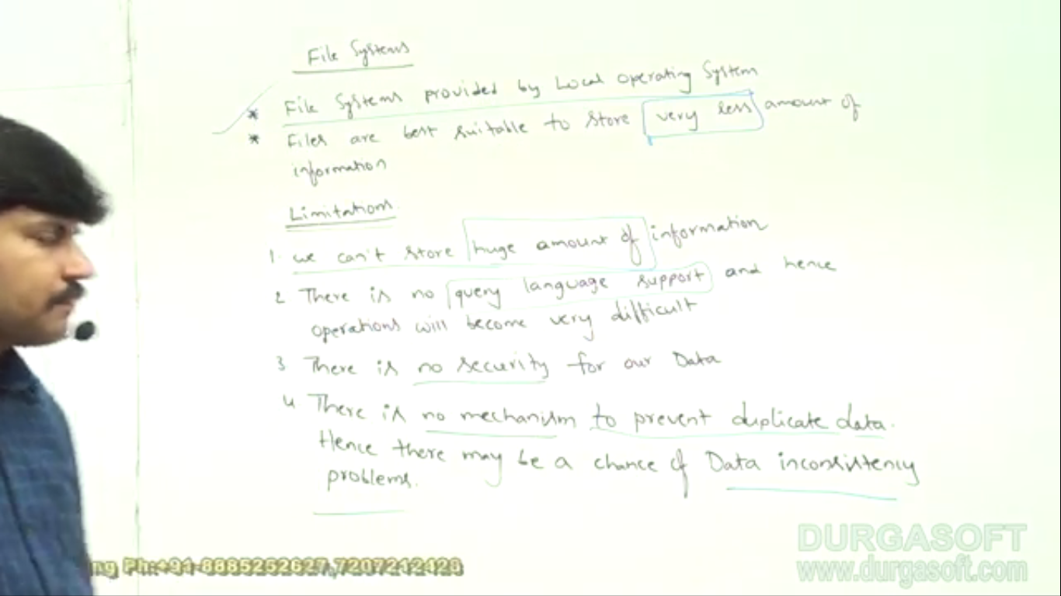

1. **DataBase**
   1. Huge amount of data.
   2. Query Language Support
   3. Security.
   4. Due to the followings, duplicate data is prevented
      1. PK
      2. Unique Key
      3. FK
      4. Normalization Process
2. **Limitations of Database**

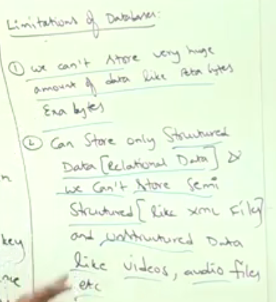

Every day on youtube.com, millions of GB data are loaded. On the back-end side, with Database is not possible to store so huge amount of data everyday.