1. **JDBC:** A technology which can be used to interact/ communicate with Database from java application.   
   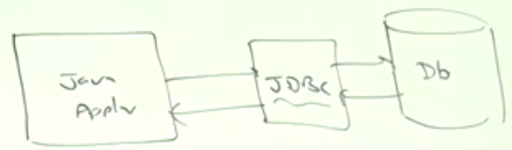
   1. JDBC is part of J2SE.
   2. JDBC is a specification/ guideline from Sun /Oracle now.   
      This specification is implemented by database vendors (sometimes, 3rd party vendor)  
      The database vendor provided implementation is called **Driver Software**.

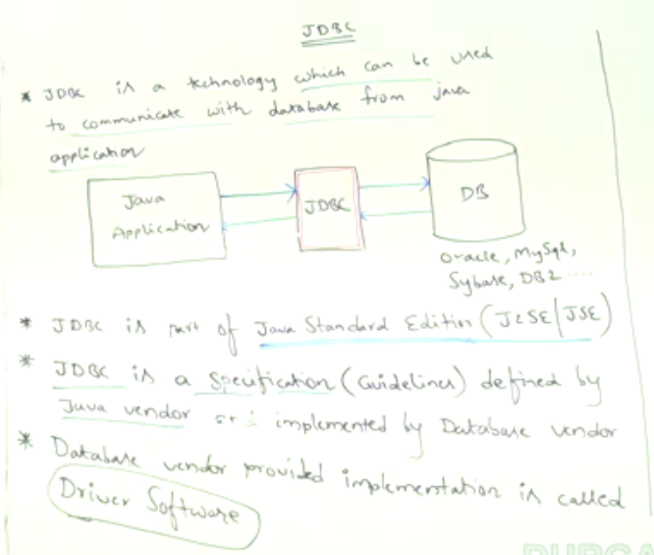

1. d

# JDBC Features

1. **Standard API**: No matter which underlying database, the steps are same for each 🡺 **Connection, Statement, ResultSet. So** JDBC is independent API.
2. **Platform independent Technology**: As Most Drivers are implemented in java 🡺 Thin (Oracle), ConnectorJ (MySQL).
3. **All DB operations Support**: Support for CRUD, All joins, Stored Procedure.
4. **Many Vendors Support:** Many vendors have contributed to JDBC-basedproducts whose list can be seen at the 🡺   
   www.oracle.com/technetwork/java/index-1366965.html

# Interview Question

What is the Just Current Version of JDBC?

**NOTE**: There is difference b/w version of Java and that of JDBC.   
