Evaluation of JDBC

1. If we want to communicate with database from C/C++ application, compulsory we have to use database specific libraries in our application provided directly by the database vendor.   
     
     
     
     
   In the above diagram, C/C++ application uses Oracle Libraries directly.

Oracle Database

C/C++ App  
(Use Oracle Libraries)

1. The problem in this approach is, if we want to migrate to other database, we have to rewrite this application again with new database specific libraries

MySQL Database

C/C++ App  
(Use MySQL Libraries)

**NOTE**: The application will become database dependent and creates maintenance problems.

# Solution: 🡺 ODBC 🡺 Open DataBase Connectivity 🡺 1992

ODBC is **database independent API**.   
To change the underlying database, we have to just replace the used ODBC driver specific for that new database.   
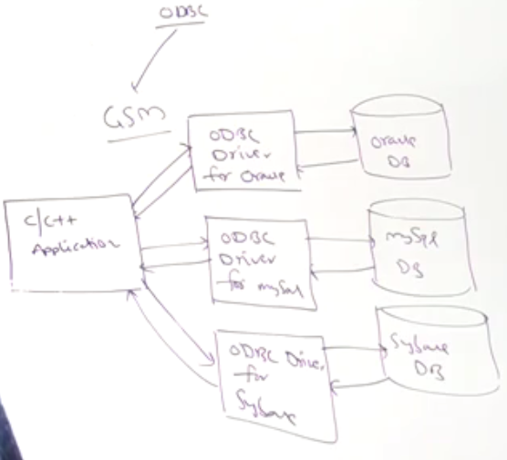  
In the above diagram, our application doesn’t communicate directly with the database but via ODBC driver.  
ODBC provided by Micro System People.  
ODBC is written in C Language.

# Limitations of ODBC

* ODBC concept will work only for **windows** platform. It’s **platform dependent technologies** as it implemented in C Language.
* ODBC drivers are implemented in C Language. If we will use for Java applications, performance will be down because of internal conversions b/w calls (From Java to C and C to Java)
* 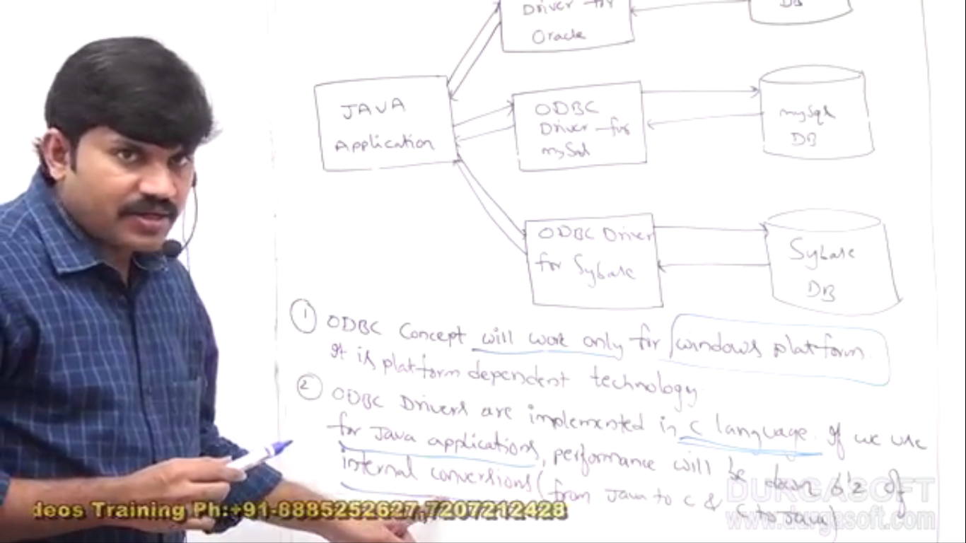

# Advantage of JDBC

