Difference b/w ODBC & JDBC

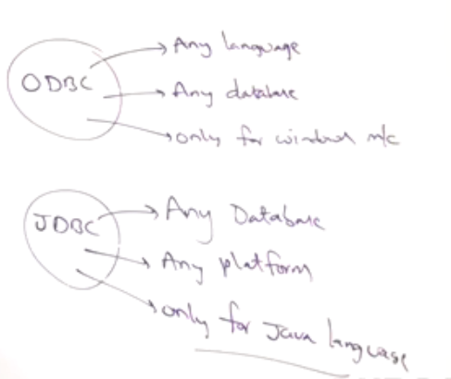

|  |  |
| --- | --- |
| ODBC | JDBC |
| ODBC 🡺 Open Database Connectivie | JDBC🡺 Java Database Connectivity |
| Introduced by Microsoft in 1992 | By **Sun Micro Systems** in 1997 |
| Can be used for any languages. | Only for java language |
| Only for Windows | For any Platforms |
| Developed with native languages like C, C++ | Most drivers In Java Language. |
| Not recommended for Java Apps due to internal conversions b/w Java Calls and C,C++ calls (Performance Down). Second App 🡺 Platform dependent. | For Java Application, recommended as no conversions and not platform dependency. |

