JDBC Architecture

Let’s first note some points.   
**Assumption**: We are using Java Application along with JDBC drivers.

* Driver is meant for translation b/w Java calls and Database specific calls and vice versa.
* When using JDBC along with Java Applications, Java application becomes Platform –independent App but the used JDBC driver is database-dependent as we have to select appropriate driver in accordance with the underlying Database.
* Driver Manager:
  + Responsible to manage all the drivers being used in our application.
  + Responsible to register and unregister drivers.
    - DriverManager.registerDriver(driver)
    - DriverManager.unregisterDriver(driver)
  + Responsible to get our application connection with the help of driver software.
    - DriverManager.getConnection()
  + DriverManager (C) : java.sql package.
  + JDBC API provides DriverManager.
  + Our App can’t directly interact with Driver but via DriverManager.   
    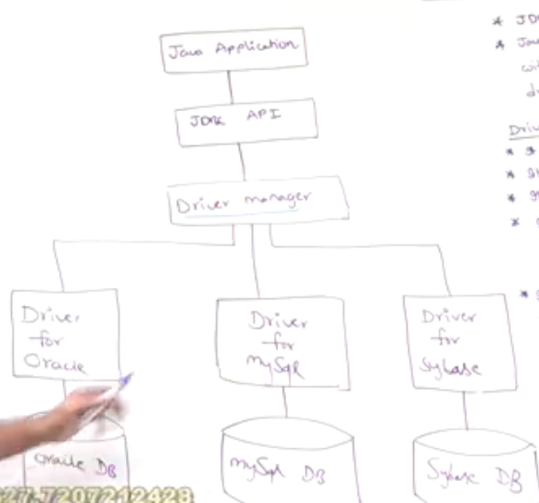 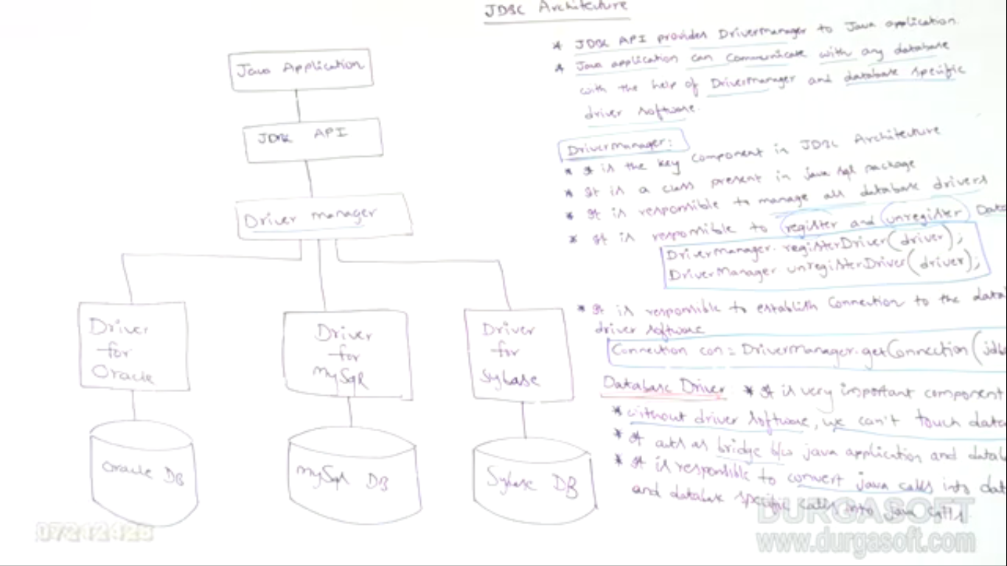 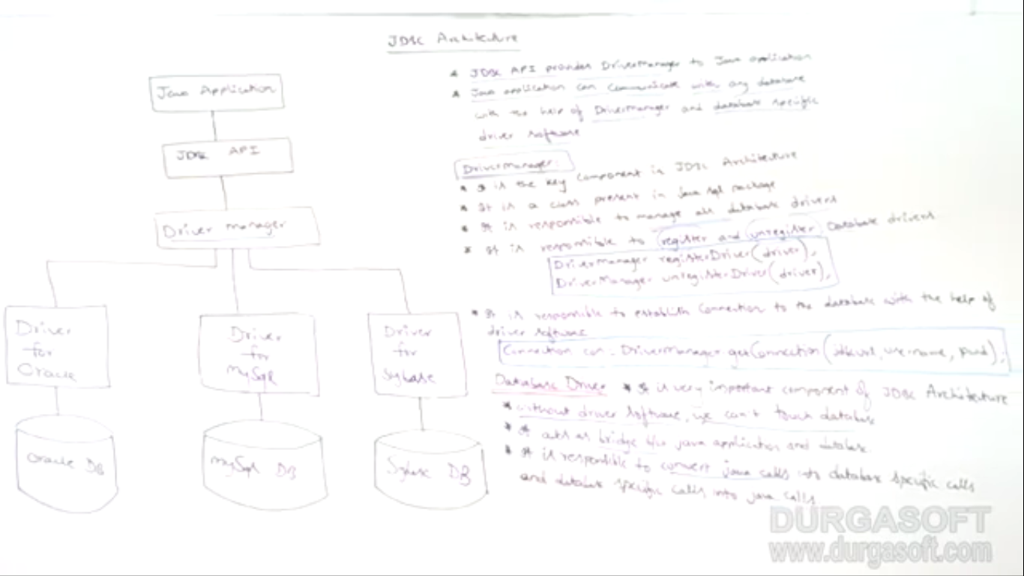

DriverManager is actually a dummy component whose responsibility is to manage drivers and provide connection but the real component is Driver which is responsible for inter-conversions b/w java calls and database specific calls.