# How is Java Application Database Independent

Just Explain the following Diagram.

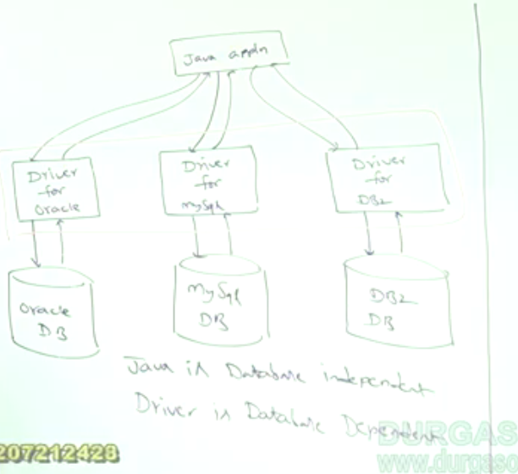

# How is the Java Application is Platform Independent

