JDBC API

1. JDBC API defines several interfaces and classes used for database communication.
2. **Who is going to use these components?**
   1. Programmers
   2. Driver Software Vendors  
      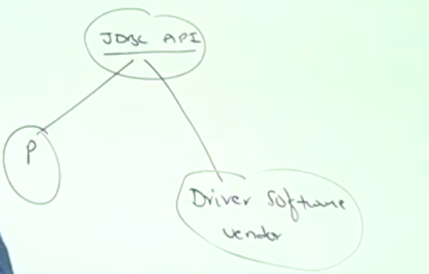
3. **JDBC API contains two packages**
   1. java.sql: Contains very basic components
      1. DriverManager, Connection, Statement, ResultSet etc.
   2. javax.sql: Contains more advanced classes and interfaces
      1. Connection Pooling, RowSet instead of ResultSet
      2. Contains several **sub-packages**
         1. **javax.sql.rowset**
         2. **javax.sql.rowset.serial** 🡺 For Serialization
         3. **javax.sql.rowset.spi** 🡺 For Synchronization Concept
      3. **d**
   3. d
4. 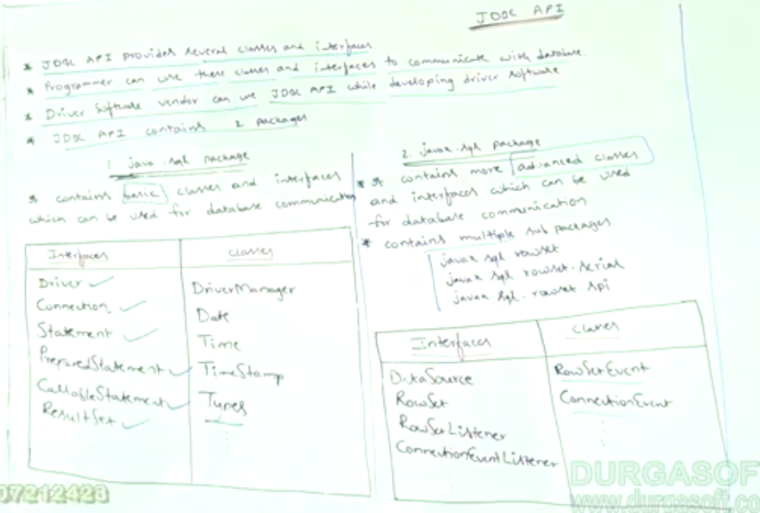 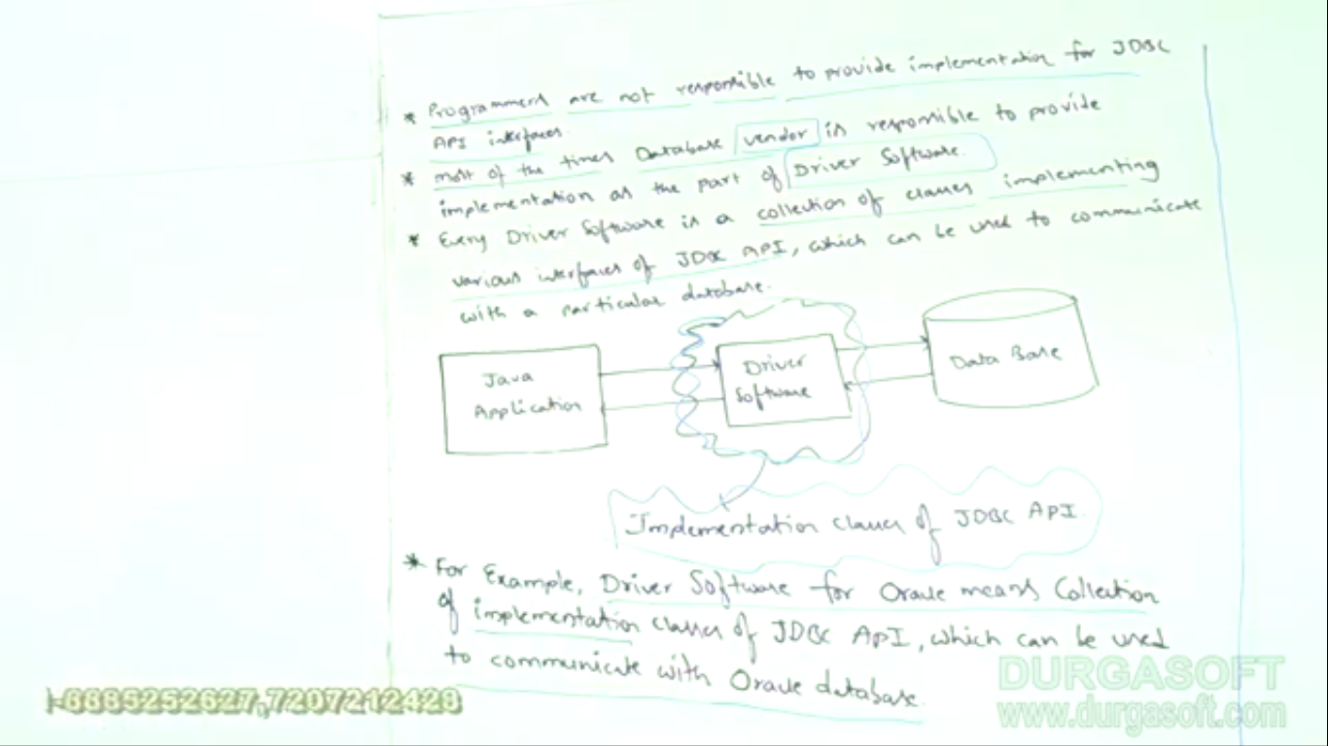
5. Every driver class has a special class 🡺 **Driver (C)** among thousands of classes which can identify a particular driver software. Analogy🡺 Ruling Government is BJP having many ministers among them, Narender Modi is the PM. So Narender Modi identifies the BJP Government. Same, Driver Software can be identified with a special class 🡺 Driver (C)
6. 