# Difference among Driver(I), XXXDriver(C), Driver Software

1. **Driver Interface**:
   1. This interface is present in java.sql package.
   2. It acts as a requirement specification to develop Driver Class.
2. **Driver Class**
   1. It is the implementation class of Driver (I).
   2. It is the main class present in Driver Software.
   3. **Example**:
      1. **Type 1:** sun.jdbc.odbc.JdbcOdbcDriver
      2. **Type 4:**  oracle.jdbc.OracleDriver
3. **Driver Software**:
   1. It is the collection of implementation classes of various interfaces present in JDBC API.
   2. It is responsible to convert java calls into Database specific calls and vice versa.
   3. It acts as a bridge Java App and Database.

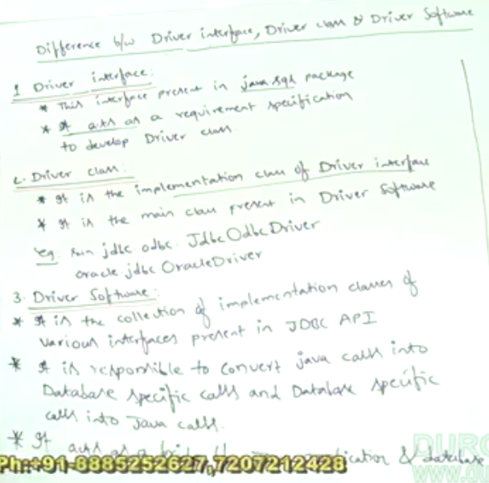

Driver Software is provided as a jar file.

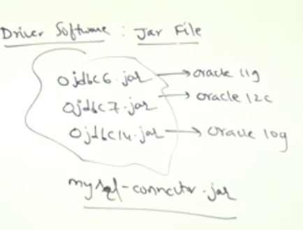

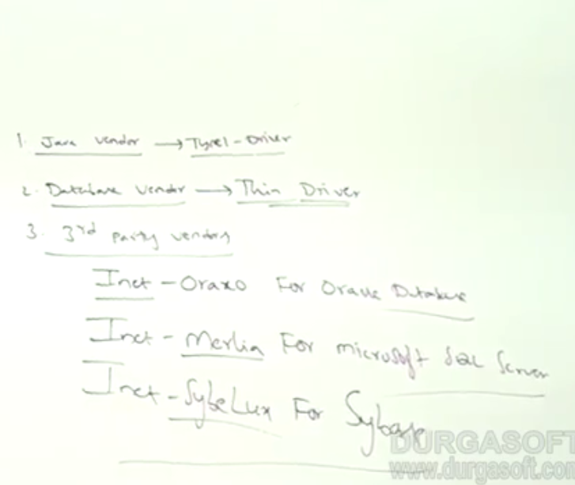

Categories of vendors providing Database Drivers.

Inet is s/w company provider DB drivers

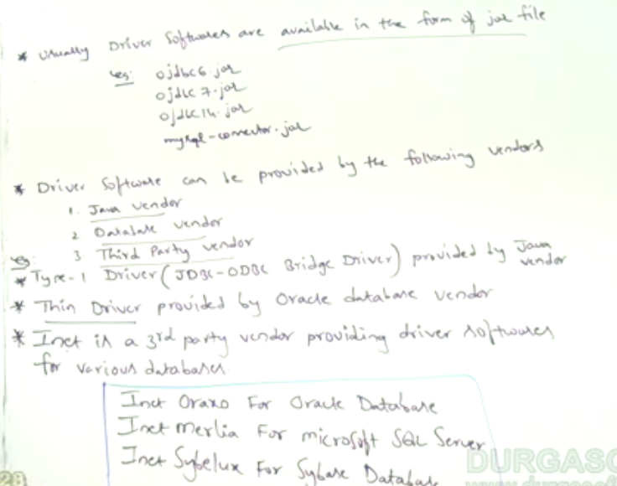

**Recommendation**: It is highly recommended to use database-vendor provided driver. In case if the vendor doesn’t provide then use 3rd party ones.   
