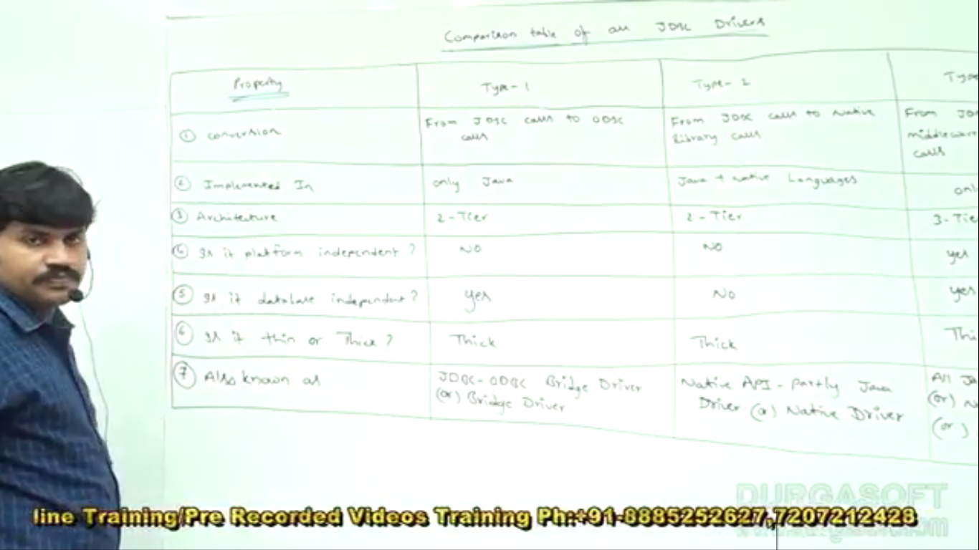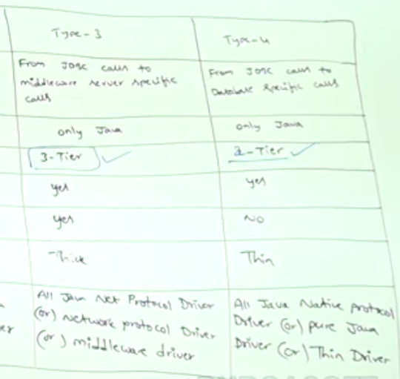

**Type1**:

1. Implemented in java as this driver comes as part of JDK itself.

**Type2**:

1. Implemented in Java + Native Languages (C, C++) 🡺 Platform-independent.

**Type3**: