Character Classes

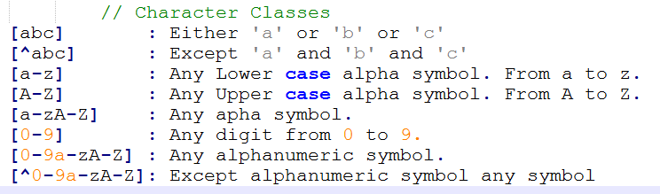  
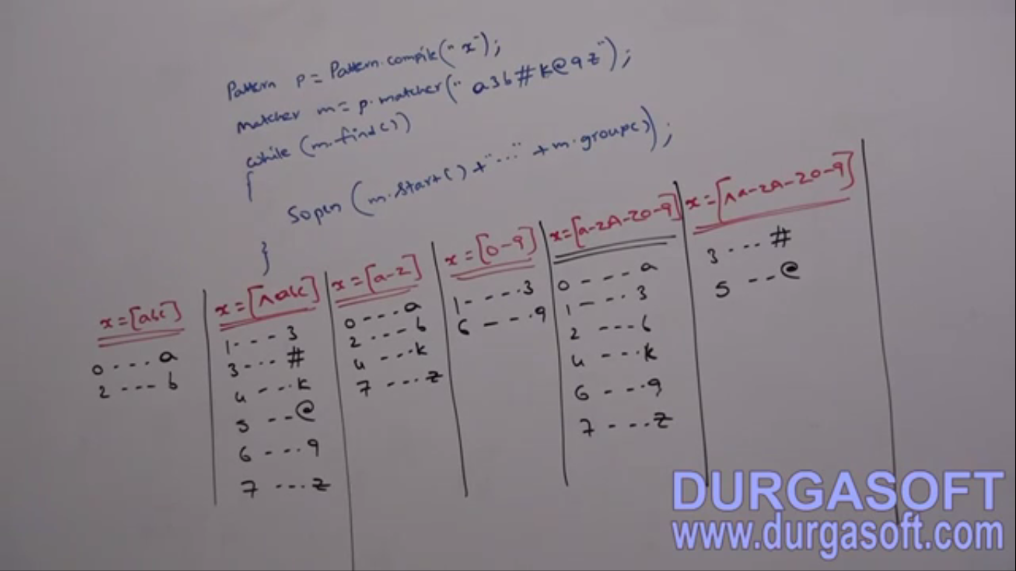

Predefined Character Classes

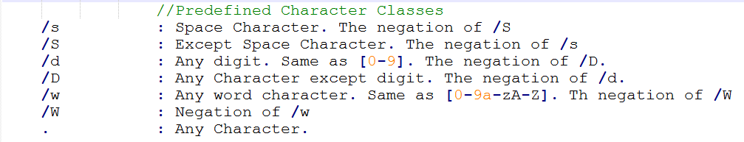

**Example**:  
Can’t use \d directly in String compiler can’t make sense of this \d escape character as there is no such escape character.

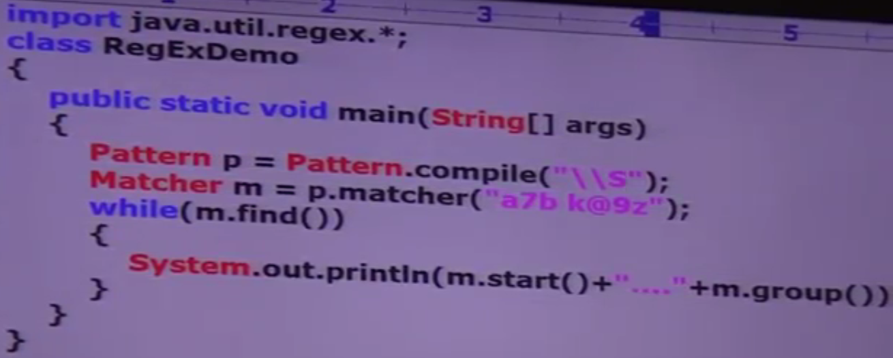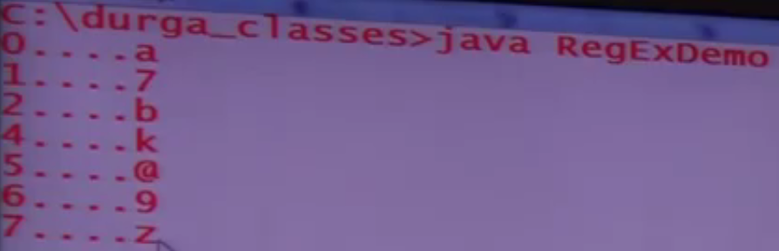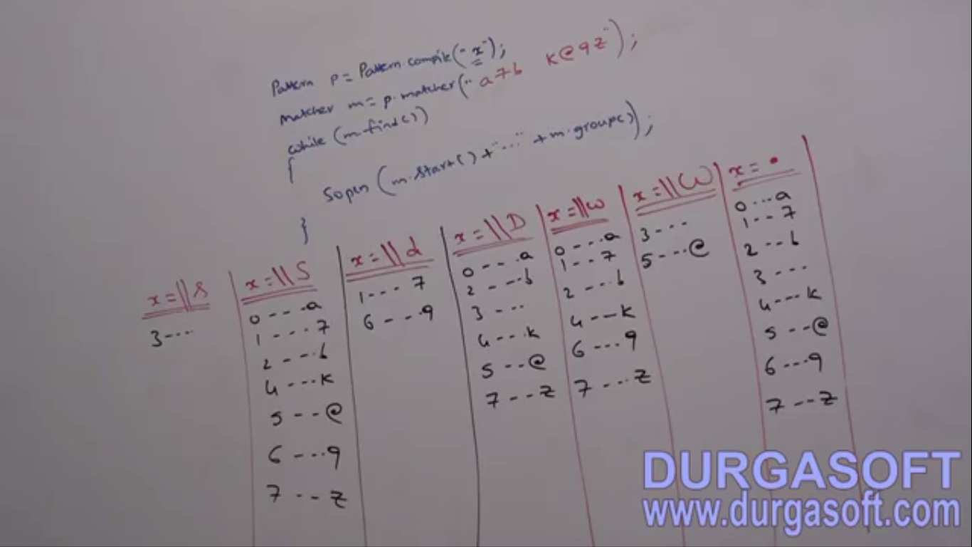

Quantifier

1. **Application**: Can be used to specify the number of occurrences to match.   
   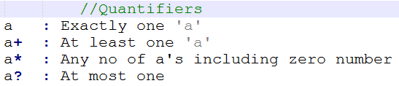
2. **Example:** Pattern = “a”  
   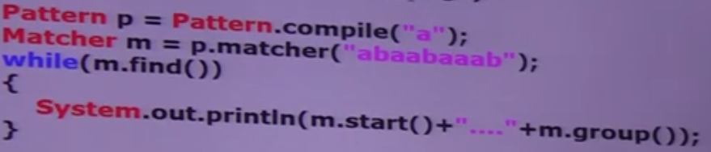  
   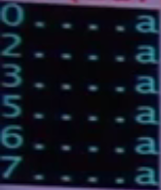
3. Pattern 🡺 “a+” 🡺 one or more  
   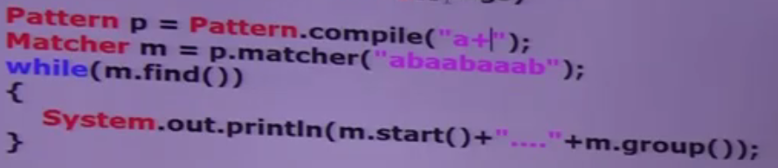  
   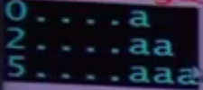
4. Pattern 🡺 “a*” 🡺 zero or more  
   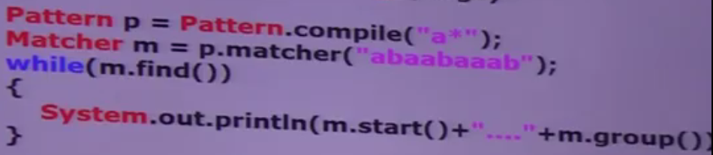  
   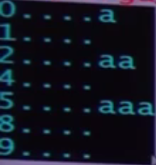

**NOTE**: there is no 9th index but here we are getting 9th index in output. It is because in case of zero match, matcher can move one location more than the last index

1. **Pattern** 🡺 “a?” 🡺 At most one meaning “Zero or One”   
   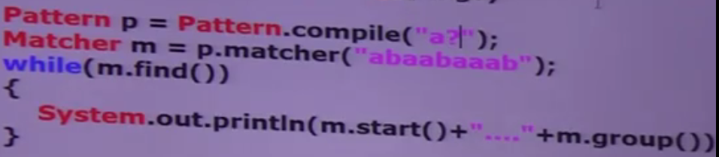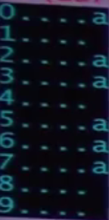

**NOTE**: there is no 9th index but here we are getting 9th index in output. It is because in case of zero match, matcher can move one location more than the last index

1. 