Examples

## Write a program to check whether the given mobile number is valid or not not.

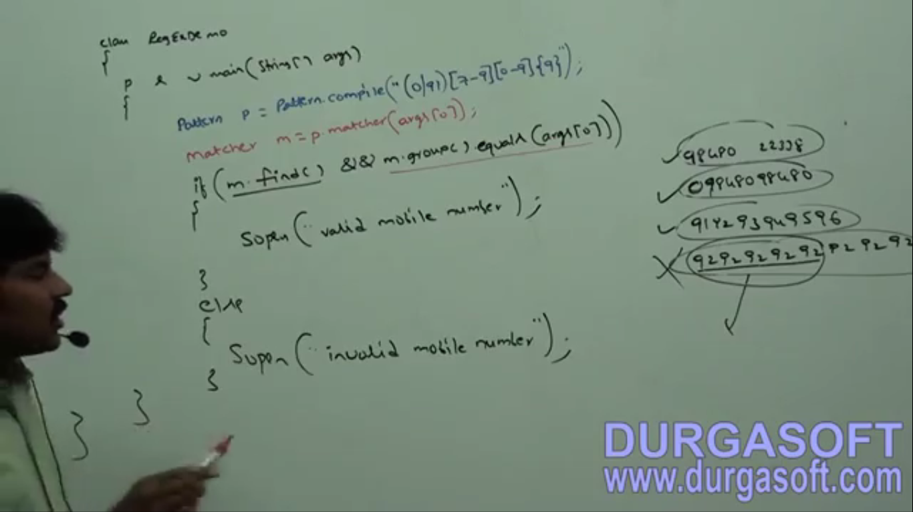

9876543212343433 🡺 this is special case. m.find() would   
return true as the pattern is matched with first 10 digits but  
this is partial match. The whole entered must matched.   
So we need to check for the “whole” condition that is why   
m.group().equals(args[0])

These mobile numbers will be entered from  
command Prompt.  
🡺 9876543212  
🡺 09876543212  
🡺 919876543212  
🡺 9876543212343433

## Write a program to check e-mail id validity

### Write a program to extract all mobile numbers from a file and save into another file.

**File**:  
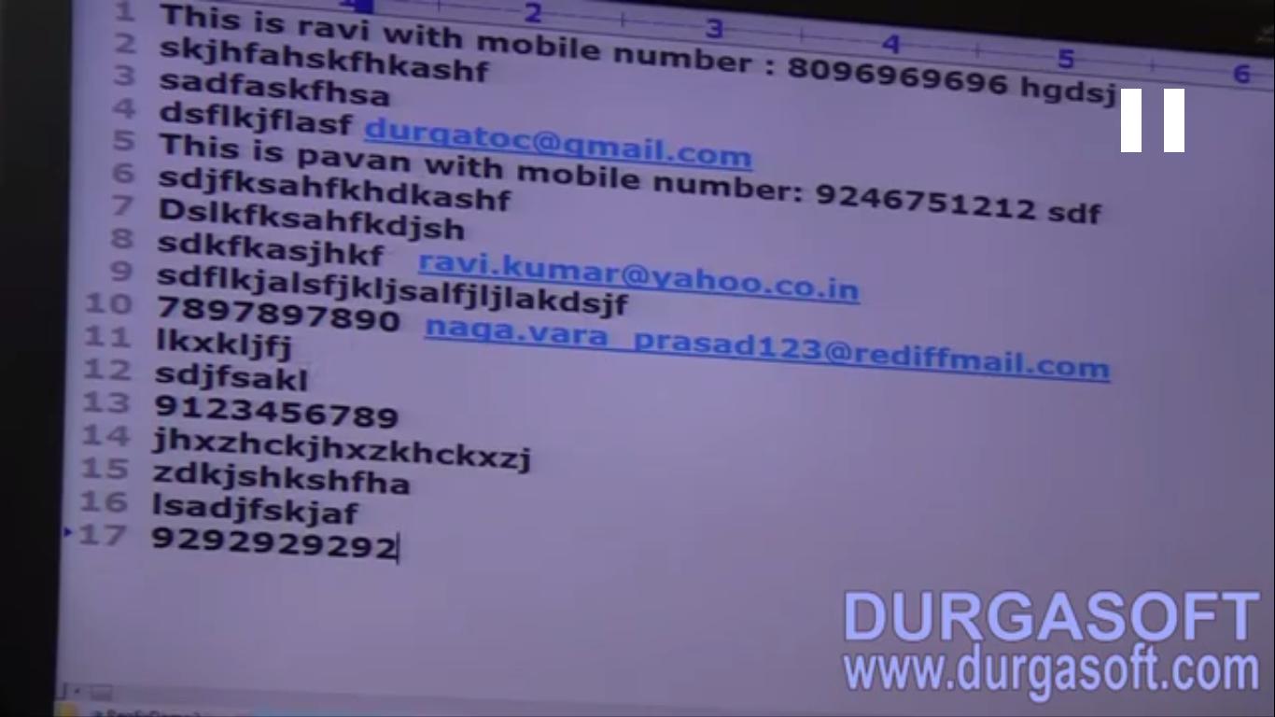  
**Program:  
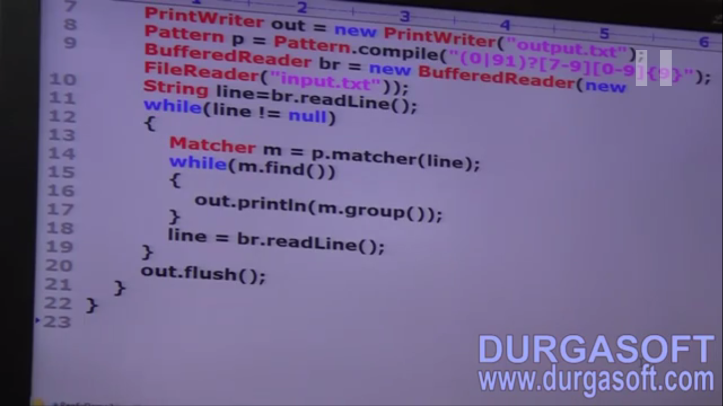  
NOTE:** If you want to do the same with email meaning extracting from a file and saving into another file just replace the patter for mobile with that with email.

## Write a program to display all .txt file names present in C:\durga_Classes NOTE: According to the above pattern this 🡺 abc.txt.mn is matched but we want that the file name must end with .txt so use 🡺 m.group().equals(compleFileNameString)