1. **Questions**:
   1. 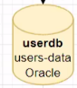 **userdb vs users-data**
   2. What is Cloud Native.
   3. DI vs Inversion of Control.
   4. Hibernate, EclipseLink and Apache OpenJPA
   5. **Designing and Implementing API**
      1. Any annotation in JPA Class?
      2. import.sql (how this file is being read)
      3. classpath 🡺 dependency 🡺 SO much auto Configuration. H2
2. 3 Hours for 8 Days = 24 Hours = Total Course Time.
3. 3 Hours Management;
   1. 1st Hour: Concept.
   2. 2nd Hour: Hands-on
   3. 3rd Hour: Q/A
4. We will take “E-Commerce Domain” as an example.
5. How traditional app looks like and how MS changed it.
6. **Traditional App**:
7. 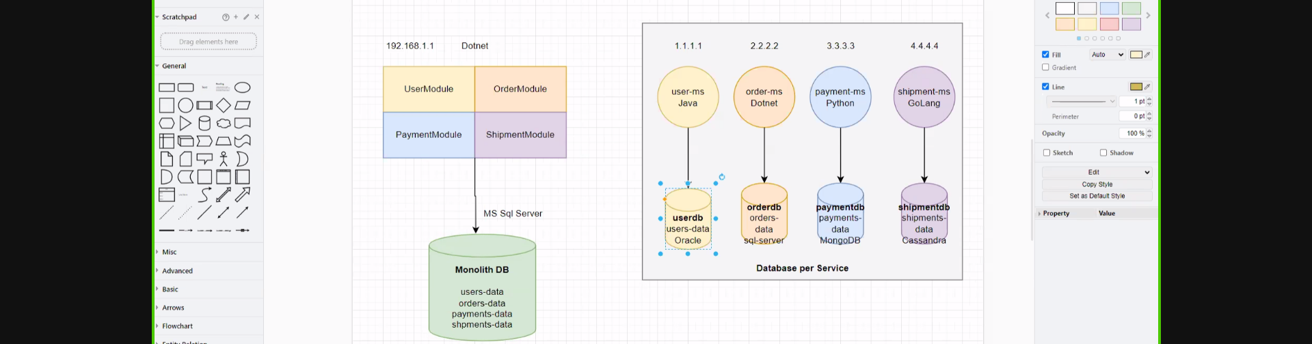
8. 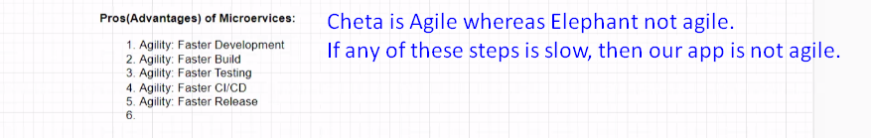  
   Development is agile as we have a part of total business.  
   If code base is small, then all of the above steps are easy to execute fast.  
   Agility of app is very important like Oracle for Java gives release every 6 months otherwise they will lose market.   
   Also take an example of Angular 1, 2, 4.  
   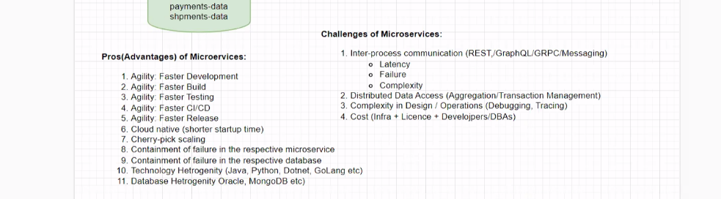
9. **Version Settlement**.  
   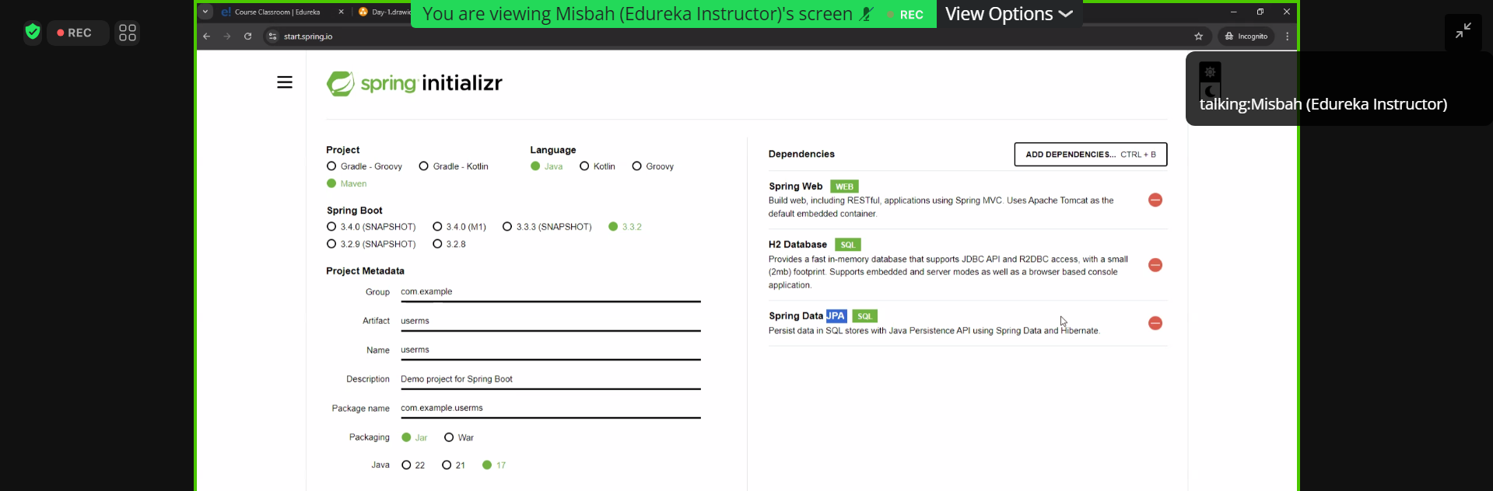
10. 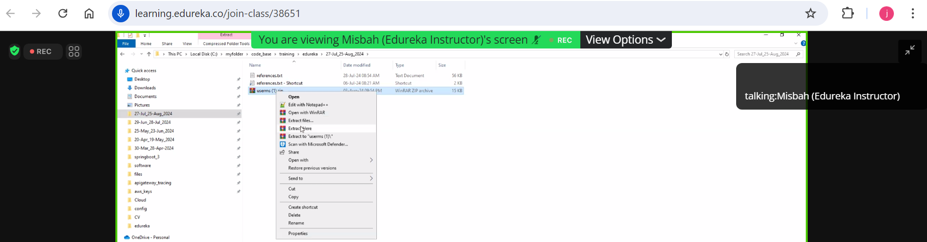
11. **Hands-On**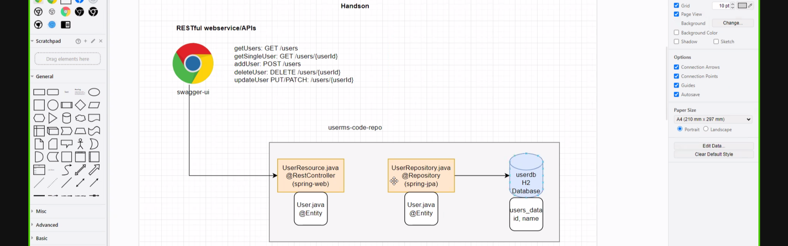
12. 