1. Load Balancer + Service Registry.
2. heartbeat.
3. **Register 🡺 Registry, Discover 🡺 Discovery.**
4. **Client Side Load Balancing : Maybe Round Robbin.**
5. **Installed, Deploy on multiple servers,**
6. 
7. 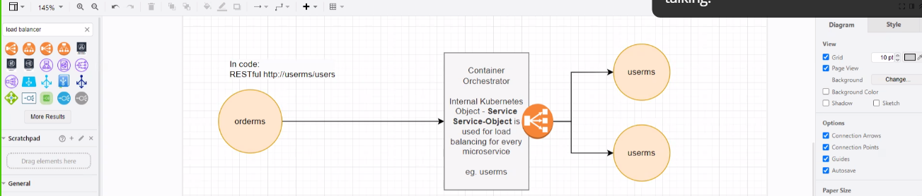
8. **Circuit Breaker: Not for availability but for resiliency.**
9. 