Contents

**No table of contents entries found.**

1. 

|  |  |
| --- | --- |
| Differences |  |
| NoClassDefFoundError | **ClassNotFoundException** |
| If we’re hardcoding a class name and at runtime, Test.class is not present in classpath. | If loading Test.class at runtime but not in classpath. |
| Test t = new Test();  Compile time, class is present. But at runtime, not present in class path. | Class.forName(“Test”); Test class is not present in classpath. |
|  |  |
| Unchecked | **Checked** |
| Error | **Exception** |
| Thrown by JVM. | **App itself.** |

1. 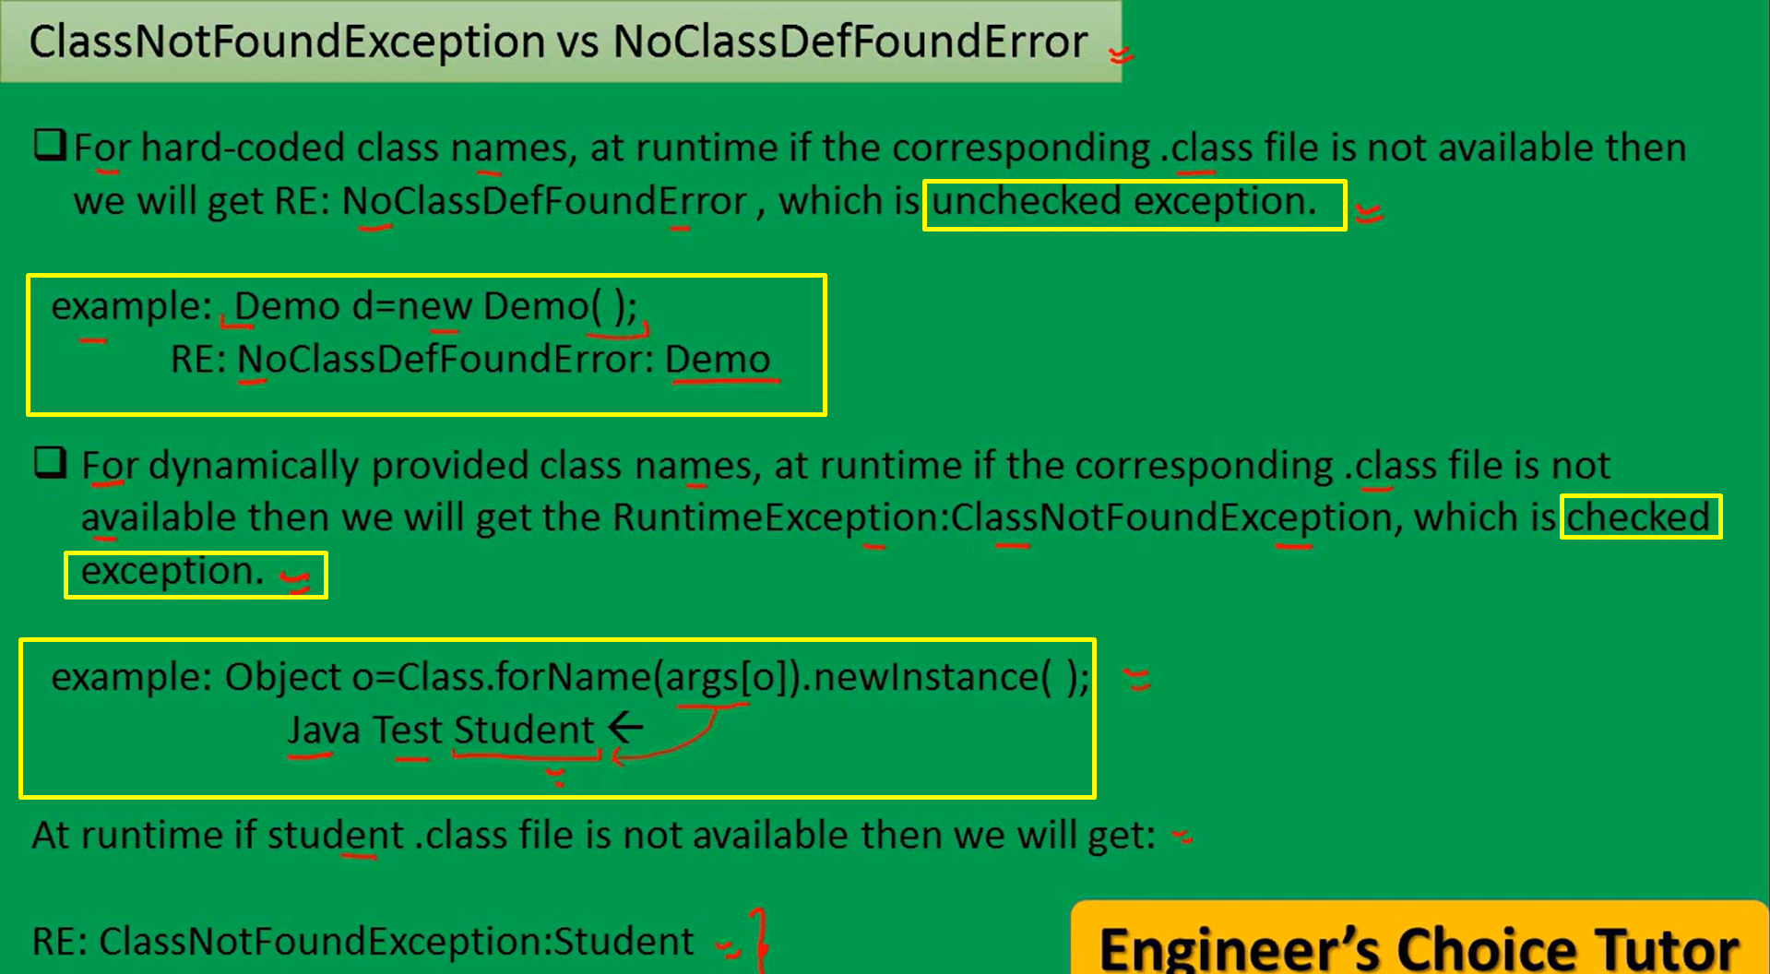
2. 