Naming Convention for Custom Maven Plug-in

1. 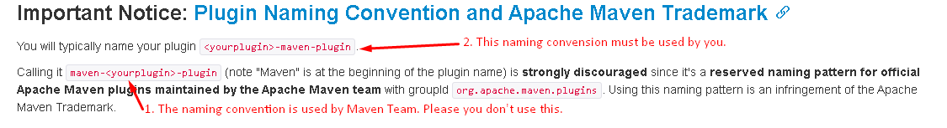
2. **<packaging>**maven-plugin**</packaging>:**

Steps you create Custom Maven Plug-in

**Purpose**: To print the number of the dependencies of a project on the console.

1. **Step 01**: Create a Maven Project to create **Custom Maven Plug-in**.  
   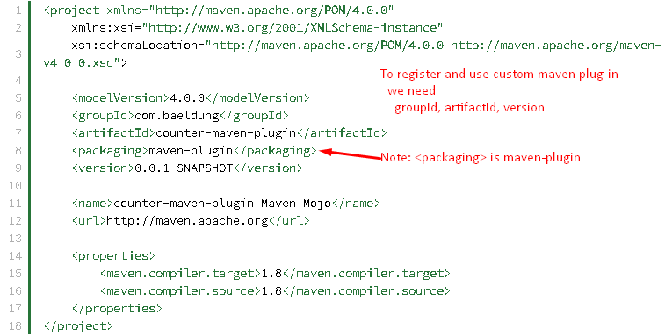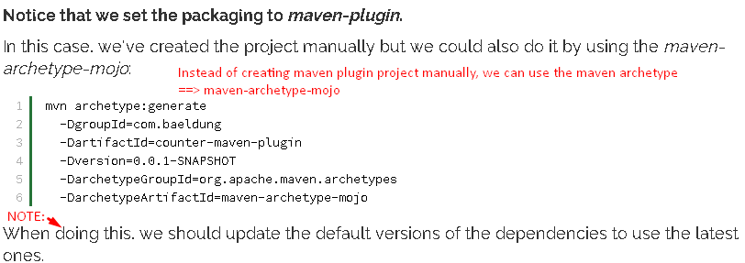
2. **Step 02**: Creating Mojo.
   1. **A java class** that represents a goal that our plugin will execute.
   2. **A** plugin contains one or more mojos.
3. This note from this site: <https://www.baeldung.com/maven-plugin>
4. <https://developer.okta.com/blog/2019/09/23/tutorial-build-a-maven-plugin>