1. Graphical user interface, text

   Description automatically generated with medium confidence
2. **Camel Message**:
   1. Graphical user interface, diagram

      Description automatically generated
3. Text, letter

   Description automatically generated
4. **Route**:Graphical user interface, text, application

   Description automatically generated
5. Diagram

   Description automatically generated
6. **Camel Architecture**:  
   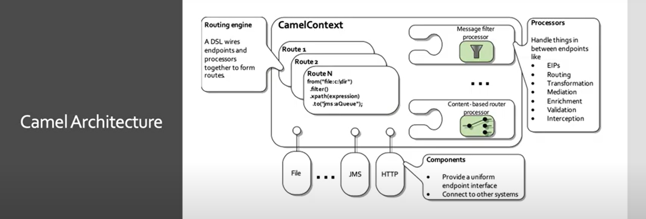
7. 