# Communications/Personality

## [Communication Skills Machine: Master Persuasion & Influence](https://www.udemy.com/course/communicationskillsmachine/learn/lecture/28185278#overview)

* 

## [English for Software Engineers: Boost Your Global Tech Career](https://www.udemy.com/course/english-for-software-engineers-speak-like-a-pro/learn/lecture/45757337#overview)

* 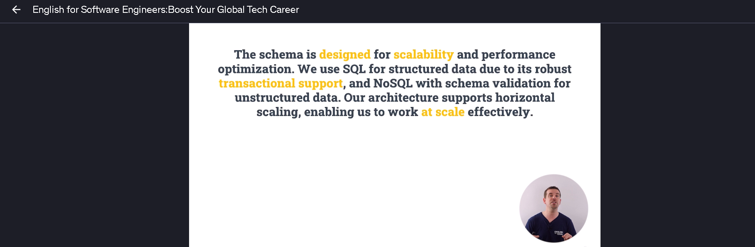

## [Business English Complete: English for Professionals](https://www.udemy.com/course/business-english-complete/learn/lecture/33602760#overview)

* 