1. <https://youtu.be/ksRCq0BJef8>
2. 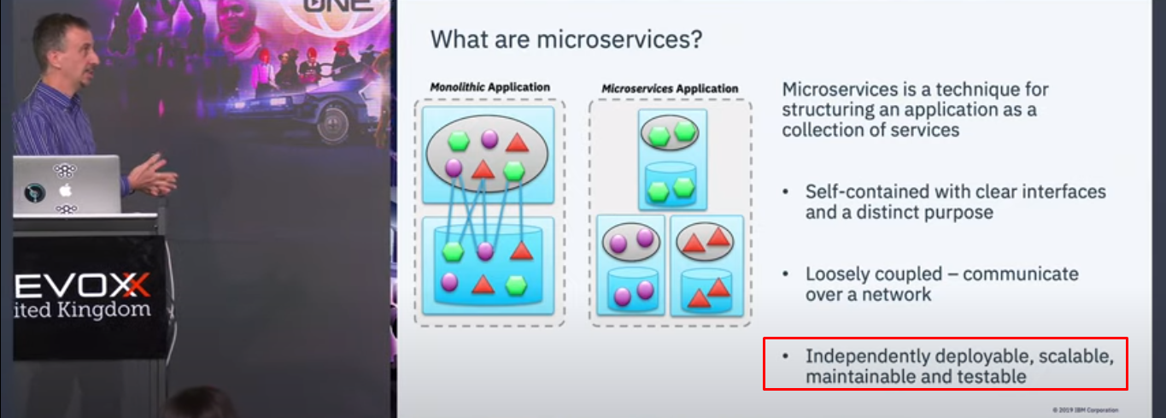

# <https://youtu.be/_PQd6aZ-ANk?t=1106>

Microservices Crash Course for beginners || Spring Boot || Hindi  
Learn Code With Durgesh  
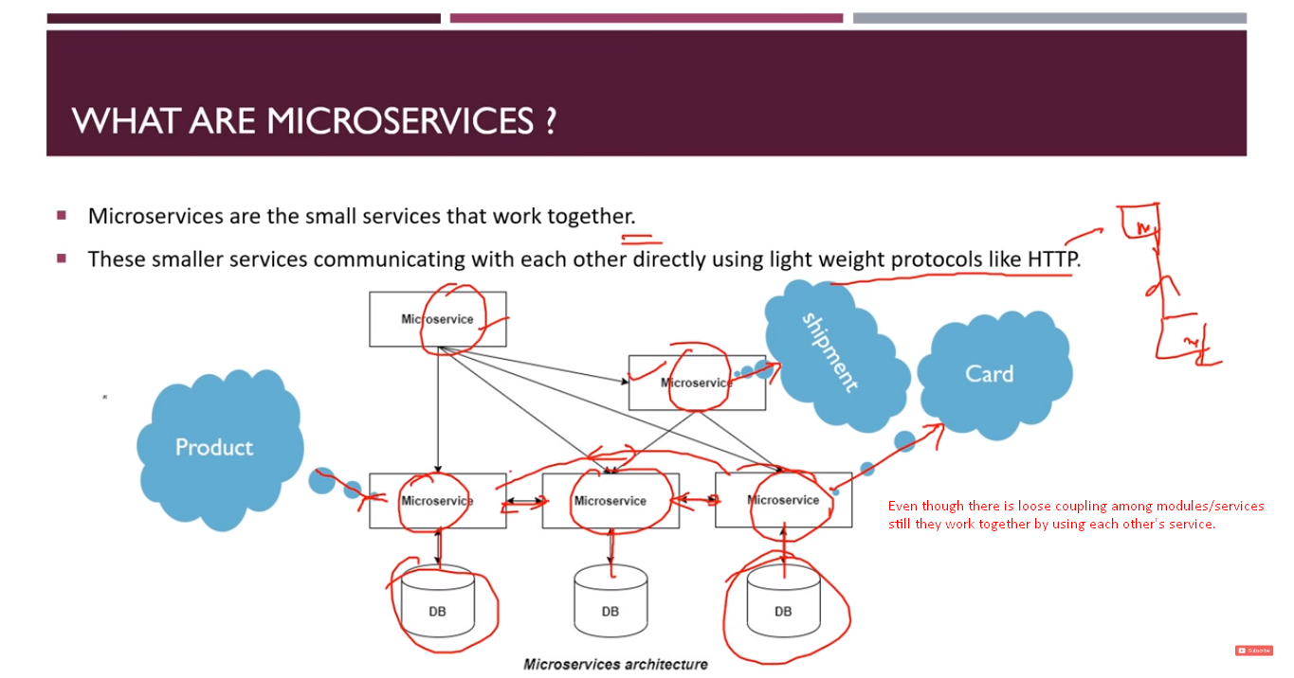

1. Microservices are the small services:
   1. Microservices architecture has multiple modules, unlike monolithic app.
   2. So, it has loose coupling.
      1. Loose coupling has many meanings:
         1. **Boundaries**: For each service, there is separate code base. So developers can work on a module and not need to worry about other code base.
         2. **Not all fails**: If one service gets failed, maybe other services or some services still work properly.
         3. **Language neutral**: We can write each service in some other language.
2. Services like Card, product would interact with each other using lightweight protocol like HTTP.