Using @ConfigurationProperties

1. Steps:
   1. **Step 01**: Add the following properties in application.properties file. This is just sample.  
      
   2. **Step 02**: Using annotation @ConfigurationProperties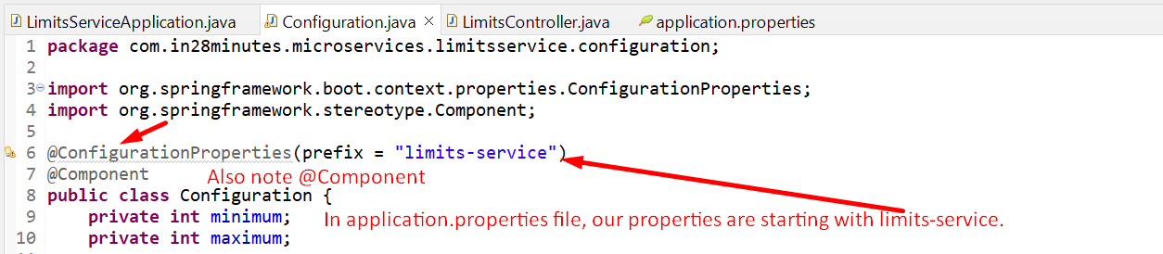  
      NOTE: if you don’t apply @Component annotation on the class annotated with @ConfigurationProperties, you will get the following error and tomcat will not run.  
      