Contents

1 How to Create Config Client 1

2 How to connect Config Client to Config Server to fetch properties 2

# How to Create Config Client

1. **Just add the following Dependency**

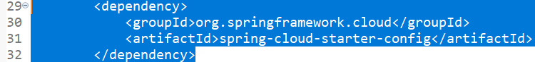

# How to connect Config Client to Config Server to fetch properties

1. Following configuration to the application.properties  
   **spring.config.import=optional:configserver:http://localhost:8888**