1. One way to define InMemoryAuthentication with users.

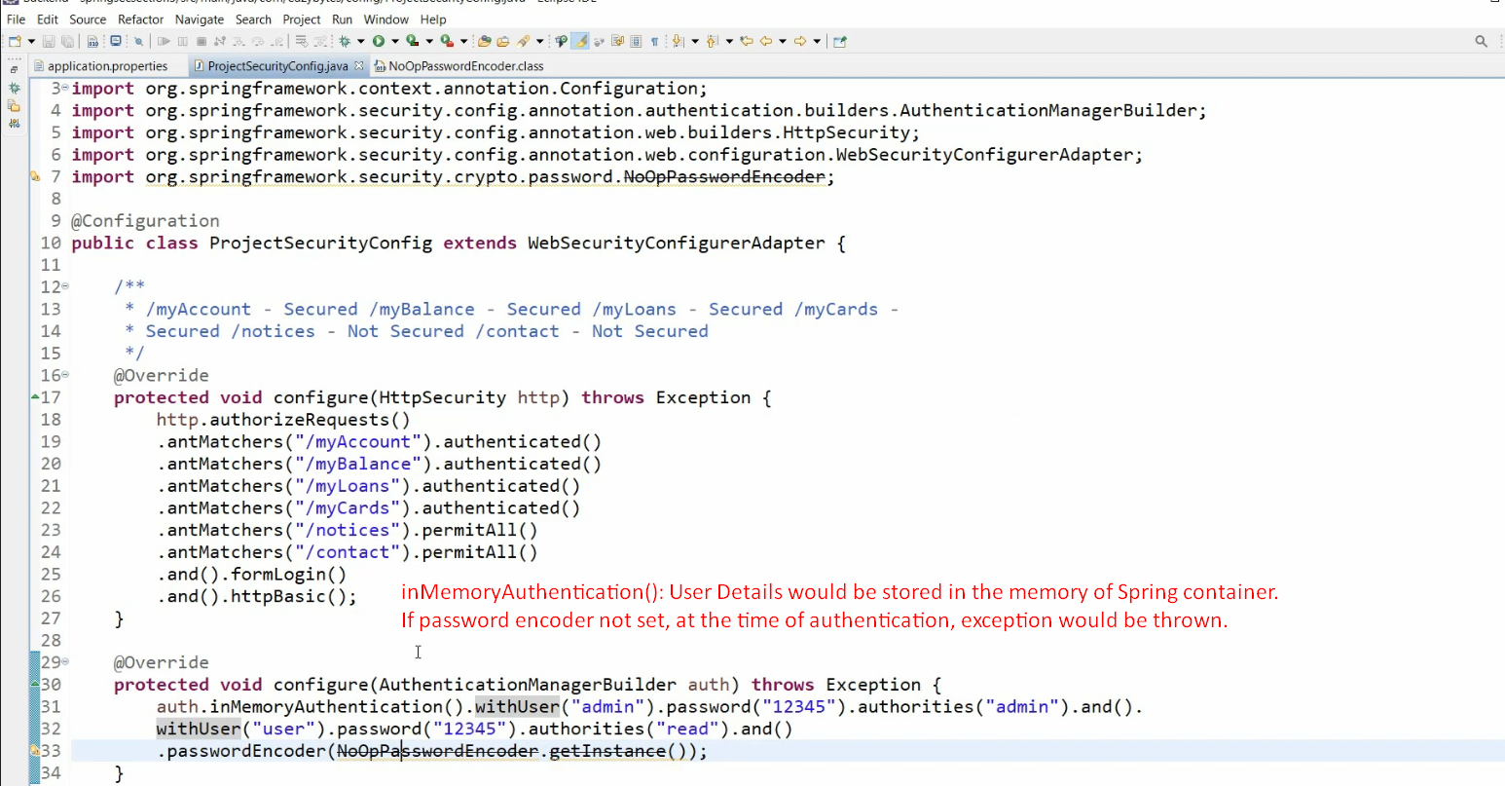

1. 2nd way to define InMemoryAuthentication with users.  
   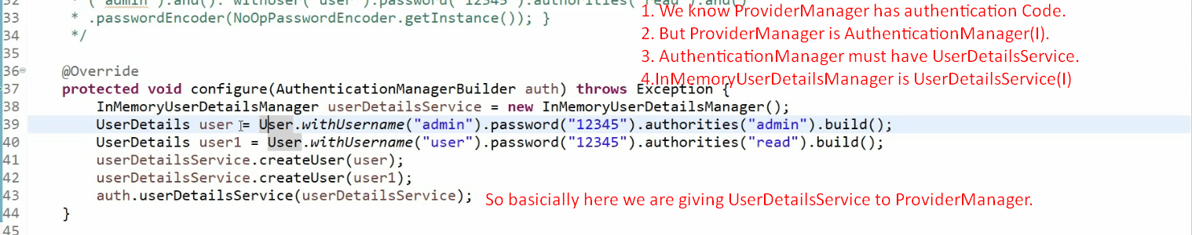
2. d

Hi All,

We will be having 15-minutes standup call daily for the following purposes

1. To share and discuss each one's daily activities.

2. To plan next days' activities related to preparations.

3. To share interview questions.

PFA. Please fill the Capgemini format Resume and mail it at

sathyabama.chinnuswamy@capgemini.com

vijayalakshmi.f.vijayalakshmi@capgemini.com