1. Study Cookies  
   Domain, Path, Expires, HttpOnly, Secure  
   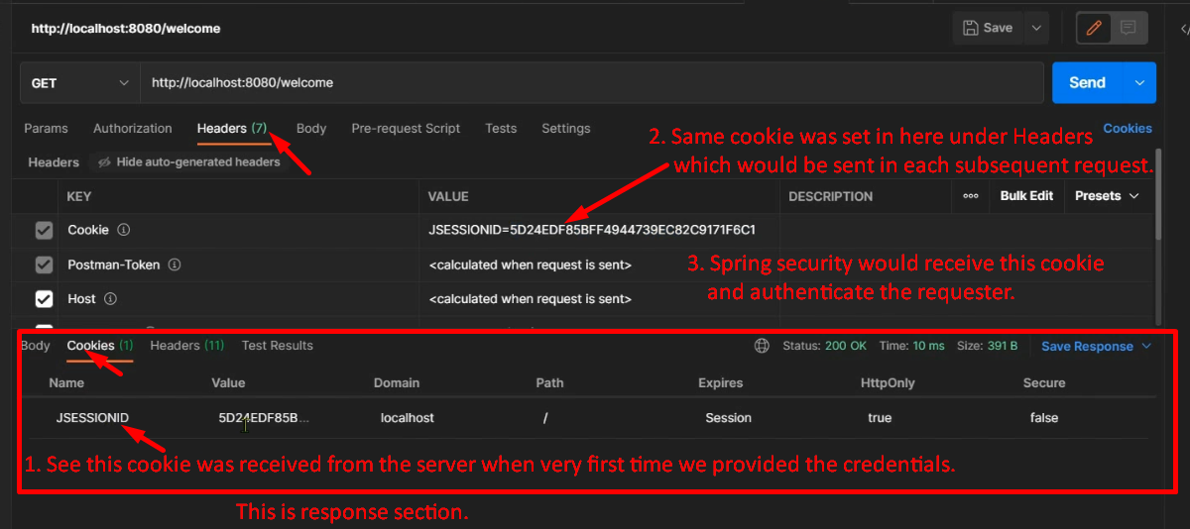
2. SecurityContext, SecurityContextHolder?