1. What is the thing that actually does the authentication? Means having business logic for authentication.
2. **Answer**:
   1. There are many ways that can be done in Spring Security App.
   2. But the most common pattern is “Provider”.  
      
   3. So, this is **AuthentictionProvider**.
3. 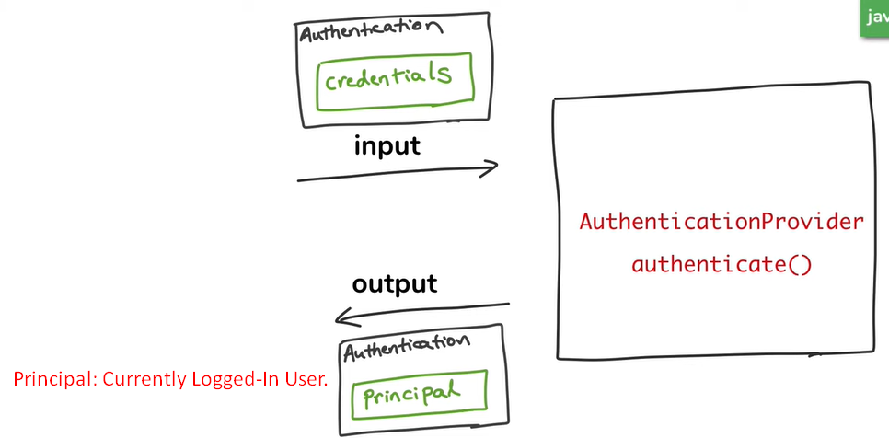
4. 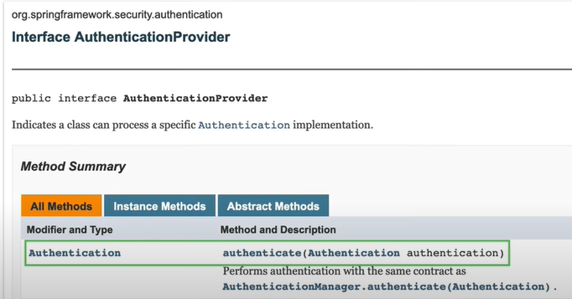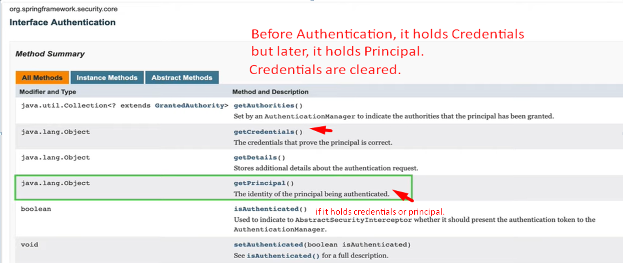
5. 