1. **CORS**: Cross Origin Resource Sharing.
2. **Very Important Note:**
   1. 
3. By **default**, it is **enabled**.
4. This configuration when it is Spring-MVC application and using Spring Security. 
5. The following Configuration when you’re using Spring Security Project.  
     
   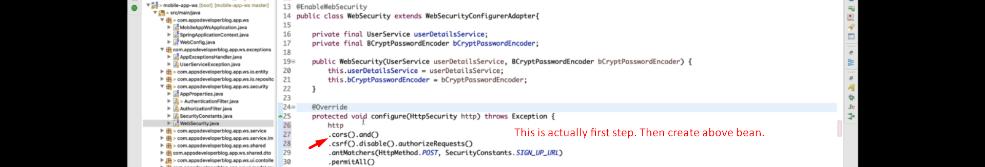  
   Let’s open the above method implementation cors()  
   