Contents

1 Advantages 2

# Advantages

1. **Auto Configuration**:
   1. We don’t need to write a lot of XML or Java based configuration to configure Spring MVC for web Layer and ORM.  
      As soon as we add dependencies, corresponding configuration are auto-configured.  
      Adding Spring-Web dependency will configure DispatcherServer for web layer.  
      Spring Data JPA dependency will configure DataSource and TransantionManager.  
      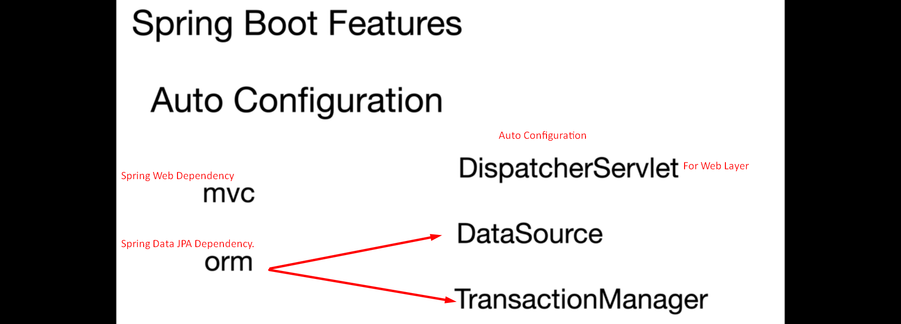
2. **Module Availability and Version Compatibiity**:
   1. Module Availability: Transitive Dependency.
   2. Version Compatibility: Parent Spring Boot pom project with version helps to manage version.  
      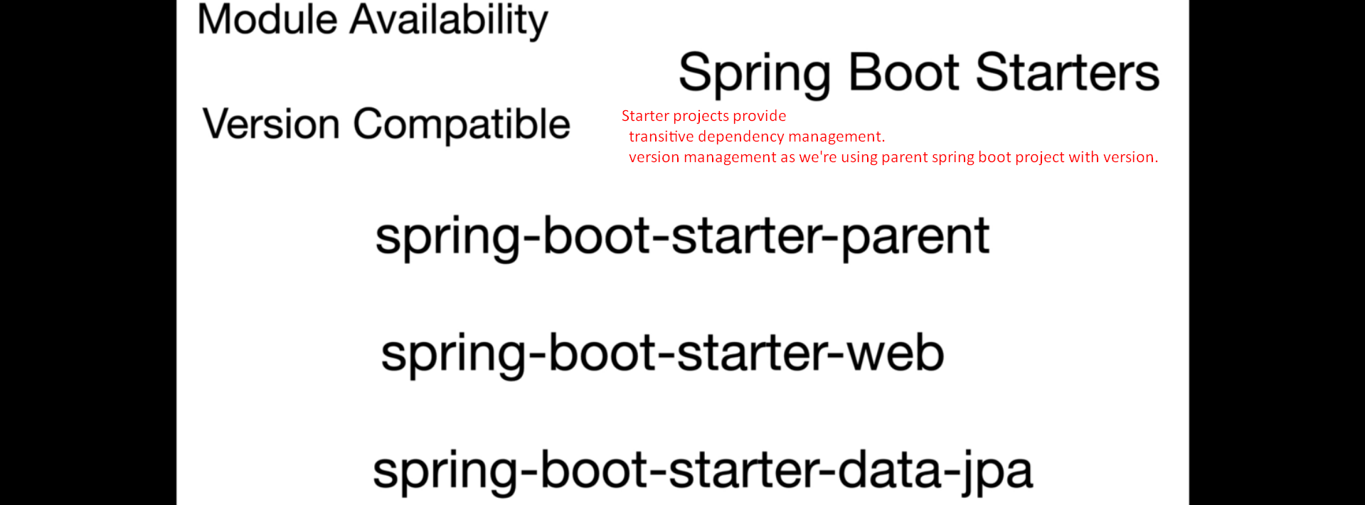
3. **Embedded Server Container:**
   1. Tomcat is embedded by default.   
      But you can change to the following too  
      Jetty, Undertow
4. **Actuators**:
5. 