Contents

1 Advantages 2

# @Conditional

## @Conditional

* + 1. In Spring 4.0
    2. Used to define “if-then-else” type of conditional checking for bean registration.
    3. Alternative to @Conditional prior to Spring 4.0
       1. 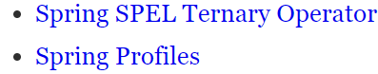
    4. @Conditional is more general version of @Profile.