Contents

1 Advantages 2

# How to replace default embedded Tomcat with embedded Jetty

1. Step 01: Remove the default embedded Tomcat.  
   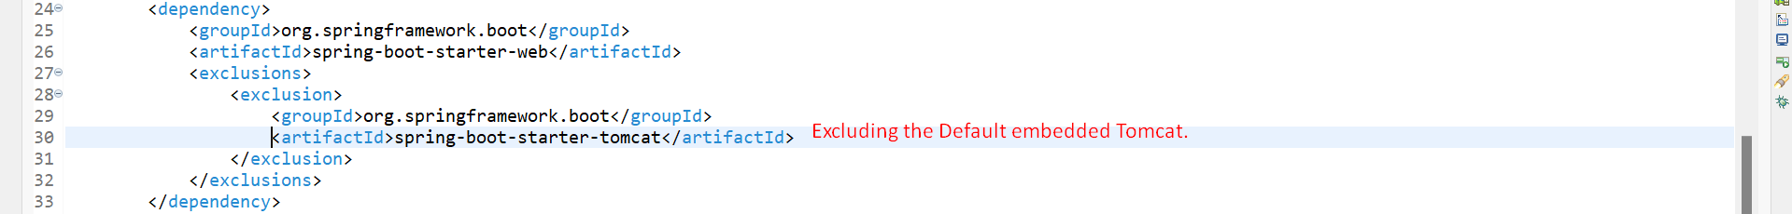
2. Step 02: Add dependency for embedded Jetty Server



# Total ways to configure Server Port

1. **Frist Way**: application.properties file
   1. server.port=8081
   2. server.port=0 Will allocate random port each time we run app.
2. Second Way: VM argument
   1. -Dserver.port=8081
      1. You can set this value
         1. In IDE under VM.
         2. Passing when running jar file from cmd  
            