1. **Agenda**:
   1. How to Stub.
2. **Gradle Dependency**:

**Maven Dependency** 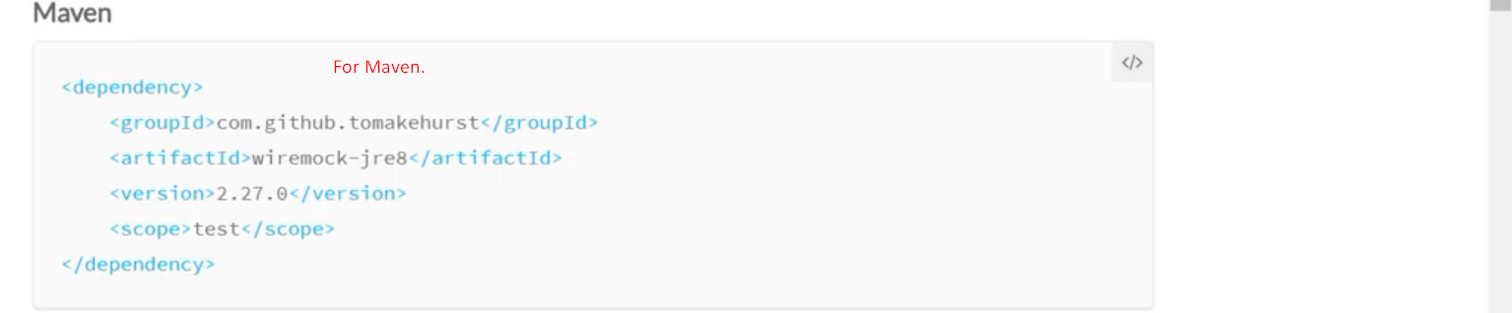

1. 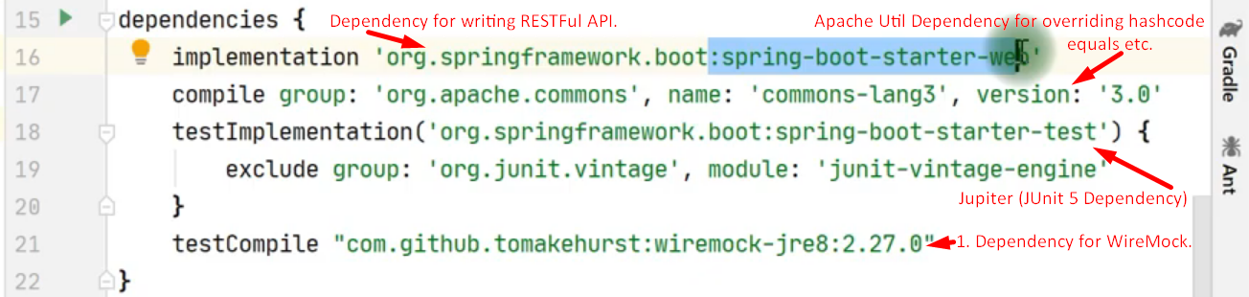
2. **Let’s first configure and run WireMock Server**.