Contents

Looking for @SpringBootApplication for Configuration. 1

## Looking for @SpringBootApplication for Configuration.

1. 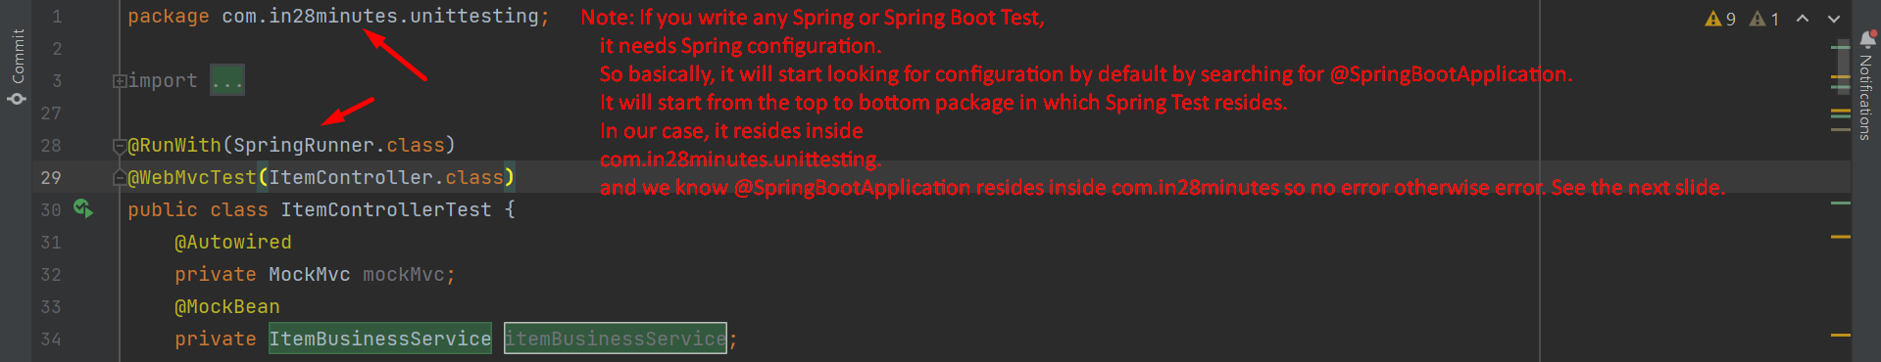
2. **Otherwise Error**:  
   Graphical user interface

   Description automatically generated with medium confidence  
   **Solution**:  
   Graphical user interface, website

   Description automatically generated