1. Every week is a project which we will plan.
2. Go to the Growth Site.   
   <https://hplcommunity.upcoach.com/p/anti-stagnation-masterclass/prg-2152ad14-5ec5-4527-9509-a9cdaba20d06>
3. Let’s create our weekly project.  
   What we call our weekly project 🡺 **Friday Finishers**.
4. 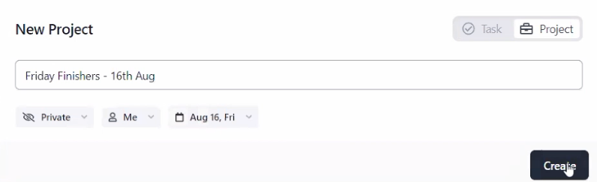  
   If we don’t fill our time with high priority actions, it will be auto fill with low priority distractions (whether you like or not).
5. 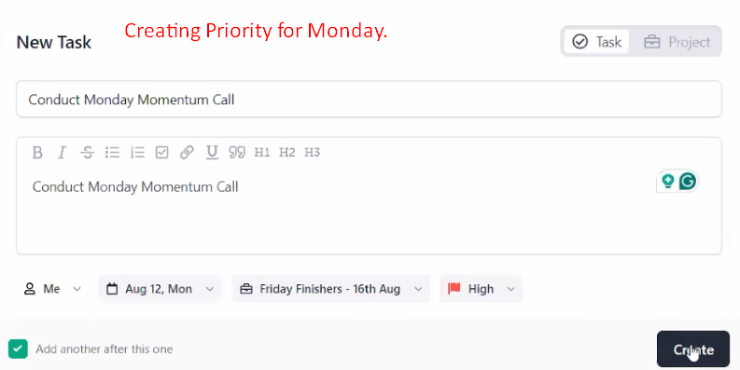
6. We will have a theme for the week so that we could identify when we are off the track and then bring ourselves back on the track.
7. **Srinivas**: Discipline.
8. **Yatan**: Focusing on study.
9. **Shubham**: Energy.
10. **Venkatesh**:
    1. **Strategy**:
       1. Break the days in 2 hours.