Youtube Study
- Keeping money in bank account will deduce its value due to inflation?
- Solution: Investment.
- 
Other kinds of investments.
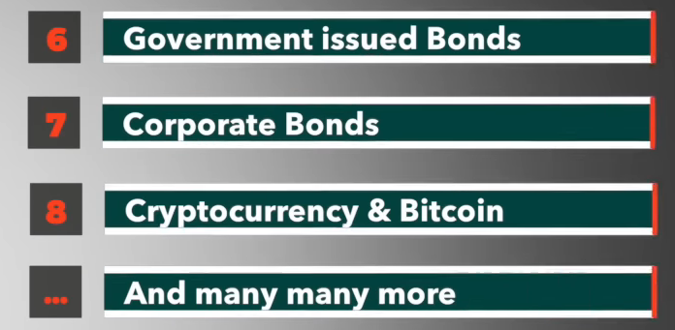
- Three factors in any investment.
  - 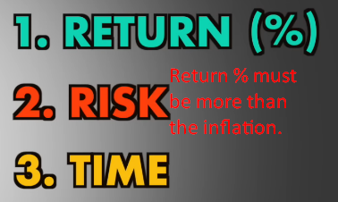
  - Basic rule:
More time & Risk More Return

Which Types of Investments are best?
- 
- Saving Account:
  - 
- FD (Fixed Account)
  - 
- Gold & Jewellery:
  - 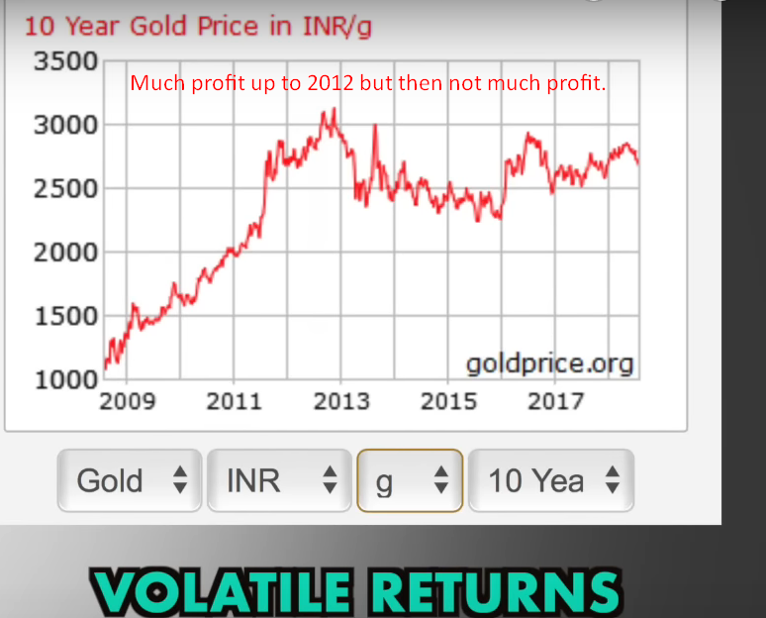
- Real Estate & Property:
  - Risk: Low to Moderate Risk.
  - In 2011 Quarter, return 30% & 2018 Quarter, return 5%.
  - Disadvantage: Need to invest huge amount that you must have in advance.
- Stock Market:
  - More loss more return.
  - 
- General rule: Never invest in one kind of way as it is very rare that stock market, gold & property price crash at the same time.
This method is called Diversification.




