Contents
Visiting Time 1
Activities 1
Contact Details: 2
Stay 2

Visiting Time
- September to April.
- Otherwise, you can visit any month.

Activities
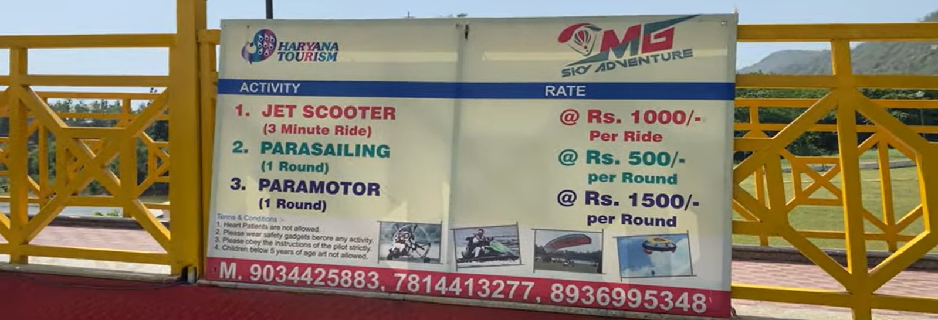

Contact Details:
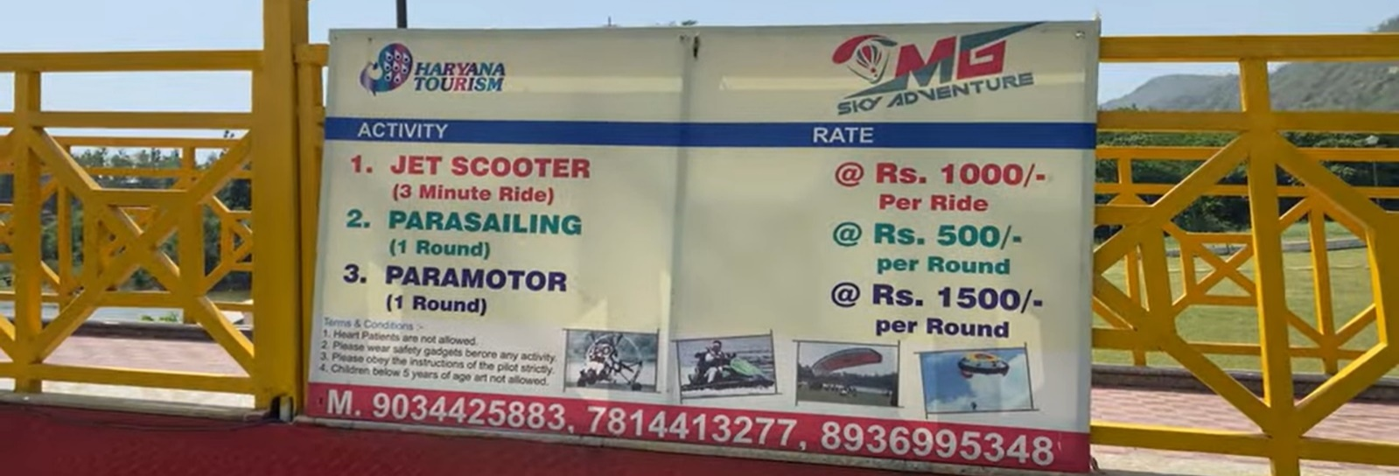

Stay
- No hotel but only resorts and that too not many.
- So, book in advance.
- Book from :
  - https://haryanatourism.gov.in/frmcustomerseeavailabilty.aspx

