https://www.youtube.com/watch?v=fWzG1q61e10
- 
- 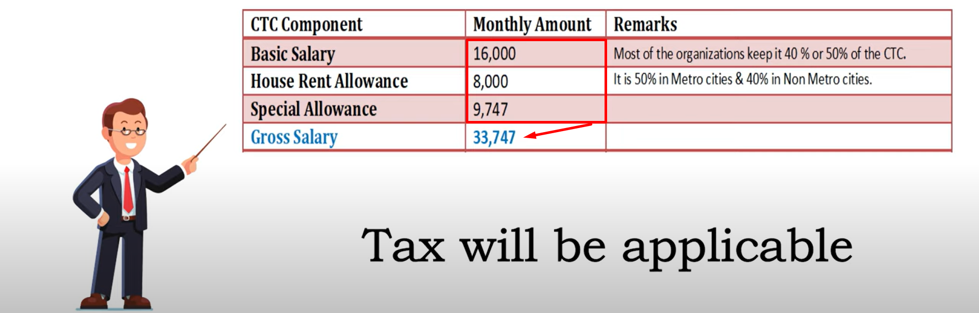
- 
- 
- 

https://www.youtube.com/watch?v=ZkOeW8cqWFM&t=602s
- CTC: Cost To Company
- Net Salary : Cash in Hand.
- Gross is the salary on which actual calculation is done.
https://youtu.be/GF_ga4qA1r4
- HRA = 40% of Basic.
- DA = 50% of Basic.

