Contents

1 Architecture Spring Cloud Config Server 1

# How to create Eureka Client

1. **Steps**:
   1. **Step 01**: **Adding Dependency**  
      
   2. **Step 02**: **@EnableEurekaClient**  
      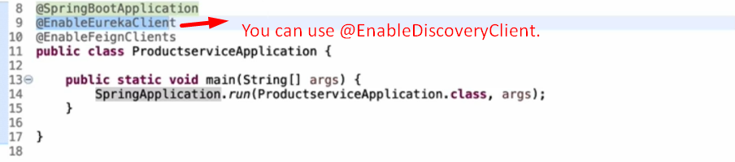 **Now this application will register itself with Eureka Server with unique application name, URL and Port#.**