Contents

1 Architecture Spring Cloud Config Server 1

# Architecture

## Architecture 01

1. 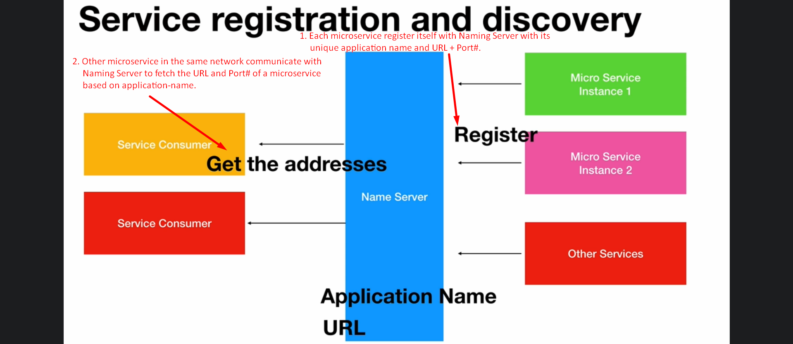  
   NOTE: This is client side routing meaning only microservices on the same network communicate with each other.   
   If some other app such as UI or some 3rd party app wants to access these microservices, for that we have API Gateway.

# How to create Eureka Server/Naming Service/Server

1. **Steps**:
   1. **Step 01**: **Adding Dependency**  
      
   2. **Step 02**: **@EnableEurekaServer**  
      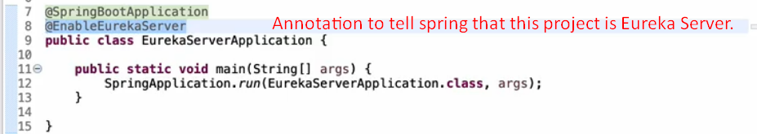
   3. **Step 03**: **Setting some flags and port**  
      