Contents

1 Architecture Spring Cloud Config Server 1

# Theory

1. Declarative HTTP Client created by Netflix.
   1. It is declarative as RestTemplate is not declarative because we have to instruct everything.
2. For load balancing in client side.

# Feign-Client Configuration

1. **Steps**:
   1. **Step 01**: **Adding Dependency**  
      
   2. **Step 02**: **@EnableFeignClients**  
      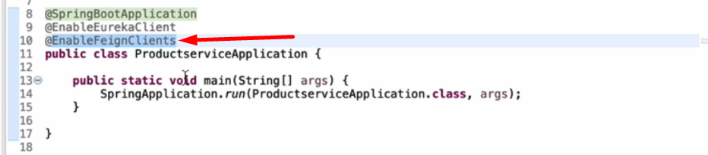
   3. **Step 03: Create Feign Client**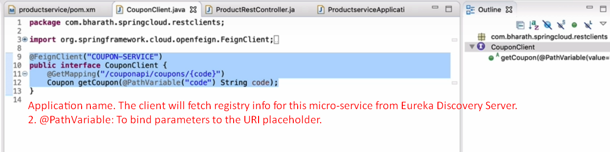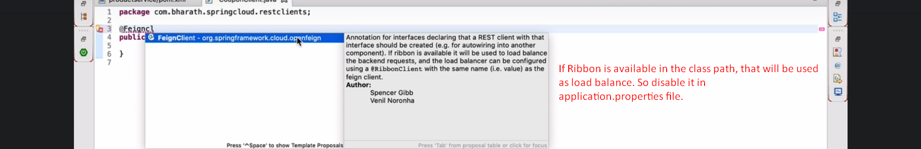
   4. **Step 04: Using Feign Client**