Contents

1 Architecture Spring Cloud Config Server 2

2 How to convert a microservice into Spring Cloud Config Server 3

3 How to configure Git as configuration repo 4

3.1 How to configure Git as local Repo 4

3.2 How to configure Git as Remote Repo 4

4 How to access properties files using Config Server’s API 5

# Architecture Spring Cloud Config Server

1. 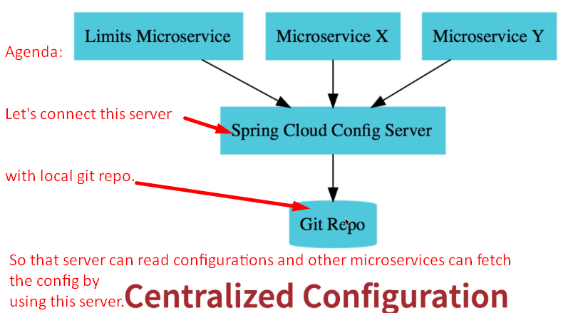

# How to convert a microservice into Spring Cloud Config Server

1. Use **@EnableConfigServer** along the side of **@SpringBootApplication**.

# How to configure Git as configuration repo

## How to configure Git as local Repo

1. In application.properties:
   1. **Linux**: spring.cloud.config.server.git.uri=file:///Jatin/git/spring-microservice
   2. **Windows**: spring.cloud.config.server.git.uri=file:///c:/Jatin/git/spring-microservice

## How to configure Git as Remote Repo

1. 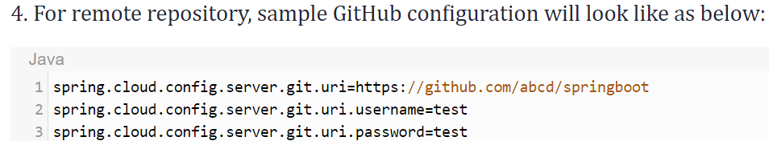

# How to access properties files using Config Server’s API

1. **Syntax:**
   1. Localhost:8081/propertyFileName/environment.
   2. **For Example:**
      1. Property File Name:
         1. account.properties
         2. account-dev.properties.
      2. localhost:8081/account/default 🡺 account.properties
      3. localhost:8081/account/dev🡺 account-dev.properties