Scan and Capture Specification and Validation Guide (SVG)

Prepared for

JLG Group

Version 0.6

Document created by: | Ramandeep Jassal
Document created on: | Sep 13, 2021
Document last saved by: | Ramandeep Jassal
Document last saved on: | Sep 13, 2021


SVG
Disclaimer | This documentation is provided "as is" and all express or implied conditions, representations and warranties, including any implied warranty of merchantability, fitness for a particular purpose or non-infringement, are disclaimed, except to the extent that such disclaimers are not enforceable at law. Basware shall not be held responsible, under any circumstances, for any indirect damage, including, but not limited to, any incidental or consequential loss (including monetary losses), that might result from the use of this documentation or the information disclosed in it.
Trademarks | The Basware name and the Basware logo are trademarks of Basware Corporation. Basware Purchase Management, Basware Invoice Processing, Basware Document Archiving and Basware Business Transactions are trademarks of Basware Corporation.  * All third party trademarks are property of their respective owner.
Copyright | © Copyright 2026 Basware Corporation.  The copyright of this document is vested in Basware Corporation. No part of this document may be reproduced, translated or transmitted in any form or by any means, electronic or mechanical, for any purpose without the express written permission of Basware Corporation, and then only on the condition that this notice is included in any such reproduction. No information as to the contents of this document may be communicated to any third party without the prior written consent of Basware Corporation.
Basware Corporation
Address: Linnoitustie 2, Cello Building, FIN-Espoo, Finland
Postal address: P.O. Box 97, FIN-02601 Espoo, Finland

www.basware.com

1 Executive Summary 7
2 Project summary and contacts 8
3 Unit Matrix 9

5 Extracts 13
5.1 Extracts to be used 13
5.2 Extract Delivery 14
6 Fields and Keywords 15
6.1 Invoice capture fields and validation rules (header-level) 15
Company 15
Supplier 16
Document Type 17
Invoice number 17
Invoice date 17
Supplier VAT Reg. Number / Tax ID / ABN 18
Supplier’s Bank Account Number 19
Supplier’s IBAN 19
Currency Code 20
Total Net Amount 20
Total Tax Amount 20
Total Gross Amount 21
Purchase Order Number 21
Contract Number / Payment plan/ Account Number 22
Buyer Reference 22
From email address 23
Buyer’s TIN/VAT registration Number 23
Ship/Bill to Address 24
Service/Billing Date period 24
Freight 24
Site Number 25
6.2 Invoice capture fields and validation rules (line-level) 25
Product Code 25
Quantity 26
Unit of Measure 26
Unit Price 26
Net Amount 27
Gross Amount 27
7 Keywords 28
7.1 Local language translations for invoice capture fields ‘Keywords’ (header-level) 28
7.2 Local language translations for invoice capture fields ‘Keywords’ (Line-level) 28
7.3 Remit to address keywords for North American customer 28
8 Appendix 29
8.1 Glossary of Terms 29
8.1.1 Legal unit name 29
8.1.2 E-Invoice Address 29
8.1.3 Unique Company Code 29
8.1.4 VAT Registration Number 29
8.1.5 Scan Provider 29
8.1.6 PO Box Address 29
8.1.7 BT Service ID 30
8.1.8 E-Mail address 30
8.1.9 Invoice Languages 30
8.1.10 Yearly Volume 30
8.1.11 Go-live date 30
8.1.12 Delivery SLA time zone 31
8.2 Keywords: 31
8.2.1 Basware maintain keywords: 31
8.2.2 Customer maintain keywords: 31
8.3 Invoice definition for North American invoices: 31
8.4 Company Amendment: 34
8.5 Mappings 35

Document History

Version | Date | Editor / Reviewer | Revisions
0.1 | 20-Sep-2021 | Ramandeep Jassal | Initial Draft
0.2 | 21-Sep-2021 | Ramandeep Jassal | -Removed field Sender’s email address as it is now by default available in XML invoice
0.3 | 21-Sep-2021 | Ravit Gutman | Final Review + adding additional line level fields
0.4 | 18-Oct-2021 | Ramandeep Jassal | Review based on feedback.
0.6 | 25-July-2022 | Aavriti jain | Added line level fields and Keywords for Product name, Product code and Purchase order.  Updated E-invoice address and name for JLG units.

Executive Summary
The purpose of this document is to act as a simple and comprehensive tool for specifying the requirements of a Scan & Capture project. The specification is used for several purposes: to ensure full and complete description of the S&C project from the start of the project, to enable technical development of the project at Basware Scan & Capture Service (BSCS) and / or scanning partners and to provide clear and concise instructions for Basware Scan & Capture Validation Teams who will process customer documents. The document can be used as a basic agenda for a kick-off meeting. It is a living document which is utilized for the entirety of a S&C project.

Project summary and contacts
Contact Person | Role & Organization | Contact E-mail Address
Lior Zohar | Project Manager, Extropy Advisors | lior@extropyadv.com
 | Project Manager, JLG Group | MLRemenick@jlg.com
Gurdayal Singh | Network Delivery Consultant, Basware | Gurdayal.Singh@basware.com
 | Contact Person for S&C notifications, JLG Group | vasmith@jlg.com, mkirby@jlg.com, stklingberg@jlg.com

Unit Matrix
Click on each heading for more information. Only five units are included in the standard startup fee.
# | Legal Unit Name | E-Invoice address | Unique Company Code | VAT Registration Number (Tax ID) | Scan Partner | PO Box Address | BT Service ID (CloudScan only) | Production E-mail Address | Test E-mail address | Languages (in order of % received) | Yearly Volume | Go-live Date | Delivery SLA Time zone
1 | JLG Industries Inc | US251199382 | US | 25-1199382 |  |  |  | JLGUS@pdf.basware.com | JLGUS @testpdf.basware.com | EN | <80k |  | GMT-6
2 | JLG Singapore | SG200903980M | SG | 200903980M |  |  |  | JLGSG@pdf.basware.com | JLGSG @testpdf.basware.com | EN | <80k |  | GMT-6
3 | JLG Eq Serv LTD-Hong Kong | HK22/30269539 | HK | 22/30269539 |  |  |  | JLGHK@pdf.basware.com | JLGHK@testpdf.basware.com | CN, EN | <80k |  | GMT-6
4 | JLG EMEA BV | NL809888336B0100 | NL | NL809888336B01 |  |  |  | JLGNL@pdf.basware.com | JLGNL@testpdf.basware.com | Dutch (NL), EN, French, German, Italian, Spanish, Swedish, Norwegian, Finnish, Russion, Danish | <80k |  | GMT+2
5 | Oshkosh Arabia | AE 100323690600003| | AE | 100323690600003| |  |  |  | JLGAE@pdf.basware.com | JLGAE@testpdf.basware.com | Arabic, EN | <80k |  | GMT+2
6 | JLG France sarl | FR80382574069 | FR | FR80382574069 |  |  |  | JLGFR@pdf.basware.com | JLGFR@testpdf.basware.com | EN, French, Dutch (NL), German, Italian, Spanish, Swedish, Norwegian, Finnish, Russion, Danish | <80k |  | GMT+2
7 | JLG Industries (Italia) SRL Italy | IT12710370151 | IT | IT12710370151 |  |  |  | JLGIT@pdf.basware.com | JLGIT@testpdf.basware.com | EN, Italian, Dutch (NL),French, German, Italian, Spanish, Swedish, Norwegian, Finnish, Russion, Danish | <80k |  | GMT+2
8 | JLG Industies (UK) Ltd. | GB712496633 | GB | 712496633 |  |  |  | JLGUK@pdf.basware.com | JLGUK@testpdf.basware.com | EN, Dutch (NL), French, German, Italian, Spanish, Swedish, Norwegian, Finnish, Russion, Danish | <80k |  | GMT+2
9 | JLG Deutschland GmbH | DE116261956 | DE | DE116261956 |  |  |  | JLGDE@pdf.basware.com | JLGDE@testpdf.basware.com | EN, German, French, Dutch (NL), Italian, Spanish, Swedish, Norwegian, Finnish, Russion, Dannish | <80k |  | GMT+2
10 | JLG Sverige AB | SE556126187501 | SE | SE556126187501 |  |  |  | JLGSE@pdf.basware.com | JLGSE@testpdf.basware.com | EN, Swedish Norweign Finnish, French, German, Italian, Spanish, Swedish, Norwegian, Russion, Dutch (NL),Danish | <80k |  | GMT+2
11 | Plat. Elev. JLG Iberica SL | ESB82205436 | ES | B82205436 |  |  |  | JLGES@pdf.basware.com | JLGES@testpdf.basware.com | Arabic, Dutch (NL), EN, Swedish Norweign Finnish, French, German, Italian, Spanish, Swedish, Norwegian, Russion,Danish | <80k |  | GMT+2
12 | FD32 JLG Ground Support BVBA | BE0559796403 | BE | BE0559796403 |  |  |  | JLGBE@pdf.basware.com | JLGBE@testpdf.basware.com | BE, EN, Spanish, Swedish, Norwegian, Russion, Dutch (NL),Danish, Finnish, French, German, Italian, Danish | <80k |  | GMT+2
13 | JLG Pacific Holdings Inc | AU52634889 884 | AU | 52 634 889 884 |  |  |  | JLGAU@pdf.basware.com | JLGAU@testpdf.basware.com | EN | <80k |  | GMT+11
14 | JLG New Zealand Access Equipment & Services | NZ942904213 9218 | NZ | 942 904 213 9218 |  |  |  | JLGNZ@pdf.basware.com | JLGNZ@testpdf.basware.com | EN | <80k |  | GMT+12:45

Extracts

Extracts to be used
Select which standard extracts will be required for this customer, based on the requirements shown below:
Extract Type | Extract Data Fields | Frequency | Relative path
☒ CompanyExtract.txt (Required if the second ‘Company matching’ option is chosen or if any data population based on company is specified) | EInvoice_Address|Company_Number|Company_Name|Company_Address_1|Company_Address_2|Company_Address_3|Company_Postcode|Company_GroupCode|VAT_Registration_Number|Currency_Code|CustomField01|CustomField02|CustomField03  Note:  Company_GroupCode: If a shared PO Box is being used then this column should contain the EInvoiceAddress of the default receiving unit.  Currency_Code: If this is used as a default value then populate with a 3 character code according to ISO 4127.  Do not change the column names for Custom fields and if they are used, please describe what values they contain here. | ☒ Daily  ☐ Weekly  ☐ Ad hoc  ☒ Other ____________ | \project-folder\extracts_upload\CompanyExtract.txt
☒ SupplierExtract.txt (Required if any supplier matching or data population based on supplier is specified) | EInvoice_Address|Company_Number|Company_Name|Supplier_Number|Supplier_Name|Supplier_Address_1|Supplier_Address_2|Supplier_Address_3|Supplier_Postcode|TelephoneNo|FaxNo|VAT _Registration_ Number |Bank_Account_Number_1|Bank_Account_Number_2|Bank_Account_Number_3|Bank_Account_Number_4|IBAN_Number1|IBAN_Number2|IBAN_Number3|IBAN_Number4|Swift_Code_1|Swift_Code_2|Supplier_EDI_ID|CurrencyCode|CustomField01|CustomField02|CustomField03  Note:  Currency_Code: If this is used as a default value then populate with a 3 character code according to ISO 4127.  Do not change the column names for Custom fields and if they are used, please describe what values they contain here. | ☒ Daily  ☐ Weekly  ☐ Other ____________ | \project-folder\extracts_upload\SupplierExtract.txt
☐ POExtract.txt (Required if captured Purchase Order numbers must be found in the customer’s purchase order register) | EInvoice_Address|Supplier_Number|Order_Number | ☒ Daily  ☐ Weekly  ☐ Other ____________ | \project-folder\extracts_upload\POExtract.txt
☐ ContractExtract.txt (Required if captured Payment Plan numbers must be found in the customer’s contract number register. This Extract is used for the Payment plans.) – Contract number is now called Payment Plan in ALUSTA. | EInvoice_Address|Supplier_Number|Contract_Number | ☒ Daily  ☐ Weekly  ☐ Other ____________ | \project-folder\extracts_upload\ContractExtract.txt
☐ UserExtract.txt (Required if captured Requester data) | EInvoice_Address|Email | ☒ Daily  ☐ Weekly  ☐ Other ____________ | \project-folder\extracts_upload\UserExtract.txt
☐ No extracts | For eOffice implementations or other situations where no matching will be done | ☒ Daily  ☐ Weekly  ☐ Other ____________

Extract Delivery
Select the desired transfer method that will be used to upload extract files to Basware:
☒ FTP
☐ sFTP (Supply a public key. We do not accept password authentication for SFTP)
☐ FTPs

Notes
- All required extracts must follow the agreed formats found below or here. If the ‘Other extract’ option above is chosen, the extract should follow the formats of the standard extracts as closely as possible and a sample should be created and provided along with this document. All extracts should be refreshed and uploaded once every 24 hours. Extracts should only contain active data; inactive suppliers or fulfilled orders should not be included in extracts.
- If any extract is likely to exceed 20MB and/or 250,000 records, the consultant should be notified for further discussion.

Fields and Keywords

Invoice capture fields and validation rules (header-level)
Describe here which data fields must be included in invoices sent to the customer at header-level (i.e. information not found in rows).
Data fields can be filled either by capturing directly from the invoice image, capturing directly from the invoice image and then comparing the value against a list (extract, see section 5.1), or populated from an extract based on supplier or company matching. Select the appropriate method based on the needs of the customer. Country specific validation rules should be determined and specified.
Any validation rules that apply to a field must be described clearly and completely here. Validation rules are needed for any field that must follow a certain format or style or whose capture and selection needs to be clarified.
If a Mandatory option is ticked for any of the fields, the Default value MUST be filled in. If a field is not mandatory, the Default value MUST be “<BLANK>”
Use the Special rules or Notes section to provide extra information. Try and avoid amending validation rules section for such as reason.
All the TEAPPS and ALUSTA mappings for each field can be found in the appendix section here.
H1 | Field Name | Company | Field type | Alphanumeric | Default value | Provide default company | ☒ Mandatory
 | Field description | Company Identifier: EInvoice_Address as provided in the company extract  Company Number: Company_Number as provided in the company extract  Company Name: Company_name as provided in the company extract
 | Source | ☒ Populate fields using values from the extract
 | Validation rules | Select which method will be used to determine the correct receiving unit:  ☒ One PO box per unit (e.g. One receiving point per PO Box/e-mail address/ CloudScan unit - Receiving unit is always determined by the PO box - E-invoice addresses listed in the unit matrix will be used for routing invoices to the receiving customer and unit.  ☐ One PO box for more than one unit - Receiving unit is determined by ++<Unique company code>++, in the invoicing address - Invoices without the identifying ++ code will be delivered to the default company for the PO Box /Email /CloudScan-BT Account as highlighted in the Unit matrix. - Company matching based on name and address is not possible.  ☐ Remote scanning - Customer sorts and scans invoices by company in-house before uploading to Basware
 | Validation rules
 | Field Format
 | Special Rules

H2 | Field Name | Supplier name | Field type | Alphanumeric | Default value | Supplier No: 999999999  Supplier Name: UNKNOWN_VENDOR | ☒ Mandatory
 | Field description | Supplier Number: Supplier_Number as provided in the supplier extract  Supplier Name: Supplier_Name as provided in the supplier extract
 | Validation rules | Supplier match filtering  # Use Item Rule  1 ☒ Bank account number / IBAN Compare last 7 digits of a bank account number or IBAN on the invoice  2 ☒ VAT registration number/Tax ID/TIN/ABN Compare Supplier VAT Reg number on the invoice  3 ☒ Supplier name Compare Supplier name on the invoice (See the note below for North American companies)  4 ☒ Supplier Name & Supplier Address Compare Supplier Name and Supplier Address from the invoice (See the note below for North American companies)  5 ☒ UNKNOWN_VENDOR Select Unknown Vendor
 | Field Format
 | Special Rules
 | Notes | Whichever option is selected for matching above, that data item must be available in the supplier extract file. If some of these rules do not apply, it should be removed unticked/amended as required. The first column suggests the order in which the supplier matching will be performed. During any steps above, if there is a unique match found, select the supplier. If there is no unique match (multiple suppliers found or no supplier found at all), continue following the next steps until the last step.  North America: For US invoices, compare the Supplier remit to name and Supplier remit to address for matching. The keywords for Remit to address can be found in the keywords section of the SVG here.

H3 | Field Name | Document Type | Field type | Alphanumeric | Default value | 00 | ☒ Mandatory
 | Field description | Invoice or credit invoice. (Used by Basware)
 | Source | Capture from the invoice
 | Validation rules | See 4.1 for more details
 | Field Format | 00 for debit invoice and 01 for credit invoice
 | Special Rules

H4 | Field Name | Invoice number | Field type | Alphanumeric | Default value | NOT_FOUND | ☒ Mandatory
 | Field description | The unique number assigned to the invoice by the supplier.
 | Source | Capture from the invoice
 | Validation rules | Options Available:  ☒ Remove spaces  ☐ Remove all non-alphanumeric characters
 | Field Format
 | Special Rules

H5 | Field Name | Invoice date | Field type | Date | Default value | 00/00/0000 | ☒ Mandatory
 | Field description | The date the invoice was created.
 | Source | Capture from the invoice
 | Validation rules | Invoice Date will be captured from the invoice, selection options below are in order of priority:  Additional Rules (Only applies when in production):
 | Field Format | DD_MM_YYYY DD_MM_YY DDMMYYYY DDMMYY YYYY_MM_DD YYYYMMDD ‘_’ indicates any separator e.g. ‘/’ or ‘. MM_DD_YYYY MMDDYYYY YYYY_DD_MM YYYYDDMM (not recommended for Non-American customers)
 | Special Rules
 | Notes | If both options for field format are selected above, the supplier extract should have the Country/Country code mentioned in the Supplier Address 3 field. Depending on the country, validation will make a decision on capturing the correct date.

H6 | Field Name | Supplier VAT Reg. Number / Tax ID / ABN | Field type | Alphanumeric | Default value | <BLANK> | ☐ Mandatory
 | Field description | The supplier’s VAT registration number or Tax Identification Number or Australian Business Number
 | Validation rules | Select options below are in order of priority:  ☒ Match VAT Reg Num on the invoice with value in the extract and populate with value from the extract (if no other options are selected below then integrity checks with the extract will be mandatory. ☐ Only match the number after country prefix.  ☒ Select VAT Reg Number from the invoice ☒ Include international values, with a country prefix (checksum validation used) ☒ Include local values, without a country prefix (only keywords are used) Regional options: ☐ Include Finnish Y-Tunnus (checksum validation used) ☐ Include Norwegian Organization Number (checksum validation used) ☐ Include French SIREN / SIRET, RCS Number (checksum validation used) ☐ Include Danish CVR number (checksum validation used) ☐ Include Danish SE number  ☐ Populate the VAT registration number from the suppler extract (if it exists)  ☐ Assign the default value  Formatting:  ☐ Remove the country code prefix  ☐ Remove the suffix:
 | Field Format
 | Special Rules

H7 | Field Name | Supplier’s Bank Account Number | Field type | Alphanumeric | Default value | <BLANK> | ☐ Mandatory
 | Field description | The supplier’s bank account number.
 | Validation rules | Selection options below are in order of priority:  ☐ Match Bank Account Number on the invoice with value in the extract and populate with value from the extract (if no other options are selected below then integrity checks with the extract will be mandatory.  ☒ Select bank account from the invoice  ☐ Select bank account from the supplier extract  ☐ Assign the default value
 | Field Format
 | Special Rules
 | Notes | - If multiple values with equal validity are detected, the first value in the document will be selected.  - Non-Alphanumeric characters and spaces will be ignored in the matching process

H8 | Field Name | Supplier’s IBAN | Field type | Alphanumeric | Default value | <BLANK> | ☐ Mandatory
 | Field description | The supplier’s IBAN.
 | Validation rules | Selection options below are in order of priority:  ☐ Match IBAN on the invoice with value in the extract and populate with value from the extract (if no other options are selected below then integrity checks with the extract will be mandatory.  ☒ Select IBAN account from the invoice  ☐ Select IBAN from the supplier extract  ☐ Assign the default value
 | Field Format
 | Special Rules
 | Notes | - International standard formats will be applied.  - Checksum validation performed on IBAN.  - If multiple values with equal validity are detected, the first value in the document will be selected.  - Non-Alphanumeric characters and spaces will be ignored in the matching process

H9 | Field Name | Currency Code | Field type | Alphanumeric | Default value | ZZZ | ☒ Mandatory
 | Field description | The unit of currency in which the invoice is issued by the supplier.
 | Source | Capture from the invoice
 | Validation rules | Selection options below are in order of priority:  ☒ Populate from the invoice, using keyword replacement  ☒ Populate from the supplier extract  ☐ Populate from the company extract  ☒ Assign the default value
 | Field Format | AAA (A=Alphabet) according to ISO 4217
 | Special Rules

H10 | Field Name | Total Net Amount | Field type | Decimal | Default value | 0.00 | ☒ Mandatory
 | Field description | The total Net amount excluding tax.
 | Source | Capture from the invoice
 | Validation rules | Locate using a combination of keywords.  A negative sign indicates a credit invoice.
 | Field Format | <whole units>.<cents>
 | Special Rules
 | Notes | The decimal separator is automatically as a comma depending on your regional settings.

H11 | Field Name | Total Tax Amount | Field type | Decimal | Default value | 0.00 | ☒ Mandatory
 | Field description | The total tax payable.
 | Source | Capture from the invoice
 | Validation rules | Locate using a combination of keywords and valid Vat Rates.  A negative sign indicates a credit invoice.
 | Field Format | <whole units>.<cents>
 | Special Rules
 | Notes | The decimal separator is automatically as a comma depending on your regional settings.

H12 | Field Name | Total Gross Amount | Field type | Decimal | Default value | 0.00 | ☒ Mandatory
 | Field description | The total amount payable.
 | Source | Capture from the invoice
 | Validation rules | Locate using a combination of keywords.  A negative sign indicates a credit invoice.
 | Field Format | <whole units>.<cents>
 | Special Rules
 | Notes | The decimal separator is automatically as a comma depending on your regional settings.

H13 | Field Name | Purchase Order Number | Field type | Alphanumeric | Default value | <Blank> | ☒ Mandatory
 | Field description | Purchase Order Number from the invoice.
 | Source | See the validation rules
 | Validation rules | Selection options below are in order of priority:  ☐ Capture from the invoice and validate against the Order extract(if no other options are selected below then integrity checks with the extract will be mandatory, supplier matching may be re-evaluated accordingly)  ☒ Capture from the invoice based on the order format (see below) and/or keywords  ☐ Populate from the order extract – possible when only one order exists for the supplier  Options:  ☒ Remove Spaces  ☐ Remove all non-alphanumeric characters  If multiple values with equal validity are detected, select the first order number from the document.
 | Field Format | Keys (N = Number and C = Char)
 | Special Rules

H14 | Field Name | Contract Number / Payment plan/ Account Number | Field type | Alphanumeric | Default value | <Blank> | ☐ Mandatory
 | Field description | Contract Number or Payment Plan from the invoice.
 | Source | See the options below
 | Validation rules | Selection options below are in order of priority:  ☐ Match Contract Number on the invoice with value in the extract and populate with value from the extract (if no other options are selected below then integrity checks with the extract will be mandatory)  ☒ Capture from invoice using keywords and format  ☐ Capture from invoice using only format (all valid formats MUST be provided)  ☐ Populate from the ContractExtract if only one ContractNum exists for this supplier (mandatory matches of SupplierExtract for VatRegNum/BankAcct are recommended for this option)  Options:  ☒ Remove spaces  ☐ Remove all non-alphanumeric characters
 | Field Format | Keys (N = Number and C = Char)
 | Special Rules

H15 | Field Name | Buyer Reference | Field type | Alphanumeric | Default value | <BLANK> | ☐ Mandatory
 | Field description | Typically, the name of the contact person.
 | Source | See options below
 | Validation rules | Selection options below are in order of priority:  ☐ Match Buyer Ref on the invoice with value in the extract and populate with value from the extract. (if no other options are selected below then integrity checks with the extract will be mandatory)  ☒ Capture from invoice using keywords and format  ☐ Capture from invoice using only format (all valid formats MUST be provided)  ☐ Populate from the BuyerRefExtract if only one Buyer exists for this supplier. (mandatory matches of SupplierExtract for VatRegNum/BankAcct are recommended for this option)  Options:  ☒ Remove spaces  ☐ Remove all non-alphanumeric characters
 | Field Format
 | Special Rules

H16 | Field Name | Buyer’s TIN/VAT registration Number | Field type | Alphanumeric | Default value | C999999999 | ☒ Mandatory
 | Field description | Buyer’s Vat registration Number
 | Source | Capture from Invoice
 | Validation rules | Validate against company extracts
 | Field Format
 | Special Rules

H17 | Field Name | Ship/Bill to Address | Field type | Alphanumeric | Default value | <Blank> | ☐ Mandatory
 | Field description | Ship/Bill to address from Invoice.
 | Source | Capture from Invoice
 | Validation rules | Sometimes keyword is missing but still capture whole address from Invoice header. Usually located on top 25% of Invoice area
 | Field Format
 | Special Rules

H18 | Field Name | Service/Billing Date period | Field type | Alphanumeric | Default value | 00/00/0000 | ☒ Mandatory
 | Field description | Service Date, Billing date, Service period, Billing period, Date of delivery
 | Source | Capture from Invoice  Please follow below keywords and from the CKG as well
 | Validation rules | Image Expected value  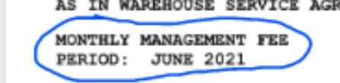 JUNE 2021  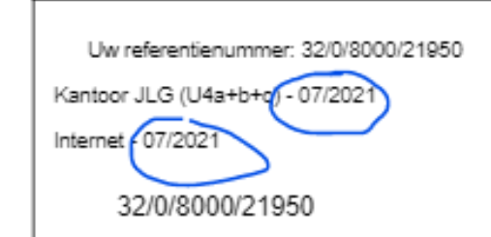 07/2021  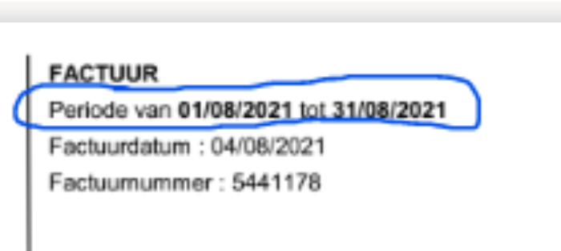 01/08/2021 tot 31/08/2021  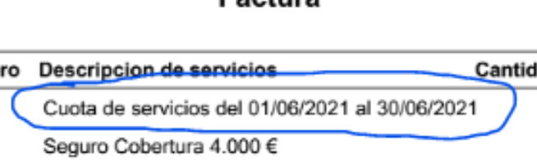 01/06/2021 al 30/06/2021  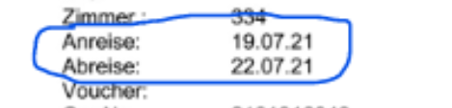 Anreise: 19.07.21 Abreise: 22.07.21  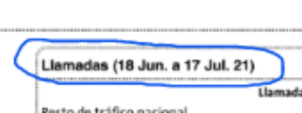 (18 Jun. a 17 Jul.21)
 | Field Format
 | Special Rules

H19 | Field Name | Freight | Field type | Decimal | Default value | 0.00 | ☒ Mandatory
 | Field description | Freight Amount
 | Source | Capture from Invoice
 | Validation rules | Captured from Invoice based on the keywords
 | Field Format | <whole units>.<cents>
 | Special Rules

H20 | Field Name | Site Number | Field type | Alphanumeric | Default value | NO_SITE | ☒ Mandatory
 | Field description | Site or Warehouse or Building number
 | Source | Capture based on leywords
 | Validation rules | Image Expected value  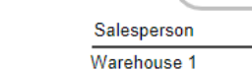 Warehouse 1  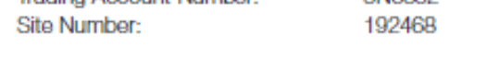 192468   358 PARK RD REGENTS PARK
 | Field Format
 | Special Rules

Invoice capture fields and validation rules (line-level)
☒ Line Level Data Extraction Is Required
Note: Capture and validation of row data is NOT included in a Scan & Capture project by default, it must be specifically requested by the customer and included in the commercial agreement. If it is required for this project, please tick the box above
Describe here which data fields must be included in invoices sent to the customer at row-level (i.e. invoice line items). The information required is the same as for header-level fields.
Line level capture is only possible for maximum 500 line items on any invoice.
The common fields for line item to be captured are as below:
- Product Code
- Quantity
- Unit of measure
- Unit price
- Net amount
- Gross amount
- Serial Number
- Product name
- Purchase order

L1 | Field Name | Product Code | Field type | Alphanumeric | Default value | <Blank> | ☐ Mandatory
 | Field description | Mentioned over Invoice
 | Source | Captured from Invoice
 | Validation rules | Captured from Invoice based on the keywords
 | Field Format
 | Special Rules
 | Notes

L2 | Field Name | Quantity | Field type | Alphanumeric | Default value | <Blank> | ☐ Mandatory
 | Field description | Mentioned over Invoice
 | Source | Captured from Invoice
 | Validation rules | Captured from Invoice based on the keywords
 | Field Format
 | Special Rules
 | Notes

L3 | Field Name | Unit of Measure | Field type | Alphanumeric | Default value | <Blank> | ☐ Mandatory
 | Field description | Mentioned over Invoice
 | Source | Captured from Invoice
 | Validation rules | Captured from Invoice based on the keywords
 | Field Format
 | Special Rules
 | Notes

L4 | Field Name | Unit Price | Field type | Decimal | Default value | 0.00 | ☒ Mandatory
 | Field description | Mentioned over Invoice
 | Source | Captured from Invoice
 | Validation rules | Captured from Invoice based on the keywords
 | Field Format | <whole units>.<cents>
 | Special Rules
 | Notes

L5 | Field Name | Net Amount | Field type | Decimal | Default value | 0.00 | ☒ Mandatory
 | Field description | Mentioned over Invoice
 | Source | Captured from Invoice
 | Validation rules | Captured from Invoice based on the keywords
 | Field Format | <whole units>.<cents>
 | Special Rules
 | Notes

L6 | Field Name | Gross Amount | Field type | Decimal | Default value | 0.00 | ☒ Mandatory
 | Field description | Mentioned over invoice
 | Source | Captured from Invoice
 | Validation rules | Captured from Invoice based on the keywords
 | Field Format | <whole units>.<cents>
 | Special Rules
 | Notes

L7 | Field Name | Serial Number | Field type | Decimal | Default value | <Blank> | ☐ Mandatory
 | Field description | Mentioned over invoice
 | Source | Captured from Invoice
 | Validation rules | Captured from Invoice based on the keywords
 | Field Format
 | Special Rules
 | Notes | Keywords:  - S/N  - Serial Number  - Serial No  - Serial No.  - Serial #

L8 | Field Name | Purchase Order | Field type | Alphanumeric | Default value | <Blank> | ☐ Mandatory
 | Field description | Purchase Order Number from the invoice based on the keywords.
 | Source | Captured from Invoice
 | Validation rules | Options:  ☒ Remove Spaces  ☐ Remove all non-alphanumeric characters
 | Field Format | Keys (N = Number and C = Char)
 | Special Rules
 | Notes | If there is no PO number in the line items, then there is no need of capturing Header PO to Line items.  Please see below example for your reference.  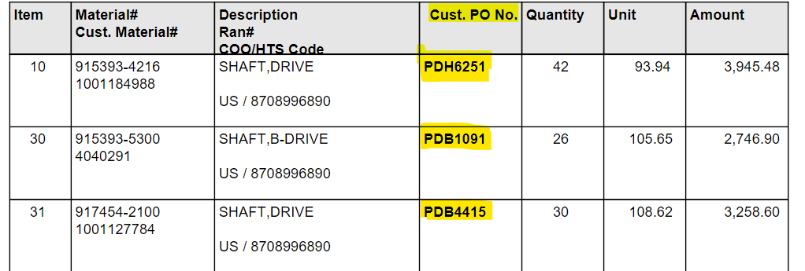

L9 | Field Name | Product Name | Field type | Alphanumeric | Default value | <Blank> | ☐ Mandatory
 | Field description | Mentioned over Invoice based upon keywords
 | Source | Captured from Invoice based upon keywords
 | Validation rules | N/A
 | Field Format
 | Special Rules | If more than one value is present over the invoice then all values should be captured from invoice
 | Notes

Field Name | Keywords | Language | Priority
Product name | Description | English | Priority-1
 | Product | English | Priority-1
 | Beschrijving | Dutch | Priority-1
 | Descripcion | Spanish | Priority-1
 | La description | French | Priority-1
 | Beskrivning | Swedish | Priority-1
 | Kuvaus | Finnish | Priority-1
 | Beskrivelse | Danish | Priority-1
 | Beschreibung | German | Priority-1
 | Opisaniye | Russian | Priority-1
 | Descrizione | Italian | Priority-1
 | Miáoshù | Chinese | Priority-1

Keywords
☐ Basware maintains keywords – Recommended option (more details here)
☒ Customer maintains keywords (more details here)
Customer Keyword Guide (CKG)

Local language translations for invoice capture fields ‘Keywords’ (header-level)
Based on the required languages recorded in the Unit Matrix, the BSCS Developer will generate and include the keyword lists here.

Local language translations for invoice capture fields ‘Keywords’ (Line-level)
Based on the required languages recorded in the Unit Matrix, the BSCS Developer will generate and include the keyword lists here.

Remit to address keywords for North American customer
Supplier matching may be done by comparing the supplier name and supplier Remit to address. Below are the keywords for Supplier remit to address:

Assign/Assigned To | Check payable to | Checks Payable To | Draw Checks Payable
By Mail | Check request | If Paying by Check, Please Remit To | Mail Check Payable To
Mail Check To | Mail Checks Payable To | Mail Checks To | Mail Payment To
Mail Payments To | Mail Remittance To | Make Check Payable To | Make Checks Payable To
Make Payable To | Payment By Check | Payment By Checks | Please Remit Payment To
Please Remit Payments To | Please Remit To | Please Send Remittance To | Regular Mail
Remit Payment To | Remit Payments To | Remit To | Remittance Address
Return This Portion With Check Payable To | Send All Payments To | Send Payment To | Send Payments To
Send Remittance To | Submit Payment To | Submit Payments To | Submit To
When Paying By Mail Send Payment To | When Paying By Mail Send Payments To

Appendix

Glossary of Terms

Legal unit name
The name of the unit within the customer organization. This should be the registered name of the unit / company. This information will be used to establish any required PO boxes and as the company name inserted into invoices from the Basware Scan Service. A dummy company may need to be created for receiving unmatchable invoices.
See unit matrix

E-Invoice Address
This is a unique identifying number that is assigned to each receiving unit in order to route e-invoices through the BT platform. In other words, it is a unique identifier for Basware Network. If the customer already is an e-invoice receiver these may already be assigned and recorded in BT. If not, it is recommended that existing unique codes be selected such as VAT registration numbers/Tax numbers, Swedish Organization number, EAN or similar. If these do not exist, they must be created and / or ordered from the appropriate authority. The e-invoice entered in the Unit matrix must be present in the extracts provided.
See unit matrix

Unique Company Code
The number or code assigned to the unit in the accounts payable system. This is used for identification and routing purposes in situations where more than one legal entity shares one PO Box. This is not the same as the e-invoice address. In IP it is the company number. The company code entered in the Unit matrix must be present in the extracts provided.
See unit matrix

VAT Registration Number
If Vat Registration number is an extracted field, then the values populated in this column will be excluded from the results
See unit matrix

Scan Provider
The entity that will receive and scan paper material. If any regional scan partner will be used, a Scan Partner Order Form must be filled out and uploaded to S&C SharePoint site.
See unit matrix

PO Box Address
This will be filled by the Basware Consultant once any new PO boxes have been ordered. The only customizable portion of the new box address is the first line, which is the legal company name (the first field). If a regional scan partner is used and new PO boxes are required, include this information in the Scan Partner Order Form. If a PO Box is shared between more than one units, the default company must be highlighted in the company capture field.
See unit matrix

BT Service ID
The BT Sender service account used for CloudScan sending. Only applicable for customers using CloudScan
See unit matrix

E-Mail address
The e-mail receiver solution is a component of the Scan & Capture service that a customer can buy as part of their agreement with Basware. It allows invoices in PDF format to be e-mailed to a specified e-mail address which will then be downloaded and processed through the implemented scan process set up for that customer.
- One e-mail address is required for each legal entity defined in the project, to enable separation and sorting of invoices in the same manner as a PO Box.
- The e-mail addresses are chosen by the customer with the following format: <customer choice>@pdf.basware.com for production and <customer choice>@bscstest.basware.com for test purposes.
- Only PDF images are to be sent to the e-mail address. Non-PDF images will be rejected and a rejection e-mail will be sent as a reply to the sender. Non-image attachments should also not be sent.
- One e-mail message may have any number of attached image files.
- One image file can contain only one invoice. Image files containing more than one invoice image cannot be guaranteed to be separated.
- Any attachments to an invoice must be included as supplementary pages in the same image file as the invoice. Attachments sent in a separate image file will be treated as a separate invoice.
- Non-invoice material should not be sent to the e-mail addresses.
- E-mail messages and attachments are not archived. If the customer requires, received e-mail messages can be forwarded to an address of their choosing for archival.
This option must be included in the contract signed by the customer.
There should be two e-mail addresses for each unit: One for Test and One for Production. The test e-mail address can be used during testing and production e-mail address should be used during production. The format for test invoices is <customer choice>@bscstest.basware.com and for production it is <customer choice>@bscs.basware.com.
See unit matrix

Invoice Languages
For each Legal Unit Name, please indicate which languages invoices can be expected to be received in. It should be in the order of languages in which invoices arrive. For example, if 70% of invoices are received in English, 20% in French and 10% in German, the values should be English, French, and German (in that order).
See unit matrix

Yearly Volume
The volume of invoices per year expected for this unit.
See unit matrix

Go-live date
The date when the first production invoices are expected to be processed and released to Production BT.
See unit matrix

Delivery SLA time zone
This is used to calculate throughput SLAs. Please provide the full time zone information for example (UTC) Dublin, Edinburgh, Lisbon, London

Keywords:

Basware maintain keywords:
Basware will maintain keywords for standard fields in the setup. Basware will make amendments (additions/removal) to keywords which are applicable to all other customers using the same language based on customer feedback as well as any suggestions from other customers for same languages. If customer wants to review the keywords for standard fields at any point of time, a request needs to be made to CSM or Customer Care team.
Advantages:
- Customers do not need to worry about providing or reviewing keywords.
- The customer solution will be kept updated with Basware Scan & Capture’s best practice for use of keywords for all languages.
- When Basware provides feedback with a suggestion for keyword changes, it will be automatically included into the technical solution. All future invoices being processed will benefit.

Disadvantages:

- If customer wants full control over what keywords are to be added, this option may not be good
- Customer cannot ask for customer specific keywords to be added which may not apply to other customers.
- Customer cannot ask for keyword priorities to change which may not apply for all customers globally.

Customer maintain keywords:
Customer will maintain keywords for all the fields in the setup. Basware will provide a list keywords during the initial implementation. The customer may add or remove keywords as required to meet their requirements. After go-live the keywords used by Basware will not be altered without customer authorization and an update to the SVG.
Advantages:
- Customer has control over what keywords are used and they can add or remove keywords for their specific project.
Disadvantages:
- Customer is required to confirm the keywords initially provided by Basware, analyse requirements and update as needed.
- Customer will not benefit from keyword changes made during S&C’s ongoing improvement.
- Every time the customer reports feedback and Basware helpdesk states that a new keyword needs to be added, customer will have to raise that as a CR and wait for it to be implemented.

Invoice definition for North American invoices:
Certain statements treated as Invoices:
Statements is a difficult category as in many cases, such as a Bank Statement, it is not an option and is considered as a non-Invoice. However, Utility Invoices often has Statement written on the document. Suppliers that fall into this category would be AT&T, Verizon, CellularOne, TMobile, and Sprint are phone companies that almost always have Statement on their Invoices. These documents should be processed as an Invoice. If a document that has Statement on it has the word/s: Gas, Electric, Water, Sewage, Cable, Garbage, Heat, or Internet. If a Statement has one or more of those words, it is typically an Invoice and should be handled as such. Credit Card Statements are to be handled as an Invoice. Statements normally have payment stubs on it. Below are some examples:

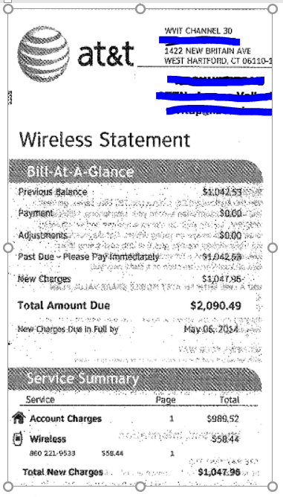
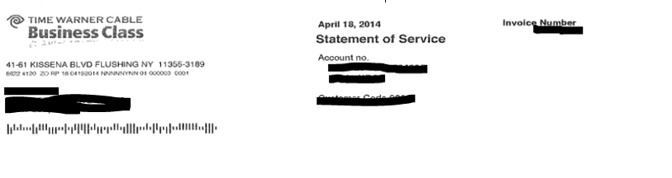
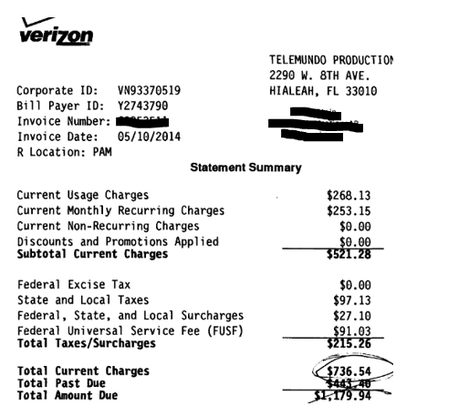

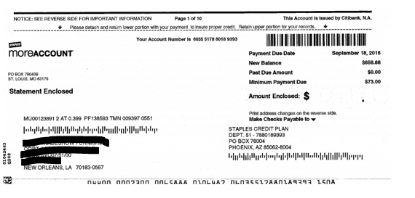
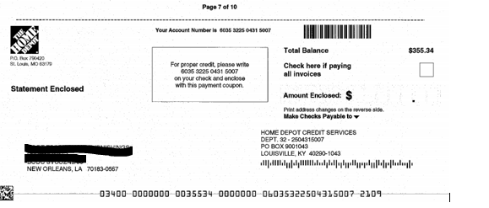

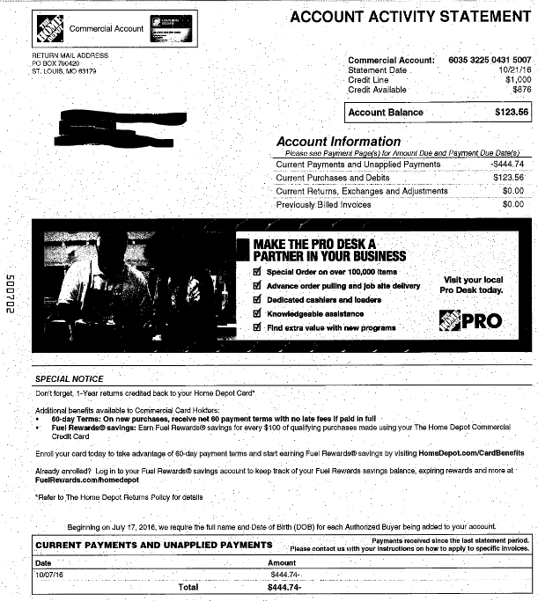

Company Amendment:
If there are changes to be made in future such as adding a new company or removing it, the following process needs to be followed:
- Customer needs to log a ticket with Customer Care.
- Customer Care will quote the customer regarding time and cost
- Customer Care needs to analyze:
- Connectivity service desk effort required if:
  - A new E_Invoice_Address is required (or changes made to an existing item). If so, the new e-invoice address must be added in Test and Prod BT.
  - A new PO Box is required (or changes made to an existing item)
- Development effort required if:
  - CompanyExtract is not provided (see 5.4)
  - A new PO Box or Email is required (or changes made to an existing item)

Mappings
Header Fields (Consultant to fill in the ALUSTA mapping for each field)

Field Name | TEAPPS Mapping | ALUSTA Mapping
Company e-invoice address | /INVOICE_CENTER/CONTENT_FRAME/INVOICES/INVOICE/RECEIVER/CUSTOMER_INFORMATION/PARTY_IDENTIFICATION_ID
Supplier number | /INVOICE_CENTER/CONTENT_FRAME/INVOICES/INVOICE/PAYEE/NET_SERVICE_ID
Document Type | /INVOICE_CENTER/CONTENT_FRAME/INVOICES/INVOICE/HEADER/INVOICE_TYPE
Invoice Number | /INVOICE_CENTER/CONTENT_FRAME/INVOICES/INVOICE/HEADER/INVOICE_ID
Invoice Date | /INVOICE_CENTER/CONTENT_FRAME/INVOICES/INVOICE/HEADER/INVOICE_DATE/DATE
Supplier’s VAT Reg. Number | /INVOICE_CENTER/CONTENT_FRAME/INVOICES/INVOICE/PAYEE/CUSTOMER_INFORMATION/VAT_NUMBER
Supplier’s Bank Account number | /INVOICE_CENTER/CONTENT_FRAME/INVOICES/INVOICE/PAYEE/BANKS/BANK_ACCOUNT_NUMBER
Supplier’s IBAN | /INVOICE_CENTER/CONTENT_FRAME/INVOICES/INVOICE/PAYEE/BANKS/IBAN_ACCOUNT_NUMBER
Currency code | /INVOICE_CENTER/CONTENT_FRAME/INVOICES/INVOICE/HEADER/CURRENCY/CODE
Total Net Amount | /INVOICE_CENTER/CONTENT_FRAME/INVOICES/INVOICE/SUMMARY/INVOICE_TOTAL/AMOUNT[@VAT="EXCLUDED"]
Total Tax Amount | /INVOICE_CENTER/CONTENT_FRAME/INVOICES/INVOICE/SUMMARY/VAT_TOTAL/AMOUNT[@VAT="INCLUDED"]
Total Gross Amount | /INVOICE_CENTER/CONTENT_FRAME/INVOICES/INVOICE/SUMMARY/INVOICE_TOTAL/AMOUNT[@VAT="INCLUDED"]
Purchase order number | /INVOICE_CENTER/CONTENT_FRAME/INVOICES/INVOICE/HEADER/ORDER_INFORMATION/ORDER_NUMBER
Contract/Account/ number/Payment plan | /INVOICE_CENTER/CONTENT_FRAME/INVOICES/INVOICE/HEADER/CONTRACT_INFORMATION/CONTRACT_NUMBER
Buyer Reference | /INVOICE_CENTER/CONTENT_FRAME/INVOICES/INVOICE/HEADER/BUYER_REFERENCE
Buyer’s Vat/TIN/ABN | /INVOICE_CENTER/CONTENT_FRAME/INVOICES/INVOICE/RECEIVER/CUSTOMER_INFORMATION/VAT_REG
Ship/Bill to address | /INVOICE_CENTER/CONTENT_FRAME/INVOICES/INVOICE/RECEIVER/CUSTOMER_INFORMATION/FREE_TEXT[@TEXT_TYPE=’Bill_To’]
Service date/period | /INVOICE_CENTER/CONTENT_FRAME/INVOICES/INVOICE/HEADER/FREE_TEXT[@TEXT_TYPE=’Service_DatePeriod’]
Freight | /INVOICE_CENTER/CONTENT_FRAME/INVOICES/INVOICE/SUMMARY/CARGO/AMOUNT
Site number | /INVOICE_CENTER/CONTENT_FRAME/INVOICES/INVOICE/RECEIVER/CUSTOMER_INFORMATION/FREE_TEXT[@TEXT_TYPE=’Site_Number’]

Line level fields (BSCS Developer to fill in the TEAPPS mappings and consultant to fill in the ALUSTA mappings)

Field Name | TEAPPS Mapping | ALUSTA Mapping
Product Code | /INVOICE_CENTER/CONTENT_FRAME/INVOICES/INVOICE/ROWS/ROW/ARTICLE/ARTICLE_ID
Quantity | /INVOICE_CENTER/CONTENT_FRAME/INVOICES/INVOICE/ROWS/ROW/QUANTITY/CHARGED
Unit of measure | /INVOICE_CENTER/CONTENT_FRAME/INVOICES/INVOICE/ROWS/ROW/UNIT
Net unit price | /INVOICE_CENTER/CONTENT_FRAME/INVOICES/INVOICE/ROWS/ROW PRICE_PER_UNIT/AMOUNT[@VAT='EXCLUDED']"
Net Amount | /INVOICE_CENTER/CONTENT_FRAME/INVOICES/INVOICE/ROWS/ROW ROW_TOTAL/AMOUNT[@VAT='EXCLUDED']
Gross amount | /INVOICE_CENTER/CONTENT_FRAME/INVOICES/INVOICE/ROWS/ROW ROW_TOTAL/AMOUNT[@VAT='INCLUDED']"
Serial Number | /INVOICE_CENTER/CONTENT_FRAME/INVOICES/INVOICE/ROWS/ROW/ARTICLE/FREE_TEXT[@TEXT_TYPE=’Serial_Number’]

