DATALINK SOFTWARE · DATA OPERATIONS
Claims, Membership & Provider
Data Pipeline — Medallion Architecture
─────────────────────────────────────
End-to-End Architecture Reference Guide
A complete walkthrough tracing Claims (EDI 837), Membership (EDI 834), and Provider (NPPES) files through every zone of DataLink's Medallion Architecture — written for technical and non-technical readers alike.
Prepared by:
Jatin · VP, Data Operations · DataLink Software
Version 1.0 · March 2026 · CONFIDENTIAL

Table of Contents
Table of Contents 2
1. The Three Core Files — What They Are and Why They Matter 4
1.1 Claims File (EDI 837 / CSV) 4
1.2 Membership File (EDI 834 / CSV) 4
1.3 Provider File (NPPES CSV / REST API) 5
2. Ingestion Layer — Three Paths from Client to ADLS Gen2 6
2.1 Path A: sFTP Ingestion (Health Plan EDI Files) 6
2.2 Path B: REST API Ingestion (NPPES Provider Data) 7
2.3 Path C: Azure Blob Direct Upload 7
2.4 ADLS Gen2 Folder Structure 7
3. Bronze Zone — Raw Ingestion into Snowflake 8
3.1 Bronze Design Principles 8
3.2 Bronze Table Schemas 9
3.3 Airflow DAG: bronze_ingest_dag 10
3.4 GX Checkpoint 1 — Structural Validation 11
3.5 AI Pre-Validation Crew (Profiler → Author → Reviewer) 11
4. Silver Zone — Data Vault 2.0 Transformation 12
4.1 What is Data Vault 2.0? 12
4.2 All 9 Silver Objects 13
4.3 GX Checkpoint 2 — Clinical Validation (The Most Critical Gate) 13
5. Gold Zone — Business-Ready Aggregates & Downstream Consumers 15
5.1 The Six Gold Tables 15
FACT_CLAIMS_SUMMARY 15
DIM_MEMBER 15
DIM_PROVIDER 16
UM_METRICS 16
STAR_RATINGS_FEED 16
AG_SUMMARY 16
5.2 GX Checkpoint 3 — Business Rule Validation 16
6. Technology Reference — What Each Component Does 18
6.1 Apache Airflow DAGs — The Pipeline Orchestrator 18
6.2 Great Expectations (GX) — The Quality Gate 18
6.3 AI Agents (CrewAI + Anthropic Claude) 18
6.4 Kubernetes AKS — The Compute Layer 19
6.5 Snowflake — The Data Warehouse 19
7. HIPAA Boundary — PHI Management and AI Safety 21
7.1 What Stays Inside (PHI — Never Crosses Boundary) 21
7.2 What Crosses to AI (Metadata Only — Safe to Share) 21
7.3 Technical Enforcement 21
8. Pipeline Failure & Recovery — State Machine and Checkpoint Resume 23
8.1 Pipeline State Machine 23
8.2 Checkpoint Resume — No Full Reprocessing 23
8.3 AI Post-Validation Crew (Root Cause → Remediation → Reporting) 23
9. Downstream Consumers — Who Uses the Gold Layer 25

📂 Section 1: The Three Core Files
Understanding Claims, Membership & Provider data — the foundation of every healthcare data platform

1. The Three Core Files — What They Are and Why They Matter
Before any pipeline can run, you need to understand what each file IS in the real world of healthcare operations. These three files are interdependent — a claim is only meaningful when you know WHO the member was and WHO the provider is.

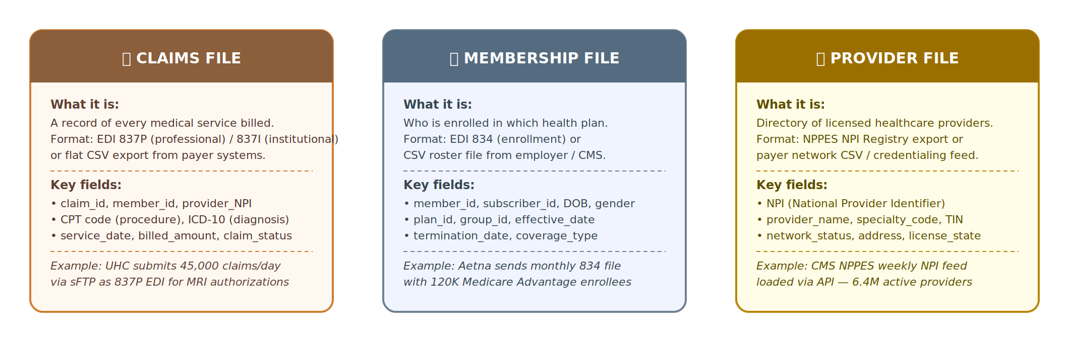
Figure 1: The three core file types — their formats, key fields, and business purpose

1.1 Claims File (EDI 837 / CSV)
A claim is a record of every medical service billed. It is the central entity in all of UM, CM, and A&G analytics — every authorization decision, every payment, every denial traces back to a claim.
Format: EDI 837P (professional services) or EDI 837I (institutional / inpatient), or flat CSV exported from payer billing systems.
- Key fields: claim_id (unique identifier), member_id, provider_npi, CPT code (procedure), ICD-10 diagnosis codes, service_date, billed_amount, claim_status, plan_id, prior_auth_ref
- Real example: UHC submits 45,000 claims per day via sFTP as 837P EDI files for Medicare Advantage prior authorization
- Why it matters: No Claims data = no UM analytics. Every authorization decision, HEDIS measure, Star Rating, and FHIR Prior Auth output is driven by claims.

1.2 Membership File (EDI 834 / CSV)
The Membership file is the enrollment roster — it tells you who is covered by which health plan and for what period of time. Before approving any service, you must verify the member WAS enrolled and eligible on the service date.
- Key fields: member_id (+ subscriber_id for dependents), DOB, gender, plan_id, group_id, effective_date, termination_date, coverage_type (Medicare Advantage, Commercial, Medicaid), state
- Real example: Aetna sends a monthly 834 EDI file with 120,000 Medicare Advantage enrollees. Daily delta files capture mid-month enrollments and terminations.
- Why it matters: If a member terminated December 31, 2025 and a claim is dated January 5, 2026, the claim must be flagged as ineligible. Silver GX Checkpoint 2 catches this.

1.3 Provider File (NPPES CSV / REST API)
The Provider file is a directory of licensed healthcare providers. Network status, specialty, and credentialing determine whether a claim can be paid and at what rate.
- Key fields: NPI (National Provider Identifier — 10 digits, unique per provider or organization), provider_name, entity_type (1=Individual, 2=Organization), specialty_code, TIN, network_status, address, license_state
- Real example: CMS publishes the full NPPES NPI registry weekly — 6.4 million active providers — available via REST API or CSV download.
- Why it matters: If a provider billed a claim but their NPI does not exist in our Provider table, the claim cannot be routed to the correct network tier or specialty bucket for UM review.

🔑 Key Dependency Insight
Claims, Membership, and Provider are NOT independent. To answer the question 'Should this $4,250 claim for Dr. Doe treating member Jane Smith be approved?' you need ALL THREE: Was Jane Smith enrolled on the service date? (Membership) Is Dr. Doe in-network with the correct specialty? (Provider) Is the procedure code valid and authorized? (Claims)

📥 Section 2: Ingestion Layer
How files travel from client systems into Azure Data Lake Storage (ADLS Gen2)

2. Ingestion Layer — Three Paths from Client to ADLS Gen2
Ingestion is the first step: getting raw files from their source system into ADLS Gen2, which is DataLink's landing zone before any transformation occurs. There are three separate ingestion paths depending on how a particular health plan or data source delivers its files.

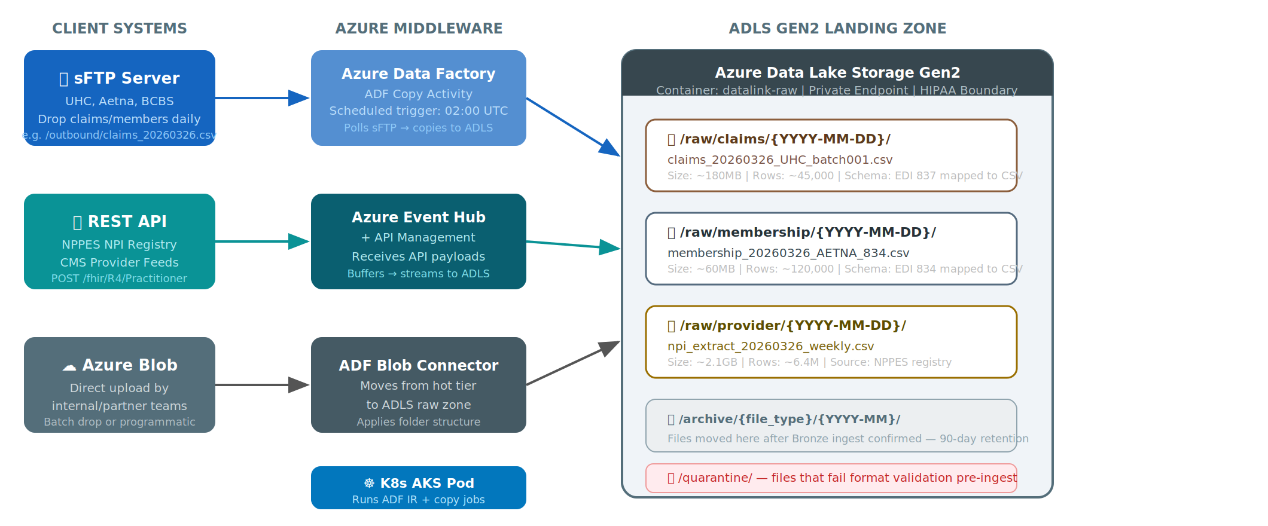
Figure 2: Three ingestion paths — sFTP (scheduled batch), REST API (event-driven), Azure Blob (direct upload)

2.1 Path A: sFTP Ingestion (Health Plan EDI Files)
Most large health plans — UnitedHealthcare, Aetna, BCBS — drop EDI 837/834 files on their managed sFTP servers each evening after business hours. This is the dominant ingestion path for Claims and Membership files.
Component | Details
Trigger | Scheduled: Azure Data Factory (ADF) polls at 02:00 UTC daily
Copy Method | ADF Copy Activity: sFTP source → ADLS sink
Target Path | /raw/claims/{YYYY-MM-DD}/ or /raw/membership/{YYYY-MM-DD}/
File Naming | claims_20260326_UHC_batch001.csv (standardized by pipeline)
Compute | Kubernetes AKS pod running ADF Integration Runtime
Retry Policy | 3 retries at 15-minute intervals. Alert fired if still missing after 30 min.

2.2 Path B: REST API Ingestion (NPPES Provider Data)
Provider data from the CMS NPPES NPI Registry arrives via REST API. CMS publishes weekly full-file exports and supports real-time FHIR R4 Practitioner lookups for incremental updates.
Component | Details
API Source | CMS NPPES: https://npiregistry.cms.hhs.gov/api/ (weekly bulk + real-time)
Event Buffer | Azure Event Hub — buffers the JSON payload before writing to ADLS
Consumer | Python K8s pod: reads from Event Hub, flattens JSON, writes to /raw/provider/
Target Path | /raw/provider/{YYYY-MM-DD}/npi_extract_weekly.csv
FHIR Support | Also accepts FHIR R4 Practitioner resources for real-time NPI updates
Scale | Weekly full file: ~2.1GB, 6.4M rows — AKS auto-scales to 4 parallel pods

2.3 Path C: Azure Blob Direct Upload
Internal DataLink implementation teams or health plan partners can upload files directly to an Azure Blob container. An ADF storage-event trigger detects new arrivals automatically.
Use cases: Initial data loads for new clients, back-loaded historical data, custom file formats from smaller payers, testing and validation uploads.

2.4 ADLS Gen2 Folder Structure
/raw/claims/  EDI 837 → CSV | → | /raw/membership/  EDI 834 → CSV | → | /raw/provider/  NPPES → CSV | → | /archive/{type}/  90-day retention | → | /quarantine/  Format failures

🔒 HIPAA Boundary at Ingestion
ADLS Gen2 is protected by Azure Private Endpoints — no public internet access. The storage account uses Microsoft-managed encryption keys (CMK optional). All access requires Azure AD authentication with RBAC. The ADLS container datalink-raw is only accessible to the ADF service principal and the AKS pod service account.

🥉 Section 3: Bronze Zone — Raw Ingestion Layer
Preserve everything. Change nothing. Prove it happened.

3. Bronze Zone — Raw Ingestion into Snowflake
The Bronze zone is your legal evidence locker. Files are loaded into Snowflake exactly as received — no renaming of columns, no type coercion, no clinical validation. The only additions are four system metadata columns added by the pipeline for provenance and auditability. If anything ever goes wrong upstream, you can always re-derive Silver and Gold from the untouched Bronze tables.

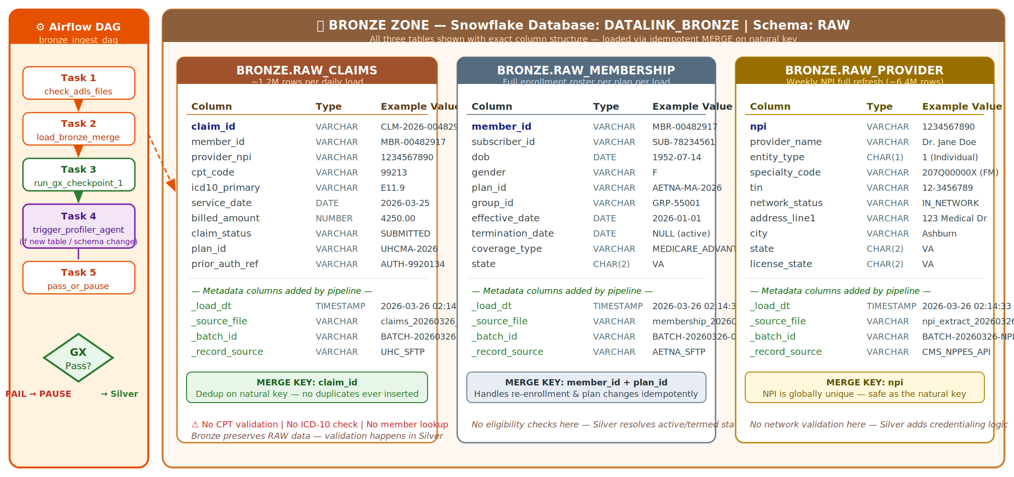
Figure 3: Bronze zone — ADLS External Stage, three RAW tables, MERGE loading, GX Checkpoint 1, and AI Pre-Val Crew trigger

3.1 Bronze Design Principles
Principle | What it means in practice
INSERT or MERGE — never DELETE | Once a row enters Bronze, it is never deleted. Corrections are additive (new rows or updated merge keys).
Idempotent MERGE loading | Snowflake MERGE INTO on the natural key (claim_id, member_id+plan_id, NPI). Running the same file twice never creates duplicates — perfectly safe to re-run.
No type coercion | CPT codes, ICD-10 codes, and member IDs are stored as VARCHAR. No attempt to cast to INTEGER or validate format at Bronze.
No clinical validation | Bronze does not check if a CPT code is valid, if a diagnosis exists, or if a member was eligible. That is Silver's job.
Metadata added only | Exactly 4 system columns are added: _load_dt, _source_file, _batch_id, _record_source. Everything else is exactly as received.

3.2 Bronze Table Schemas
Three tables in the DATALINK_BRONZE database. Columns highlighted in green are pipeline-added metadata — all other columns are source fields.

BRONZE.RAW_CLAIMS — Claims ingestion table
Column | Type | Example Value | Notes
claim_id | VARCHAR | CLM-2026-00482917 | MERGE key
member_id | VARCHAR | MBR-00482917 | FK to membership
provider_npi | VARCHAR | 1234567890 | FK to provider
cpt_code | VARCHAR | 99213 | No validation at Bronze
icd10_primary | VARCHAR | E11.9 | No validation at Bronze
icd10_secondary | VARCHAR | I10 | No validation at Bronze
service_date | DATE | 2026-03-25 | Must be valid DATE format
billed_amount | NUMBER | 4250.00 | Must be ≥ 0 (GX)
claim_status | VARCHAR | SUBMITTED
plan_id | VARCHAR | UHCMA-2026
prior_auth_ref | VARCHAR | AUTH-9920134
_load_dt | TIMESTAMP | 2026-03-26 02:14 | Pipeline adds
_source_file | VARCHAR | claims_20260326_UHC.csv | Pipeline adds
_batch_id | VARCHAR | BATCH-20260326-001 | Pipeline adds
_record_source | VARCHAR | UHC_SFTP | Pipeline adds

BRONZE.RAW_MEMBERSHIP — Member enrollment table
Column | Type | Example Value | Notes
member_id | VARCHAR | MBR-00482917 | MERGE key (+ plan_id)
subscriber_id | VARCHAR | SUB-78234561
dob | DATE | 1952-07-14
gender | VARCHAR | F
plan_id | VARCHAR | AETNA-MA-2026 | MERGE key (with member_id)
group_id | VARCHAR | GRP-55001
effective_date | DATE | 2026-01-01 | Must be valid date (GX)
termination_date | DATE | NULL | NULL = still active
coverage_type | VARCHAR | MEDICARE_ADVANTAGE
state | CHAR(2) | VA
_load_dt | TIMESTAMP | 2026-03-26 02:14 | Pipeline adds
_source_file | VARCHAR | membership_20260326_AETNA.csv | Pipeline adds
_batch_id | VARCHAR | BATCH-20260326-001 | Pipeline adds
_record_source | VARCHAR | AETNA_SFTP | Pipeline adds

BRONZE.RAW_PROVIDER — NPI provider directory table
Column | Type | Example Value | Notes
npi | VARCHAR | 1234567890 | MERGE key — exactly 10 digits
provider_name | VARCHAR | Dr. Jane Doe
entity_type | CHAR(1) | 1 | 1=Individual, 2=Organization
specialty_code | VARCHAR | 207Q00000X | CMS taxonomy code
tin | VARCHAR | 12-3456789
network_status | VARCHAR | IN_NETWORK
address_line1 | VARCHAR | 123 Medical Dr
city | VARCHAR | Ashburn
state | CHAR(2) | VA
license_state | CHAR(2) | VA
_load_dt | TIMESTAMP | 2026-03-26 02:14 | Pipeline adds
_source_file | VARCHAR | npi_extract_weekly.csv | Pipeline adds
_batch_id | VARCHAR | BATCH-20260326-NPI | Pipeline adds
_record_source | VARCHAR | CMS_NPPES_API | Pipeline adds

3.3 Airflow DAG: bronze_ingest_dag
Apache Airflow orchestrates all Bronze tasks in the correct sequence. The DAG runs at 02:00 UTC daily for Claims and Membership. The Provider DAG runs weekly (Sundays at 03:00 UTC).
Task 1: check_adls_files  ADLS Sensor | → | Task 2: load_bronze_merge  K8s + Snowflake | → | Task 3: run_gx_cp1  GX Suite | → | Task 4: profiler_trigger  Conditional | → | Task 5: pass_or_pause  Decision Gate

3.4 GX Checkpoint 1 — Structural Validation
GX Checkpoint 1 runs immediately after Bronze loading. It validates structure only — not clinical content. If more than 5% of rows fail any expectation, the pipeline AUTO-PAUSES and the AI Root Cause Agent is triggered.
File | GX Expectations at Bronze
Claims | claim_id never null · billed_amount ≥ 0 · service_date valid DATE format · row count ±20% of 7-day average · no duplicate claim_id in batch
Membership | member_id never null · effective_date ≤ today · no duplicate member_id+plan_id · termination_date NULL or ≥ effective_date
Provider | NPI exactly 10 digits · entity_type is '1' or '2' · specialty_code not null · no duplicate NPI in batch
All Files | Threshold: >5% failure → AUTO-PAUSE · Results written to GX_VALIDATION_RESULTS · Checkpoint state saved to pipeline_checkpoints

3.5 AI Pre-Validation Crew (Profiler → Author → Reviewer)
Three CrewAI agents powered by Anthropic Claude automate the creation of GX expectation suites for new tables or schema changes. This process previously took 2–3 engineer days; with AI agents it takes approximately 4 hours.
Agent |  | Role & HIPAA Boundary
Agent 1: Profiler |  | Runs SQL aggregates (NULL%, DISTINCT count, MIN/MAX, percentiles) on the Bronze table. ONLY statistics are computed — no individual rows, no PHI.
Agent 2: Expectation Author |  | Receives statistical profile from Profiler. Calls Claude API with column names + aggregate stats only (zero PHI). Generates GX expectation suite JSON with healthcare domain rules.
Agent 3: Reviewer |  | Reviews the generated GX suite. Flags columns needing domain expertise (CPT ranges, ICD-10 groupings, member ID patterns). Routes to human approver before going live.
HIPAA Guarantee |  | PHI NEVER leaves Snowflake. Claude API receives: column names, data types, null%, distinct counts, min/max values. Zero individual records, zero member names, zero SSNs.
⚡ Business Impact
Before AI agents: 2–3 engineer days to build a GX suite for a new health plan's data format. After: ~4 hours from schema detection to approved expectations. New health plan LOBs onboard approximately 5× faster.

🥈 Section 4: Silver Zone — Data Vault 2.0
Cleansed, validated, historically tracked. Hub · Satellite · Link.

4. Silver Zone — Data Vault 2.0 Transformation
The Silver zone transforms raw Bronze tables into a structured, historized, validated data warehouse using the Data Vault 2.0 methodology. Silver answers questions that Bronze cannot: Was this member eligible on THIS date? What was the provider's network status LAST YEAR? How has this claim's status changed over time?

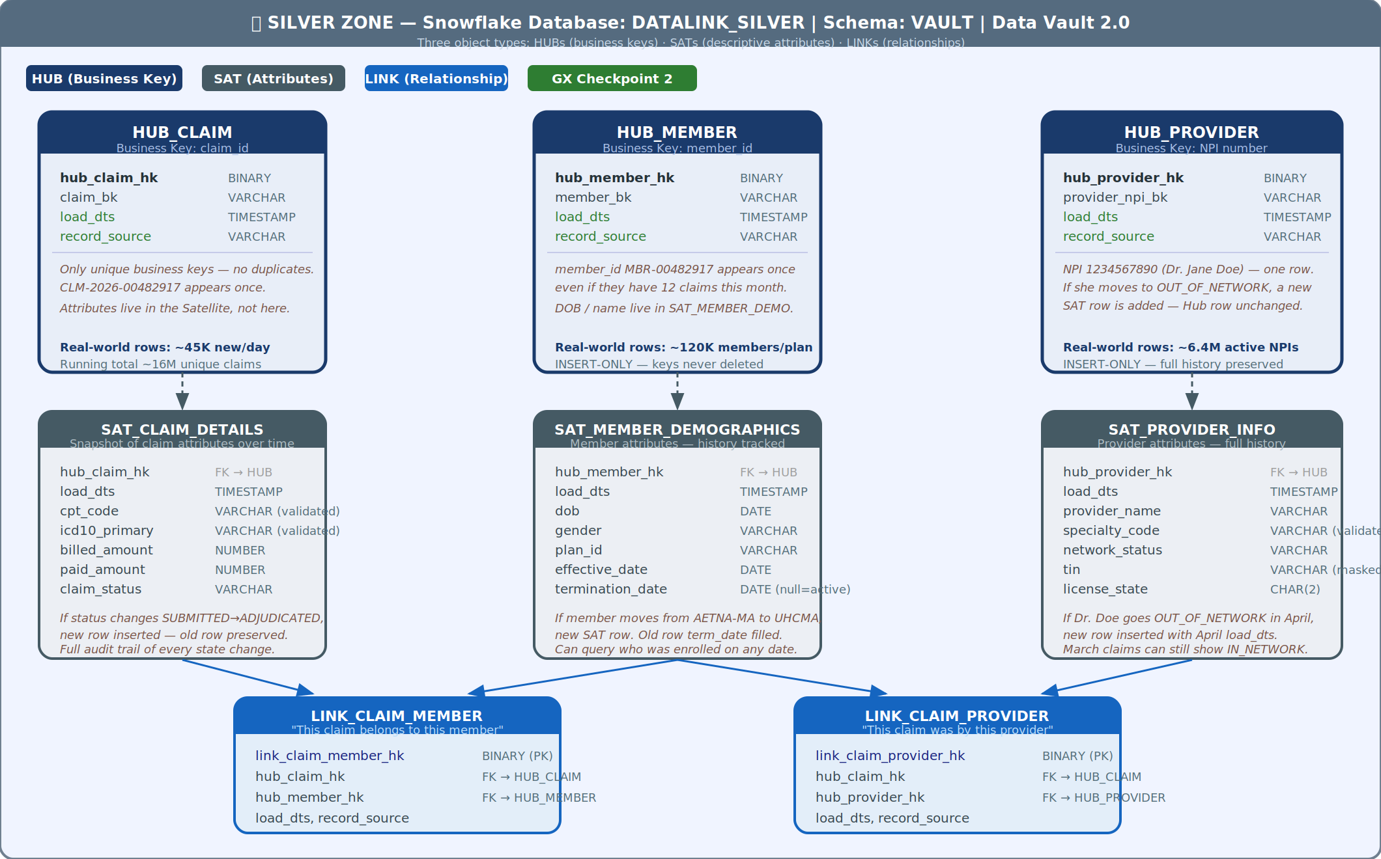
Figure 4: Silver Zone — Data Vault 2.0 object model: 3 Hubs, 3 Satellites, 2 Links

4.1 What is Data Vault 2.0?
Data Vault 2.0 is an enterprise data warehouse methodology that separates three distinct questions into three distinct object types. It is auditable (every change is recorded), scalable (no cascade updates when source systems change), and historically complete (point-in-time queries always work).
Object Type | Answers the Question / Key Properties
HUB | Who/what exists in our world? — Contains only the unique business key + load metadata. INSERT-ONLY. One row per unique entity, ever. Never deleted, never updated.
SATELLITE | What does it look like at any point in time? — Stores all descriptive attributes as new rows on every change. INSERT-ONLY. Full history preserved. Point-in-time queries possible.
LINK | How are entities connected? — Stores many-to-many relationships between Hubs. INSERT-ONLY. Relationships never deleted — full historical lineage maintained.

4.2 All 9 Silver Objects
Silver Object | Description
HUB_CLAIM | Business key: claim_id (surrogate: hub_claim_hk). One row per unique claim ever seen.
HUB_MEMBER | Business key: member_id + plan_id (surrogate: hub_member_hk). One row per unique member enrollment ever seen.
HUB_PROVIDER | Business key: NPI (surrogate: hub_provider_hk). One row per unique provider ever seen.
SAT_CLAIM_DETAILS | All claim attributes historized: CPT code, ICD-10s, billed_amount, claim_status, prior_auth_ref. New row on every change.
SAT_MEMBER_DEMOGRAPHICS | All member attributes historized: DOB, gender, effective_date, termination_date, coverage_type, state. Enables point-in-time eligibility lookups.
SAT_PROVIDER_INFO | All provider attributes historized: specialty, network_status, address, TIN, license. Enables 'what was network status on this date' queries.
LINK_CLAIM_MEMBER | Connects HUB_CLAIM.hub_claim_hk → HUB_MEMBER.hub_member_hk. One row per claim-member relationship.
LINK_CLAIM_PROVIDER | Connects HUB_CLAIM.hub_claim_hk → HUB_PROVIDER.hub_provider_hk. One row per claim-provider relationship.
LINK_MEMBER_PLAN | Connects HUB_MEMBER → plan enrollment periods. Supports multi-plan member histories.

💡 Key Insight: Why INSERT-ONLY Matters
Because Satellites are INSERT-ONLY with a load_dts timestamp on every row, you can answer: 'What was the status of claim CLM-2026-00482917 on March 15th at 09:00 UTC?' by querying WHERE load_dts <= '2026-03-15 09:00' ORDER BY load_dts DESC LIMIT 1. Bronze CANNOT answer this — it only stores the current state.

4.3 GX Checkpoint 2 — Clinical Validation (The Most Critical Gate)
GX Checkpoint 2 is where healthcare domain validation happens. Unlike Bronze (structural only), Silver validates clinical content — CPT codes, ICD-10 diagnoses, member eligibility, and referential integrity across all three entities.
Validation Rule | Detail & Failure Action
CPT Code Validation | Every CPT code in SAT_CLAIM_DETAILS must exist in the CMS CPT Master Reference table for the current service year. Codes change annually. >5% invalid → AUTO-PAUSE.
ICD-10 Validation | All ICD-10-CM codes must be valid for the service year. E11.9 (Type 2 Diabetes) valid; E12.9 (obsolete) fails. >2% invalid → AUTO-PAUSE.
Member Eligibility | Every claim's member_id must resolve to an active SAT_MEMBER_DEMOGRAPHICS row where effective_date ≤ service_date AND (termination_date IS NULL OR termination_date > service_date). >2% unresolved → AUTO-PAUSE.
Provider NPI Resolution | Every claim's provider_npi must exist in HUB_PROVIDER. >1% unresolved → WARNING + review queue.
Referential Integrity | Every LINK row must reference valid Hub hash keys on both sides. ANY orphaned Link records → AUTO-ABORT (indicates pipeline bug).
Length-of-Stay (Institutional) | For 837I claims: LOS must be > 0 and ≤ 365 days. LOS > 365 → QUARANTINE + Root Cause Agent.

🥇 Section 5: Gold Zone — Business Aggregates
Pre-joined. Pre-aggregated. Query-ready. The layer that analysts, dashboards, and APIs actually use.

5. Gold Zone — Business-Ready Aggregates & Downstream Consumers
Gold tables are pre-joined, pre-aggregated, and query-optimized. They are built by reading from the Silver Data Vault and assembling business views that directly answer specific healthcare analytics questions. A business analyst, BI developer, or FHIR API consumer never needs to touch Bronze or Silver — they only interact with Gold.

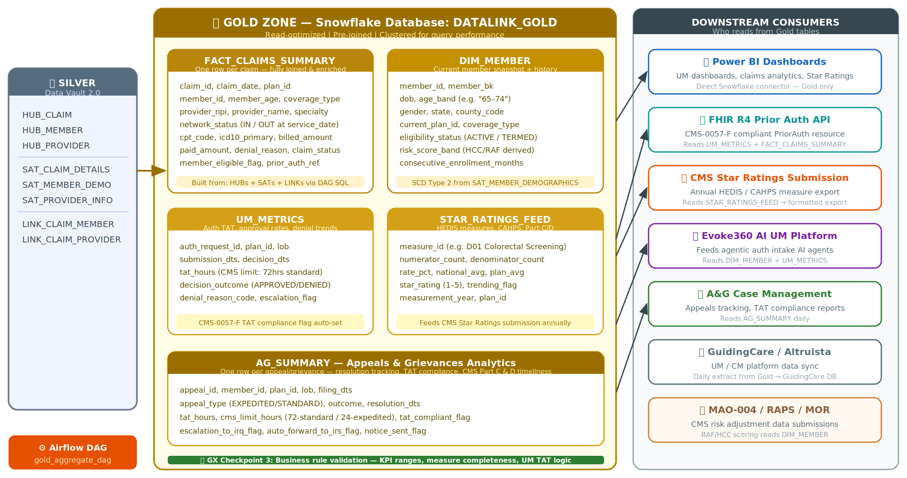
Figure 5: Gold Zone — 6 business tables and their downstream consumers

5.1 The Six Gold Tables

FACT_CLAIMS_SUMMARY
One row per claim, fully joined from Silver Hub+Sat+Link. Pre-computes member age at service date, network status at service date, eligibility flag, denial reason. Clustered on (plan_id, service_date) for fast plan-level reporting. Feeds: Power BI, FHIR R4 Prior Auth, Evoke360.

DIM_MEMBER
Current member snapshot + full eligibility history (SCD Type 2 from SAT_MEMBER_DEMOGRAPHICS). Computed fields: age_band, risk_score_band (HCC/RAF derived), consecutive_enrollment_months. Feeds: Star Ratings, MAO-004/RAPS, Evoke360.

DIM_PROVIDER
Current + historical provider snapshot (SCD Type 2). Computed: network status at any date, active credential flag, specialty grouping. Feeds: GuidingCare, provider portal, Power BI.

UM_METRICS
Authorization TAT tracking for CMS-0057-F compliance. Standard = 72 hours, expedited = 24 hours. Decision outcome, denial reason codes, escalation flags, auto-forward to IRQ. Feeds: FHIR R4 Prior Auth, CMS submission, A&G system.

STAR_RATINGS_FEED
HEDIS measures, CAHPS scores, Part C and D measures. Numerator/denominator counts, rates, national benchmarks, plan averages. Trending flags for declining measures. Feeds: CMS Star Ratings annual submission.

AG_SUMMARY
Appeals and Grievances analytics. One row per A&G case. TAT tracking (72 hours standard, 24 hours expedited), CMS Part C and D resolution requirements, auto-forward to Independent Review (IRQ) flags. Feeds: A&G case management system, CMS.

5.2 GX Checkpoint 3 — Business Rule Validation
GX Checkpoint 3 validates Gold tables against business rules and KPI range expectations. Failures trigger the AI Post-Validation Crew (Root Cause + Remediation + Reporting agents).
Gold Table |  | Business Rule Validations
FACT_CLAIMS_SUMMARY |  | billed_amount between $0 and $2,000,000 · tat_compliant_flag never NULL · service_date ≤ load_dt
DIM_MEMBER |  | effective_date ≤ termination_date (when not null) · age_band never NULL · risk_score_band within valid range
UM_METRICS |  | tat_hours ≤ 8,760 (1 year maximum) · decision_outcome in allowed values · auth_status never NULL
STAR_RATINGS_FEED |  | denominators never zero · all measure rates between 0.0 and 1.0 · HEDIS measure completeness > configured threshold
AG_SUMMARY |  | tat_compliant_flag never NULL · resolution_date ≥ receipt_date · irq_forwarded_flag populated when required
💡 Bronze is what was received. Silver is what it means. Gold is what it tells you.
A business analyst asking 'How many BCBS Medicare Advantage members aged 65–74 had a prior authorization approved in fewer than 24 hours in Q1 2026?' queries FACT_CLAIMS_SUMMARY joined to DIM_MEMBER with a 5-line SQL statement. In Silver, this requires joining 6 objects across 3 Hub+Satellite pairs. In Bronze, this question cannot be answered at all.

⚙️ Section 6: Technology Reference
Airflow DAGs · Great Expectations · AI Agents · Kubernetes AKS · Snowflake

6. Technology Reference — What Each Component Does

6.1 Apache Airflow DAGs — The Pipeline Orchestrator
Apache Airflow is the orchestration layer — it decides WHEN each task runs, in what ORDER, and what happens if one fails. Every Bronze, Silver, and Gold task is a separate Airflow task inside a DAG (Directed Acyclic Graph).
DAG Name | Schedule / Purpose / Task Sequence
bronze_ingest_dag | 02:00 UTC daily (Claims + Membership) / Weekly Sunday 03:00 UTC (Provider) · check_adls_files → load_bronze_merge → run_gx_checkpoint_1 → profiler_trigger (conditional) → pass_or_pause
silver_transform_dag | Triggered after Bronze GX pass · wait_bronze_complete → load_hubs → load_satellites → load_links → run_gx_checkpoint_2 → post_val_crew_trigger
gold_aggregate_dag | Triggered after Silver GX pass · wait_silver_complete → build_dim_tables → build_fact_claims → build_um_metrics → build_star_ratings → run_gx_checkpoint_3 → reporting_agent
pipeline_resume_dag | Manual trigger only · validate_checkpoint → resume_from_silver OR resume_from_gold → re-run failed step → notify_teams

6.2 Great Expectations (GX) — The Quality Gate
Great Expectations is the data quality framework used at all three zone transitions. It acts as an automated quality gate — no data moves to the next zone until it passes all defined expectations for the current zone.
Checkpoint | Validates / Threshold
CP1 — Bronze | Structural: nulls, row counts, date formats, duplicates, numeric ranges. Threshold: >5% failure → AUTO-PAUSE.
CP2 — Silver | Clinical: CPT codes, ICD-10 codes, member eligibility, NPI resolution, referential integrity. Threshold: >5% fail → AUTO-PAUSE, any orphaned Link → AUTO-ABORT.
CP3 — Gold | Business rules: KPI ranges, measure completeness, TAT bounds, denominator non-zero. Failures trigger Root Cause + Remediation + Reporting agents.

6.3 AI Agents (CrewAI + Anthropic Claude)
Six AI agents organized into two crews automate the most labor-intensive data quality and incident response tasks.
Agent | Crew / What It Does
Profiler Agent | Pre-Validation · Runs SQL aggregates on Bronze tables. Sends only statistics (NULL%, distinct counts, min/max) to the next agent — never raw data.
Expectation Author | Pre-Validation · Generates GX expectation suite JSON using the statistical profile. Calls Claude API with column metadata only — zero PHI.
Reviewer Agent | Pre-Validation · Reviews generated suite for domain accuracy. Routes CPT/ICD-10 domain rules to human approver.
Root Cause Agent | Post-Validation · Fires after any GX failure. Queries GX results + pipeline history. Classifies: new issue vs recurring. Output: structured diagnosis.
Remediation Agent | Post-Validation · Generates step-by-step fix instructions from Root Cause output. NEVER auto-executes — always human-reviewed.
Reporting Agent | Post-Validation · Sends formatted pipeline status alerts to Teams and Email. Daily: row counts, processing times, warnings. On failure: Root Cause summary + recommended action.

6.4 Kubernetes AKS — The Compute Layer
Every processing task runs in an isolated Azure Kubernetes Service (AKS) pod. Pods are ephemeral — they spin up, run, and are destroyed. No idle costs, no shared state, no cross-tenant data co-mingling at the compute level.
Pod Type | Purpose / Auto-Scaling Behavior
ADF Integration Runtime Pod | Runs the sFTP → ADLS copy jobs. Scales to match file size.
Bronze Load Pod | Executes the Snowflake MERGE INTO statements for all 3 tables. Ephemeral per DAG run.
Agent Pod | Runs the CrewAI agent crews (Pre-Val or Post-Val). One pod per crew invocation.
API Consumer Pod | Reads from Azure Event Hub and writes NPPES JSON to ADLS. Scales to 4 pods for weekly 6.4M row full-file load.
Multi-tenancy | Separate K8s namespace per health plan client. UHC data never co-mingles with Aetna at the compute level.

6.5 Snowflake — The Data Warehouse
Feature | How DataLink Uses It
Three databases | DATALINK_BRONZE (raw schema), DATALINK_SILVER (vault schema — DV2.0), DATALINK_GOLD (analytics schema)
External Stage | Snowflake reads files directly from ADLS via External Stage — no intermediate copy step.
MERGE (Bronze) | Idempotent upsert on natural keys. Running the same file twice is always safe.
INSERT-ONLY (Silver) | Data Vault principle — Hub/Sat/Link rows are never updated or deleted. Full history always preserved.
Micro-partition clustering (Gold) | FACT_CLAIMS_SUMMARY clustered on (plan_id, service_date). Queries by plan + date range scan only relevant micro-partitions.
RBAC | Bronze: pipeline service accounts only. Silver: pipeline + analytics. Gold: BI roles, FHIR API, reporting tools.
Control tables | pipeline_control_state, pipeline_checkpoints, GX_VALIDATION_RESULTS, agent_reasoning_log — all in Snowflake for full audit trail.

🔒 Section 7: HIPAA Data Boundary
What stays inside Azure/Snowflake — and what can safely cross to AI services.

7. HIPAA Boundary — PHI Management and AI Safety
HIPAA (Health Insurance Portability and Accountability Act) requires that Protected Health Information (PHI) be protected from unauthorized disclosure. PHI includes any information that can be used to identify a patient — names, dates of birth, SSNs, diagnosis codes tied to an individual, and more.

🔴 CRITICAL RULE
PHI NEVER leaves Azure or Snowflake. The AI agents interact with DataLink data only via aggregate statistics — column names, null percentages, distinct counts, min/max values. Zero individual records, zero patient information, zero claims data ever crosses the Azure boundary to an external AI API.

7.1 What Stays Inside (PHI — Never Crosses Boundary)
- Member names, Social Security Numbers, dates of birth
- Diagnosis descriptions, medication names, treatment details
- Claim amounts tied to identified individuals
- Provider Tax Identification Numbers (TINs), full addresses
- Any raw row from RAW_CLAIMS, RAW_MEMBERSHIP, RAW_PROVIDER
- Any row from any Silver (Hub, Satellite, Link) or Gold table

7.2 What Crosses to AI (Metadata Only — Safe to Share)
- Column names (e.g., 'cpt_code', 'billed_amount', 'member_id')
- Data types (VARCHAR, DATE, NUMBER)
- Aggregate statistics: null percentage, distinct count
- Min/max aggregate values (e.g., billed_amount: $0 to $1.2M)
- GX expectation suite JSON configuration files (no data values)
- Pipeline metadata: row counts, batch IDs, processing timestamps

7.3 Technical Enforcement
Control | Implementation
Azure Private Endpoints | ADLS Gen2 and Snowflake private link. No public internet access path to healthcare data.
Azure AD RBAC | Every service principal has only the minimum permissions needed. Pipeline pods cannot read Silver or Gold; they can only write Bronze.
Snowflake RBAC | Row-level and column-level security policies. AI agent service accounts can only access statistical aggregate views — not base tables.
Data Masking | Snowflake dynamic data masking on columns flagged as PHI. Even if a connection is compromised, masked values are returned.
Audit Logging | All Snowflake queries logged to agent_reasoning_log. All ADLS access logged to Azure Monitor. Immutable audit trail for HIPAA audits.
CMS-0057-F FHIR Compliance | The FHIR R4 Prior Auth API output (Gold → external API) uses tokenized member identifiers — the external API consumer receives a FHIR resource, not raw Snowflake data.

🔄 Section 8: Failure & Recovery
Auto-pause on quality failure · Checkpoint resume · No full reprocessing · AI root cause analysis

8. Pipeline Failure & Recovery — State Machine and Checkpoint Resume
The pipeline is designed to fail safely and recover gracefully. When a GX validation fails, the pipeline does not crash — it enters a controlled PAUSED state, preserves its progress, and waits for human intervention after providing AI-generated root cause analysis.

8.1 Pipeline State Machine
RUNNING  Normal processing | → | PAUSED  >5% GX failure | → | RESUMING  Manual resume DAG | → | ABORTED  Critical failure

State | Trigger / What Happens
RUNNING | Normal state. All DAG tasks execute in sequence. GX checkpoints pass.
PAUSED | GX failure rate > 5% threshold on any checkpoint. Pipeline writes PAUSED to pipeline_control_state table. AI Root Cause Agent triggers automatically. Teams/email alert fired with failure summary.
RESUMING | Engineer resolves the root cause and manually triggers pipeline_resume_dag. Pipeline reads the last successful checkpoint and starts from there.
ABORTED | Critical failure: schema mismatch between source file and expected structure, OR referential integrity violation (orphaned Link records). Requires full investigation and schema remediation before restart.

8.2 Checkpoint Resume — No Full Reprocessing
💾 How Checkpoint Resume Works
When the pipeline resumes after PAUSED state, it starts from the LAST SUCCESSFUL CHECKPOINT. The pipeline_checkpoints table in Snowflake records each zone's completion independently: bronze_complete, silver_complete, gold_complete with timestamps. If Bronze completed successfully but Silver failed during member eligibility validation, the resume runs only Silver and Gold — Bronze is NOT re-processed. For the 6.4M-row Provider file, this saves approximately 40 minutes of reprocessing time per incident.

8.3 AI Post-Validation Crew (Root Cause → Remediation → Reporting)
Agent | What It Does
Root Cause Agent | Queries GX_VALIDATION_RESULTS + 30-day pipeline history. Classifies failure as: New issue (never seen before) vs Recurring (seen in last 30 days). Identifies affected columns, rule names, and failure percentages. Example output: 'CPT 99491 was added to CMS 2026 code set but is missing from our reference table — affects 8.3% of March claims.'
Remediation Agent | Generates structured remediation steps from Root Cause analysis output. Step-by-step: what to fix, in which system, estimated time, and blast radius. NEVER auto-executes any fix — always presents options to the engineer.
Reporting Agent | Sends formatted alerts to Microsoft Teams and Email. Daily report: row counts, processing times, GX pass rates, any warnings. Failure report: Root Cause summary, Remediation options, link to Snowflake validation results, pipeline state and checkpoint location.

📡 Section 9: Downstream Consumers
Power BI · FHIR R4 Prior Auth API · CMS Star Ratings · Evoke360 · GuidingCare · MAO-004/RAPS

9. Downstream Consumers — Who Uses the Gold Layer
The Gold layer exists to serve a specific set of downstream systems and users. Each consumer connects to Gold via a controlled interface — no consumer has direct access to Bronze or Silver.

Consumer | Gold Tables Used / What It Gets
Power BI (Internal Analytics) | FACT_CLAIMS_SUMMARY, DIM_MEMBER, DIM_PROVIDER, UM_METRICS, STAR_RATINGS_FEED. Interactive dashboards for health plan operations, UM approval rates, denial analytics, network adequacy.
FHIR R4 Prior Auth API (CMS-0057-F) | FACT_CLAIMS_SUMMARY + UM_METRICS. The CMS-0057-F mandate (effective January 2026) requires payers to expose prior authorization decisions via FHIR R4 PriorAuthorization resource. DataLink's FHIR API reads Gold and transforms to FHIR R4 format.
CMS Star Ratings Submission | STAR_RATINGS_FEED. Annual CMS submission covering HEDIS measures, CAHPS scores, and Part C/D administrative measures. Each 0.5-star improvement can mean millions in Medicare Advantage bonus payments.
Evoke360 Agentic AI UM Platform | FACT_CLAIMS_SUMMARY, DIM_MEMBER, UM_METRICS. DataLink's AI-powered UM transformation platform reads Gold as context for authorization decisions and clinical criteria matching.
GuidingCare / Altruista UM System | FACT_CLAIMS_SUMMARY, DIM_MEMBER, DIM_PROVIDER. The core UM workflow system uses Gold for prior authorization intake, clinical review queue population, and TAT tracking.
MAO-004 / RAPS / MOR Submissions | DIM_MEMBER, FACT_CLAIMS_SUMMARY. CMS Medicare Advantage Risk Adjustment submissions (RAPS, MAO-004, MOR) use member enrollment and claims diagnosis data from Gold for HCC/RAF score calculation.

📌 CMS-0057-F Compliance Note
The CMS Prior Authorization Rule (CMS-0057-F) took effect January 2026. It requires Medicare Advantage plans to respond to prior authorization requests via FHIR API within 72 hours (standard) and 24 hours (expedited). DataLink's UM_METRICS Gold table tracks TAT compliance for every authorization, and the FHIR R4 Prior Auth API reads this table directly to serve compliant responses to health plan members and providers.

Document Version 1.0 · DataLink Software · Data Operations · March 2026 · CONFIDENTIAL
Prepared by Jatin, VP Data Operations. For questions, contact the DataLink Data Operations team.

