DataLink Software

Data Operations Division

GX Pipeline Control & Agentic AI Integration Architecture

Medallion Architecture + Great Expectations + CrewAI Agents
Snowflake | Azure | Apache Airflow | Anthropic Claude

CONFIDENTIAL
Prepared by: VP, Data Operations
Version 1.0 — March 2026

Table of Contents
Table of Contents 1
1. Executive Summary 1
2. Current State Architecture 1
2.1 Technology Stack 1
2.2 Medallion Architecture Overview 1
3. Pipeline Control Framework 1
3.1 Overview 1
3.2 State Machine Design 1
3.3 Auto-Pause Triggers and Thresholds 1
3.4 Snowflake Control Tables 1
3.5 Airflow Integration 1
4. CrewAI Agentic AI Integration 1
4.1 Vision and Design Principles 1
4.2 Architecture Overview 1
4.3 Pre-Validation Crew 1
4.3.1 Profiler Agent 1
4.3.2 Expectation Author Agent 1
4.3.3 Reviewer Agent 1
4.4 Post-Validation Crew 1
4.4.1 Root Cause Agent 1
4.4.2 Remediation Agent 1
4.4.3 Reporting Agent 1
4.5 Shared Tools and Infrastructure 1
5. End-to-End Integration Flow 1
5.1 Flow Sequence 1
6. Implementation Roadmap 1
6.1 Phase Summary 1
7. Pipeline Control Task List 1
8. CrewAI Agentic Integration Wishlist 1
8.1 Must-Have Items 1
8.1.1 Infrastructure and Setup 1
8.1.2 Pre-Validation Crew 1
8.1.3 Post-Validation Crew 1
8.1.4 General 1
8.2 Nice-to-Have Items 1
8.2.1 Pre-Validation Crew Enhancements 1
8.2.2 Post-Validation Crew Enhancements 1
8.2.3 General Enhancements 1
9. Risk Considerations and Mitigations 1
10. Appendix 1
10.1 Glossary 1
10.2 Document History 1

1. Executive Summary
This document presents the comprehensive architecture and implementation plan for two interrelated initiatives at DataLink Software: (1) the Pipeline Control Framework for our Great Expectations (GX) data validation pipelines operating within a Medallion Architecture on Snowflake and Azure, and (2) the Agentic AI Integration using CrewAI with Anthropic Claude to automate and augment the data validation lifecycle.
Our current data platform processes healthcare data (UM/CM/A&G workflows) through a Bronze-Silver-Gold medallion architecture orchestrated by Apache Airflow, with GX serving as the primary data validation tool. Pandas and Spark handle data transformations, running within containerized environments on Azure.
The Pipeline Control Framework introduces state management capabilities including automated pause, resume, and abort operations triggered by GX validation failures. This ensures data quality gates prevent bad data from propagating through the medallion layers while providing operational teams with the tools to manage pipeline interruptions efficiently.
The CrewAI Agentic Integration introduces AI-powered agents organized into two independent crews — a Pre-Validation Crew and a Post-Validation Crew — that automate statistical profiling, expectation suite generation, root cause analysis, remediation suggestions, and stakeholder reporting. Critically, this is designed as a fail-safe system where agents suggest but never auto-execute pipeline changes.
This document serves as the technical blueprint for a prototype phase, targeting organizational approval to proceed with full-scale implementation.

2. Current State Architecture

2.1 Technology Stack
The DataLink data platform is built on the following core technologies:
- Snowflake: Primary data warehouse hosting Bronze, Silver, and Gold layers with structured healthcare data (claims, members, providers, authorizations)
- Azure: Cloud platform providing storage (Azure Blob/ADLS), compute (ACI/AKS containers), and networking infrastructure
- Apache Airflow: DAG-based orchestration for scheduling, executing, and monitoring all data pipeline tasks
- Great Expectations (GX): Data validation framework running checkpoint-based expectation suites at each medallion layer transition
- Pandas + Spark: Data transformation engines running within Azure containers for ETL processing

2.2 Medallion Architecture Overview
Data flows through three layers: Bronze (raw ingestion with MERGE idempotency), Silver (cleansed, deduplicated, conformed with CPT/ICD validation and member ID resolution), and Gold (business-ready aggregates for UM metrics, auth turnaround KPIs, Star Ratings, and A&G summaries). GX checkpoints validate data quality at each layer transition.

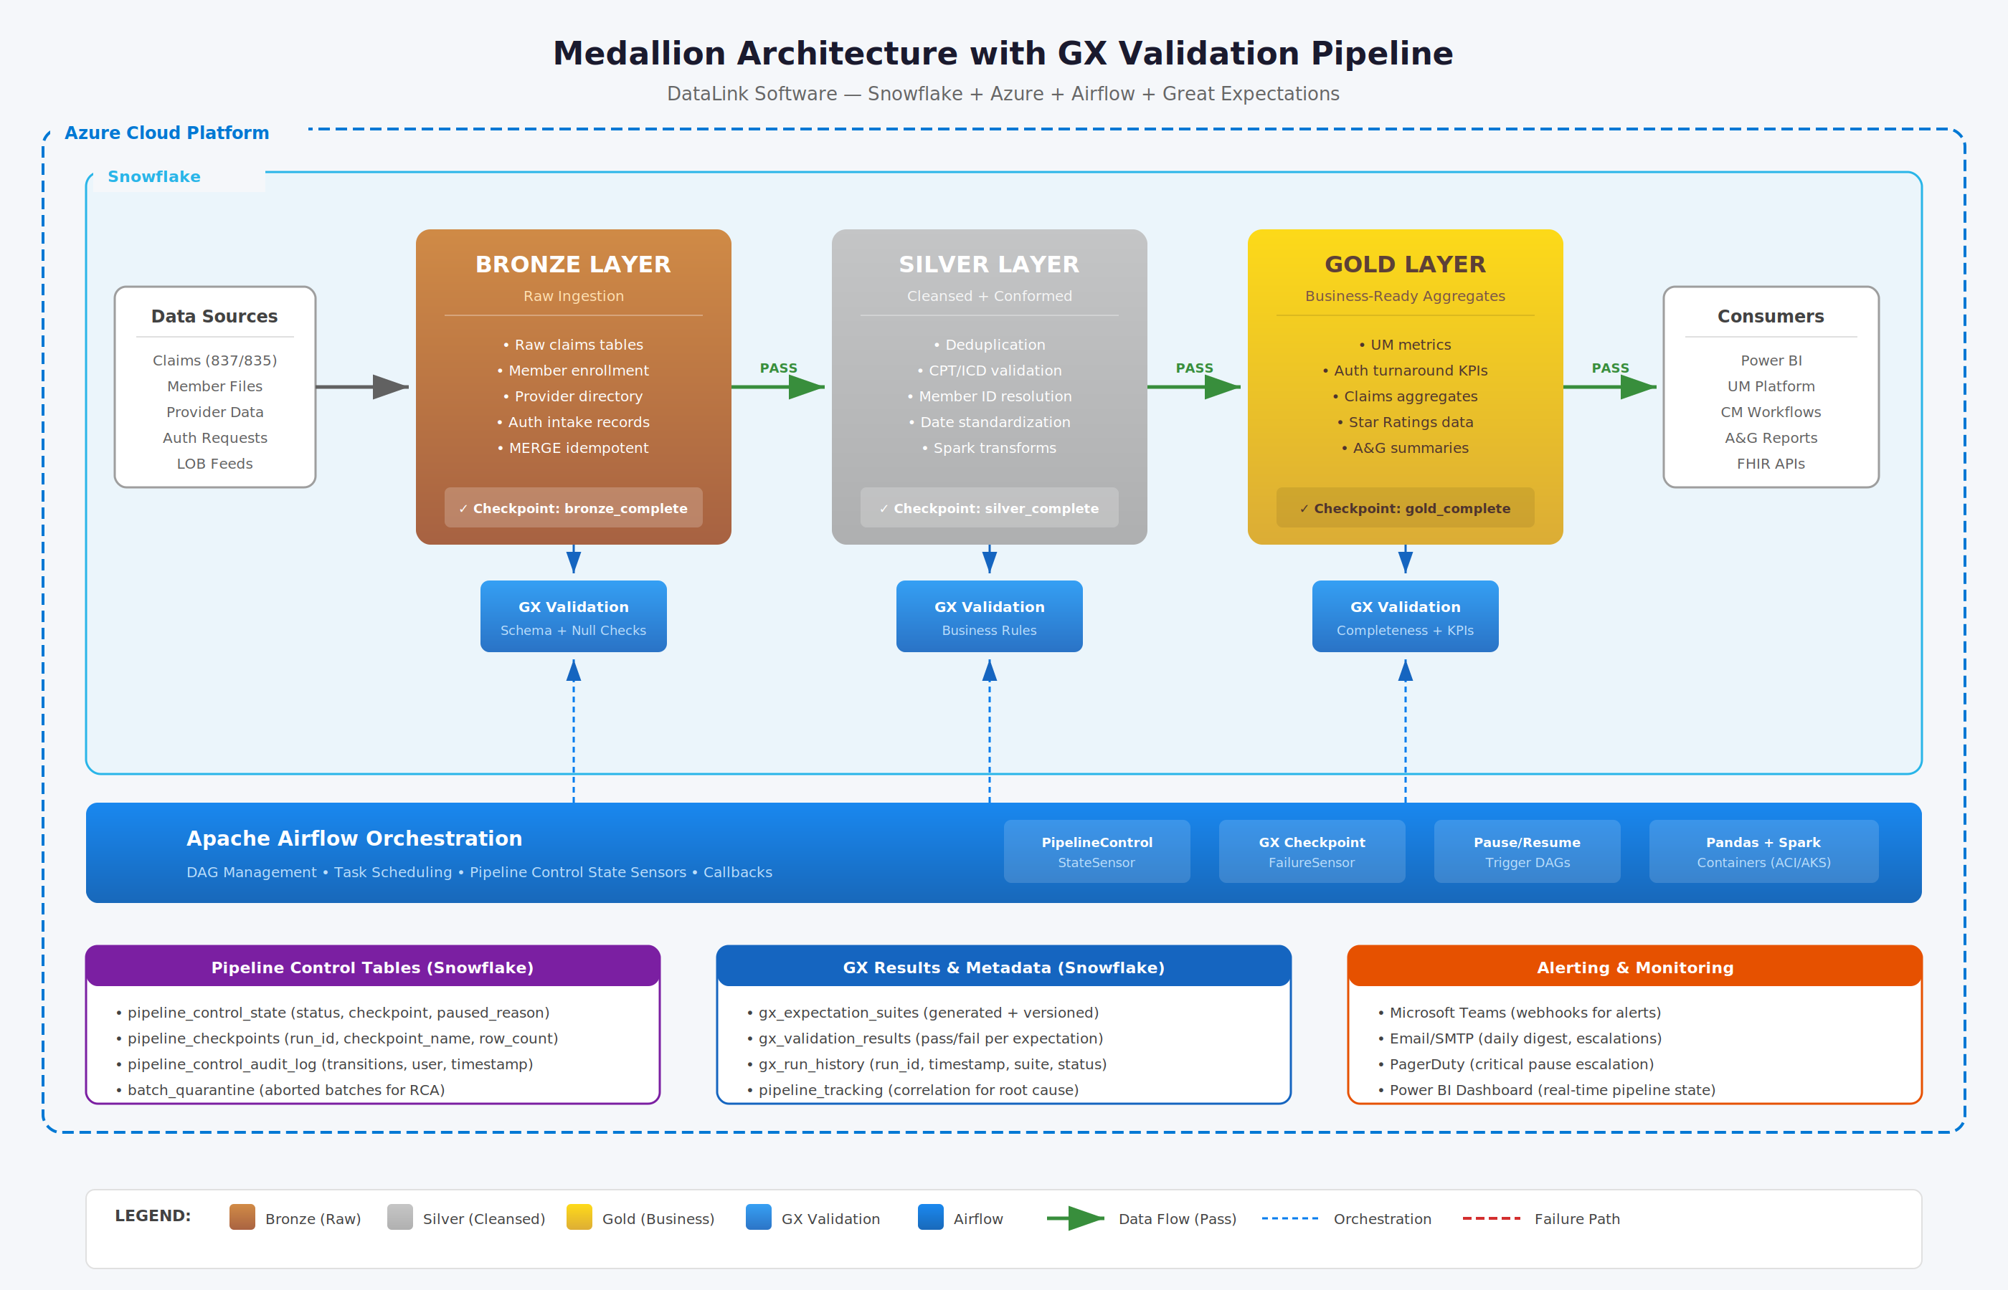
Figure 2.1 — Medallion Architecture with GX Validation Pipeline (Snowflake + Azure + Airflow)

3. Pipeline Control Framework

3.1 Overview
The Pipeline Control Framework introduces a state machine that governs pipeline execution, enabling automated and manual control over data flow. When GX validation identifies critical data quality issues, the framework can automatically pause pipeline execution, preventing bad data from advancing to downstream layers. Operational teams can then investigate, apply fixes, and resume from the last successful checkpoint without re-processing already-validated data.

3.2 State Machine Design
The pipeline control state machine defines four primary states with well-defined transitions:
- RUNNING: Pipeline is actively executing, GX checks are active, and checkpoints are being written at each layer completion.
- PAUSED: Pipeline execution is halted due to GX failure threshold being exceeded, manual operator request, or business rule violation. The pipeline awaits resolution.
- RESUMING: An approved resume operation is in progress. The system validates the checkpoint integrity, verifies no duplicate keys exist, and restarts processing from the last successful checkpoint.
- ABORTED: An irrecoverable error has been detected (schema mismatch, file format change, critical data corruption). The batch is quarantined and a new pipeline run is required.

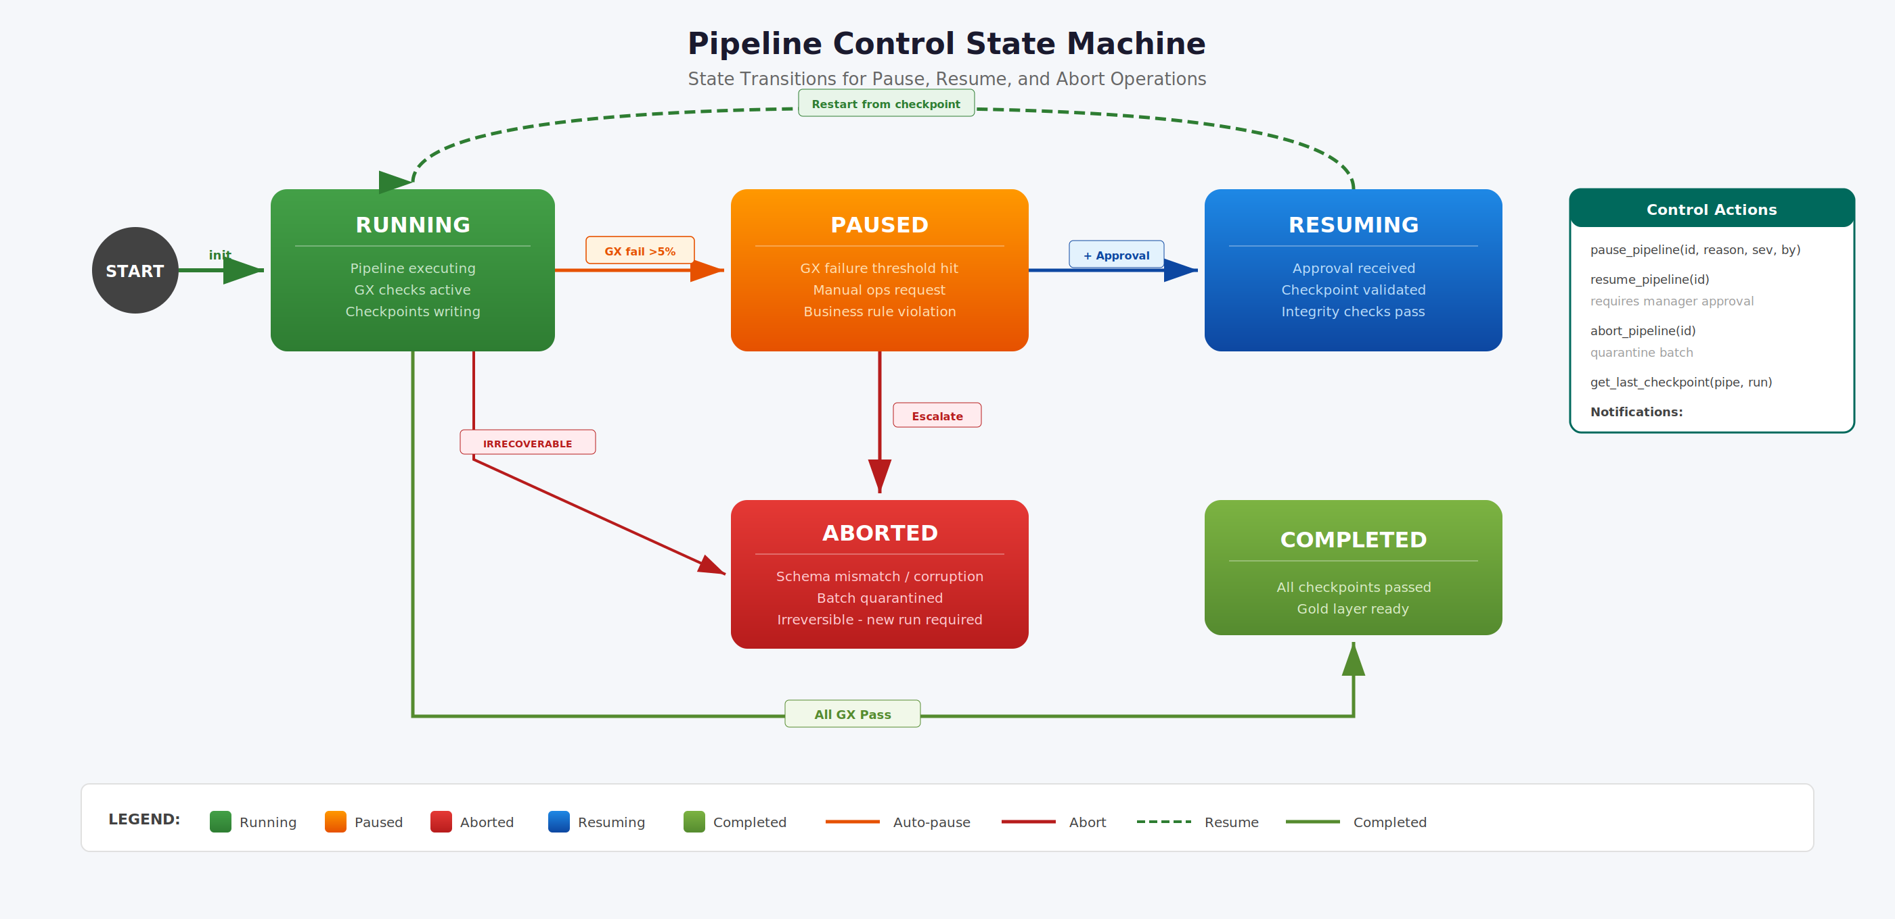
Figure 3.1 — Pipeline Control State Machine with Pause, Resume, and Abort Transitions

3.3 Auto-Pause Triggers and Thresholds
The system implements configurable thresholds per pipeline that trigger automatic pause operations:
Trigger Condition | Threshold | Action | Escalation
Critical GX expectation failures | >5% of suite | Auto-PAUSE | Teams alert
Invalid CPT codes in batch | >5% of records | Auto-PAUSE | Teams alert
Average length of stay | >365 days | Auto-PAUSE | Teams alert
Null member_id records | >2% of batch | Auto-PAUSE | Teams alert
Schema mismatch detected | Any | Auto-ABORT | PagerDuty
File format change | Any | Auto-ABORT | PagerDuty
Critical data corruption | Any | Auto-ABORT | PagerDuty
Table 3.1 — Auto-Pause and Auto-Abort Trigger Configuration

3.4 Snowflake Control Tables
Three core tables and one quarantine table support the pipeline control framework:
Table | Purpose & Key Columns
pipeline_control_state | Tracks current state of all pipelines. Columns: pipeline_id, status (RUNNING/PAUSED/ABORTED/RESUMING), checkpoint_id, paused_at, paused_reason, paused_by, severity
pipeline_checkpoints | Stores checkpoint markers for each pipeline run. Columns: run_id, checkpoint_name (bronze_complete, silver_complete, gold_complete), completed_at, row_count, status
pipeline_control_audit_log | Logs all state transitions with full audit trail. Columns: transition_id, pipeline_id, from_state, to_state, timestamp, user, reason
batch_quarantine | Stores aborted batch data for root cause analysis. Columns: batch_id, pipeline_id, abort_reason, original_data_ref, quarantined_at, metadata
Table 3.2 — Snowflake Pipeline Control Tables

3.5 Airflow Integration
The pipeline control framework integrates with Apache Airflow through several mechanisms:
- PipelineControlStateSensor: A custom Airflow sensor that polls the pipeline_control_state table and pauses the DAG execution if the pipeline state is PAUSED.
- State Check Injection: Control state checks are injected as the first operation in each critical DAG task (bronze_load, silver_transform, gold_aggregate).
- GX Failure Callback: An on_failure_callback triggers pause_pipeline() when critical GX validation failures exceed the configured threshold.
- Manual Resume DAG: A separate Airflow DAG allows the operations team to resume paused pipelines with required approval, specifying run_id and checkpoint_id parameters.

4. CrewAI Agentic AI Integration

4.1 Vision and Design Principles
The agentic integration leverages CrewAI with Anthropic Claude as the LLM provider to automate labor-intensive aspects of the data validation lifecycle. The design follows three core principles:
- Fail-Safe by Design: Agents suggest actions but never auto-execute pipeline changes. All state-altering operations require human approval gates.
- Crew Separation: Pre-Validation and Post-Validation crews operate independently and can be triggered separately, enabling modular adoption.
- Full Auditability: All agent reasoning, tool calls, and outputs are logged to Snowflake or file for debugging and compliance review.

4.2 Architecture Overview

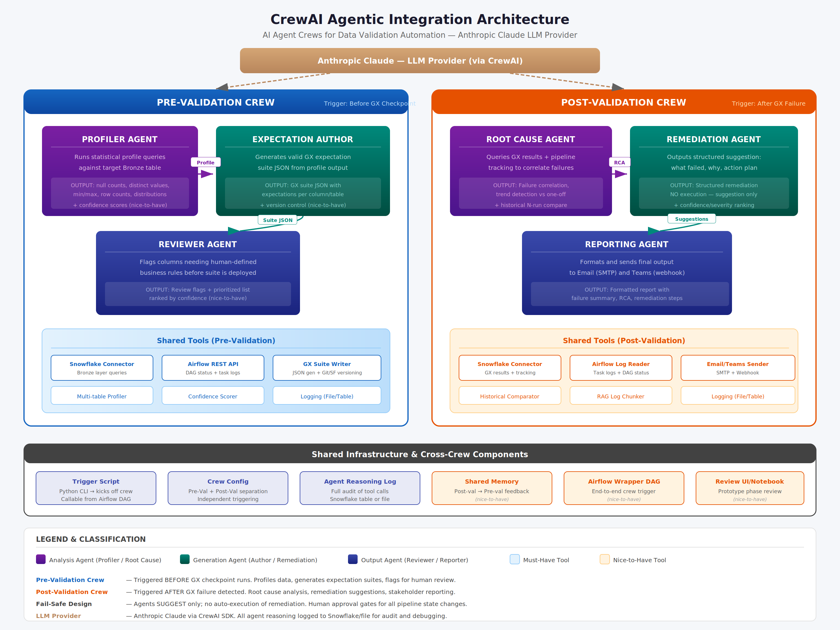
Figure 4.1 — CrewAI Agentic Integration Architecture with Pre-Validation and Post-Validation Crews

4.3 Pre-Validation Crew
The Pre-Validation Crew is triggered before GX checkpoints run. It profiles data, generates expectation suites, and flags items requiring human review.

4.3.1 Profiler Agent
The Profiler Agent runs statistical profile queries against a target Bronze table using the reusable Snowflake connector class. It computes null counts, distinct value distributions, min/max ranges, row counts, and data type distributions for each column. The output serves as the input for the Expectation Author Agent.

4.3.2 Expectation Author Agent
The Expectation Author Agent takes the statistical profile output and generates a valid GX expectation suite in JSON format. Each expectation is mapped to a specific column or table-level assertion. The agent ensures the generated JSON conforms to the GX expectation suite schema and can be directly deployed to a GX checkpoint.

4.3.3 Reviewer Agent
The Reviewer Agent examines the generated expectation suite and flags columns or expectations that require human-defined business rules before the suite can be used in production. This is critical for healthcare-specific validations such as CPT code ranges, ICD-10 groupings, and member eligibility rules that cannot be inferred from statistical profiling alone.

4.4 Post-Validation Crew
The Post-Validation Crew is triggered after a GX checkpoint failure is detected. It performs root cause analysis, generates remediation suggestions, and reports findings to stakeholders.

4.4.1 Root Cause Agent
The Root Cause Agent queries the GX results table and pipeline tracking table to correlate failures. It identifies whether a failure is a one-off anomaly or part of a recurring trend by comparing the current failure against historical runs. The agent outputs a structured analysis including the specific expectations that failed, the data characteristics that triggered the failure, and a preliminary root cause hypothesis.

4.4.2 Remediation Agent
The Remediation Agent takes the Root Cause Agent output and generates a structured remediation suggestion. This includes what failed, why it failed, and a recommended corrective action. Critically, the Remediation Agent does not execute any changes — it provides suggestions only. Actions might include adjusting thresholds, adding data cleansing rules, contacting the source system for data corrections, or escalating to a domain expert.

4.4.3 Reporting Agent
The Reporting Agent formats the combined output from the Root Cause and Remediation agents into a structured report and distributes it via Email (SMTP) and Microsoft Teams (webhook). The report includes a failure summary, root cause analysis, remediation recommendations, and links to the relevant pipeline run and GX validation results.

4.5 Shared Tools and Infrastructure
Tool / Component | Category | Description
Snowflake Connector | Must-Have | Reusable connector class for Bronze layer queries and GX results tables. Used by all agents across both crews.
Airflow REST API Wrapper | Must-Have | Tool for fetching DAG run status and task logs. Enables agents to correlate pipeline execution context with validation failures.
Crew Config | Must-Have | Configuration separating Pre-Val and Post-Val crews for independent triggering. Defines agent roles, tools, and task sequences.
Trigger Script | Must-Have | Python CLI script that kicks off the appropriate crew. Designed to be callable from an Airflow DAG.
Agent Reasoning Logger | Must-Have | Logs all agent reasoning and tool calls to a Snowflake table or file for debugging and audit compliance.
GX Suite Version Control | Nice-to-Have | Stores generated expectation suites in Snowflake or Git with version tracking for rollback and audit.
Confidence Scorer | Nice-to-Have | Assigns confidence scores to each generated expectation so the Reviewer Agent can prioritize human review.
Multi-Table Profiler | Nice-to-Have | Supports profiling multiple tables in one run for full LOB onboarding scenarios.
Historical Comparator | Nice-to-Have | Compares current failure against last N runs to detect trends vs one-off issues for the Root Cause Agent.
RAG Log Chunker | Nice-to-Have | Airflow log chunking with RAG layer for cleaner log interpretation at scale.
Shared Memory Object | Nice-to-Have | Cross-crew memory so post-validation findings can inform future expectation generation.
Airflow Wrapper DAG | Nice-to-Have | Full DAG wrapping both crews end-to-end, triggered by GX checkpoint failure sensor.
Review UI/Notebook | Nice-to-Have | Lightweight interface for reviewing agent outputs during prototype phase.
Table 4.1 — CrewAI Shared Tools and Infrastructure Components

5. End-to-End Integration Flow
The following diagram illustrates how all components work together in the complete data validation lifecycle, from DAG trigger through data ingestion, AI-assisted profiling, GX validation, pipeline control decisions, and agent-driven root cause analysis and reporting.

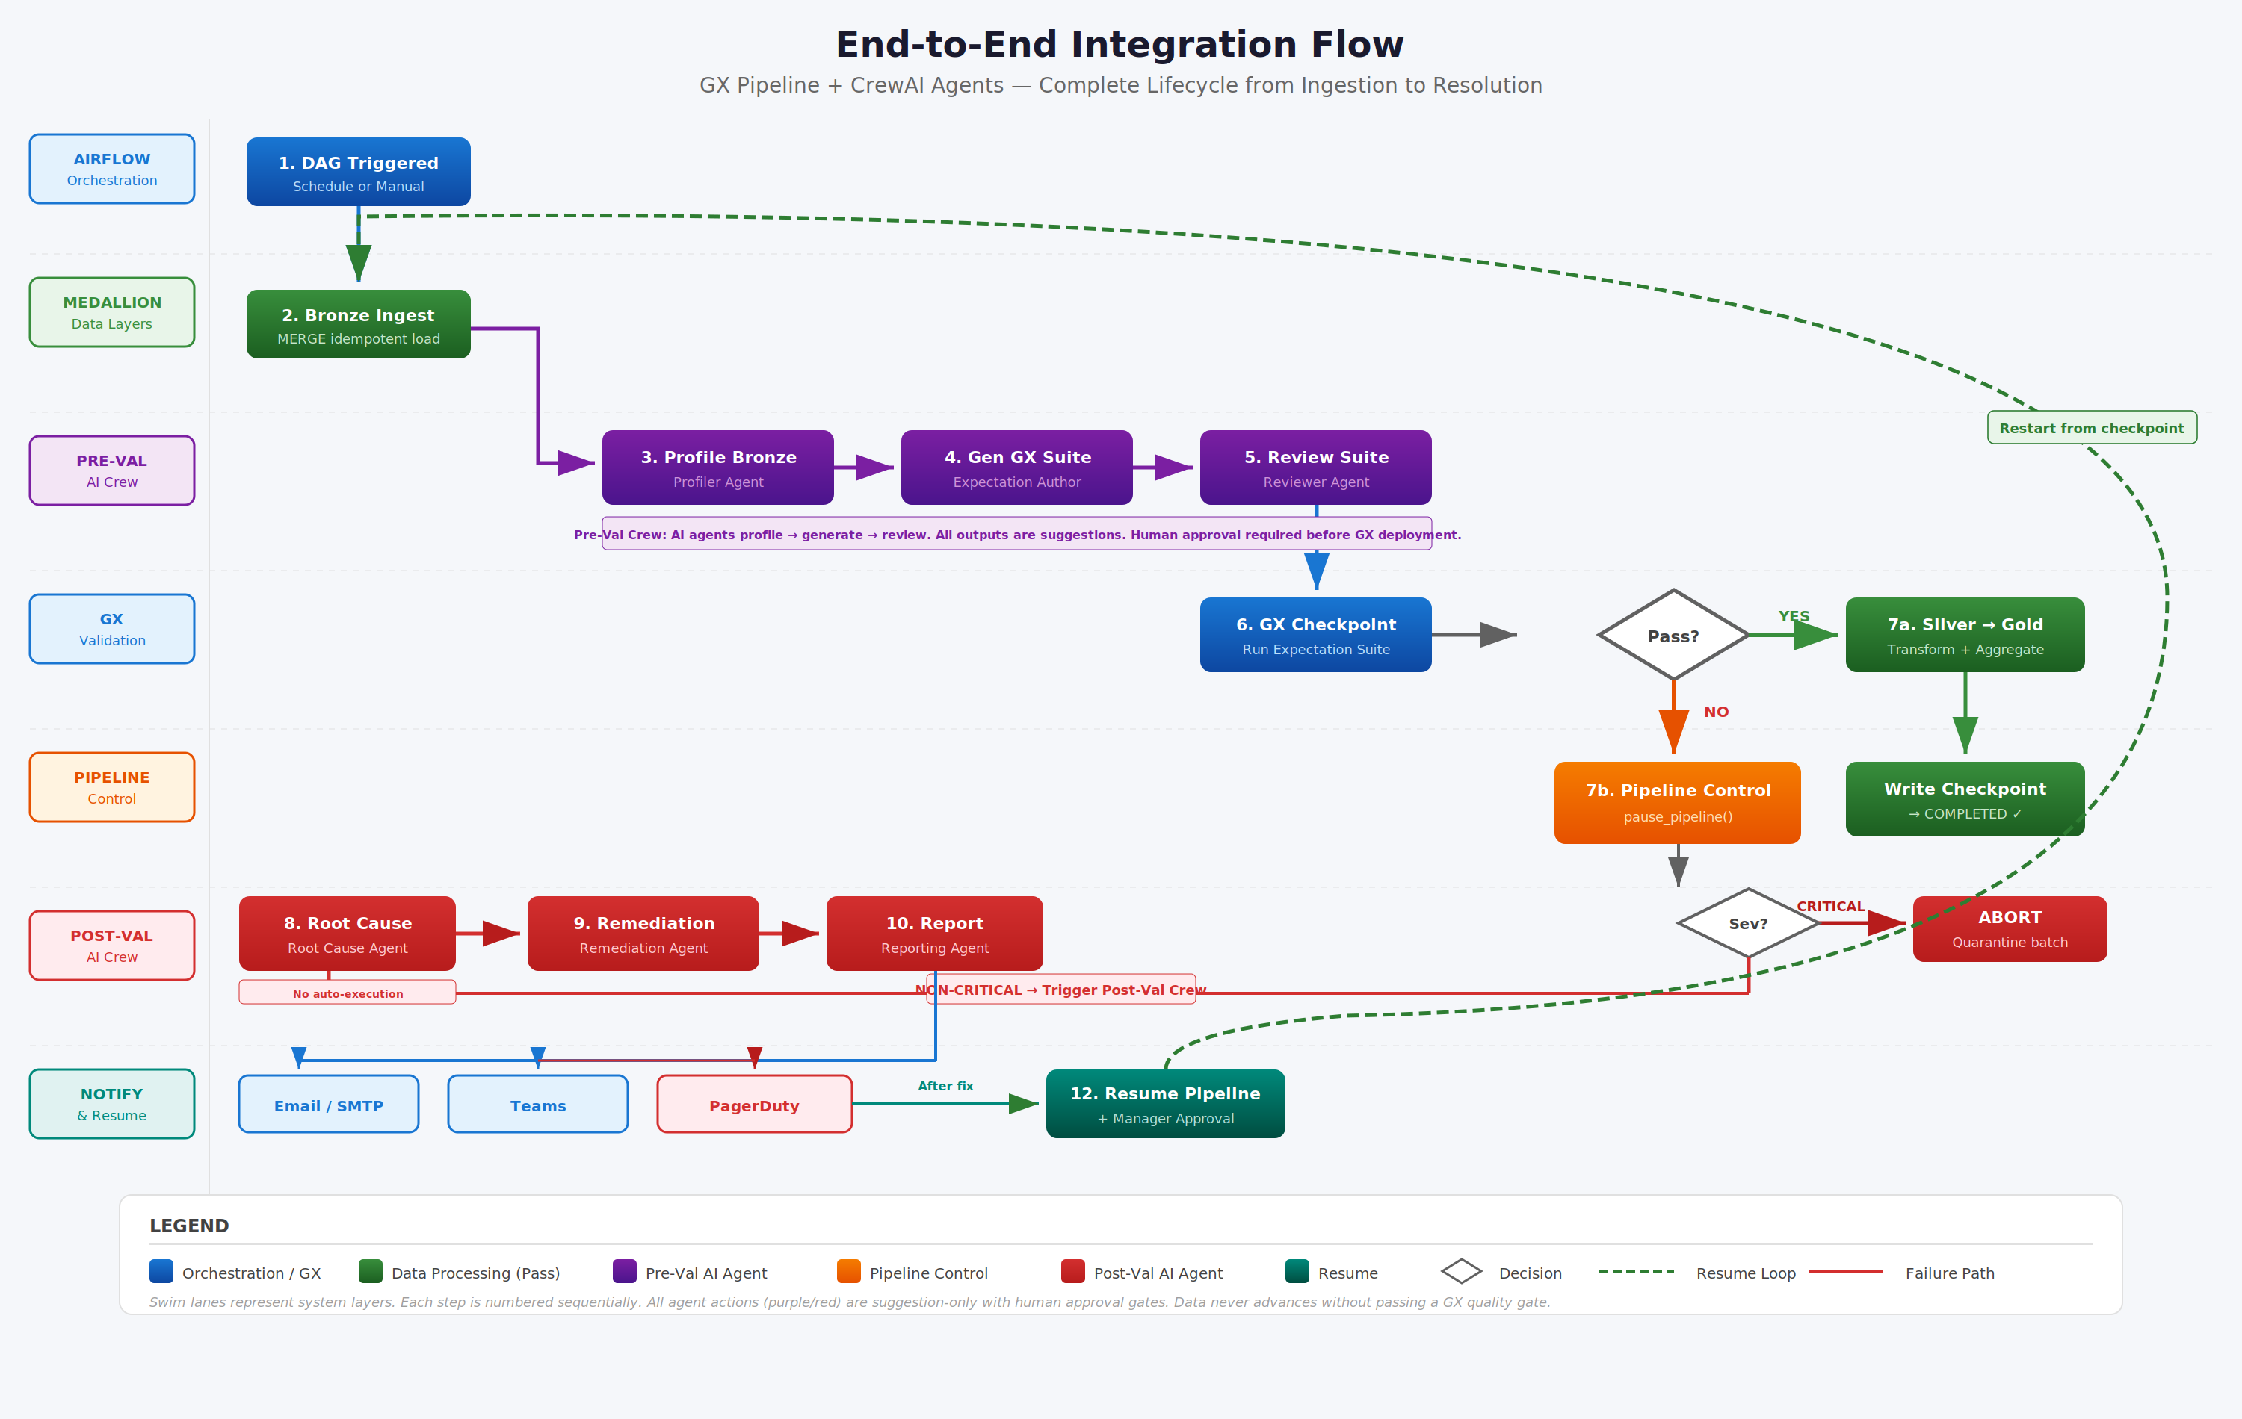
Figure 5.1 — End-to-End Integration Flow — GX Pipeline + CrewAI Agents (Swim Lane Diagram)

5.1 Flow Sequence
- DAG Triggered: Airflow DAG initiates on schedule or manual trigger.
- Bronze Ingest: Data is loaded into Bronze tables using idempotent MERGE logic.
- Profile Bronze (Pre-Val Crew): Profiler Agent runs statistical analysis on the ingested data.
- Generate GX Suite: Expectation Author Agent creates a GX expectation suite from the profile.
- Review Suite: Reviewer Agent flags items requiring human business rule definitions.
- GX Checkpoint: Great Expectations runs the expectation suite against the data.
- Decision: If all expectations pass, data advances to Silver and Gold. If failures exceed thresholds, pipeline control engages.
- Pipeline Control: pause_pipeline() is invoked. Severity assessment determines PAUSE vs. ABORT.
- Root Cause Analysis (Post-Val Crew): Root Cause Agent correlates GX results with pipeline tracking.
- Remediation: Remediation Agent generates structured corrective action suggestions.
- Report: Reporting Agent sends findings to Email and Teams.
- Resume: After resolution and approval, pipeline restarts from the last successful checkpoint.

6. Implementation Roadmap
The implementation follows a five-phase delivery plan spanning approximately 16 weeks. The phasing ensures foundational infrastructure is established before building higher-order capabilities, and that the CrewAI prototype can be demonstrated for organizational approval at the earliest feasible milestone.

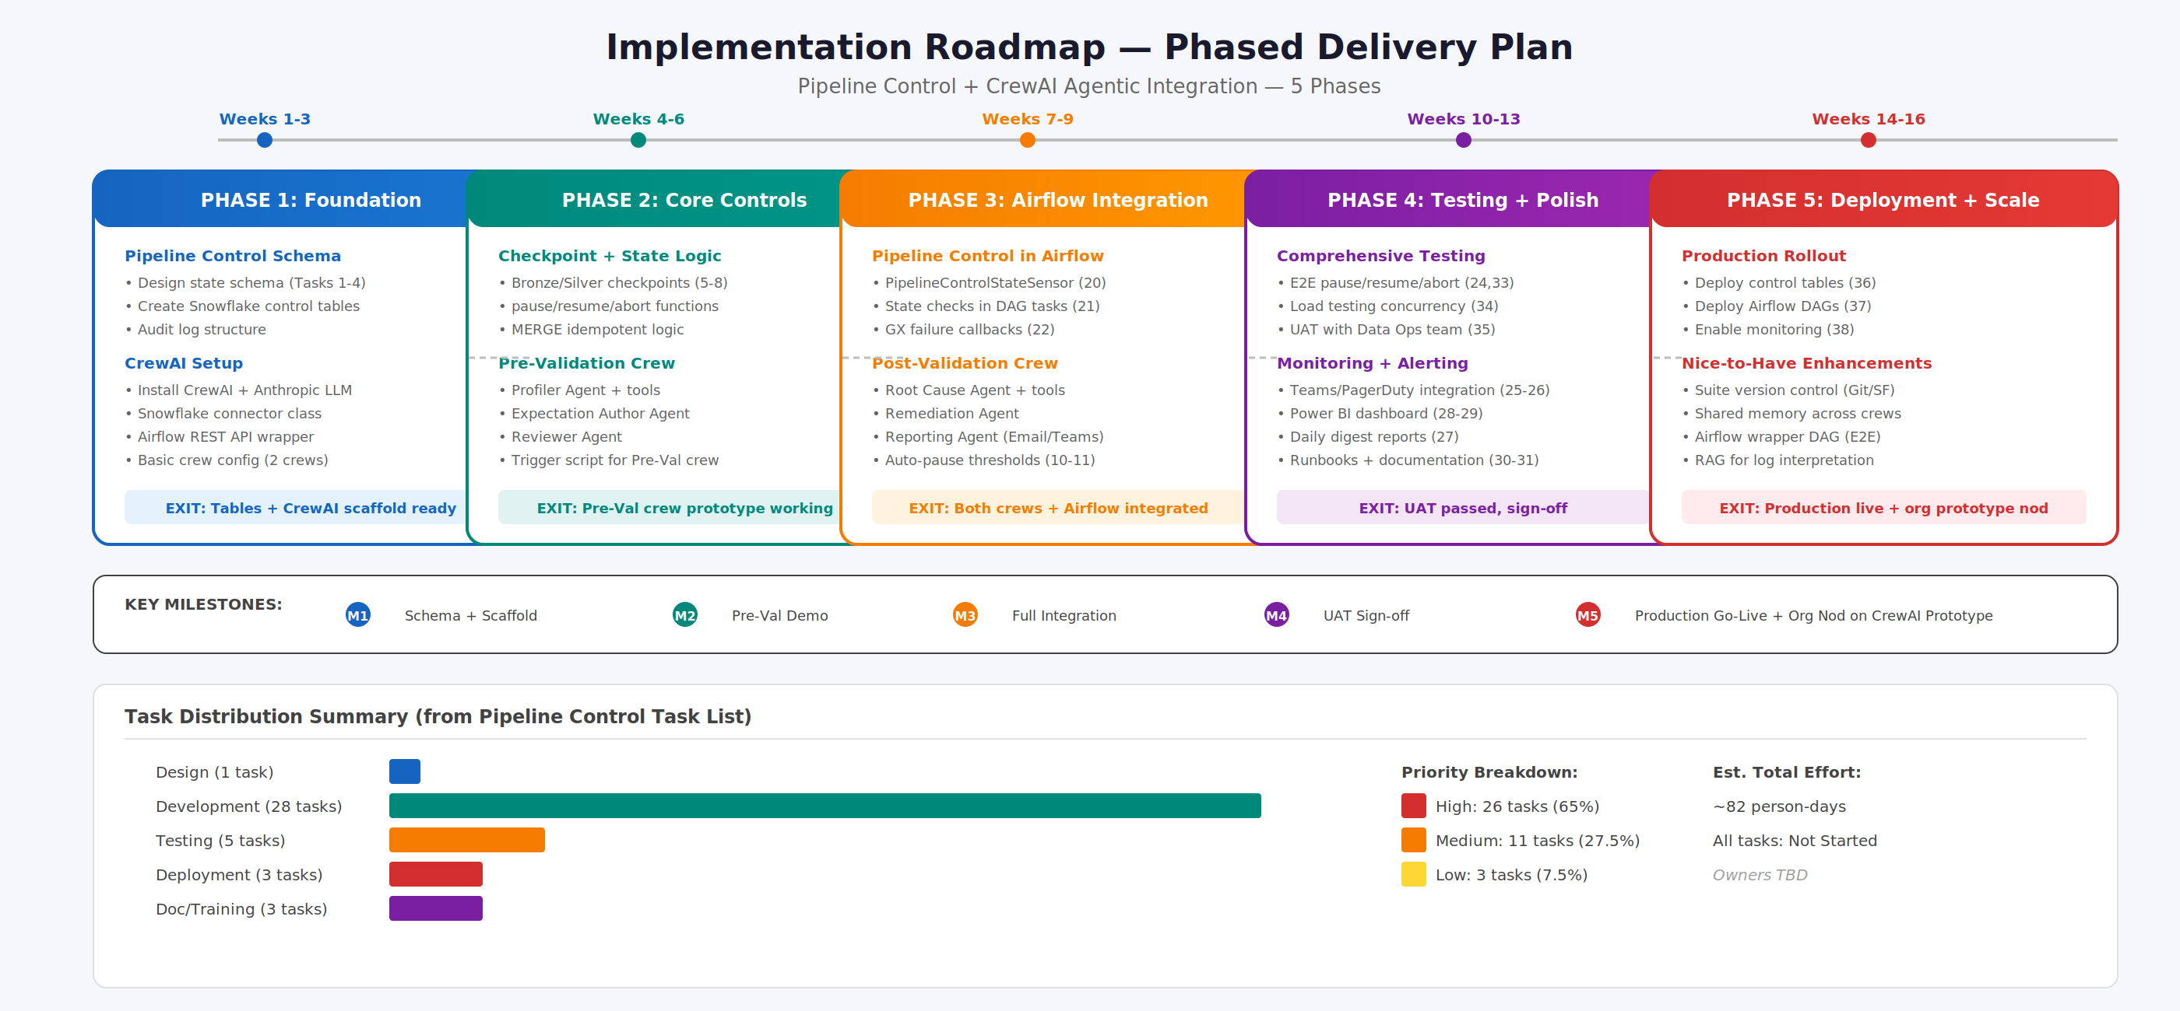
Figure 6.1 — Phased Implementation Roadmap with Key Milestones

6.1 Phase Summary
Phase | Timeline | Key Deliverables | Exit Criteria
Phase 1 | Weeks 1–3 | Pipeline control schema design, Snowflake control tables, CrewAI installation with Anthropic, Snowflake connector, Airflow REST wrapper, basic crew config | Tables deployed + CrewAI scaffold
Phase 2 | Weeks 4–6 | Bronze/Silver checkpoints, pause/resume/abort functions, MERGE idempotent logic, Profiler Agent, Expectation Author, Reviewer Agent, Pre-Val trigger script | Pre-Val crew prototype working
Phase 3 | Weeks 7–9 | PipelineControlStateSensor, DAG state checks, GX failure callbacks, Root Cause Agent, Remediation Agent, Reporting Agent, auto-pause thresholds | Both crews + Airflow integrated
Phase 4 | Weeks 10–13 | E2E testing, load testing, UAT with Data Ops, Teams/PagerDuty integration, Power BI dashboard, daily digests, runbooks, documentation, training | UAT passed, sign-off
Phase 5 | Weeks 14–16 | Production deployment (tables, DAGs, monitoring), nice-to-have enhancements (version control, shared memory, RAG layer, wrapper DAG) | Production live + org nod
Table 6.1 — Phase Summary with Timelines and Exit Criteria

7. Pipeline Control Task List
The following table presents the complete task list for the Pipeline Control Framework implementation, encompassing 40 tasks across design, development, testing, deployment, documentation, training, monitoring, and optimization work streams. Total estimated effort is approximately 82 person-days.

# | Type | Task Description | Priority | Days | Status
1 | Design | Design pipeline control state schema | High | 2 | Not Started
2 | Development | Create pipeline_control_state table in Snowflake | High | 1 | Not Started
3 | Development | Create pipeline_checkpoints table in Snowflake | High | 1 | Not Started
4 | Development | Create pipeline_control_audit_log table | Medium | 1 | Not Started
5 | Development | Implement checkpoint creation after Bronze validation | High | 2 | Not Started
6 | Development | Implement checkpoint creation after Silver validation | High | 2 | Not Started
7 | Development | Create checkpoint query logic for resume operations | High | 2 | Not Started
8 | Development | Implement idempotent MERGE logic for Bronze tables | High | 3 | Not Started
9 | Development | Create pause_pipeline() Python function | High | 2 | Not Started
10 | Development | Integrate automatic pause with GE validation results | High | 3 | Not Started
11 | Development | Create business rule threshold checks for auto-pause | High | 3 | Not Started
12 | Development | Implement manual pause capability | Medium | 2 | Not Started
13 | Development | Create resume_pipeline() Python function | High | 3 | Not Started
14 | Development | Implement approval workflow for resume operations | Medium | 3 | Not Started
15 | Development | Create resume validation logic | High | 2 | Not Started
16 | Testing | Test resume from Bronze checkpoint | High | 2 | Not Started
17 | Development | Create abort_pipeline() Python function | High | 2 | Not Started
18 | Development | Implement abort triggers for irrecoverable errors | High | 2 | Not Started
19 | Development | Create batch quarantine logic on abort | Medium | 2 | Not Started
20 | Development | Create Airflow sensor for pipeline control state | High | 3 | Not Started
21 | Development | Add control state check before each major DAG task | High | 3 | Not Started
22 | Development | Implement Airflow callback for GE validation failures | High | 2 | Not Started
23 | Development | Create manual trigger DAG for resume operations | Medium | 2 | Not Started
24 | Testing | Test Airflow pause/resume integration end-to-end | High | 3 | Not Started
25 | Development | Create alert notification function | High | 2 | Not Started
26 | Development | Implement escalation workflow for critical pauses | Medium | 2 | Not Started
27 | Development | Create daily digest report of paused pipelines | Low | 2 | Not Started
28 | Development | Create pipeline control dashboard in Power BI | Medium | 3 | Not Started
29 | Development | Add metrics tracking to dashboard | Medium | 2 | Not Started
30 | Documentation | Create runbook for pause/resume operations | Medium | 2 | Not Started
31 | Documentation | Document checkpoint strategy and resume logic | Low | 1 | Not Started
32 | Training | KT data ops team on new pipeline control features | Medium | 1 | Not Started
33 | Testing | Create test scenarios for all pause/resume/abort cases | High | 3 | Not Started
34 | Testing | Load testing for control state table under high concurrency | Medium | 2 | Not Started
35 | Testing | Test all pipeline control in stage with data ops team | High | 2 | Not Started
36 | Deployment | Deploy pipeline control tables to production | High | 1 | Not Started
37 | Deployment | Deploy updated Airflow DAGs with control logic | High | 1 | Not Started
38 | Deployment | Enable monitoring and alerting in production | High | 1 | Not Started
39 | Monitoring | Monitor first week of production usage | High | 5 | Not Started
40 | Optimization | Performance tuning based on production metrics | Medium | 3 | Not Started
Table 7.1 — Complete Pipeline Control Task List (40 Tasks, ~82 Person-Days)

8. CrewAI Agentic Integration Wishlist

8.1 Must-Have Items

8.1.1 Infrastructure and Setup
- CrewAI installed with Anthropic as the LLM provider
- Snowflake connector class (reusable across all agents) for Bronze layer queries and GX results tables
- Airflow REST API wrapper tool for fetching DAG run status and task logs
- Basic crew config separating the two crews (pre-validation and post-validation) so they can be triggered independently

8.1.2 Pre-Validation Crew
- Profiler Agent: tool to run statistical profile queries against a target Bronze table using Snowflake connector (nulls, distinct values, min/max, row counts)
- Expectation Author Agent: generates a valid GX expectation suite JSON from the profile output
- Reviewer Agent: flags columns that need human-defined business rules before the suite is used

8.1.3 Post-Validation Crew
- Root Cause Agent: tool to query GX results table + pipeline tracking table to correlate failures
- Remediation Agent: outputs a structured suggestion (what failed, why, recommended action) — no execution
- Reporting Agent: formats and sends output to Email and Teams via webhook/SMTP

8.1.4 General
- A trigger mechanism — at minimum a simple Python script that kicks off the appropriate crew (can be called from an Airflow DAG later)
- Logging of agent reasoning and tool calls to a file or table for debugging

8.2 Nice-to-Have Items

8.2.1 Pre-Validation Crew Enhancements
- Version control for generated expectation suites (store in Snowflake or Git)
- Confidence scoring on each generated expectation so the Reviewer Agent can prioritize what needs human attention
- Support for profiling multiple tables in one run (e.g., a full LOB onboarding)

8.2.2 Post-Validation Crew Enhancements
- Historical context for the Root Cause Agent — comparing current failure against the last N runs to detect trends vs one-off issues
- Remediation suggestions ranked by confidence or severity
- Airflow log chunking/RAG layer for cleaner log interpretation at scale

8.2.3 General Enhancements
- A shared memory object between the two crews so post-validation findings can inform future expectation generation
- Airflow DAG that wraps both crews end-to-end, triggered by a GX checkpoint failure sensor
- A lightweight UI or notebook interface for reviewing agent outputs during the prototype phase

9. Risk Considerations and Mitigations
Risk | Severity | Mitigation Strategy
Agent hallucination in expectation generation | High | Reviewer Agent provides human-in-the-loop gate. All generated suites require approval before deployment. Agent reasoning is fully logged.
LLM latency impacting pipeline throughput | Medium | Crews operate asynchronously from pipeline execution. Pre-Val can run during off-peak. Post-Val triggers only on failure.
Snowflake concurrent access during state checks | Medium | Load testing (Task 34) validates performance with 50+ concurrent checks. Snowflake auto-scaling mitigates contention.
Incorrect root cause attribution | Medium | Post-Val agents provide suggestions only, never auto-remediate. Human review required for all corrective actions.
CrewAI framework stability | Low | Prototype phase validates framework suitability before full investment. Fallback to manual processes if needed.
HIPAA compliance for agent data access | High | Agents connect via existing Snowflake RBAC. No PHI leaves the Azure/Snowflake boundary. Anthropic API calls send metadata, not raw data.
Table 9.1 — Risk Assessment and Mitigation Strategies

10. Appendix

10.1 Glossary
Term | Definition
GX / Great Expectations | Open-source data validation framework that defines expectations as testable assertions against data.
Medallion Architecture | Multi-layer data architecture (Bronze/Silver/Gold) that progressively refines data quality.
CrewAI | AI agent orchestration framework for building multi-agent systems with defined roles, tools, and tasks.
Anthropic Claude | Large language model used as the LLM provider for CrewAI agent reasoning and generation.
UM/CM/A&G | Utilization Management, Case Management, and Appeals & Grievances — core healthcare payer workflows.
Checkpoint | A marker indicating successful completion of a pipeline stage, enabling resume-from-checkpoint operations.
RAG | Retrieval-Augmented Generation — technique to provide LLMs with relevant context from external data sources.
FHIR | Fast Healthcare Interoperability Resources — standard for exchanging healthcare information electronically.
LOB | Line of Business — refers to health plan product lines (e.g., Medicare Advantage, Medicaid, Commercial).
Table 10.1 — Glossary of Terms

10.2 Document History
Version | Date | Author | Change Description
1.0 | March 2026 | VP, Data Operations | Initial document creation
Table 10.2 — Document Revision History

