## What is the Document Mailer?

To run the DocumentMailer, run the EXE file highlighted below:

***Figure 1***

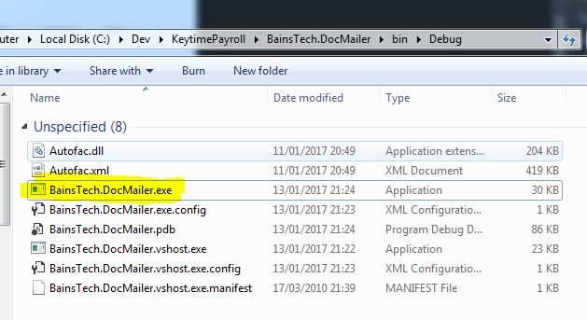

The application’s interface is shown and explained below:

***Figure 2***

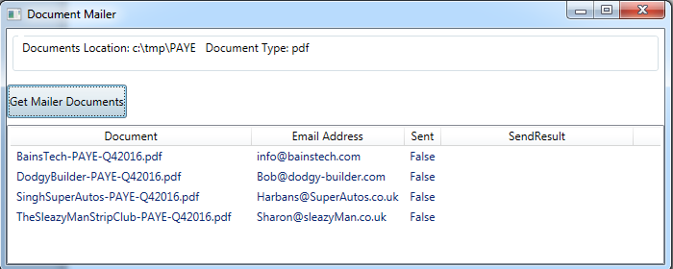

1) The folder to get documents from

2) The file type we’re interested in

3) Press this to build the documents list, below

4) The document to email

Where to send document to

Has document been sent?

Did it gent sent successfully?

Later, I’ll add a “Send” button – the Sent and Send Result columns will then show data

**Configure Target Documents Path and Type**

You can configure:

1. which folder DocumentMailer picks up documents from and the type of documents to pick up
2. the email addresses of each company

.. by opening the ***BainsTech.DocMailer.exe.config*** (shown just below the highlighted EXE file in figure one) file in notepad (or any other text file editor) and changing the settings highlighted below:

***Figure 3 – DocumentMailer app.config file.***

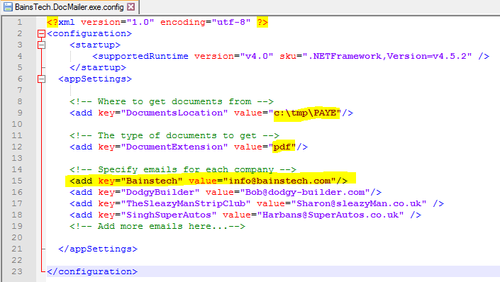

**File Naming Convention**

Currently, DocumentMailer expects the PAYE filenames to be in format: “***CompanyName* Qe dd-mm-yy.pdf**” with a space in between “CompanyName” and “Qe…” e.g. “**Bainstech Qe 30-09-16.pdf**”.

To specify an email address for a company name, simple copy and paste the company name portion of the filename into the appconfig file shown in figure 3, above, and add an email address.