

**Objective : Objective of this study is to provide a predictive model to establish rankings based on available parameters**

**Data Acquisition:**

* **Rank Analyzer ranks schools in all the 50 states in Texas**
* **Current dataset is for elementary school**
* **Data was obtained from Data server in csv format**

**Variables in the Dataset:**

* school$Rank.2013.14.: This is the response variable that we are using to predict the rank of the schools in Texas. This is numeric
* Number.Fulltime.Teachers : Is the number of full-time teachers in the schools. This was included to see whether having more full-time teachers affects the ranking of schools. This is a numeric variable.
* Student. Teacher. Ratio : the ratio of students to teachers in the classroom. This is a numeric variable.
* Percent.Pacific.Islander the percentage of pacific islander in the schools. This is a numeric variable.
* Percent.American.Indian: The percent of American Indians in the schools. This is a numeric variable.
* Percent.Hispanic : the percentage of Hispanics in the schools. This is a numeric variable. Percent.Two.or.More.Races : percent of two or more races. This is a numeric variable
* Percent.African.American : the percent of African Americans. This is a numeric variable
* Percent.Asians: The percentage of Asians . This is a numeric variable
* Percent.White : the percentage of Whites . This is a numeric variable
* Number.Students : the number of students in the schools . This is a numeric variable
* Percent.FreeDisc.Lunch : the percentage of students that choose to have discounted lunch. This is a numeric variable
* IsMagnet:Whether it is a magnet school or not. It is a Boolean variable.
* IsCharter:Is it a charter school or not. It is a Boolean variable.
* IsTitle : Is it a public school or not. It is a Boolean variable.
* District:A string type variable
* City :A String type variable
* Zip : A numeric type variable
* County: A string type variable



* Regression Tree Model
* Statistical Analysis
* 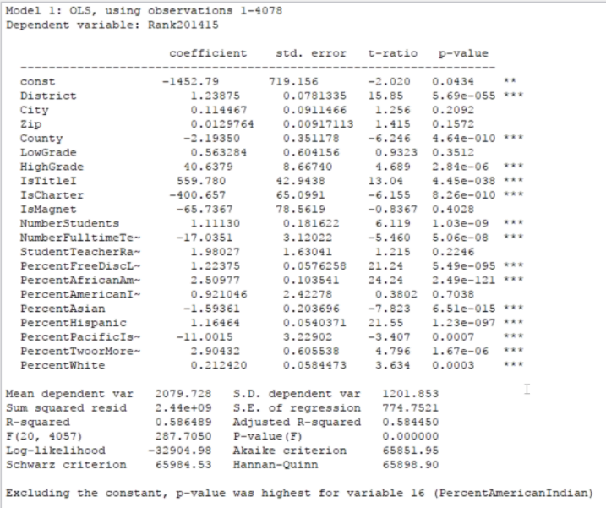

Some of the Biggest Influencers

Free lunch

District

Number of students

Number of full time teachers

Title Schools

Charter schools

Take Away – Influencers able to explain 58% of the Ranking process

**Data Visualization**

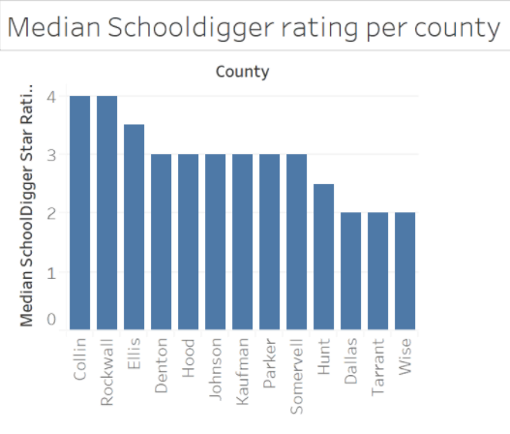

Take Away – Counties with lower number of schools have better Ratings

Tree displaying significant variables

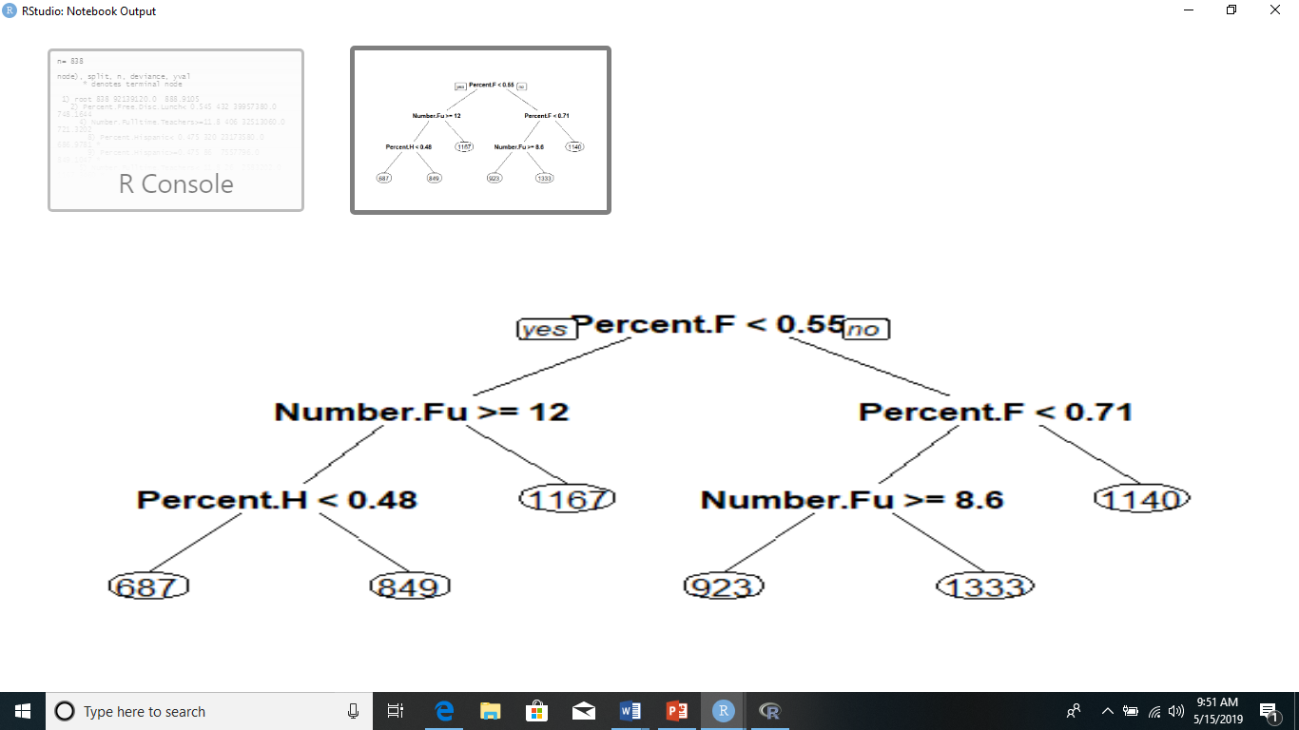 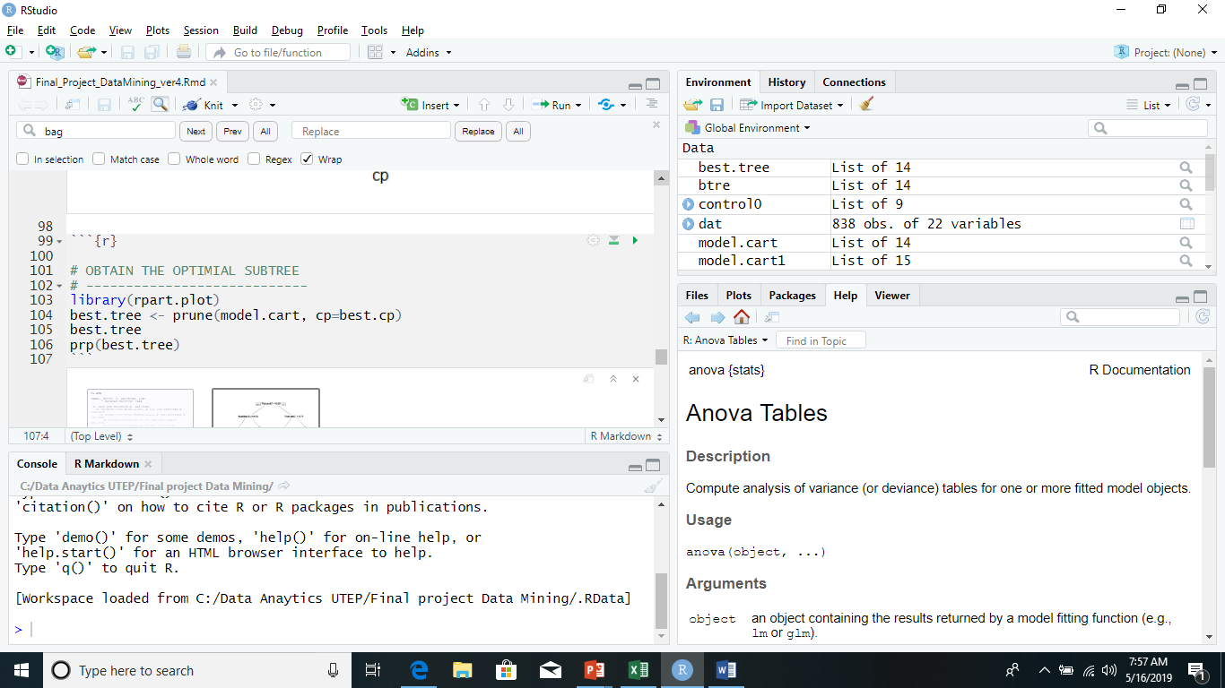

Central line

