**PROGRAM 1**

**PROCEDURE TO CREATE AN ANIMATION TO REPRESENT THE GROWING MOON.**

1. Open **flash 8** software -> click on **flash document**->go to **windows**->**properties** ->select the **properties** tool-> choose the **Background** to black.
2. Go to **fill color** under tool bar-> select the white color.
3. Select the **oval tool** in order to draw the moon. u will get a white circle.
4. Select the **oval tool** in order to draw the moon. u will get a white circle.
5. Select the white circle on the worksheet using the **selection tool**->right click->**convert to symbol**->select **movie clip**->give suitable name eg: moon->click **ok**.
6. Go to **filter**->click on the **+** symbol->select **glow** to apply glowing effect-> select the **color** to white under **glow** and adjust the **blur x/blur y** values.
7. Click on the **+** symbol again and chose **blur**-> again adjust the **blur x/blur y** values.
8. Place the moon where ever you want on the work area.double click on **layer 1** and rename as **MOON**.
9. **Insert** another layer->rename it as **Animation.**
10. Select the **fill color** to black-> select **oval tool** and draw a circle on the moon to cover the moon->select the newly added circle-> right click-> **convert to symbol**-> **movie** **clip**-> name it as **Animation**.
11. Go to **filter**-> select **+** symbol->give the **glow** and **blur** effect as did for moon.
12. Select the 150th frame in moon layer->right click->**insert key frame**. repeat the same for Animation layer.
13. Click on the 149th keyframe of animation layer ->right click->press **create motion**-> select the animation movie clip and move slowly across the moon.
14. Finally go to **control**-> **test movie**-> u will get a growing moon as the output.

|  |  |
| --- | --- |
| * | 2017-18 |
|  |  |
|  |  |

**OUTPUT**

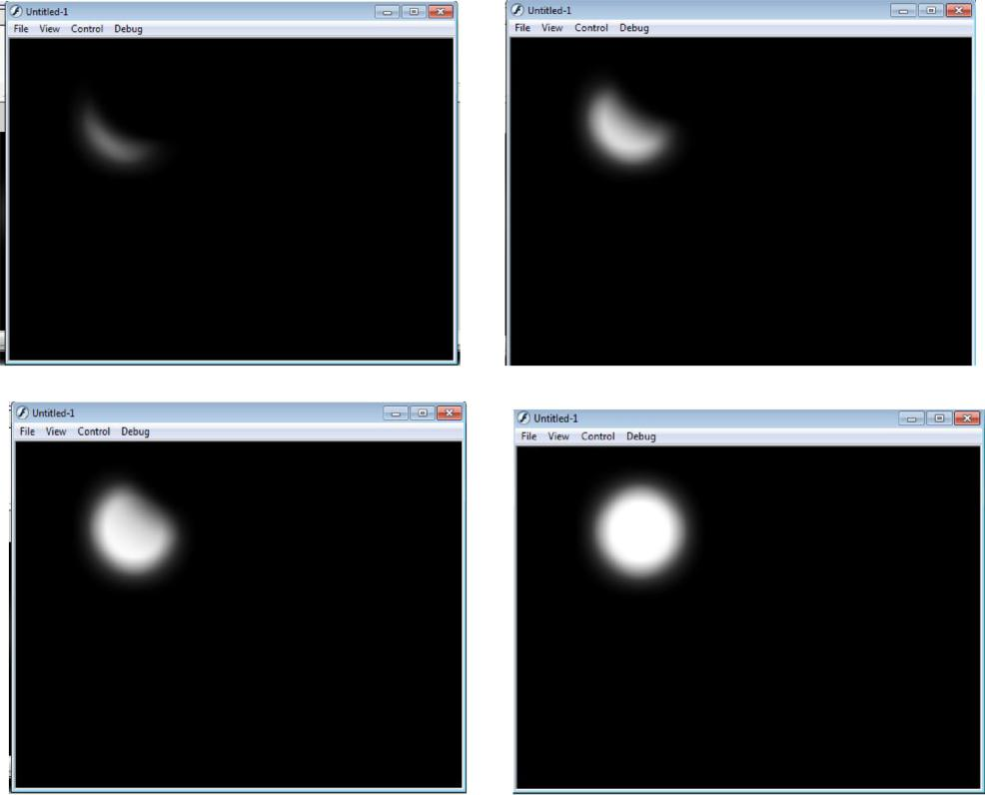

Page

|  |  |
| --- | --- |
| * | 2017-18 |
|  |  |
|  |  |

**PROGRAM 2**

**PROCEDURE TO CREATE AN ANIMATION TO INDICATE A BALL BOUNCING ON STEPS.**

1. Go to **start**- **macromedia**- click on **flash document**
2. select the **line** tool and draw the steps. colour it using the paint bucket tool
3. Select the **circle** from the tool bar and create a circle on the work area.
4. Now fill the colour to the circle using the **paint bucket tool** from the tool bar.
5. Go to **frames** right click on the first frame and choose **insert key frame**. slightly move the ball. Repeat the same procedure by adding new key frames to show the ball change the shape of the ball slightly when it touches the surface.
6. In order to change the shape use the **free transform tool**.
7. Go to **control** and click on **test movies** .you will observe the ball bouncing on steps.

**OUTPUT**

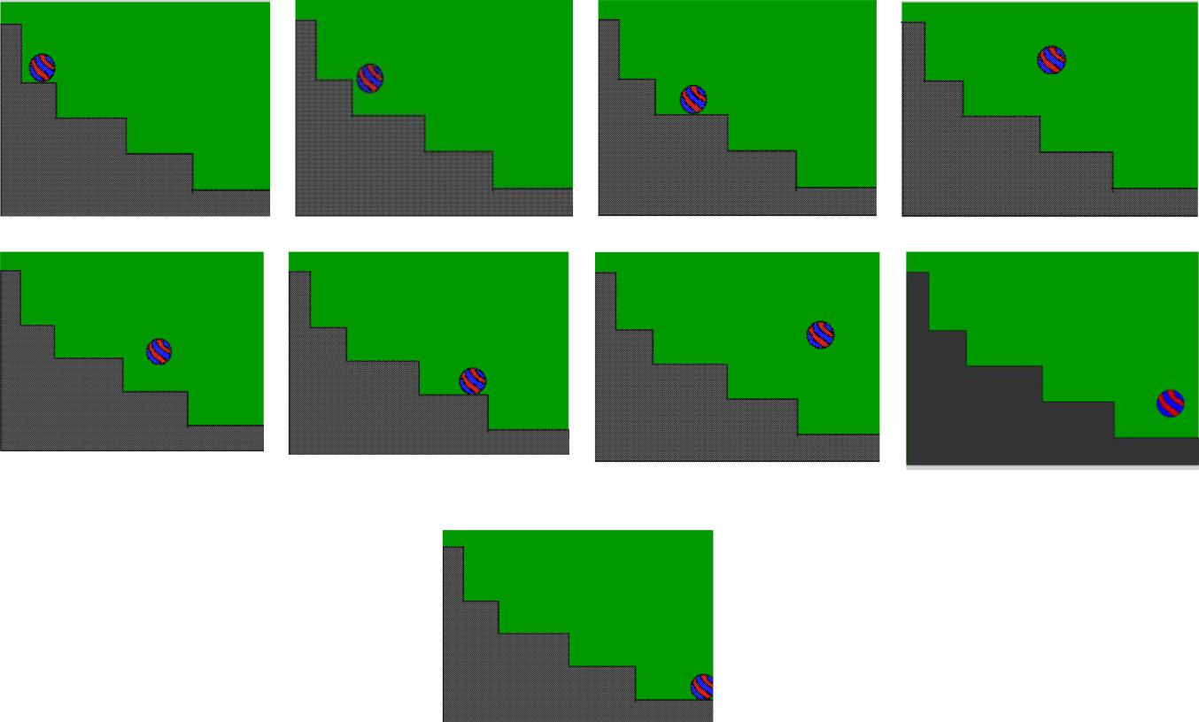

* Page 4

|  |  |
| --- | --- |
| * | 2017-18 |
|  |  |
|  |  |

**PROGRAM 3**

**PROCEDURE TO SIMULATE MOVEMENT OF A CLOUD.**

1. go to **start- macromedia**- click on **flash document**
2. create a blue background in **layer 1**
3. Now insert a **layer 2** and draw the clouds in this layer.
4. in order to create the clouds, go to **tool bar** and select **pencil** option, draw the cloud in **layer2**
5. fill the colour to the cloud, right click on it- choose **convert to symbol** option- give the name as cloud
6. select the **movie clip** option and click **ok**.
7. Go to **filter**->click on the **+** symbol->select **glow** to apply glowing effect-> select the colour to white
8. under **glow** and adjust the **blur x/blur y** values.
9. give the appropriate **blur** effect to the cloud.
10. go to **frames**, insert key frame on both the layer, create the motion tween on 2nd layer and move the clouds
11. finally go to **control**->click on **test movies**

**OUTPUT**

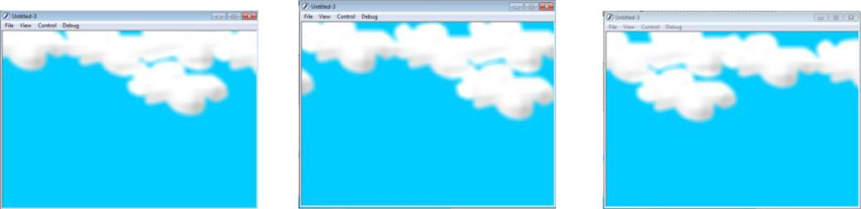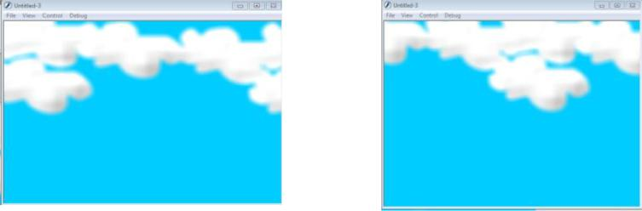

* Page 5

|  |  |
| --- | --- |
| * | 2017-18 |
|  |  |
|  |  |

**PROGRAM 4**

**PROCEDURE TO DRAW THE FAN BLADES AND TO GIVE PROPER ANIMATION.**

1. go to **start**-> **macromedia**-> click on **flash document**
2. Create a background on **layer 1**.
3. Insert another layer-> draw only fan blades and its circle.
4. Insert another layer and draw fan stand.
5. On each layer right click on frames and insert **key frames**.
6. Select the fan blade’s layer and insert new key frame-> select the fan blades by **free transform** tool and **rotate** the circle a little bit.
7. repeat the rotation until you get the fan rotation animation
8. Go to **control**->**test movie** to see the animation.

**OUTPUT**

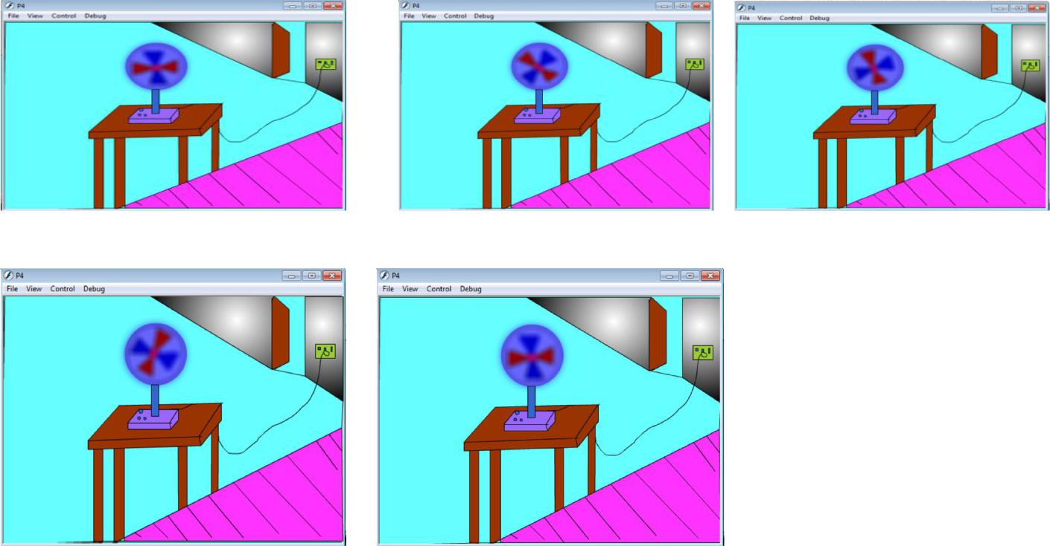

* Page 6

|  |  |
| --- | --- |
| * | 2017-18 |
|  |  |
|  |  |

**PROGRAM 5**

**PROCEDURE TO DISPLAY THE BACKGROUND GIVEN** **(FILENAME:**

**TULIP.JPG) THROUGH YOUR NAME.**

1. Go to **start**-> **macromedia**-> click on **flash document**
2. Go to **file**-> **import**->open **external library**-> select a background image Click **open.**
3. The selected image will be stored in your library. Open library and **drag** the image on the work area by selecting the image.
4. Resize the image to fit on the work area.
5. Select the **text tool** from the **tool bar**.
6. Type your name. Select the text and go to property to apply appropriate font effects like font size, style and Colour etc.
7. Go to **control**-> **movie clip** to see the final output.

**OUTPUT**

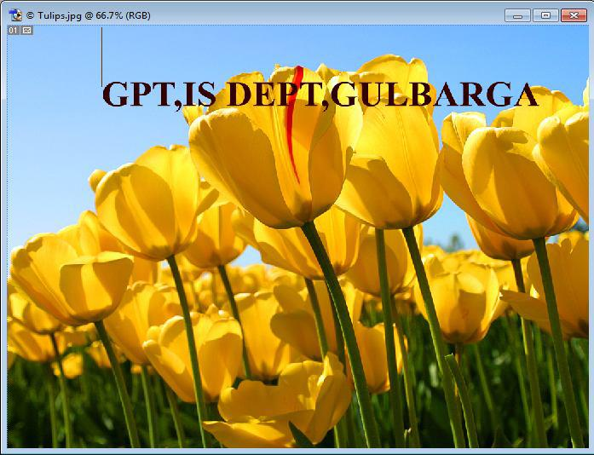

* Page 7

|  |  |
| --- | --- |
| * | 2017-18 |
|  |  |
|  |  |

**PROGRAM 6**

**procedure to create an animation with the following features.**

**WELCOME**

* **Letters should appear one by one**
* **The fill colour of The text should change to a different colour after**

**the display of the full word.**

1. Go to **start**->**Macro Media**-click on **Flash document**.
2. Choose the **textbox** from the tool bar. Type the word as **‘WELCOME’** on **layer1**.
3. Select the complete word, increase its Font size and change the colour.
4. In the **timeline** window, select the **1st** **frame**-Right click on it-choose insert key frame. Now delete a last letter {E} and change the colour of the remaining word.
5. Repeat the above procedure till you delete every word in **‘WELCOME’**.
6. Now select all the key frames->Right click ->choose ‘**Reverse key frames’**.
7. After reversing the frames copy the last frame and paste on its next. now in the new frame Select all the complete word ‘**welcome’** and change the colour.
8. Finally, go to ‘**control**’-click on **‘test movie’** you will get the required animation.

**OUTPUT**

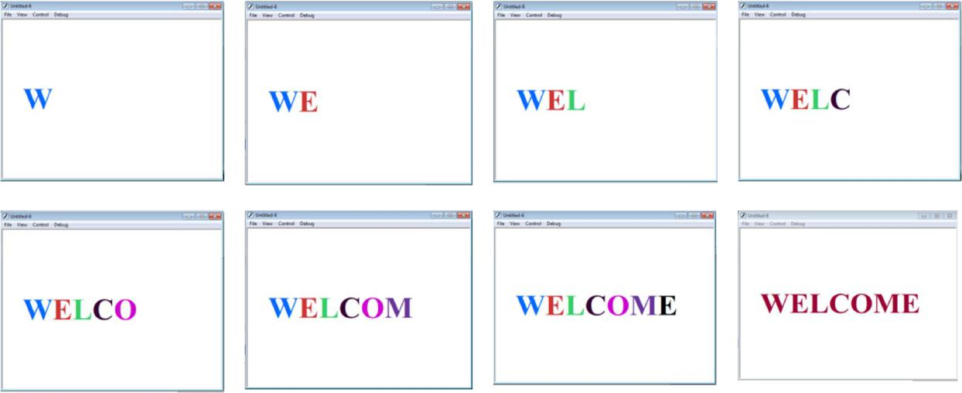

* Page 8

|  |  |
| --- | --- |
| * | 2017-18 |
|  |  |
|  |  |

**PROGRAM 7**

**PROCEDURE TO SIMULATE A BALL HITTING ANOTHER BALL.**

1. Go to **start**->**Macro Media**-click on **Flash document**.
2. choose the **circle** option displayed in the **toolbar**. create two circle at the opposite ends.
3. go to **frames**-> right click on the 1st blank frame and click insert **key frames**.
4. Select the 1st ball and make it to move towards the other till it touches.
5. Change the shape of the ball using **free transform tool** as soon as the two ball touches each other. after hitting each other make them to move towards opposite direction.
6. before moving to the opposite direction bring back the balls to its original shapes.
7. finally test the animation by selecting **control**->**movie clip**.

**OUTPUT**

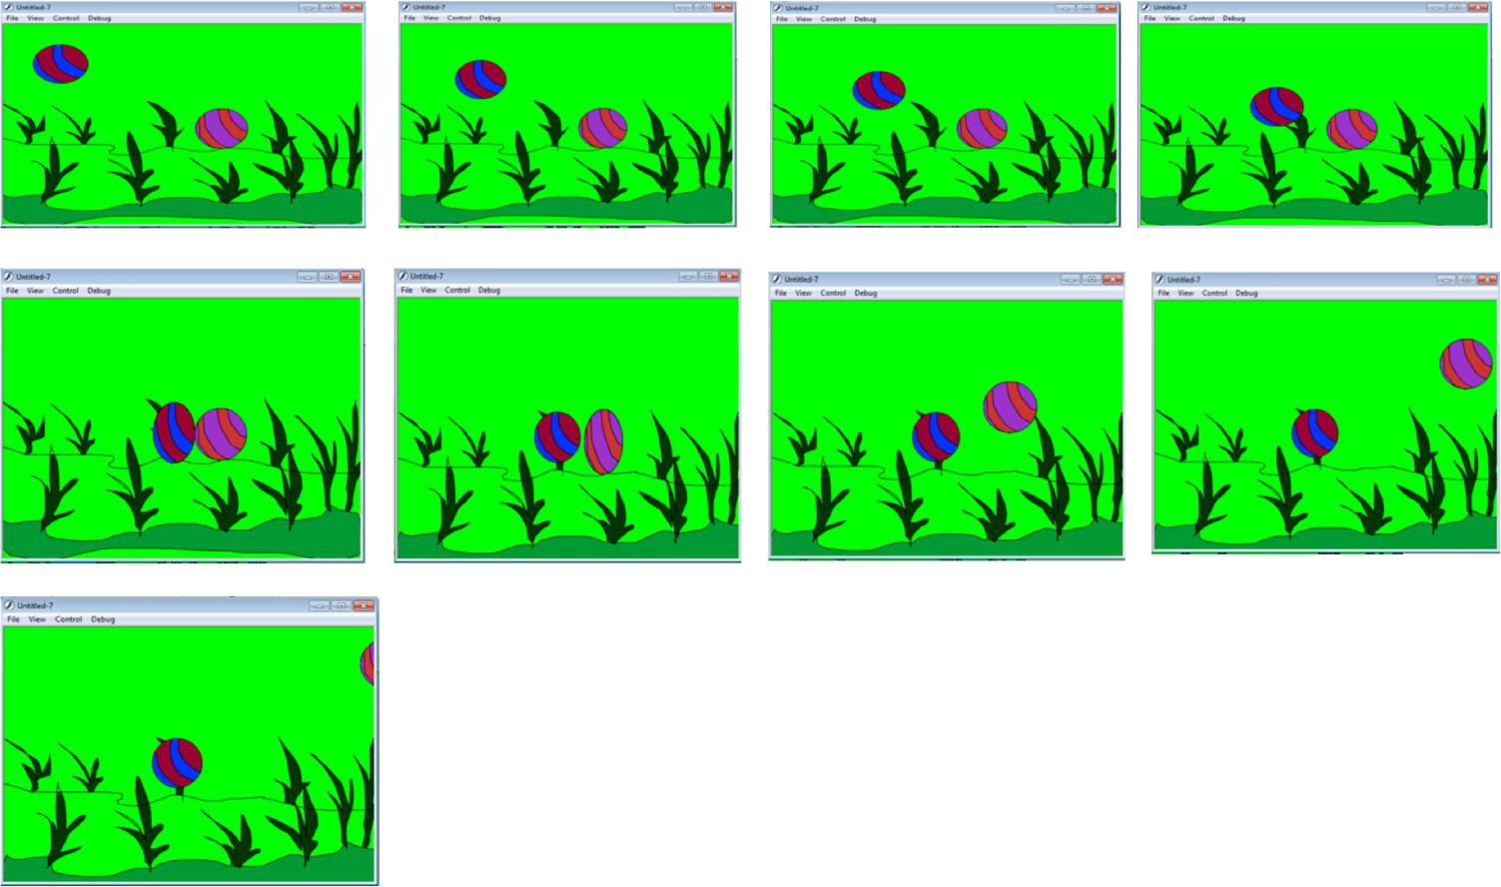

* Page 9

|  |  |
| --- | --- |
| * | 2017-18 |
|  |  |
|  |  |

**PROGRAM 8**

**PROCEDURE TO CREATE AN ANIMATED CURSOR USING STARTDRAG("SS", TRUE); MOUSE.HIDE();**

1. Go to **start**->**Macro Media**-click on **Flash document**
2. Insert or draw any object of your choice for example butterfly in this example.

3. Using **free transform tool** select the object-right click-**convert to symbol**- select **movie** **clip**- give the **name(mm)-** click **ok**.

3.Enter the **instance name** as (mm) using the **property tool box**.(same as the movie clip name).

1. Select the object using **free transform tool**- go to **modify**-> **timeline**->**distribute to** **layers.**
2. Select **layer1** and rename it to **Action**
3. Select the first key frame in the **action layer**- go to **windows**- click **action**.
4. You will get **action frame**- enter the following code in the action frame.

**Mouse.hide();**

**this.mm.onEnterFrame=function() {**

**startDrag(this,true);**

**};**

8.To run the animation go to **control**-> **movie clip**.

**OUTPUT**

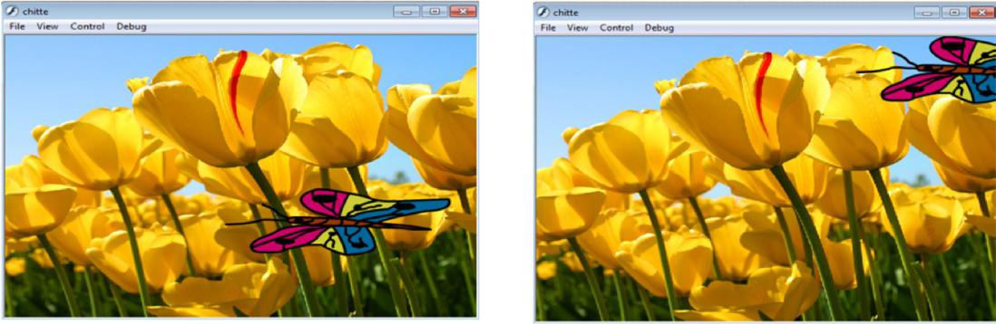

* Page 10

|  |  |
| --- | --- |
| * | 2017-18 |
|  |  |
|  |  |

**PROGRAM 9**

**PROCEDURE TO DESIGN A VISITING CARD CONTAINING ATLEAST ONE GRAPHIC AND TEXT INFORMATION.**

1. Open **adobe Photoshop 7.0**-> **file-> new**-> enter **height 200 and width 400** for the visiting card.
2. Select the **rectangle tool** in the **tool bar** and **draw** on the half of the work area-> colour it. Repeat the same for remaining half-> use different colours to colour.
3. Copy any picture of your choice and place it on the work area-> Resize it using **transform** **tool.**
4. Select the **text tool** and type text of your choice.
5. Apply the text **font size**, **colour** and **style** of your choice.

**OUTPUT**

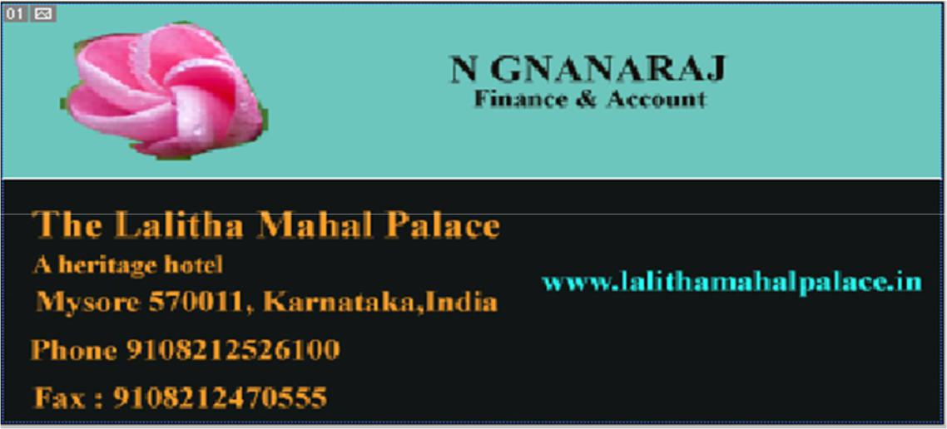

* Page 11

|  |  |
| --- | --- |
| * | 2017-18 |
|  |  |
|  |  |

**PROGRAM 10**

**PROCEDURE TO TAKE A PHOTOGRAPHIC IMAGE. GIVE A TITLE FOR THE IMAGE. PUT THE BORDER. WRITE YOUR NAMES. WRITE THE NAME OF INSTITUTION AND PLACE.**

1. Open **adobe Photoshop 7.0**-> **file**-> **new**-> enter **height 800** and **width 600**
2. Open an image file and copy the image->**paste** the copied image on the new file.
3. Right click on the **rectangle tool**->**custom shape**-> select the **shape**->select the **colour**->**drag** on your image.
4. Select the **text tool**->type your **name, institution name and place**.
5. Save the file.

**OUTPUT**

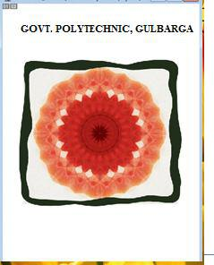

* Page 12

|  |  |
| --- | --- |
| * | 2017-18 |
|  |  |
|  |  |

**PROGRAM 11**

**PROCEDURE TO PREPARE A COVER PAGE FOR THE BOOK IN YOUR SUBJECT AREA. PLAN YOUR OWN DESIGN.**

1.open **adobe Photoshop 7.0**-> **file**-> **new**-> enter **height 500** and **width 400** for the cover page.

1. Select the **rectangle tool** in the **tool bar** and draw on the half of the work area-> colour it Repeat the same for remaining area-> use different colours to colour.
2. Copy any picture of ur choice and place it on the work area->resize it using **free** **transform tool.**
3. Select the **text tool** and type text of your choice.
4. Apply the text font size, colour and style of your choice.
5. Go to **layer**->**layer style**->**blended option**-> select **glow** options of your choice.
6. Apply the effects using **blended options**.

**OUTPUT**

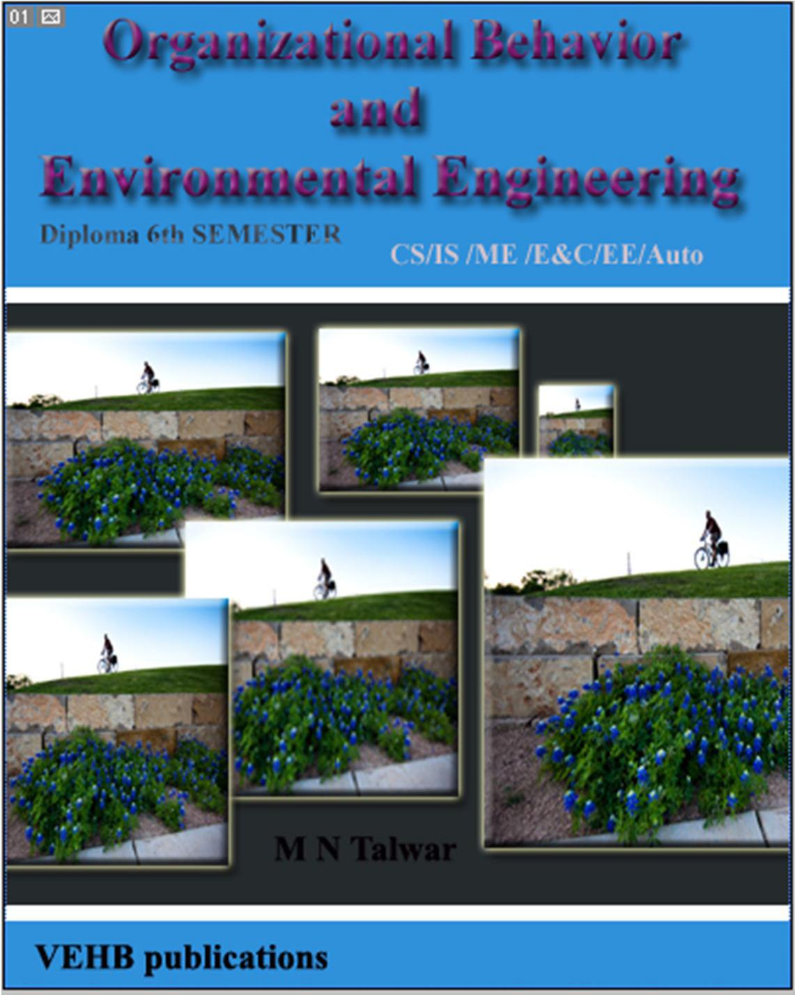

* Page 13

|  |  |  |  |  |
| --- | --- | --- | --- | --- |
| * |  |  |  | 2017-18 |
|  |  |  |  |  |
|  |  |  |  |  |
|  |  | **PROGRAM 12** |  |  |
| **PROCEDURE TO** | **EXTRACT THE FLOWER ONLY FROM GIVEN** | | | |
| **PHOTOGRAPHIC** | **IMAGE AND ORGANISE** | | | **IT ON A BACKGROUND.** |

**SELECTING YOUR OWN BACKGROUND FOR ORGANISATION.**

1. Open **adobe Photoshop 7.0**-> **file**->**open**-> choose a file and open it.
2. Select the flower from the image using the **lasso tool.**
3. Go to **edit**-> **copy**->Again go to **file**->**new**->give **height 500** and **width 500**.
4. Choose appropriate background and foreground colour from the tool bar.
5. Go to **edit**->**fill**->under **use** select **background colour**->**ok.**
6. Go to **edit->paste**.

**OUTPUT**

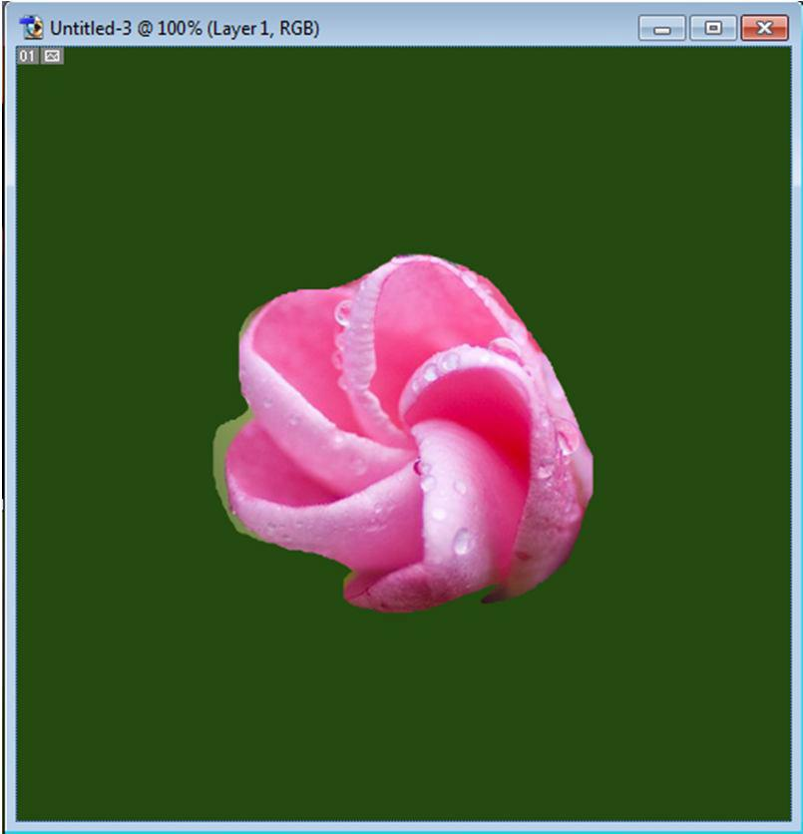

* Page 14

|  |  |
| --- | --- |
| * | 2017-18 |
|  |  |
|  |  |

**PROGRAM 13**

**PROCEDURE TO ADJUST THE BRIGHTNESS AND CONTRAST OF THE PICTURE SO THAT IT GIVES AN ELEGANT LOOK.**

* 1. Open **adobe Photoshop 7.0-> file->open->** choose a file and open it.
  2. Go to **image->adjustments->Brightness/Contrast**.
  3. After getting the Brightness/Contrast window adjust the brightness and contrast by Dragging the appropriate bar setting.

1. Finally save the image file.

**OUTPUT**

Before setting brightness/Contrast: After setting brightness/Contrast:

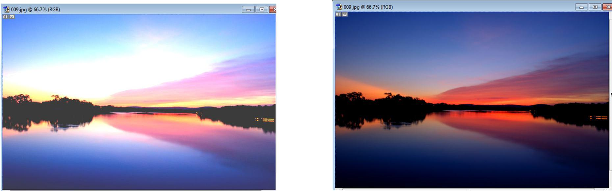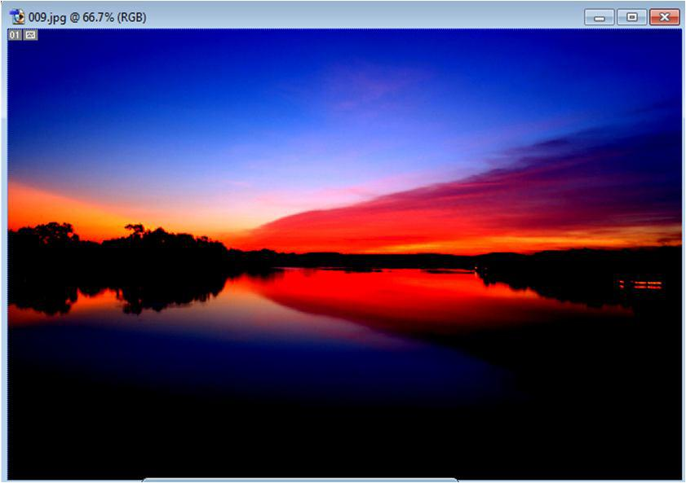

* Page 15

|  |  |
| --- | --- |
| * | 2017-18 |
|  |  |
|  |  |

**PROGRAM 14**

**PROCEDURE TO POSITION THE PICTURE PREFERABLY ON A PLAIN BACKGROUND OF A COLOUR OF YOUR CHOICE - POSITIONING INCLUDES ROTATION AND SCALING.**

1. Open **adobe Photoshop 7.0-> file->open->** choose a file and open it.
2. Select the flower from the image using the **lasso tool**.
3. Go to **edit-> copy->**Again go to **file->new->**give **height 500** and **width 500**.
4. Choose appropriate background and foreground colour from the tool bar.
5. Go to **edit->fill->**under **use** select **background colour->ok**.
6. Go to **edit->paste->**again go to **edit->free transform tool->** you will get a box around the image for scaling and rotating.
7. **Rotate** and **scale** as per your requirement->and press **apply.**

8.Save the image.

**OUTPUT**

Before scaling and rotating: After scaling and rotating:

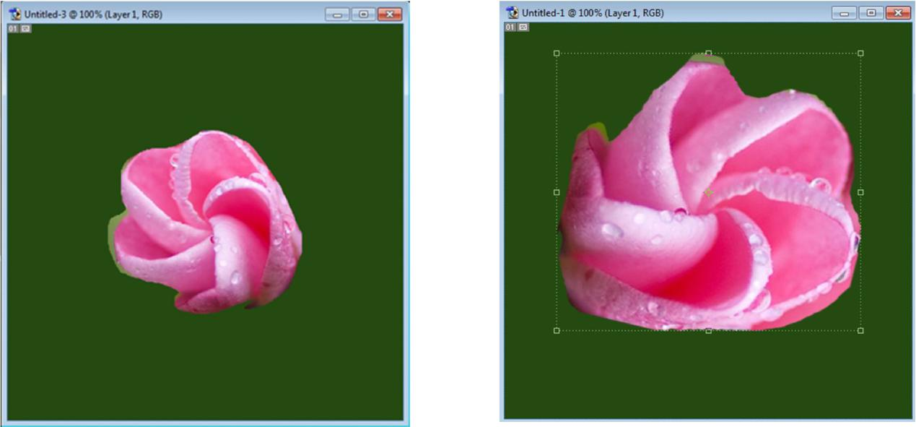

* Page 16

|  |  |
| --- | --- |
| * | 2017-18 |
|  |  |
|  |  |

**PROGRAM 15**

**PROCEDURE TO REMOVE THE ARROWS AND TEXT FROM THE GIVEN PHOTOGRAPHIC IMAGE**

1. Open **adobe Photoshop 7.0-> file->open->** choose a file with arrows and some text -> open it.

2.select the arrows from **lasso tool** from the **tool bar** which you want to **delete->**go to **edit-> cut**.

1. Select the text on the image using **text tool** and press **delete**.
2. Save the file.

**OUTPUT**

Original image After Removing arrows and text

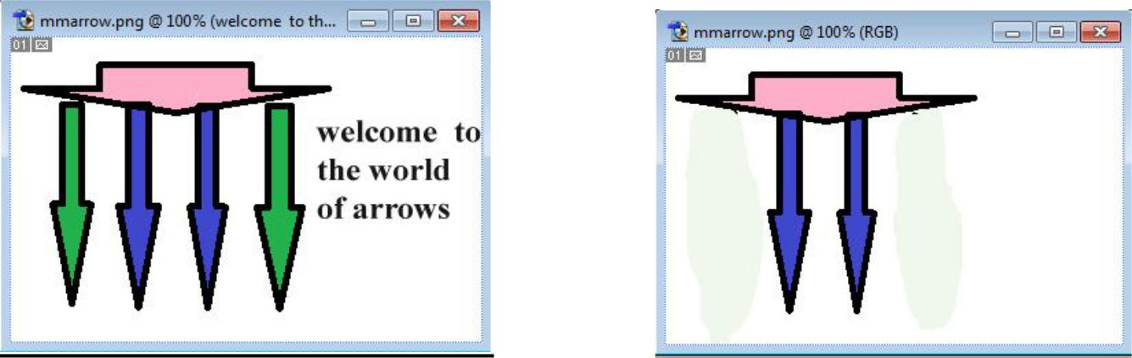

* Page 17

|  |  |
| --- | --- |
| * | 2017-18 |
|  |  |
|  |  |

**PROGRAM 16**

**PROCEDURE TO TYPE A WORD AND APPLY THE EFFECTS SHADOW EMBOSS**

1. Open **adobe Photoshop 7.0-> file->open->** choose a file and open it.
2. Select the **text tool** and place on the work area-> type your institute name
3. Select the typed text go to **layer->layer style->blended option->** tick **drop shadow, inner** **shadow, bevel** and **emboss->contour->satin->gradient overlay.**
4. finally save the image.

**OUTPUT**

**Before Applying shadow emboss effect:** **After Applying shadow emboss effect:**

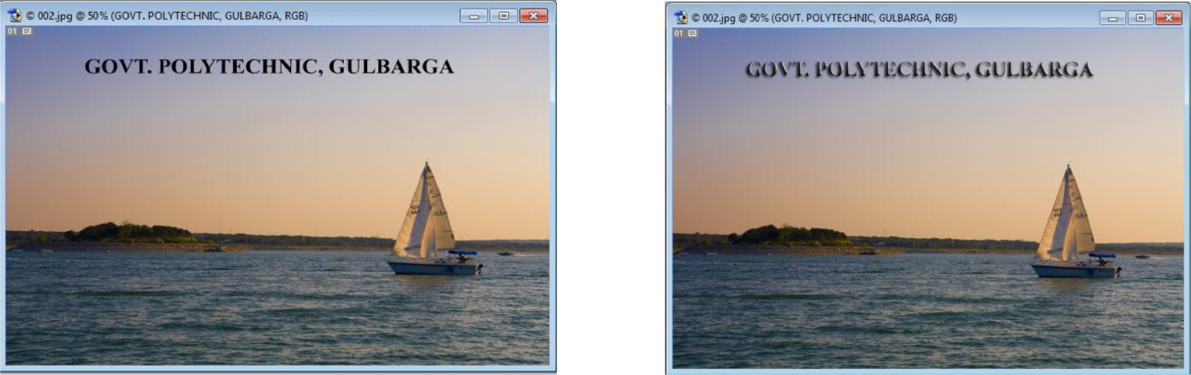

* Page 18

|  |  |
| --- | --- |
| * | 2017-18 |
|  |  |
|  |  |

**PROGRAM 17**

**PROCEDURE TO USE APPROPRIATE TOOL(S) FROM THE TOOLBOX, CUT THE OBJECTS FROM 3 FILES (F1.JPG, F2.JPG & F3.JPG); ORGANISE THEM IN A SINGLE FILE AND APPLY FEATHER EFFECTS.**

1. Open **adobe Photoshop 7.0-> file->open** f1.jpg.
2. Select the flower in it using **lasso tool ->right click->feather->** give feather **radius 20** **pixels.**
3. Go to **edit-> copy->** open a new file with **height 500 and width also 500->paste** the flower.
4. Repeat the same procedure for f2.jpg and f3.jpg-> select the flower ->give **feather effect->** **edit->copy->** open a new file-> **paste.**
5. You will get o final single file with 3 flowers from different files.
6. Save the new file.

**OUTPUT**

**F1.JPG** **F2.JPG** **F3.JPG**

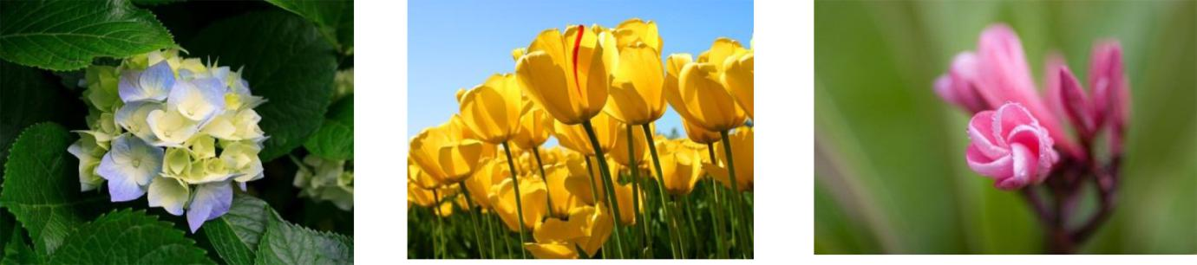

**Final image**

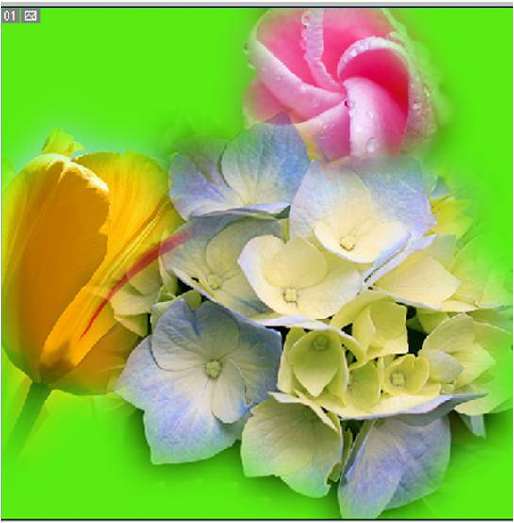

* Page 19

|  |  |
| --- | --- |
| * | 2017-18 |
|  |  |
|  |  |

**PROGRAM 18**

**PROCEDURE TO DISPLAY THE BACKGROUND GIVEN** **(FILENAME:**

**GARDEN.JPG) THROUGH YOUR NAME USING MASK.**

1. Go to **start**-> **macromedia**-> click on **flash document**
2. Go to **file**-> **import**->open **external library**-> select a background image Click **open.**
3. The selected image will be stored in your library. Open library and **drag** the image on the work area by selecting the image.
4. go to **view->zoom out->**resize the picture such that it should fit the work area.

5.insert **layer2.** choose the **text tool** from the **toolbar** and type your name.

6.Select the text to change its font size and colour of your choice. place the text on the left of the workarea.

7.**Right click** on the **70th** **keyframe** of **layer 2** and insert a **keyframe**. move the text to the right side of the workarea->**right click** on the **69th** **frame of layer 2->** choose **create motion** **tween.**

8.right click on **layer 2** choose the option **mask**.

9.Go to **control**->**test movie** to see the animation.

**OUTPUT**

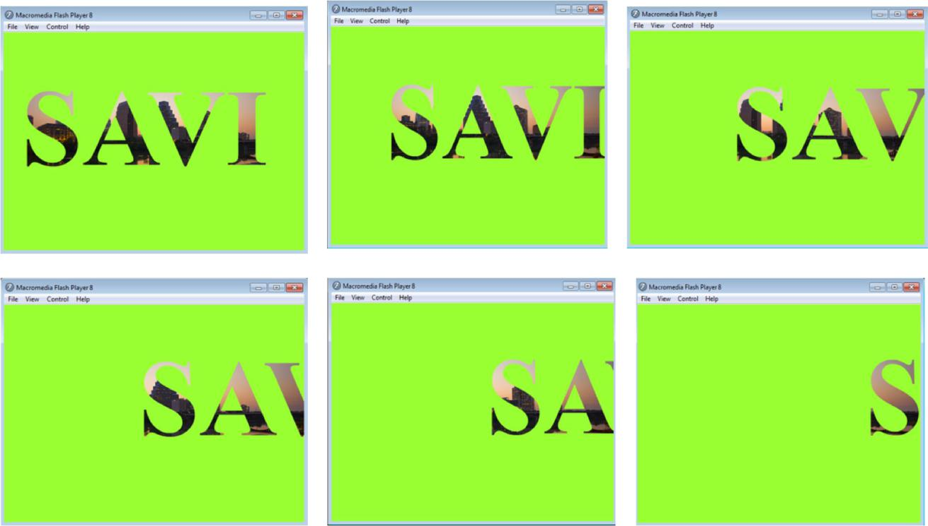

* Page 20

|  |  |
| --- | --- |
| * | 2017-18 |
|  |  |
|  |  |

**PROGRAM 19**

**PROCEDURE TO MAKE ANYONE OF ONE OF THE PARROTS BLACK & WHITE IN A GIVEN PICTURE.**

1. Open **adobe Photoshop 7.0-> file->open** original parrot picture.
2. Select a parrot using **lasso tool** from the **tool bar**.
3. after selection->go to **image-adjustments->desaturate.**
4. Then selected picture will now turn to black and white.
5. save as modified image.

**OUTPUT**

Original picture Modified picture

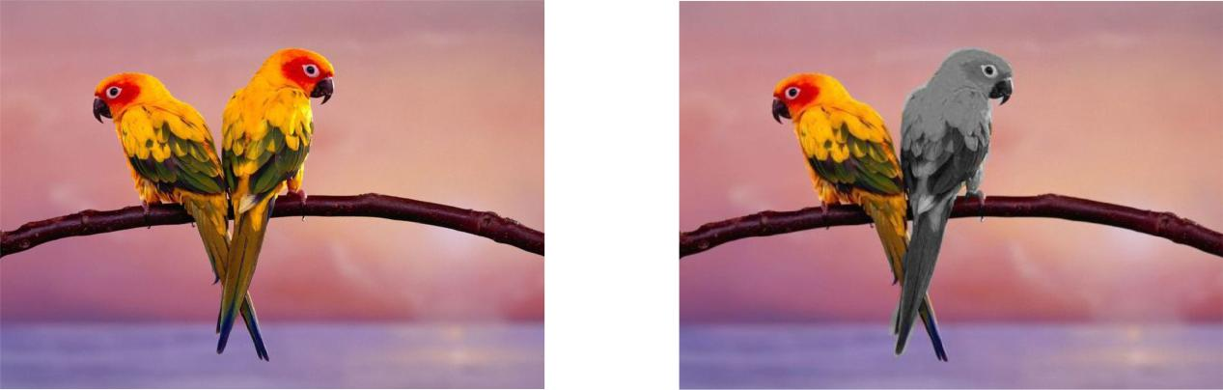

* Page 21

|  |  |
| --- | --- |
| * | 2017-18 |
|  |  |
|  |  |

**PROGRAM 20**

**PROCEDURE TO CHANGE A CIRCLE INTO A SQURE USING FLASH.**

1. Go to **start->macromedia->flash document**
2. Select the **circle** tool from the **tool bar**. draw a circle on the work area.colour it

3. Click on the **40th** **key frame-> insert new key frame.**

1. Selecting the last **key frame->**draw a **rectangle** on the circle by selecting the rectangle tool bar so that it will cover the circle. colour the rectangle by the different colour.
2. Again click on the last frame->under **properties->**under **tween->**change the option **shape**

from none.

1. Then again select the last but one **frame->**go to **properties->tween->**change to **shape**.
2. Go to **control->test movie->**see the circle changing in to rectangle.

**OUTPUT**

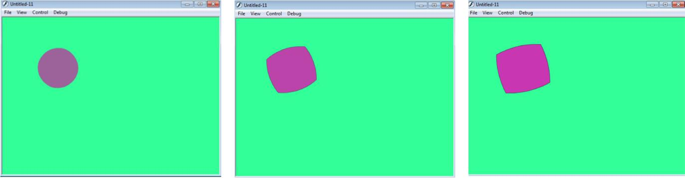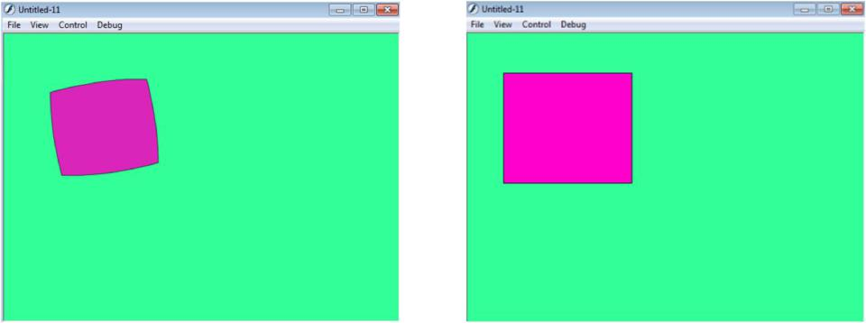

* Page 22