Steps :

- Clone the repo in local machine
- Start Minikube:
minikube start
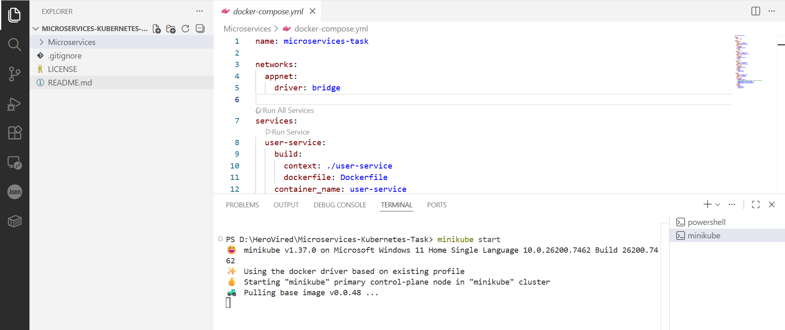
- Build the docker images from the respective directory of each service
docker build -t user-service:latest .
docker build -t product-service:latest .
docker build -t order-service:latest .
docker build -t gateway-service:latest .
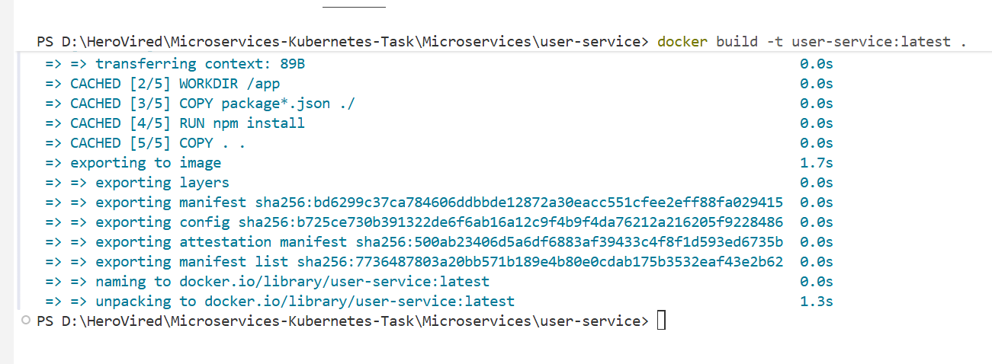
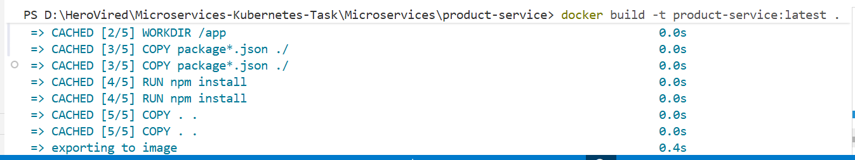
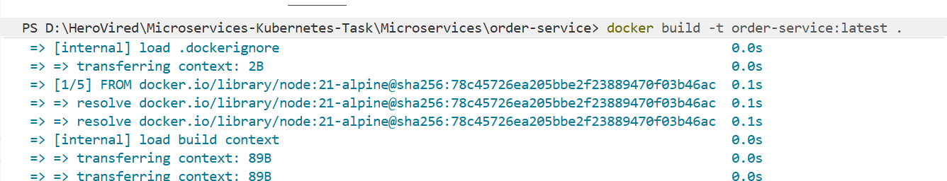
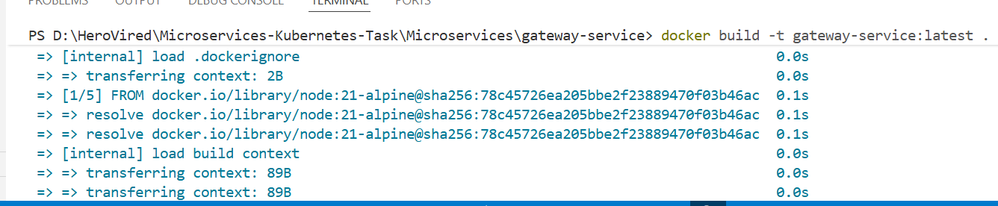
- Point your shell to minikube's Docker daemon and check if the environment variables are active:
minikube docker-env | Invoke-Expression
ls env:DOCKER*
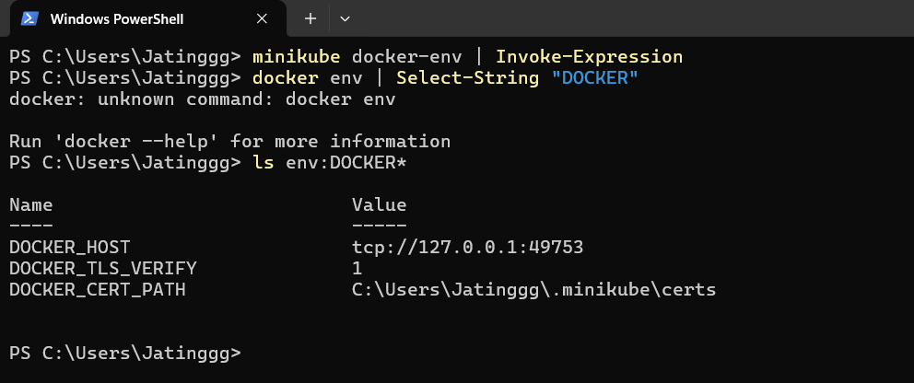
- Push the built images from docker desktop into minikube:
minikube image load <your-image-name>:latest
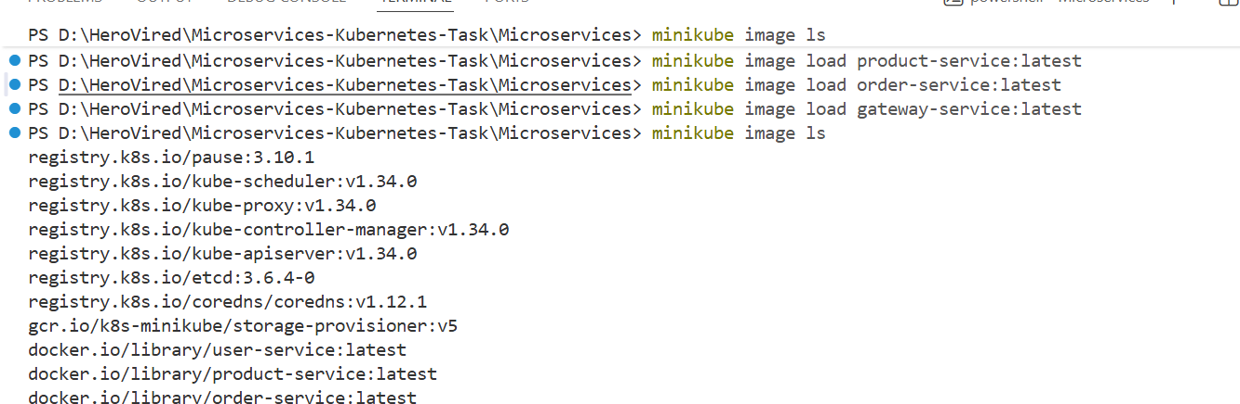
- Create k8s folder and create folders for deployment, service, ingress manifests for each microservice.
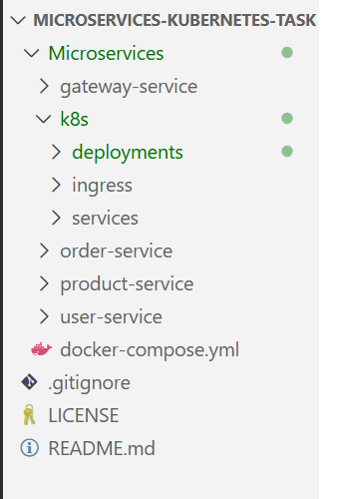
- Create Deployment Manifests for each service:
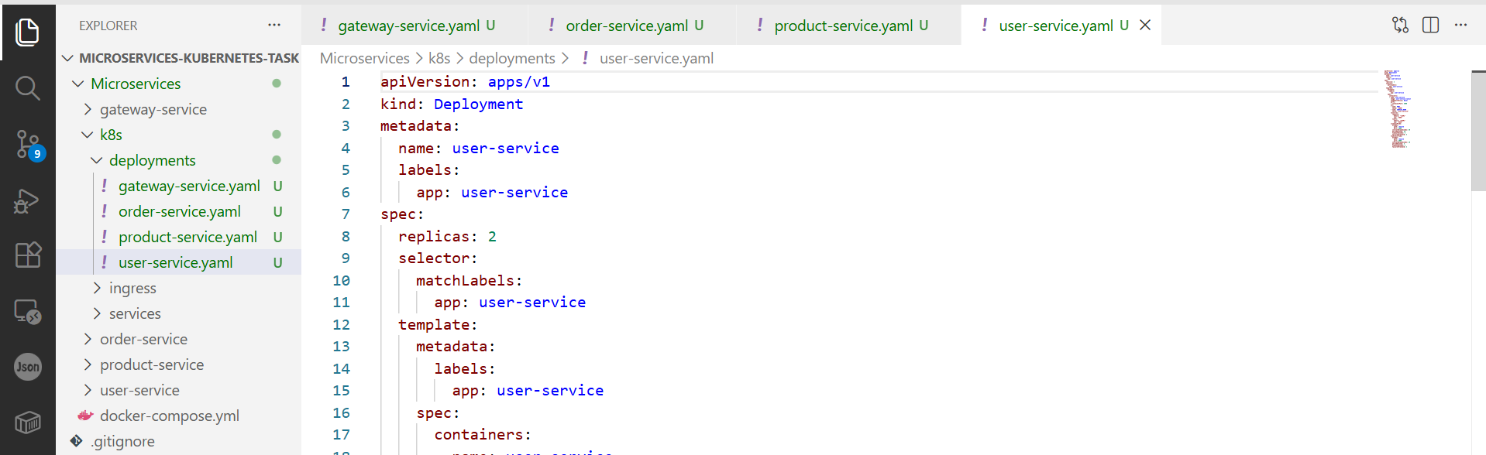
- Create service Manifests for each service:
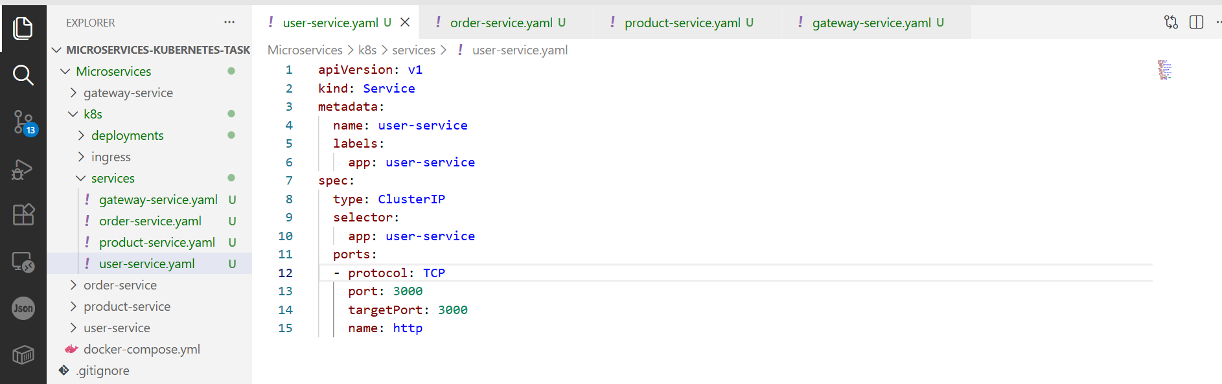
- Apply the deployment manifests
kubectl apply -f k8s/deployments/
- Apply the services manifests
kubectl apply -f k8s/services/
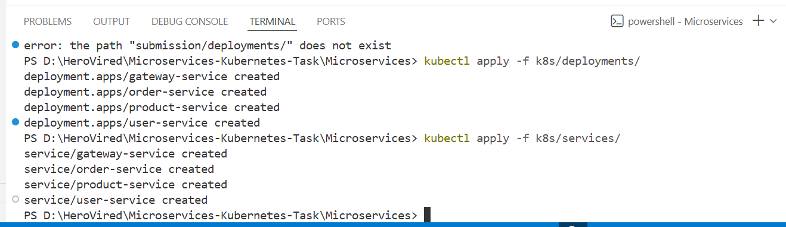
- Check if the pods are created and running:
kubectl get pods
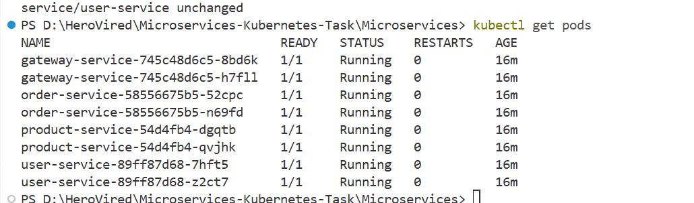

- Verify Inter-Service Communication:
kubectl exec -it <gateway-pod-name> -- sh
wget -O- http://user-service:3000/health
wget -O- http://user-service:3000/health
wget -O- http://user-service:3000/health
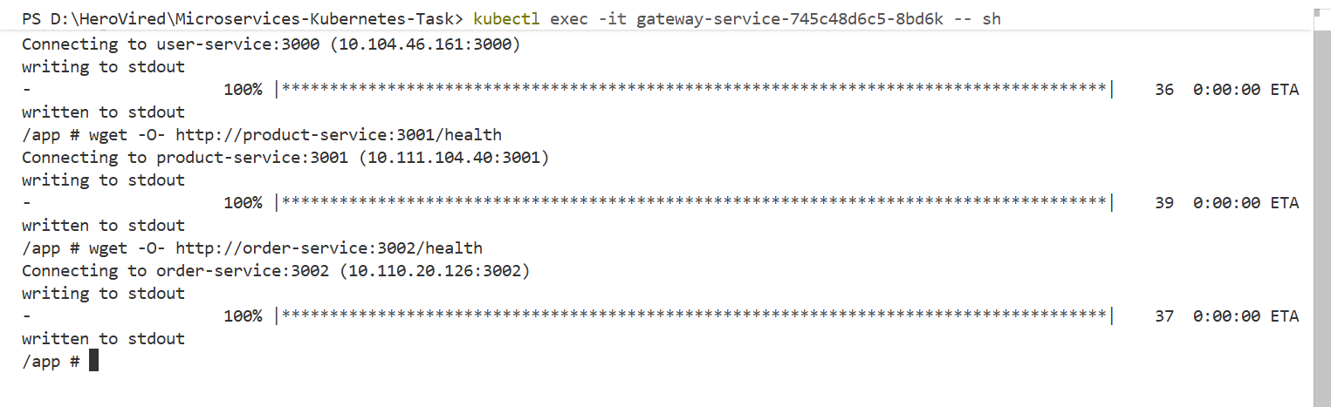
- Check logs for each pod, example gateway-service
kubectl logs -l app=gateway-service
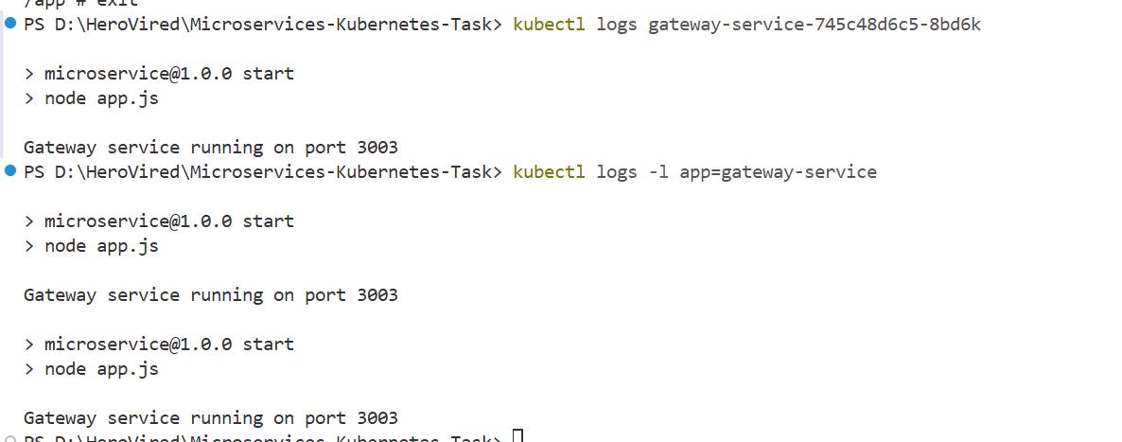
- Port Forward the gateway service
kubectl port-forward service/gateway-service 8080:3003
- Verify the application on the browser
http://localhost:8080/health
http://localhost:8080/api/users
http://localhost:8080/api/products
http://localhost:8080/api/orders
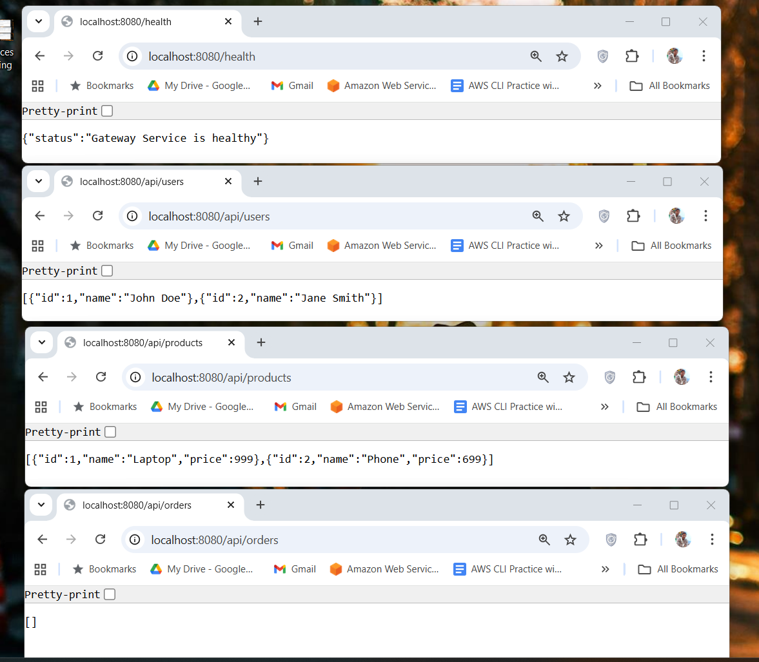
- Create the ingress.yaml file
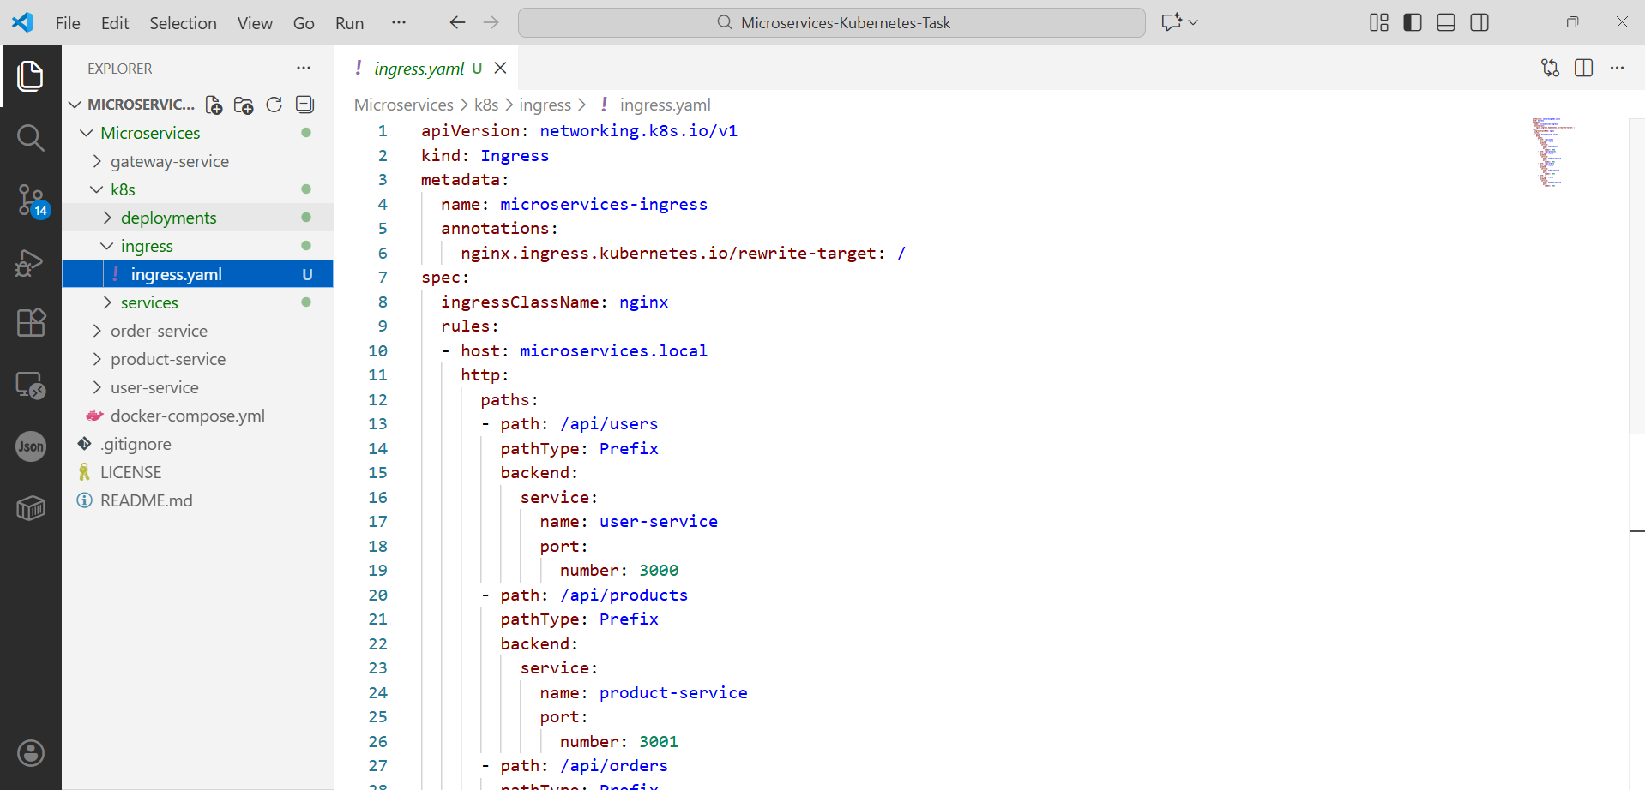
- Enable ingress addon
minikube addons enable ingress
- Apply the ingress.yaml
kubectl apply -f k8s/ingress/ingress.yaml
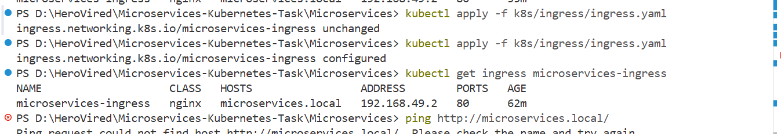
- Get Ingress Ip
minikube ip


