GitHub repo: https://github.com/jatinggg/shopNow-Capstone.git

STEPS:

- Fork the provided repo
- Clone the repo in your local computer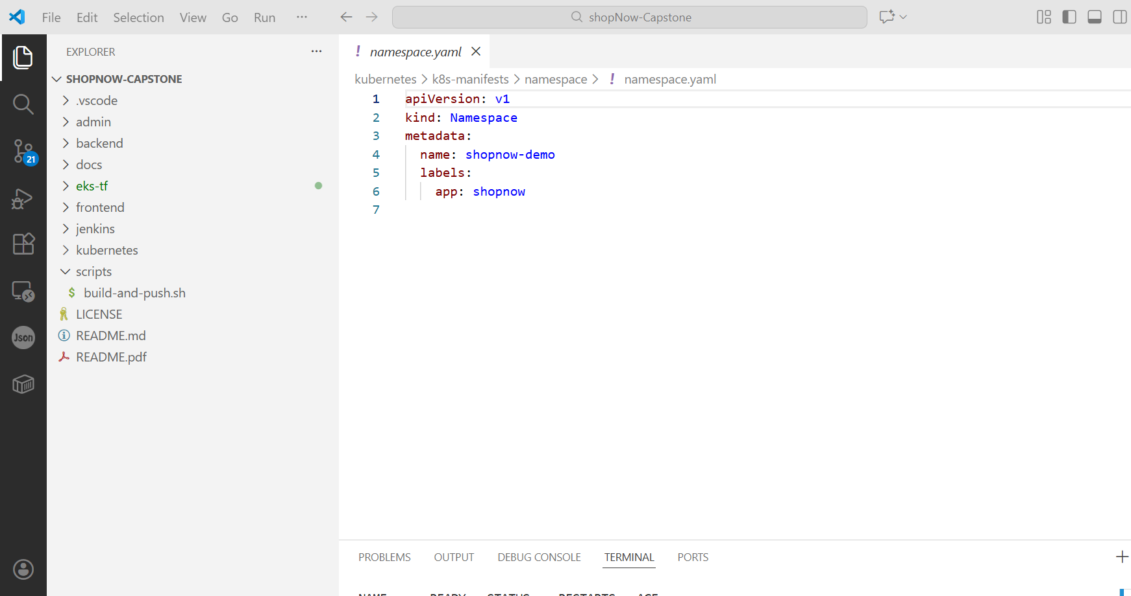
- Prepare & verify the Kubernetes Manifests for each service. 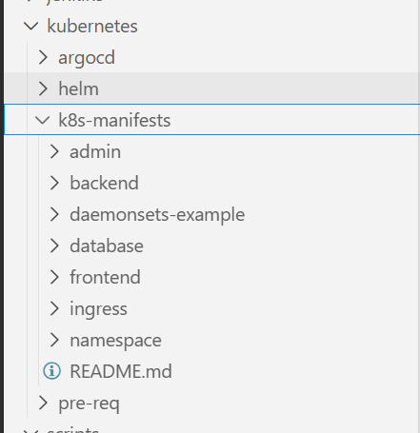
- Dry run the k8s manifests to check for any errors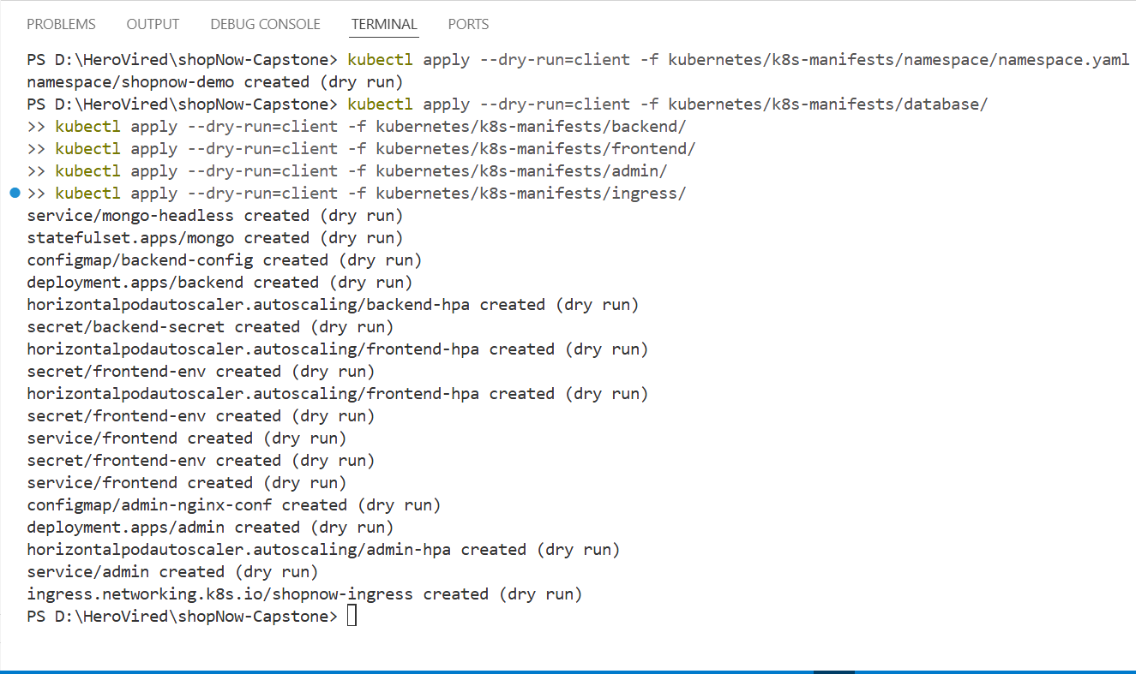
- Now run helm lint to check for any errors or issues in the helm charts and values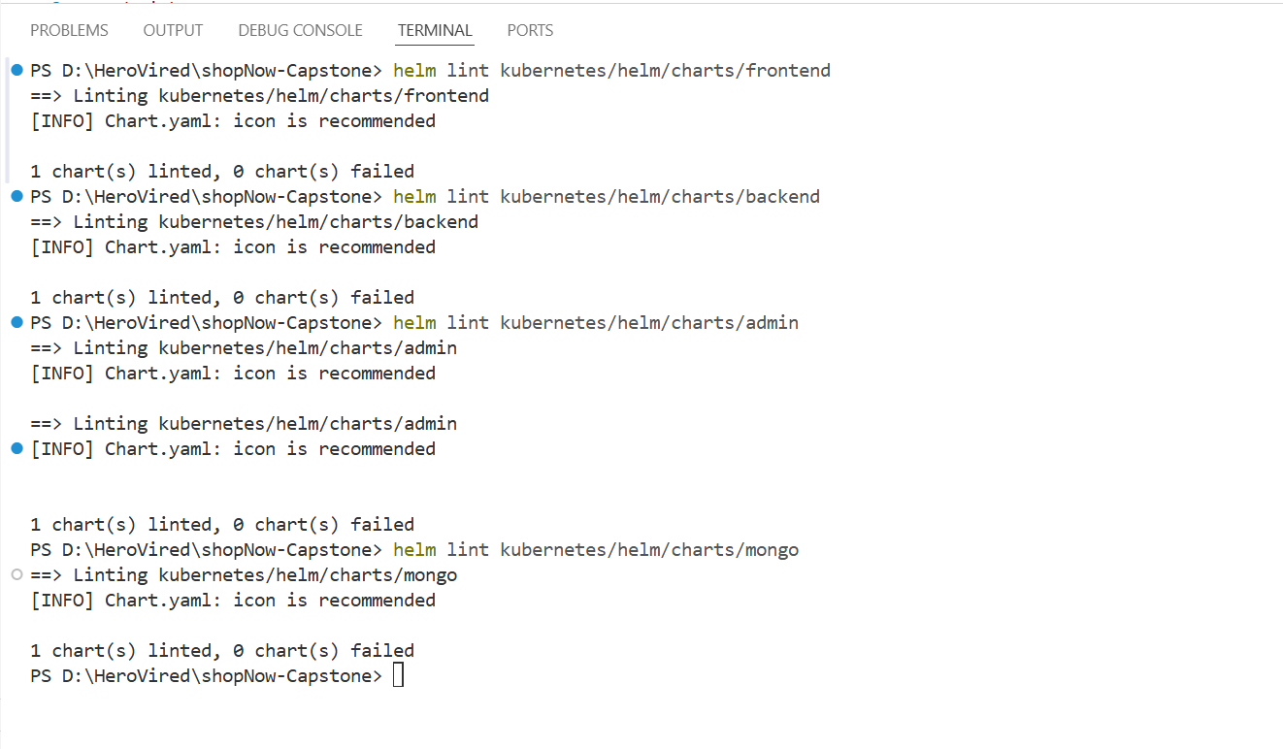

- Now apply the k8s namespace manifest first
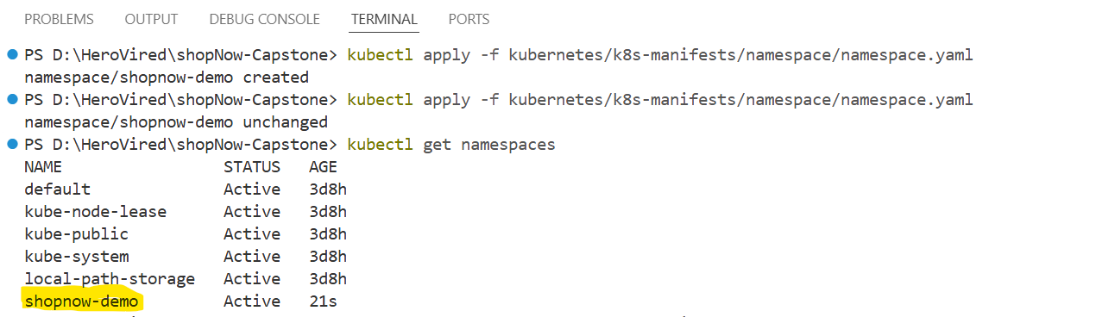
- Now apply the k8s mongo manifest
(for docker desktop Kubernetes cluster change the storageclass to hostname for pvc)
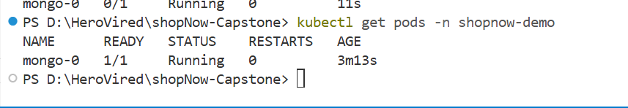
- Now apply the k8s backend, frontend and admin manifests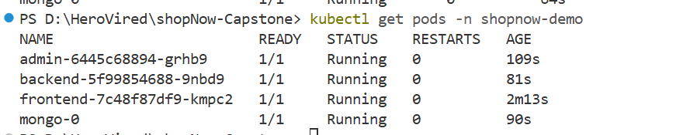
- Deploy the ingress manifest
- Now port forward the Frontend, Backed and Admin services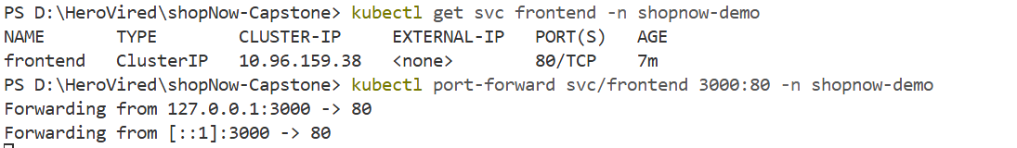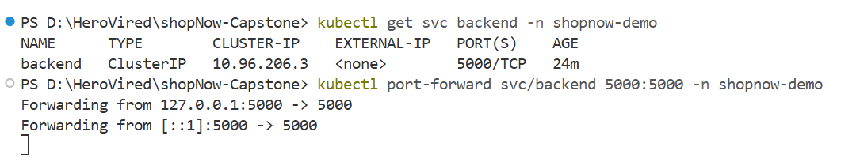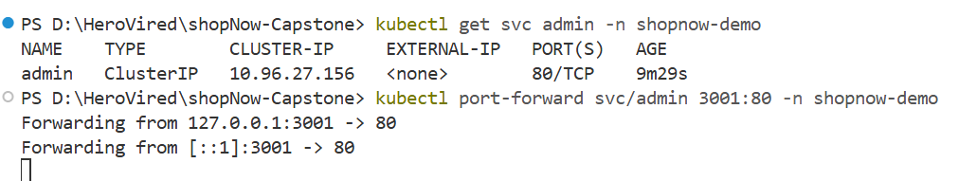
- Access the services on your local browser 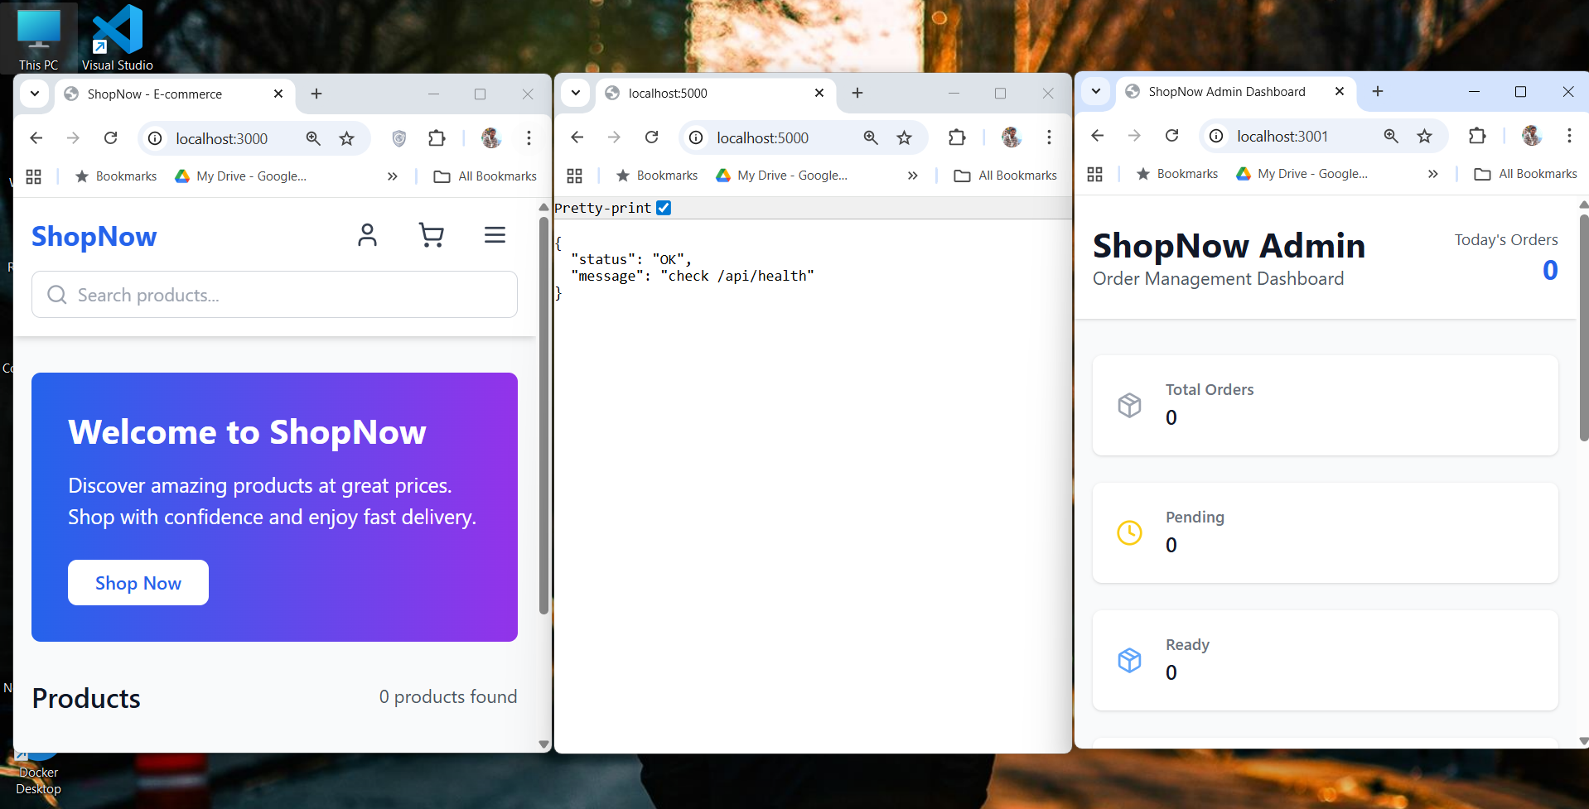

Testing with HELM

- First Delete the previous deployment 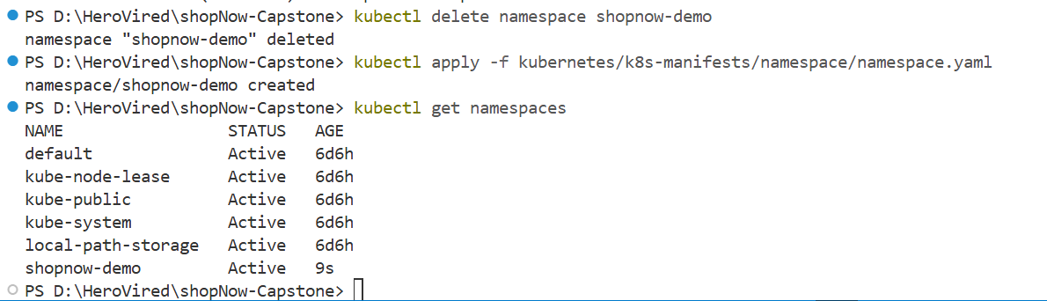
- Helm deploy order
MongoDB >> Backend >> Frontend >> Admin
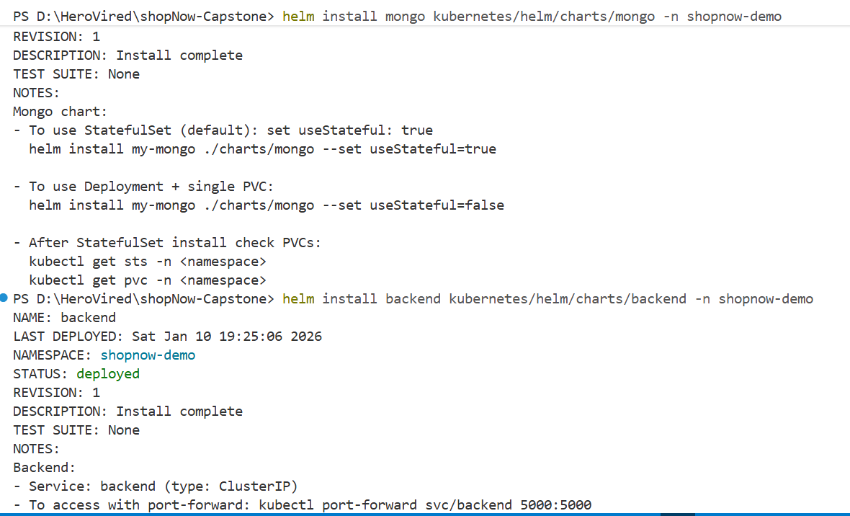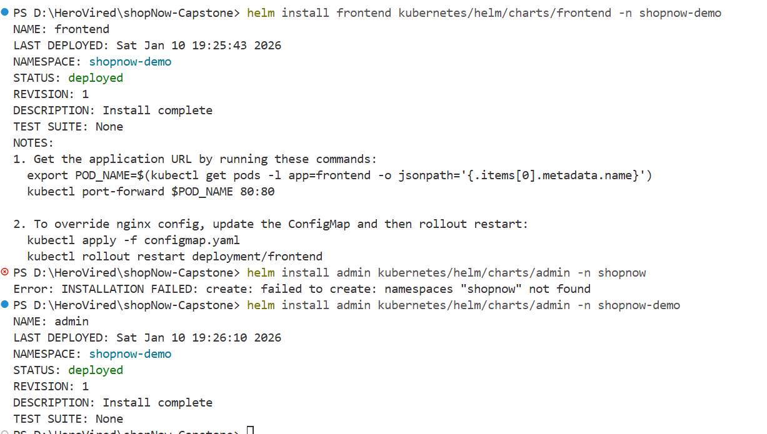

- Verify the helm deployment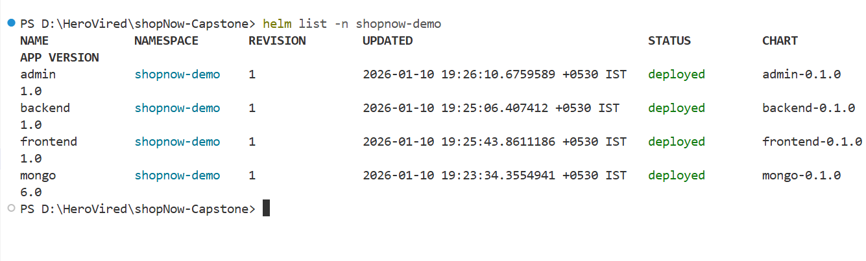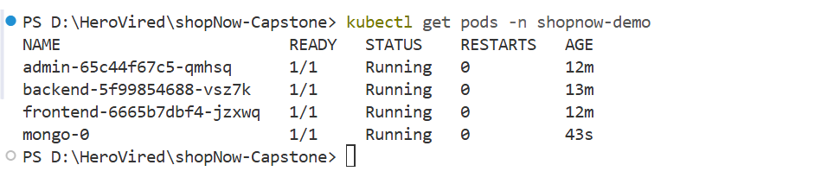
- Access on the browser
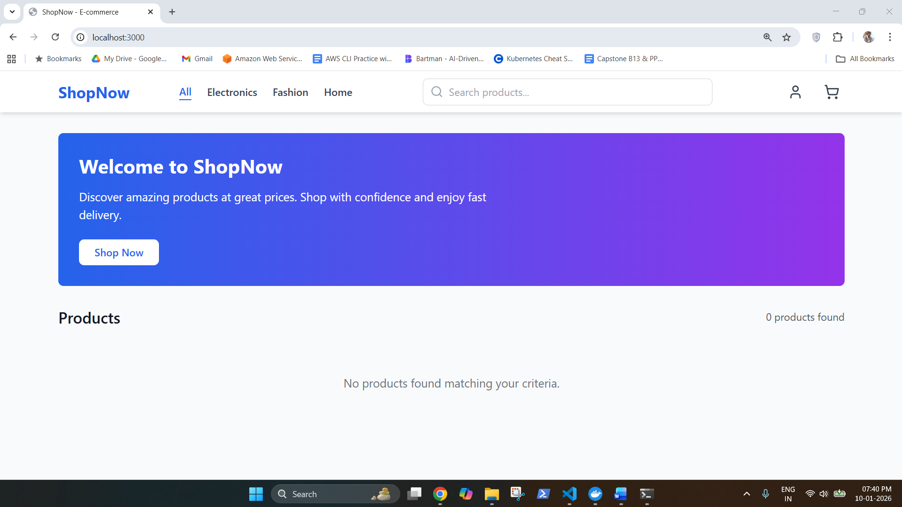
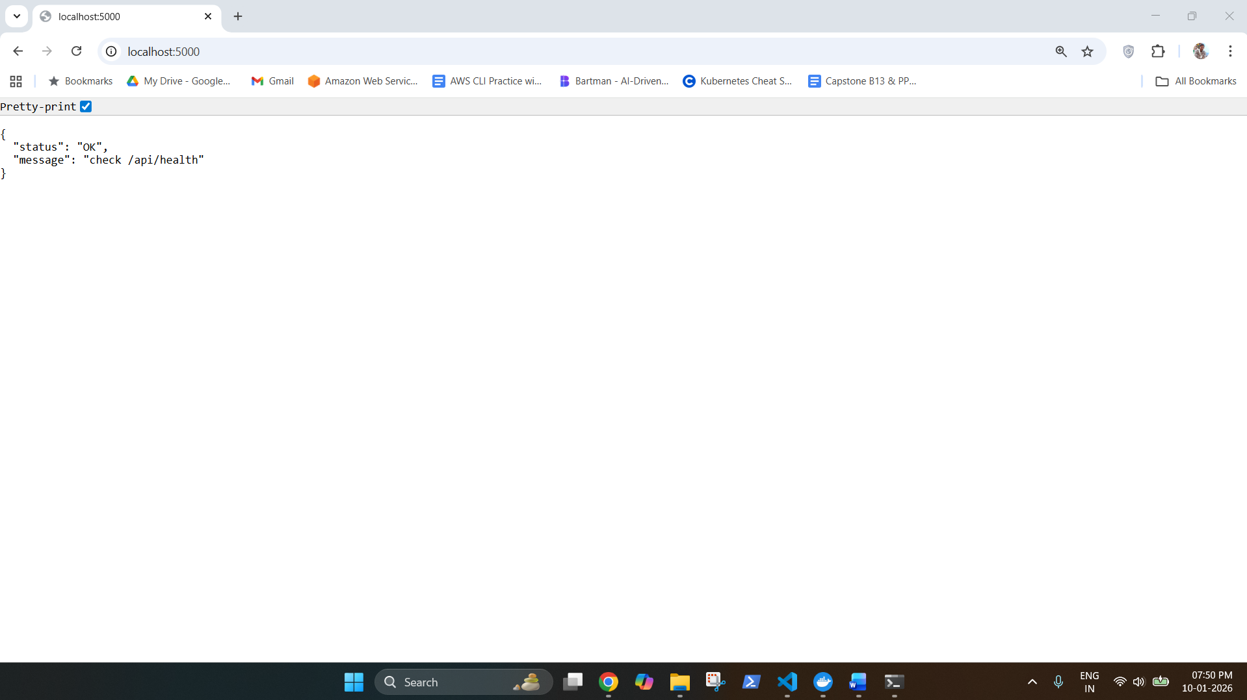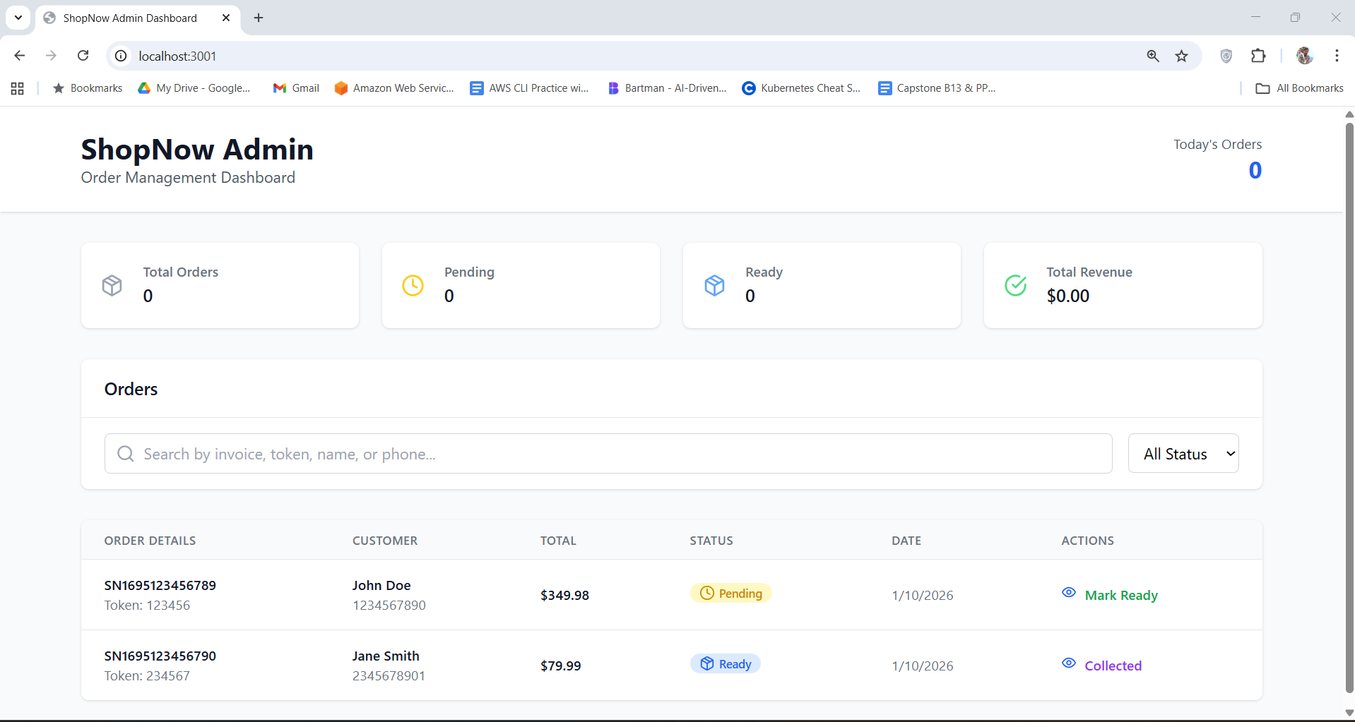

Creating the Jenkins Files for CI/CD
- Check the CI and CD groovy files for each service in Jenkins folder
