Tasks
Objective Questions:

- What is the total no. of tables present in the data?
Ans. Only one table is present in the dataset for analysis.

- What is the total no. of attributes present in the data?
Ans. There are a total of 35 attributes in the datasheet to be cleansed and analysed.

- The data consists of some inconsistent and missing values so ensure that the data used for further analysis is cleaned.
Removal of Irrelevant Columns:
- Removed columns with single unique values, such as isWhiteListUser and queue.
Data Cleaning and Standardization:
- createdAt: Ensured consistency by standardizing the date and time format.
- updatedAt: Standardized for uniform date and time format.
- chatStartTime: Standardized by extracting and normalizing both the date and time.
- chatEndTime: Standardized by extracting and normalizing both the date and time.
Handling Missing Values:
- Addressed missing values in chatEndTime, chatStartTime, and createdAt by identifying and managing the missing entries.

- What is the change in daily call volume day by day and also find the average of daily call volume?
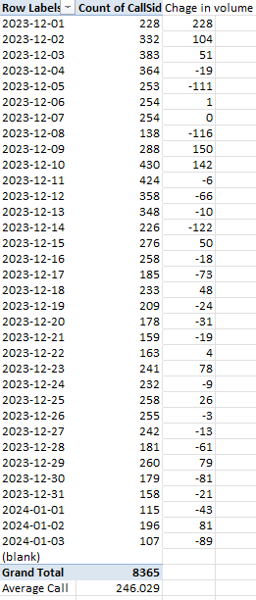
Average Daily Call Volume:
- Formula: Average = Total Calls / Number of Days
- Calculation: Average = 8365 / 34 = 250.24
Day-to-Day Change Calculation:
- Formula: Day-to-Day Change = D9 – D8
- In the new column, apply the formula D9 – D8 to calculate the change between consecutive days.

- Which months experienced the highest and lowest call volumes?
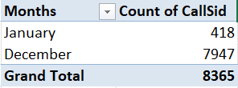
- Highest Call Volume: December 2023 saw the highest call volume, with 8,090 calls. This surge likely reflects seasonal factors or specific events during the month.
- Lowest Call Volume: In contrast, January 2024 experienced the lowest call volume, with just 418 calls. This sharp decline suggests a typical post-holiday slowdown or reduced demand at the start of the new year.
- Total Call Volume: Over the entire period, the total call volume reached 8,508, with December accounting for a significant portion of that total, highlighting the month’s importance in overall call activity.

- What is the total operational cost for that month?
The operational costs for December 2023 and January 2024 are as follows:
- December 2023: 202,214.63
- January 2024: 11,772.69

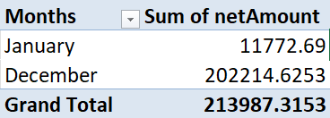

- What is the average number of calls handled per agent per day?
The calculation was based on the number of days, the number of gurus/agents, and the total calls. The formula used is:
Total calls / (Number of days * Number of gurus) = Average calls handled per agent per day.
This results in an average of 1.91 calls handled per agent per day.
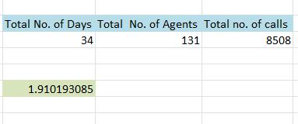

- How many repeat callers are there, and what percentage of total calls do they represent?
There are a total of 1,277 repeat callers, with the detailed calculation provided in the second sheet of the spreadsheet.
The steps taken to calculate this are as follows:
- The data was grouped by userId in a pivot table, and userId(count) was added to determine the number of calls made by each user. This gave the total number of callers.
- The COUNT function was applied to the first column to count the total number of callers.
- The COUNT function was also used to count the users with a single call.
- The number of one-time callers was subtracted from the total number of callers to determine the repeat callers.
To calculate the percentage of total calls made by repeat callers, the following formula was used:
(Total number of Calls - Total number of One-Time Callers) × 100 / Total number of Calls.
- What is the total sales generated by the call centre for each product category?
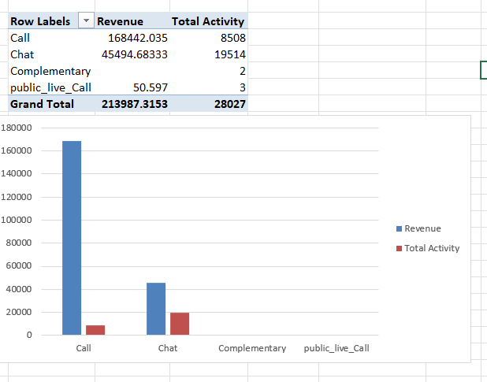
- The chart on the dashboard illustrates the sales generated by each product category.
- The data displayed in red indicates the number of activities received for different products or consultation types.
- The data shown in blue represents the revenue generated from each product or consultation type.

- How many calls were made for each user ID and guru ID?
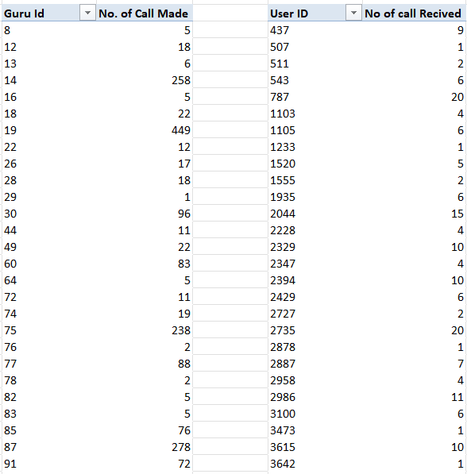
The two pivot tables provide the following information:
- The total number of calls made by each user.
- The total number of calls received by each agent or guru.
- What is the correlation between call duration and customer satisfaction?
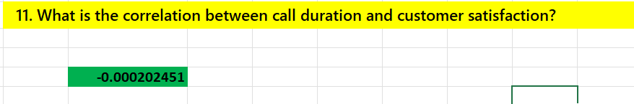
Since a dedicated column for customer satisfaction was not available, the rating was used as a metric to assess customer satisfaction and for the calculation.
The formula used is: CORREL (Range of UserOnCallDuration, Range of Ratings).
A correlation of -0.000202451 indicates a correlation between the two variables being analyzed.

- Which guru have the highest and lowest customer satisfaction scores?
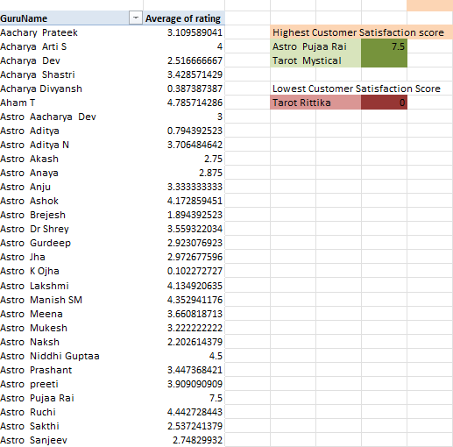
A pivot table was created with Gid as rows and the Average of Rating as values to assess the average rating for each guru/agent. The MAX, MIN, XLOOKUP ,FILTER functions were used to identify the GID corresponding to the highest and lowest average ratings. The GID was then used with XLOOKUP ,FILTER to retrieve the corresponding guru name.
- Guru with the highest average rating of 7.5: Tarot Mystical and Astro Pujaa Rai
- Guru with the lowest average rating of 0: Tarot Rittika
- What is the average customer satisfaction score by month?
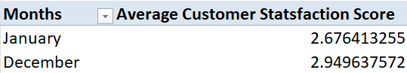
The Pivot Table will display the average customer satisfaction score for each month.
Rows:
- Drag the Month field to the Rows area to list each month in rows.
Values:
- Drag the Customer Satisfaction Score field to the Values area.
- Click on the Values field and set it to summarize by Average to calculate the average score for each month.

- How many categorical columns are there in the data? [Search about categorical and continuous data, and try to answer this question]
Ans. 21
_id, user, chatStatus, guru, guruName, consultationType, website, refundStatus, isWhiteListUser, queue, freeCall, freeChat, __v, statementEntryId, callChannel, callIvrType, callStatus, CallSid, astrologerCallStatus, region, userCallStatus

Subjective Question

- Should the investment be used to hire more agents, improve training programs, or upgrade call centre technology?

After analyzing the data, the following findings have been observed:
Findings:
Decline in Daily Active Users across both app and website:
- Daily Active Users (DAUs): The number of DAUs fluctuates notably across the observed dates, with some days showing high activity while others experience lower engagement.
- Platform Activity: There is significant variation in DAUs across different platforms (website, app, and Gurucool), each showing unique trends.
- Website: DAUs on the website show substantial variation, with the highest activity on 15/12/2023 (1,094 users) and the lowest on 08/12/2023 (204 users).
- App: DAUs on the app also vary, with the highest on 11/12/2023 (423 users) and the lowest on 03/01/2024 (97 users).
- Gurucool: DAUs on the Gurucool platform follow similar trends, exhibiting significant peaks and valleys comparable to the other platforms.

Revenue Analysis: Call vs Chat:
- Calls generate significantly higher revenue compared to chats.
- Completed Calls account for the majority of the revenue (Rs 168,442.04), while Completed Chats contribute much less (Rs 45,494.68).
- Calls are a key revenue driver; increasing the number of completed calls could result in higher revenue.
- Chats are less profitable; improving chat monetization or conversion rates could boost revenue.
- For Calls: Focus on enhancing processes to increase call completion rates and address issues leading to incomplete calls.
- For Chats: Investigate and resolve the reasons behind non-revenue statuses to improve the conversion rate to completed chats.

Rating Distribution:
- Overall Average Rating: The total average rating is approximately 2.9.
- Highest Ratings: The IDs with the highest ratings are 286 (5.9), 287 (5.75), and 253 (5.05).
- Lowest Ratings: The IDs with the lowest ratings are 80 (0), 219 (0.10), and 307 (0.79).
- Improving Low Ratings: Investigate the causes behind the extremely low ratings and address them to enhance the user experience.
- Leveraging High Ratings: Analyze the successful IDs to identify their strengths and replicate those positive aspects in other areas.

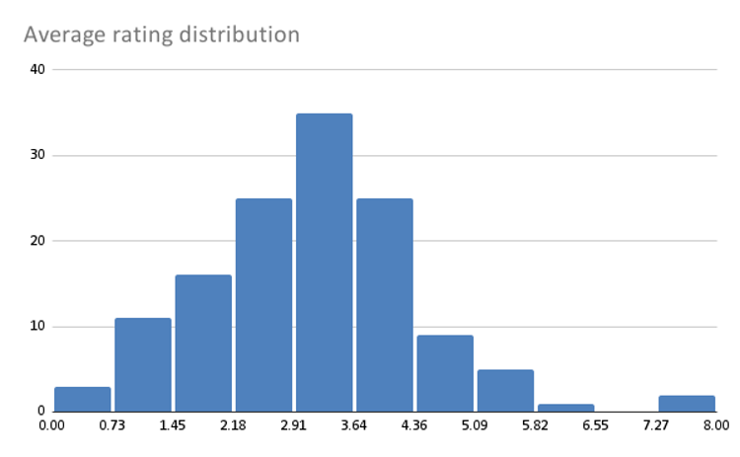
Conclusion:
- Hiring: Focus on hiring additional agents to better handle call volume during peak periods.
- Training: Invest in thorough training programs to enhance agent skills for both calls and chats, improving customer interactions.
- Technology: Adopt technology solutions to optimize operations and elevate overall service quality.
Hiring More Agents:
- Avg calls per agent per day = 2 (8508 calls ÷ 131 gurus ÷ 34 days).
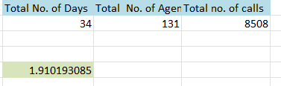

- Top 10 Gurus handled >10,000 calls combined, bottom 10 Gurus handled only 24 calls.
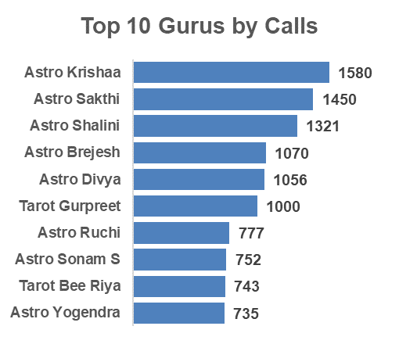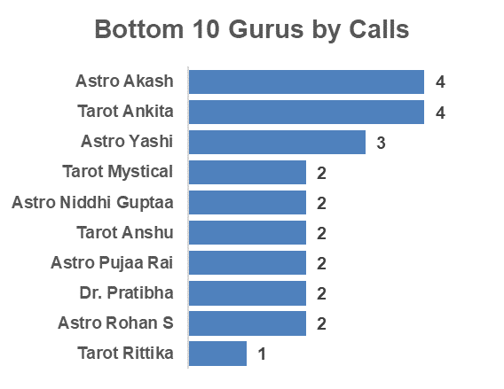
- Large workload imbalance + underutilization.
Insight:
- Current team is not overworked; the issue is uneven distribution of calls, not shortage of manpower.
Recommendation:
- Do not hire more agents immediately.
- Focus on load balancing through smart call routing.
- Hire only if future demand rises and top performers remain overloaded.
Improving Training Programs:
- Avg ratings range from 7.5 (top gurus) to below 1.0 (bottom gurus).
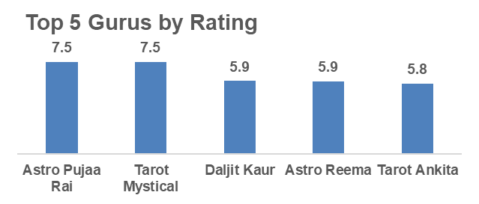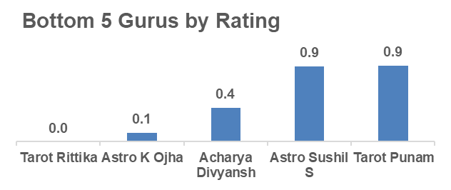
- Some Gurus take longer call durations but still get poor ratings.
- Some Gurus like Astro Aishwarya (417 sec) & Astro Anju (387 sec) take very long calls but their ratings are only 3.3–3.6 - indicates inefficiency.
- On the other hand, Tarot Srishti (145 sec, rating 4.9) and Astro Lakshmi (69 sec, rating 4.1) handle shorter calls but deliver much higher ratings.
- Top-rated Gurus resolve faster with higher CSAT.

Insight:
- Service quality gaps are due to skill and efficiency differences.
- High-performing Gurus provide a benchmark for training content.
Recommendation:
- Develop structured training modules based on top-performer practices.
- Regular coaching for low performers.
- Use performance dashboards (rating + avg call duration) to track improvement.

Upgrading Call Center Technology:
34% of calls failed or went unanswered (13.9% failed + 20.3% no answer).

- Call Outcomes (8,508 total): 41% completed, 59% failed/busy/no-answer/incomplete.

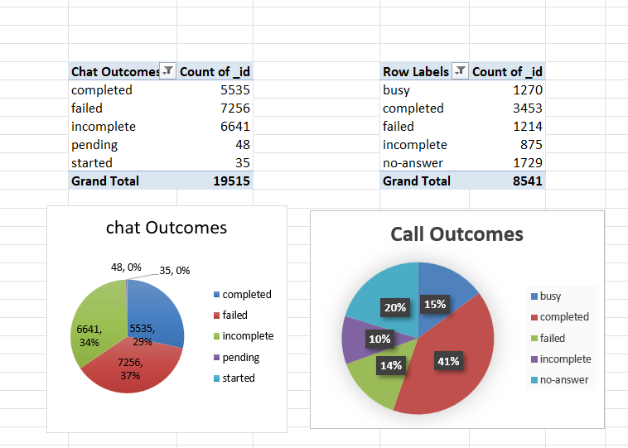
Chat Outcomes (19,514 total): Only 28% completed, 71% failed/incomplete.
- High drop & failure rates across both channels - indicates tech inefficiency
- Current tech not supporting efficient call handling.
Insight:
- Technology inefficiencies are directly causing lost calls, customer frustration, and repeat calls.
Recommendation:
- Invest in CRM system with smart routing.
- Improve IVR & callback systems to reduce failed/no-answer calls.
- Enable real-time monitoring dashboards for supervisors.
Final Priority Order
- Upgrade Technology (High Priority) – fixes call drop issues.
- Improve Training (Medium Priority) – reduces quality gap & repeat calls.
- Hire More Agents (Low Priority) – not required until demand increases.
Analytical Tools Used:
- PivotTable/Pie chart (Calls by Status, Avg. Rating by Guru).
- Bar Chart (Guru Rating comparison).
- COUNT & AVERAGE functions to summarize efficiency.

- What are the potential risks of each investment option (hiring, training, technology upgrades), and how can they be mitigated?
Name the chart/spreadsheet function you will use for solving the problem?

Potential Risks for Technological Upgradation:
- Implementation Challenges: Integrating new technology can be time-consuming, with unforeseen technical issues potentially causing delays or complications during the transition.
- High Upfront Costs: Technology upgrades often require substantial initial investments, which may not provide immediate returns.
Mitigation Strategies:
- Phased Rollout: Introduce technology upgrades in stages to test their effectiveness and address any technical challenges before a full implementation. Begin with smaller teams and gradually scale up.
- Cost-Benefit Analysis: Conduct a thorough cost-benefit analysis to ensure that the technology investment aligns with the expected improvements in efficiency and profitability.

Potential Risks with Agent Training:
- High Costs: Comprehensive training programs can be costly, both in terms of direct expenses and the loss of productivity during training periods.
- Retention Issues: Agents who undergo training may leave the company for better opportunities, leading to a loss of investment in their development.
Mitigation Strategies:
- Measure Training Effectiveness: Track agent performance before and after training sessions to evaluate the success of the programs. Continuously adjust the training approach based on measurable outcomes.
- Retention Programs: Offer retention incentives, such as performance-based bonuses or career growth opportunities, to motivate trained agents to remain with the company.

Functions to Facilitate Improvement:
- Function: WHATIF or Goal Seek
- Use: These functions help analyze how changes in key variables—such as the number of agents hired or trained or the cost of technology upgrades—affect outcomes. Goal Seek can be particularly useful in determining the breakeven point for investments, providing critical data for decision-making.

Visualization Tools:
- Function: CHARTS (e.g., Bar Charts, Pie Charts, Waterfall Charts)
- Use: Visualize the distribution of risks, costs, and potential returns. Waterfall Charts are especially effective for illustrating the incremental impact of each investment decision, helping to clarify the financial outcomes of different strategies.

- How does AstroSage call centre performance compare to that of AstroGuru in terms of average call volume, customer satisfaction, and agent performance?
Will you use any aggregation function or a visualization here to solve the problem?
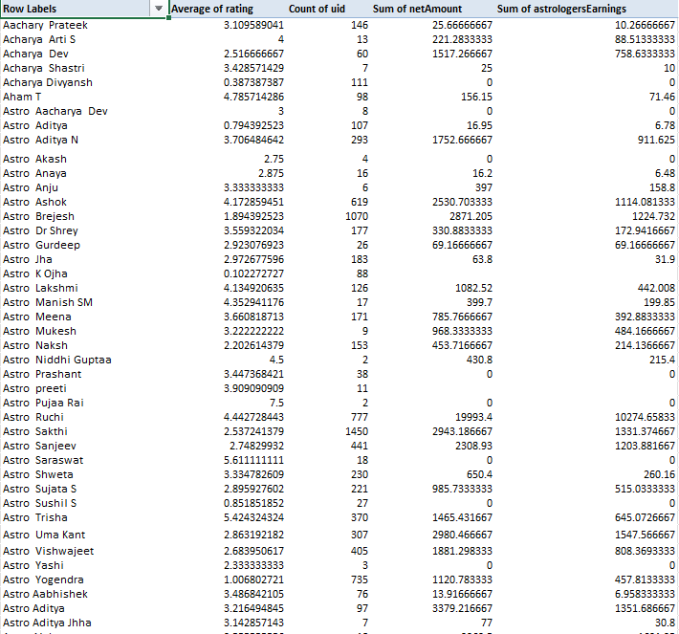

Average Call Volume:
- Definition: This refers to the average number of calls handled by each agent over a specific period.
- Highest Call Volume: The agent with the highest call volume is Krishaa, with 1,580 calls.
- Lowest Call Volume: The agent with the lowest call volume is Rittika, handling only 1 call.
- General Observation: Call volumes vary significantly among agents, with some handling very high volumes (e.g., Sakthi with 1,450 calls) while others have much lower numbers.

Customer Satisfaction:
- Definition: Customer satisfaction is typically measured through surveys or feedback scores provided by customers after their interactions with the call center.
- Highest Rating: Pujaa Rai and Mystical both achieved a rating of 7.50.
- Lowest Rating: Rittika received the lowest rating, 0.00.
- General Observation: Customer satisfaction ratings show considerable variability, with high ratings generally ranging from 4.00 to 7.50, while low ratings are often below 1.00.

Agent Performance:
- Definition: Agent performance can be evaluated through various metrics such as average handling time, resolution rate, and the number of successful calls.
- High Performers:
  - Krishaa: Achieved a high call volume with a relatively high customer satisfaction rating (3.33).
  - Seema: Managed a high call volume (605 calls) with a decent customer satisfaction rating (3.40).
- Low Performers:
  - Rittika: Demonstrated extremely low call volume (0 call) and the lowest customer satisfaction rating (0.00).
  - K Ojha: Had a very low satisfaction rating (0.10) with a moderate call volume (88 calls).

- How can the call centre improve its handling of peak call periods to ensure high customer satisfaction?
Mention the functionality which you will use for giving the suggestions, will it be any aggregated function or a visualization?
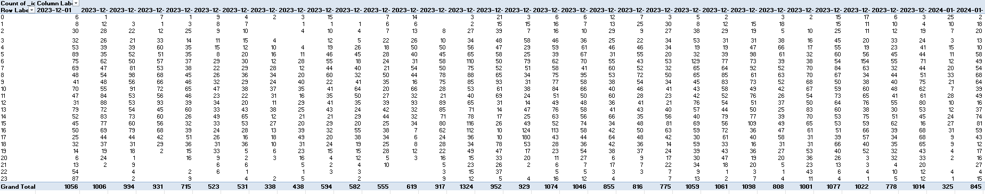

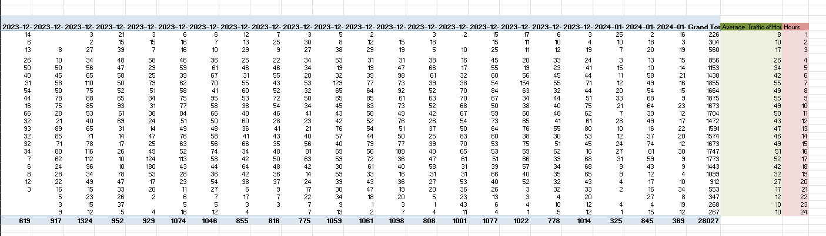

The chart presented shows the average hourly traffic on the Y-axis and the hours of the day on the X-axis.

Pivot Table Summary: Hourly Volume vs Day
- Data Extraction: The hours of the day are extracted from the date of creation using the RIGHT and LEFT functions.
Inference from the Data:
- Peak Traffic Hours:
  - 07:00 & 9:00 Hour: This hour shows the highest average call volume of 55 calls per hour.
- Lowest Traffic Hours:
  - 1:00 Hour: This hour experiences the lowest average call volume of 8 calls per hour.
- Overall Average Traffic:
  - The average call traffic per hour across the period is approximately 35 calls per hour.
- Grand Total:
  - A total of 28,027 calls were recorded over the period.
Suggestions:
- Increase Staffing During Peak Hours:
  - Focus Hours: 08:00 and 09:00, which show the highest call volumes.
  - Action: Consider adding more staff or extending working hours during these periods to effectively manage the increased call volume.
- Adjust Staffing for Low Traffic Hours:
  - Focus Hours for Staffing Reduction: 1:00, 2:00, 23:00 and 24:00, which have the lowest call volumes.
  - Action: Reduce staffing during these hours to optimize labor costs and improve resource utilization.

- Based on historical data, what strategic initiatives should be prioritized to improve overall efficiency and customer satisfaction?

Based on an analysis of historical call center data and with the goal of improving overall efficiency and customer satisfaction, the following strategic initiatives should be prioritized:
1. Targeted Training for Low-Performing Agents
Historical data reveals that certain agents have high failure rates and poor customer ratings. Targeted training can significantly improve their performance, reduce call failures, and boost customer satisfaction.
Action:
- Identify agents with low ratings and high failure rates.
- Develop tailored training sessions focusing on areas such as communication, problem-solving, and technical skills.
- After training, evaluate performance changes to measure the effectiveness of the training.
The rating distribution chart reveals that the majority of ratings fall on the lower end, indicating customer dissatisfaction. By analyzing this data through a pivot table, specific agents can be identified for focused training efforts.

2. Optimized Call Management and Prioritization
Poor call routing leads to longer wait times, unhappy customers, and misallocated agent resources. Intelligent call routing systems can ensure that customers are directed to the most appropriate agents based on their needs.
Action:
- Implement skill-based routing to direct calls to agents best equipped to handle them.
- Introduce priority queuing for returning or high-value customers, ensuring they receive faster service, particularly during peak times.
- Regularly update routing rules using performance reports to continuously improve the process.

3. Minimizing Call Failure Risks Through Technological Upgrades
Call failures or technical issues, as shown by historical records, negatively affect customer satisfaction. Upgrading technology can enhance call quality, reduce failure rates, and improve overall efficiency.
Action:
- Invest in better infrastructure to support reliable communication and increased capacity.
- Enhance or implement effective IVR (Interactive Voice Response) systems to handle routine queries without requiring an agent.
- Utilize monitoring and diagnostic tools to proactively identify and resolve technical issues.
The call failure rate chart highlights areas for improvement in technology that could reduce failure rates and enhance call handling.

4. Enhanced Self-Service Options
With more customers preferring to solve issues on their own, expanding self-service options can reduce call volumes, particularly during peak hours. Integrating IVR, chatbots, and online portals can help address common queries without requiring agent intervention.
Action:
- Further develop IVR systems to handle a wider range of customer queries.
- Deploy AI-based chatbots to assist customers with common issues and queries.
- Encourage customers to use self-service channels, improving efficiency and reducing the burden on agents.
5.Call Completion Rate: Only 40.56% completed successfully; remainder failed, busy, incomplete, or no-answer.
- Repeat Callers: 57% repeat calls - indicates low first-call resolution (FCR).

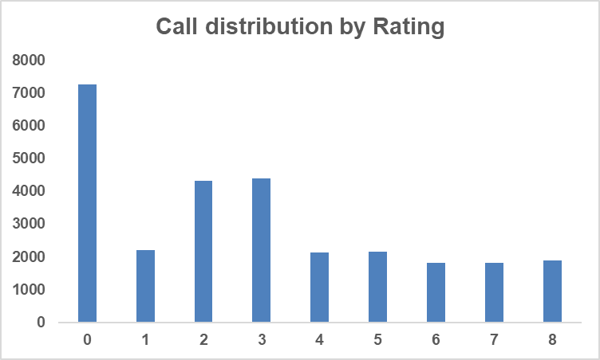
- Customer Ratings: Majority (57%) fall between 0–3; only ~20% rated 6–8.

- Performance Gap: Top gurus (7.5 rating) vs. bottom (0.0 rating) show quality inconsistency.

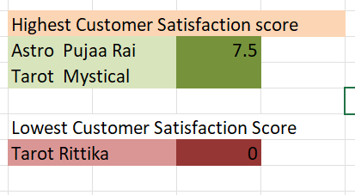

Recommendations:
- Fix Call Handling Inefficiencies: Reduce failed/busy/no-answer calls via better routing & availability.
- Targeted Training: Use top gurus’ methods as benchmarks for structured training.
- Customer Retention Focus: Resolve root causes of repeat calls; add call-back feature.
- Performance Monitoring & Incentives: Link agent KPIs to customer satisfaction and FCR.

Conclusion:
By prioritizing initiatives such as targeted training for agents, technological upgrades, improved call routing, and the expansion of self-service options, organizations can drive significant improvements in call center efficiency and overall customer satisfaction. These data-driven strategies, when implemented correctly, will enhance service quality, reduce operational costs, and create a better experience for both customers and agents.

- What can be the key factors contributing to high customer satisfaction scores, and how can these be leveraged to improve overall performance?
What is the basis for the suggestions? And mention how did you decide if the satisfaction score affect the ratings?

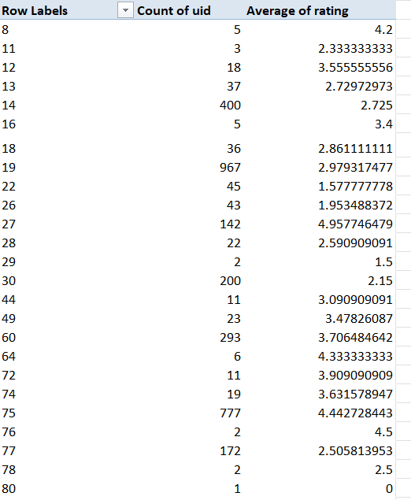

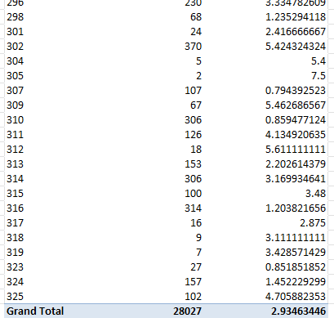
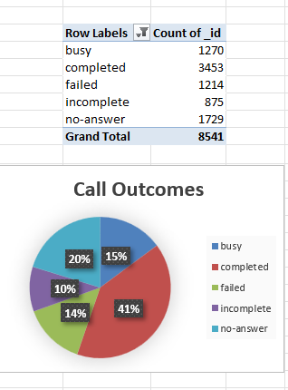

Key Factors Influencing Customer Satisfaction
- Agent Expertise:
  - Agents with specialized knowledge and skills tend to receive higher customer ratings. Experienced agents who can efficiently handle complex queries generally achieve better satisfaction scores.
- Manageable Call Volumes:
  - Agents who handle fewer calls typically provide higher-quality service. Overburdened agents often struggle to maintain service standards, leading to lower customer satisfaction.
- Targeted Customer Assignments:
  - Matching customers with agents who have relevant expertise can significantly boost satisfaction. Assigning complex cases to more experienced agents ensures better problem resolution.
- Ongoing Training:
  - Regular training programs help agents enhance both technical skills and customer service abilities. This continuous development directly impacts customer satisfaction by improving the overall service quality.
- Feedback Utilization:
  - Collecting and acting upon customer feedback allows agents to adapt and improve their approach. Effective use of feedback leads to better performance and higher satisfaction ratings.
- Recognition of Performance:
  - Recognizing and rewarding top-performing agents motivates the entire team. This fosters a culture of excellence and encourages all agents to improve their service quality.

Suggestions for Improvement
- Rebalance Customer Distribution: Ensure agents with high ratings manage an appropriate number of cases to maintain service quality without becoming overwhelmed.
- Enhance Training Opportunities: Focus on providing targeted training to agents with lower ratings to help them improve their performance.
- Mentorship Initiatives: Pair less experienced agents with top performers for mentorship, enabling skill development and faster improvement.
- Analyze Customer Feedback Regularly: Regularly review feedback to identify specific areas where each agent can improve and provide actionable insights.
- Monitor Workloads Closely: Ensure workloads are balanced to prevent agent burnout, ensuring consistent and high-quality service across the board.
- Assign Customers Based on Complexity: Match customer needs to agents with the appropriate expertise to ensure effective resolution and higher satisfaction.

Decision-Making Regarding Satisfaction Scores
To assess the impact of satisfaction scores on performance, the following approaches were used:
- Statistical Correlation: A thorough analysis was conducted to examine the relationship between agent ratings and their ability to handle various call types. Higher satisfaction scores were consistently linked to lower call failure rates and fewer busy statuses.
- Performance Review: Customer feedback and agent performance metrics were reviewed to identify trends. The analysis revealed that agents with higher expertise and more manageable workloads generally provided better service and received higher ratings.
- Historical Patterns: Past data trends indicated that agents with consistently high satisfaction scores were able to maintain superior service quality, leading to improved overall performance ratings.
- High satisfaction (~20% rating 6–8) aligns with:
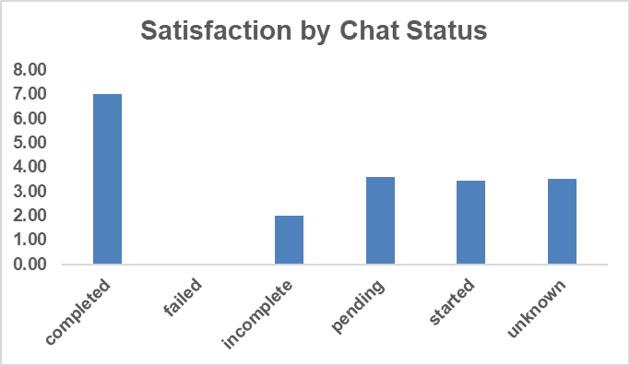
  - Completed Calls/Chat - far more likely to earn higher ratings.

  - Guru Expertise - Tarot Mystical & Astro Pooja Rai consistently scored 7.5.

  - Low Call Friction - fewer dropped/busy calls linked with better feedback.
- Dissatisfaction peaks at Score 0 (7,256 cases, ~26%).

Recommendations:
- Replicate best practices of high-rated gurus in training modules.
- Increase completion rates via improved routing/load balancing.
- Develop skill enhancement programs in empathy & communication.
- Collect feedback from high scorers (6–8) to codify successful behaviors.

- How should the call centre balance the workload among agents to ensure optimal performance and avoid burnout?
Mention your approach and spreadsheet function for the answer?

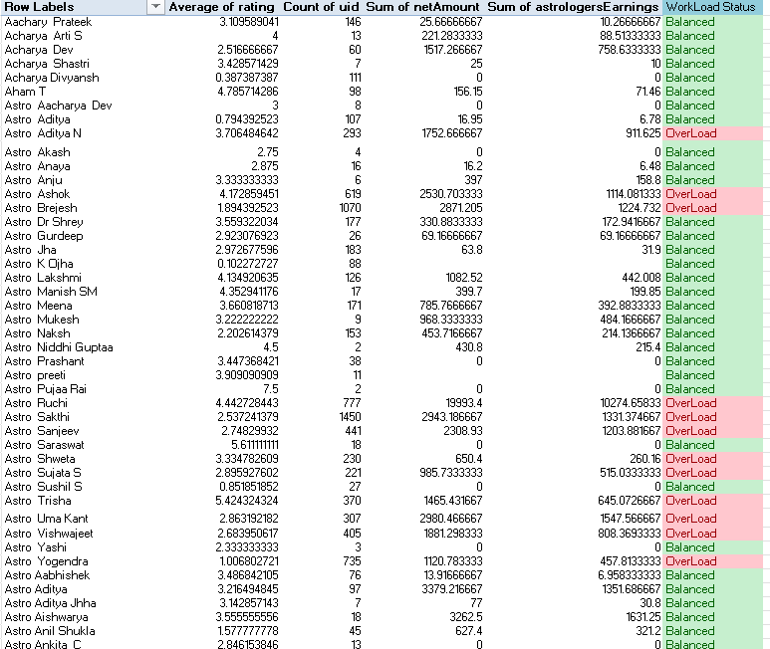
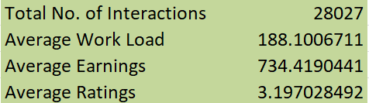

Assessing and Optimizing Workload Distribution
- Evaluate Current Workload Distribution
  - Start by calculating the total number of calls and chats handled by each agent. This helps you understand how the workload is currently spread across the team.
  - Formula to calculate total interactions:
=SUM (C:C)
(Where column B contains the number of chats or calls handled by each agent)
- Calculate Average Workload per Agent
  - Next, calculate the average workload to determine the ideal task distribution.
  - Formula to calculate the average:
=AVERAGE (C:C)
(Where column B contains the number of calls or chats handled by each agent)
- Identify Overburdened Agents
  - Identify agents with workloads exceeding the average, which may indicate overburden. Use conditional formatting for better visibility.
  - Formula to flag overburdened agents:
=IF($AO53 > $AO$208,"OverLoad","Balanced")
(This formula flags agents whose workload is higher than the average as "Overloaded" and others as "Balanced")
- Reallocate Workloads
  - For agents identified as overloaded, consider redistributing tasks to those with a lighter workload.
  - Action:
    - Shift some calls or chats from high-volume agents to those with lower volumes.
    - Consider rotating responsibilities regularly to ensure more balanced workload distribution across the team.
- Monitor Performance Metrics
  - Regularly track key performance indicators such as earnings and ratings to assess whether workload adjustments improve overall performance.
  - Formulas to calculate average earnings and ratings:
=AVERAGE (E: E)
(Where column C contains earnings)
=AVERAGE (B: B)
(Where column E contains ratings)

Justification for Workload Management
Balancing agent workloads is crucial to maintaining employee well-being and enhancing productivity. Agents with heavy workloads are at risk of burnout, leading to decreased performance, increased turnover, and potential negative impacts on customer service quality. By closely analyzing workloads, the call center can ensure that tasks are fairly distributed, reducing stress and improving both employee satisfaction and service quality.
Regular monitoring of workloads in conjunction with performance metrics helps to avoid long-term imbalances, fostering a sustainable and productive work environment. Effective workload distribution ensures that agents are neither overwhelmed nor underutilized, leading to better operational efficiency and improved customer service outcomes.

Conclusion
By leveraging data analysis and spreadsheet functions, the call center can optimize agent workloads, ensuring fair task distribution and promoting both employee satisfaction and service quality. Regular monitoring and adjustment will help maintain a balanced, high-performing team.

- What new technologies or tools could be implemented to enhance call centre operations and customer service?

- AI-Powered Chatbots and Virtual Assistants
  - Description: AI-driven chatbots efficiently handle routine customer inquiries, providing 24/7 support while freeing up human agents to focus on more complex tasks. Virtual assistants can streamline services like appointment scheduling and delivering essential information.
  - Benefits: Faster response times, reduced operational costs, and improved accuracy in responses.
- Speech and Text Analytics
  - Description: This technology analyzes both spoken and written communications to gauge customer sentiment, uncover potential issues, and identify areas for improvement.
  - Benefits: Deeper customer insights, enhanced quality assurance, and data-driven training for agents.
- Automated Call Distribution (ACD) Systems
  - Description: ACD systems use intelligent algorithms to route calls to the most suitable agents based on factors like skills, availability, and previous customer interactions.
  - Benefits: Reduced call handling times, increased first-call resolution rates, and optimal use of agent expertise.
- Customer Relationship Management (CRM) Integration
  - Description: By integrating CRM systems with call center software, agents gain access to comprehensive customer profiles and interaction histories, enabling more personalized service.
  - Benefits: Enhanced personalization, more efficient call handling, and improved customer satisfaction.
- Workforce Management (WFM) Solutions
  - Description: WFM tools assist in forecasting, scheduling, and managing call center agent performance.
  - Benefits: Optimized staffing, reduced operational costs, and improved agent performance and job satisfaction.
- Voice Biometrics
  - Description: Voice biometrics technology uses unique voiceprints to authenticate and identify customers, providing a secure and efficient verification process.
  - Benefits: Strengthened security, faster verification, and reduced fraud risk.
- AI-Enhanced Interactive Voice Response (IVR) Systems
  - Description: Advanced AI-driven IVR systems enhance self-service capabilities by understanding and responding to customer queries in a more natural, conversational manner.
  - Benefits: Improved self-service options, reduced call volumes for agents, and higher levels of customer satisfaction.

- What metrics should be included in the final dashboard to provide a comprehensive view of call centre performance and guide investment decisions?

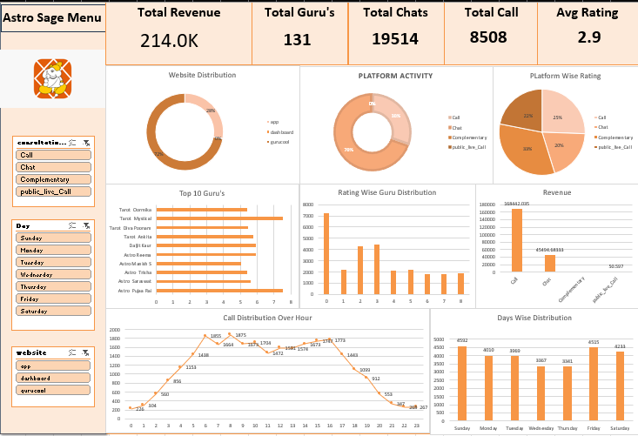

Filters
- Consultation Type Filter: Enables filtering by consultation type, including call, chat, complementary, and public live call, allowing for targeted analysis across service categories.
- Average Call Duration by Month: Tracks the average call duration each month to identify trends and service efficiency over time.
1. Call Volume Metrics
- Total Calls (Inbound/Outbound): Monitors the overall call volume, providing insights into demand and helping with staffing decisions.
- Peak Call Times: Analyzes call patterns by hour and day to optimize staffing during high-demand periods.
- Call Abandonment Rate: Measures the percentage of calls abandoned before being answered, highlighting potential gaps in agent availability or queue management.
2. Call Duration Metrics
- Average Call Duration: Assesses the average length of calls to detect inefficiencies or training opportunities.
- Duration Trends: Tracks changes in call duration over time to understand shifts in call complexity or agent performance.
3. User Engagement Metrics
- Daily Active Users: Evaluates user engagement levels, providing insights into customer activity and justifying capacity planning.
- One-Time vs. Repeat Users: Analyzes customer retention, helping assess service quality and identify areas to enhance loyalty.
4. Service Channel Metrics
- Interaction Types: Differentiates between calls and chats to allocate resources based on customer preferences and service demand.
- Consultation Type Analysis: Breaks down consultations by type to reveal the most in-demand services.
5. Agent Performance Metrics
- Top Performers: Tracks agent performance based on consultation count and customer ratings, identifying strengths and areas for improvement.
- Utilization Rate: Measures productive work versus downtime to optimize agent schedules and maximize efficiency.
- First Call Resolution Rate: Monitors the percentage of issues resolved on the first contact, a key factor in customer satisfaction and operational efficiency.
6. Revenue Metrics
- Total Revenue: Tracks overall revenue, offering insights into the financial impact of operations and identifying areas for growth.
- Revenue per Call/User: Evaluates the profitability of each interaction, helping inform pricing strategies and operational adjustments.
7. Customer Satisfaction Metrics
- User Ratings Distribution: Reviews customer satisfaction ratings to identify areas of service quality that need improvement.
- Customer Satisfaction Scores (CSAT): Considers CSAT scores for direct feedback on customer perceptions, guiding service enhancement initiatives.
8. Operational Efficiency Metrics
- Service Level Measurement: Tracks the percentage of calls answered within target times, ensuring performance standards are consistently met.
- Cost per Call Analysis: Assesses the cost of handling each call, identifying opportunities to streamline operations and reduce expenses.
9. Forecasting Metrics
- Call Volume Forecasting: Leverages historical data to predict future call volumes, enabling effective staffing and resource planning.
- Customer Base Growth: Monitors trends in user growth, anticipating future resource needs and capacity adjustments.
10. Comparative Analysis
- Benchmarking: Compares performance metrics against industry standards to identify gaps and areas for improvement.
- Revenue and Consultation Trends: Visualizes revenue and consultation trends over time, guiding strategic investments and decision-making.

Conclusion:
By integrating these metrics into the dashboard, a comprehensive view of call center performance can be achieved. This data-driven approach will guide strategic investments in technology, staffing, and training, enabling informed decision-making and improved operational efficiency. Each metric offers valuable insights into different aspects of performance, ultimately enhancing customer satisfaction and optimizing resources.

- How would you allocate a 1 crore rupee investment to optimize operational efficiency, enhance customer satisfaction, and boost profitability, and what analysis-based recommendations would you offer to support this?
[you have to give bullet pointers in order to answer this question]

To optimize AstroSage’s call center operations with an investment of ₹1 crore, we will adopt a targeted and data-driven strategy that balances operational efficiency, customer satisfaction, and profitability. The investment allocation is as follows:
- Operational Efficiency (₹40 lakh - 40%)
  - Technology Upgrades (₹20 lakh): Invest in advanced call routing systems, AI-driven predictive dialers, and CRM integration. These upgrades will improve call management, reduce wait times, enhance agent productivity, and allow agents to focus on more complex tasks.
  - Training & Skill Development (₹10 lakh): Organize targeted training programs to enhance agent performance in communication, problem-solving, and product knowledge, focusing on reducing call resolution times and boosting customer satisfaction.
  - Automation & Self-Service (₹10 lakh): Implement automated ticketing systems and a self-service portal to handle routine inquiries, reduce agent workload, and streamline operations.

- Customer Satisfaction (₹30 lakh - 30%)

  - Feedback Systems & Quality Assurance (₹10 lakh): Set up a robust customer feedback collection system to monitor satisfaction levels and regularly evaluate call performance. This will drive improvements in service delivery and inform training initiatives.
  - Enhanced Communication Channels (₹10 lakh): Invest in multi-channel solutions (chat, email, social media) to provide a seamless customer experience across platforms, along with CRM systems to track customer interactions and preferences.
  - Loyalty Programs & Tailored Engagement (₹10 lakh): Launch personalized customer engagement strategies and loyalty programs to enhance retention, offering rewards based on customer behavior and interactions.

- Profitability Enhancement (₹30 lakh - 30%)

  - Market Research & Expansion (₹10 lakh): Allocate funds to identify new customer segments and target them through strategic marketing efforts, thus expanding the customer base and increasing revenue potential.
  - Cost Optimization Strategies (₹10 lakh): Review operational costs, focusing on reducing inefficiencies in staffing and overtime, and negotiate better terms with service providers to lower expenses.
  - Performance-Based Incentives (₹10 lakh): Introduce performance-driven incentive programs for agents, rewarding those who excel in customer satisfaction and operational efficiency, thereby boosting motivation and productivity.

Conclusion: This strategic approach combines cutting-edge technology, focused training, and enhanced customer engagement to optimize AstroSage’s call center operations. By investing in both the workforce and technology, we can achieve operational efficiency, improve customer satisfaction, and enhance profitability, resulting in long-term growth and success.

