Domain Registration & Hosting - Assignment
Assignment
Name: Jatin Joshi
Subject: Digital Marketing

Task 1: Domain Availability Search for a Food Blog
Domain name idea: cravetrail.com (a food-discovery blog, similar in spirit to Zomato). Search result shown below:
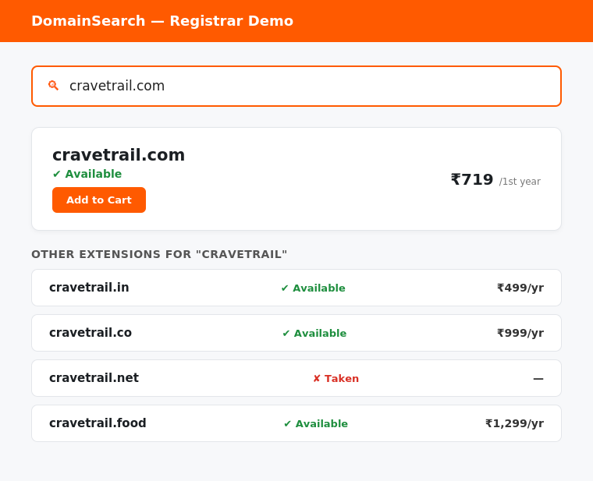
Result: cravetrail.com is available, along with cravetrail.in, cravetrail.co and cravetrail.food. Only cravetrail.net is already taken.

Task 2: Hostinger vs Bluehost - Shared Hosting Comparison (for a Small Ecommerce Site)
- Starting Price - Hostinger: cheaper promotional price, around Rs. 149-269/month | Bluehost: slightly higher promotional price, around Rs. 179-299/month, though both renew at a higher rate after year one.
- Storage - Hostinger's entry-level plan typically offers more storage (around 20-50 GB SSD/NVMe) | Bluehost's entry-level plan usually offers less (around 10 GB SSD), scaling up on higher tiers.
- Control Panel - Hostinger uses its own custom hPanel interface, which is modern but different from most tutorials | Bluehost uses the standard cPanel, which is widely documented and easier to find help for.
- Ecommerce/WooCommerce Readiness - Bluehost is officially recommended by WordPress.org and has stronger built-in WooCommerce and staging tools, which matters for a Flipkart-style store | Hostinger supports WooCommerce too, but with fewer store-specific built-in features.
- Free Extras - Bluehost commonly bundles a free domain for the first year, free SSL and a CDN on shared plans | Hostinger also includes free SSL and a website builder, with a free domain usually only on longer/higher-tier plans.
- Customer Support - Bluehost offers 24/7 live chat plus phone support | Hostinger offers 24/7 live chat only, with generally faster response times reported by users.
(Note: shown here as a labelled comparison list rather than a grid table to match the plain document format - happy to convert this into an actual Word table if you'd prefer that instead.)

Task 3: Free Subdomain with a Basic HTML Homepage
Important update: the hint suggests Freenom, but Freenom stopped offering free domains in February 2024 after exiting the domain business, and it has since relaunched as a paid registrar - so it can no longer be used for a free subdomain. InfinityFree is still a genuinely free option in 2026 and was used instead.
Steps followed:
- 1. Signed up for a free account at infinityfree.com using an email address.
- 2. Created a new hosting account and chose a free subdomain, for example jatinjoshi.rf.gd (InfinityFree issues free subdomains under domains like .rf.gd and .great-site.net).
- 3. Opened the Online File Manager (or connected with an FTP client such as FileZilla using the credentials InfinityFree provides).
- 4. Uploaded the index.html file below into the htdocs folder, which is the default folder InfinityFree serves the website from.
- 5. Visited the subdomain in a browser to confirm the page loads and shows the message.
HTML file used (also submitted separately as index.html):
<!DOCTYPE html>
<html>
<head><title>My Website</title></head>
<body style="display:flex;align-items:center;justify-content:center;height:100vh;background:#2F6F4E;font-family:Arial;">
<h1 style="color:white;">Hello from My Website!</h1>
</body>
</html>

Task 4: Domain Registration vs Web Hosting (Instagram Analogy)
Registering a domain name is like reserving a username on Instagram - it makes sure that specific name belongs only to you, and nobody else can use it. Web hosting, on the other hand, is like Instagram's servers that actually store and display your photos and videos whenever someone visits your profile. In other words, the domain is just the address people type to find you, while hosting is the storage space and server that actually holds your website's files and content. You need both together for a website to work, just like an Instagram profile needs both a unique username and Instagram's servers storing your posts.

Task 5: 7-Step Checklist to Launch a Basic Website (AI-Generated)
- 1. Decide on a domain name that reflects your brand and is easy to remember.
- 2. Check domain availability and register it through a domain registrar.
- 3. Choose a web hosting plan suited to your website's size and expected traffic.
- 4. Point the domain's nameservers to your hosting provider so they are connected.
- 5. Build the website using a website builder, CMS (like WordPress) or custom HTML/CSS.
- 6. Install an SSL certificate so the site loads securely over HTTPS.
- 7. Test the website on different devices and browsers, then make it live for visitors.

