Marketing Funnel - Assignment
Assignment
Name: Jatin Joshi
Subject: Digital Marketing

Task 1: Marketing Funnel Diagram for a Daily-Use App
App chosen: Zomato. Each stage is labelled with a real example action a user might take at that point.
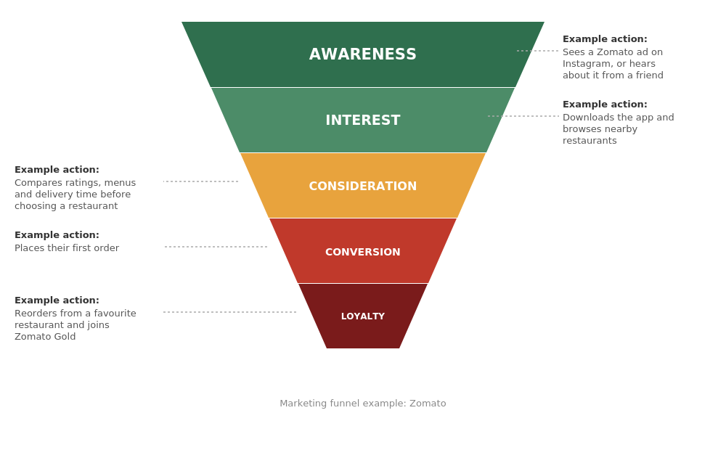

Task 2: Key Metrics for Each Funnel Stage (Flipkart)
- Awareness - Impressions, Reach, Video Views
- Interest - Click-Through Rate (CTR), App/Website Visits, Time on Page
- Consideration - Add to Cart, Wishlist Adds, Product Page Views
- Conversion - Purchases, Conversion Rate, Average Order Value
- Loyalty - Repeat Orders, Repeat Purchase Ratio, Customer Retention Rate
(Note: shown here as a labelled list rather than a grid table to match the plain document format - happy to convert this into an actual Word table if you'd prefer that instead.)

Task 3: Conversion Rate Calculations (Food Delivery Campaign)
Given: 10,000 people saw the ad -> 1,200 clicked -> 300 installed the app -> 60 placed an order.
- Ad Seen -> Clicked: (1,200 / 10,000) x 100% = 12%
- Clicked -> Installed: (300 / 1,200) x 100% = 25%
- Installed -> Ordered: (60 / 300) x 100% = 20%
- Overall (Ad Seen -> Ordered): (60 / 10,000) x 100% = 0.6%

Task 4: Using a Funnel Metric to Improve a Spotify Campaign
Metric chosen: Click-Through Rate (CTR)
If a Spotify campaign's CTR is low, a marketer immediately knows the ad creative or targeting isn't resonating with the audience, even if the ad is reaching plenty of people. They could then test different headlines, visuals or audience segments to see which version drives more clicks, and shift budget toward whichever performs best. This directly improves the Interest stage of the funnel without needing to change anything about the product itself.

